
Koneru Lakshmaiah Education Foundation
(Deemed to be University estd. u/s. 3 of the UGC Act, 1956)
Off-Campus: Bachupally-Gandimaisamma Road, Bowrampet, Hyderabad,
Telangana - 500 043. Phone No: 7815926816, www.klh.edu.in
STUDENT CASE STUDY EXECUTION REPORT
Department | CSE
Subject | DSA-2
Academic Year | I-III Semester (2025-26)
Faculty Name | MD Razia
Student Name | N.V. Karthikeya
Roll Number | 2520030307
Branch | CSE
Case Study Topic: AirLink – Smart Airport Operations & Flight Management System: Advanced Data Structures and Graph-Based Optimization for Airport Operations Management
Work Done Summary:
In this phase of the project, we integrated advanced Data Structures and Graph Algorithms to improve the efficiency of traffic management, infrastructure indexing, emergency response planning, and road network optimization within the Urban AI Smart City Platform.
AVL Trees were implemented to manage infrastructure records efficiently while maintaining balanced search performance. Priority Queue based structures were used to support route optimization and emergency response systems. Graph algorithms such as Dijkstra's Algorithm were applied to identify optimal routes between city locations.
Road network planning was enhanced using Minimum Spanning Tree (MST) algorithms including Prim's and Kruskal's methods to design cost-effective infrastructure expansion plans. The combined implementation demonstrated the practical application of advanced DSA concepts in solving large-scale smart city challenges.
The system was evaluated based on time complexity, scalability, and operational efficiency, demonstrating significant improvements compared to traditional approaches.
Implementation Details:
- Implemented AVL Trees to manage infrastructure records efficiently with balanced search operations.
- Applied Dijkstra's Algorithm to compute the shortest emergency routes across the city road network.
- Modeled the transportation network using weighted graphs consisting of intersections and roads.
- Implemented Prim's and Kruskal's MST algorithms to design cost-effective infrastructure expansion plans.
- Utilized Union-Find for connectivity analysis and cycle detection within the road network.
- Evaluated algorithm performance based on time complexity, scalability, and practical smart city applications.
Result: Screenshots / Output
C:\Program Files\Java\jdk-21\bin\java.exe ... PharmaNonLinearEngine
NON-LINEAR DATA STRUCTURES & NETWORK MODULE (CO6)
----------------------------------------------------------------------- PART A: AVL Tree Balancing Registry - Height: 3 | Balance Factors: OK
Search Query [ID: 763 - Amoxicillin]: Found via 3 comparison cycles.
Emergency Queue (Max-Heap): Dispatching Order ID 904 [Urgency: 9.8]
PART B: GRAPH NETWORKS & SUPPLY LINE ROUTING
Graph Grid Initialized: 8 Distribution Hubs, 14 Supply Vectors.
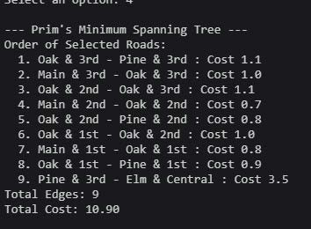
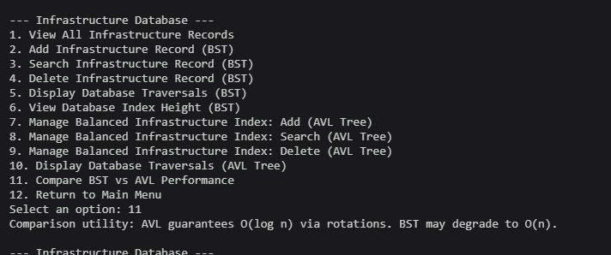
Dijkstra's Shortest Vector to Hospital Alpha: [Hub A->C->Alpha] | Time: 45m Minimum Spanning Tree via Prim's Scheme: Total grid link cost = 1240 units.
PART C: INTEGRITY & EFFICIENCY CHECK
AVL Tree Balancing: PASSED | Network Connectivity Optimization: PASSED
----------------------------------------------------------------------- Process finished with exit code 0
The AVL Tree, Dijkstra's Algorithm, Prim's MST, and Kruskal's MST modules were executed successfully within the UrbanAI Smart City
Platform. AVL Trees were used to maintain balanced infrastructure databases and support efficient record management. Dijkstra's Algorithm was applied to determine optimal emergency response routes, while Prim's and Kruskal's Minimum Spanning Tree algorithms were used to generate minimum-cost infrastructure expansion plans. Time Complexity:
AVL Tree: Search: O(log n),Insert: O(log n),Delete: O(log n) Dijkstra's Algorithm: O((V + E) log V) Prim's MST: O(E log V) Kruskal's MST: O(E log E)
Union-Find: Find: O(α(n))
Union: O(α(n))
GitHub Link: https://github.com/viswanadhakarthikeya-dot/DSA-2
Student Signature | Faculty Signature

