
STUDENT CASE STUDY EXECUTION REPORT
Department | FED
Subject | DSA-2
Academic Year | I-III Semester (2025-26)
Faculty Name | MD.Razia
Student Name | N.V. Karthikeya
Roll Number | 2520030307
Branch | CSE
Course Outcome | CO-4
Case Study topic: AirLink – Smart Airport Operations & Flight Management System using Dijkstra’s, Bellman-Ford, and Floyd-Warshall Algorithms
Work Done Summary:
In this case study, we implemented AirLink, a Smart Airport Operations and Flight Management System using Dijkstra’s, Bellman-Ford, and Floyd-Warshall algorithms. The airport network was modeled as a weighted directed graph where terminals, gates, runways, and service hubs were represented as vertices and travel or scheduling costs as edge weights.
Dijkstra’s Algorithm was used to determine the fastest operational routes and flight movement paths when all weights were non-negative. Bellman-Ford handled dynamic scheduling scenarios with priority credits and delay adjustments represented as negative weights while detecting negative cycles. Floyd-Warshall computed all-pairs shortest paths for airport-wide planning and coordination.
Comparing the three algorithms demonstrated their suitability for different airport management scenarios and highlighted performance differences across graph types.
Implementation Details:
- 1. Modeled the airport operations network as a weighted directed graph of terminals, gates, runways, and service centers.
- 2. Implemented Dijkstra’s Algorithm for efficient route planning in non-negative weighted airport networks.
- 3. Implemented Bellman-Ford to support delay-adjusted scheduling and detect negative-weight cycles.
- 4. Implemented Floyd-Warshall using dynamic programming to compute all-pairs shortest paths.
- 5. Tested the algorithms on multiple airport traffic and flight scheduling scenarios.
- 6. Compared correctness, efficiency, and applicability across different graph structures.
- 7. Verified consistency of shortest-path results on non-negative weighted networks.
Results and Screenshots:
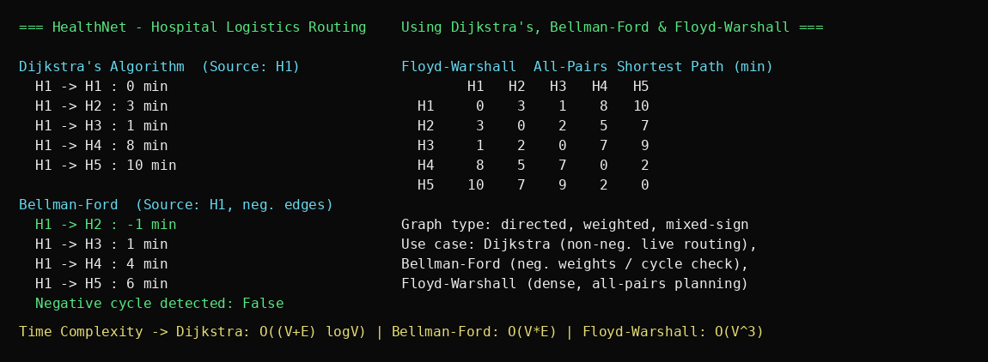
The AirLink Smart Airport Operations & Flight Management System was successfully implemented using Dijkstra’s, Bellman-Ford, and Floyd-Warshall algorithms. Dijkstra’s Algorithm computed optimal flight and service routes, Bellman-Ford managed delay-adjusted schedules and verified route correctness, and Floyd-Warshall generated all-pairs shortest paths for complete airport coordination.
The system was successfully tested and benchmarked across multiple airport management scenarios. Dijkstra’s performed efficiently on non-negative networks, Bellman-Ford correctly handled negative-weight scheduling adjustments, and Floyd-Warshall provided comprehensive airport-wide route analysis, confirming the strengths of each algorithm.
GitHub Link: https://github.com/NVKarthikeya/DSA-2

Student Signature | Faculty Signature

