1. Which route is generating the most revenue per year

Here in this screenshot you can see the list of routes with their distances .

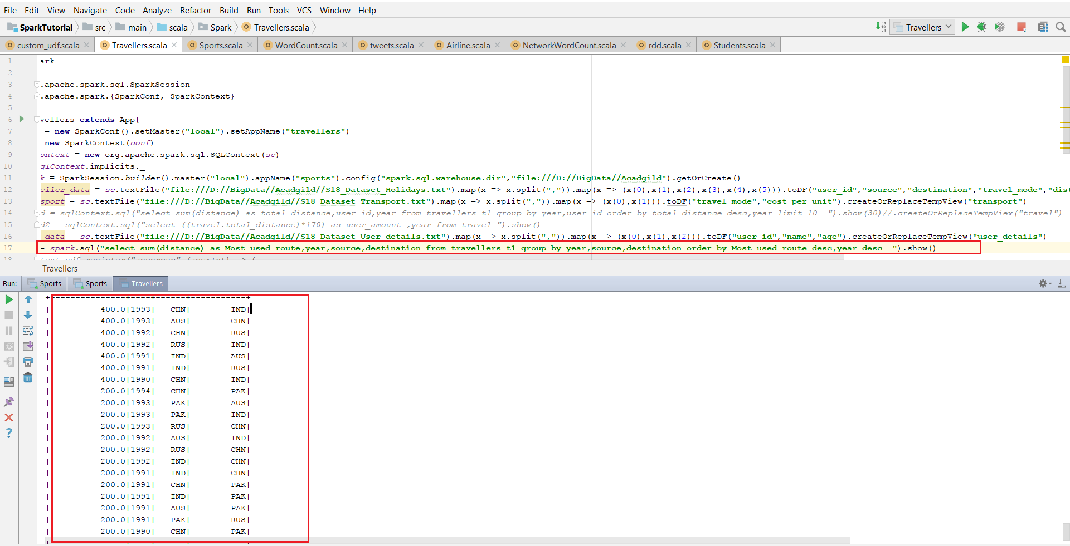

In the below screenshot I had filtered the most used routes per year.

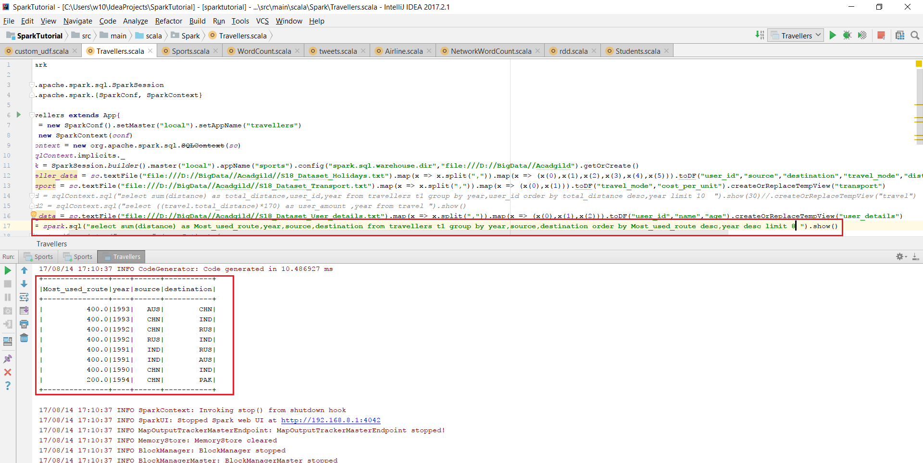

In this one we can see the most revenue generated from these routes per year.

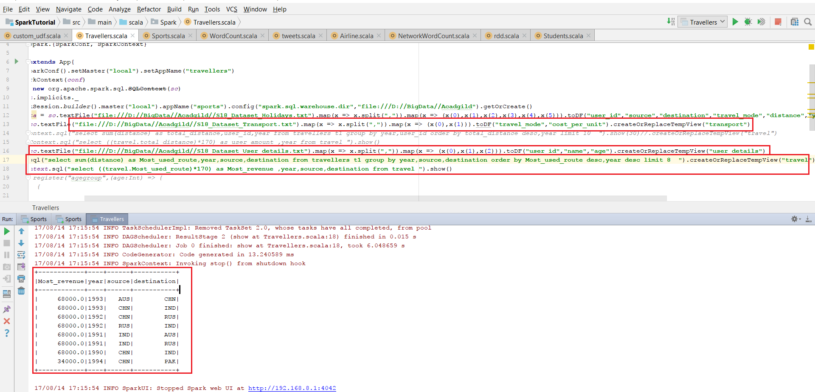

1. What is the total amount spent by every user on air-travel per year

Here output is total distance covered per user per year.

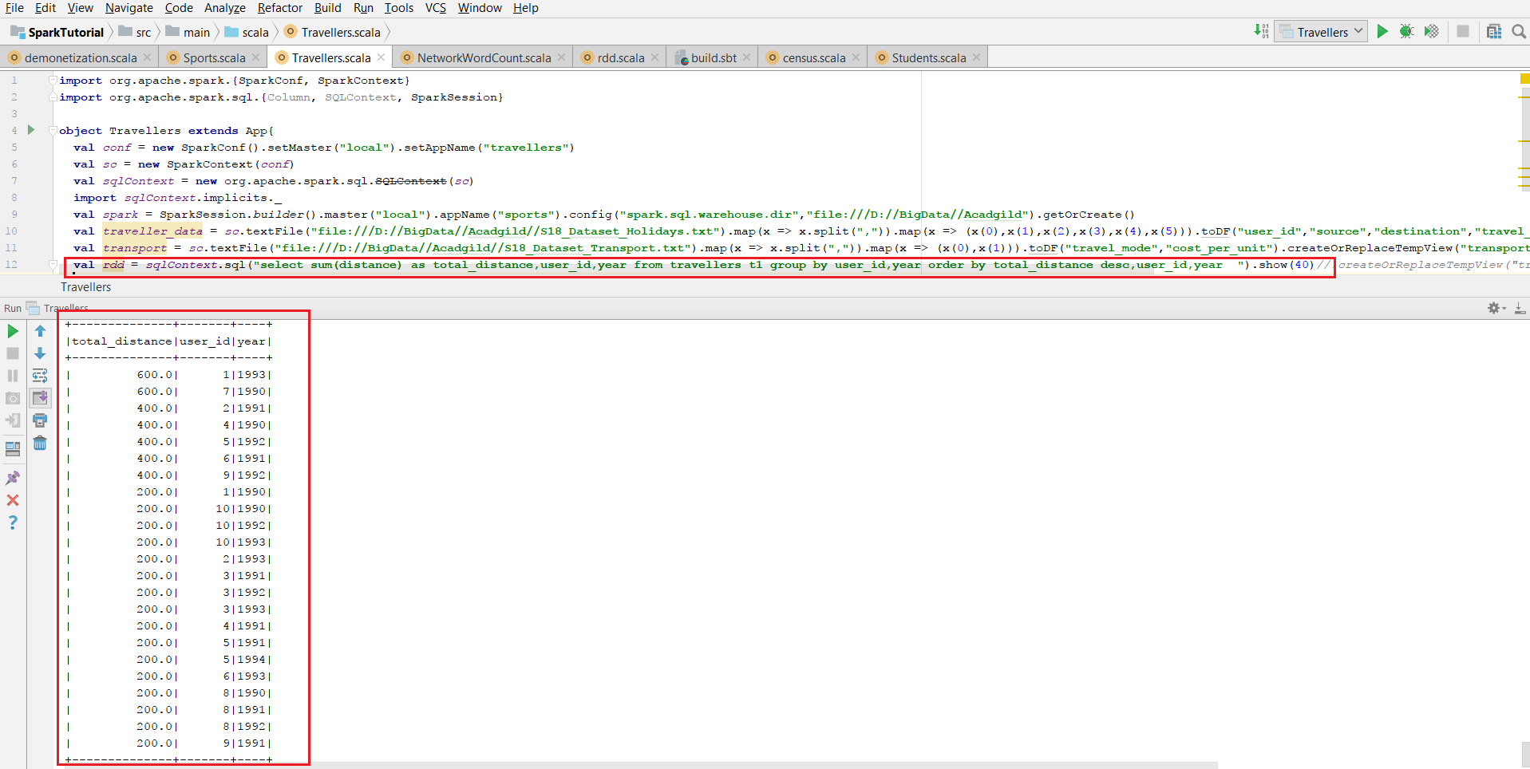

In this below screenshot we can see the total_amount spend by each user per year.

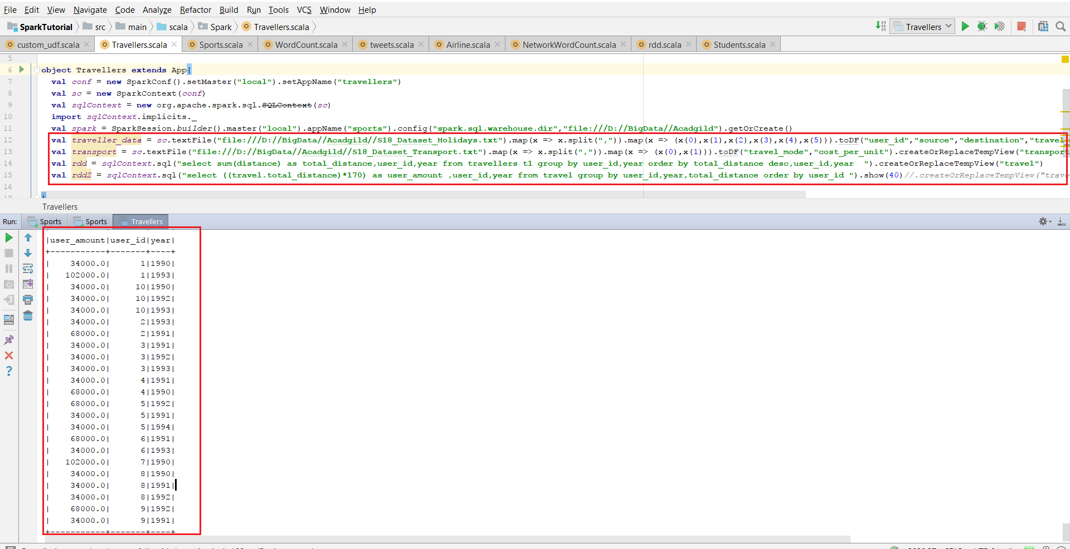

This is the screenshot for the user with highest money spent per year among all users.

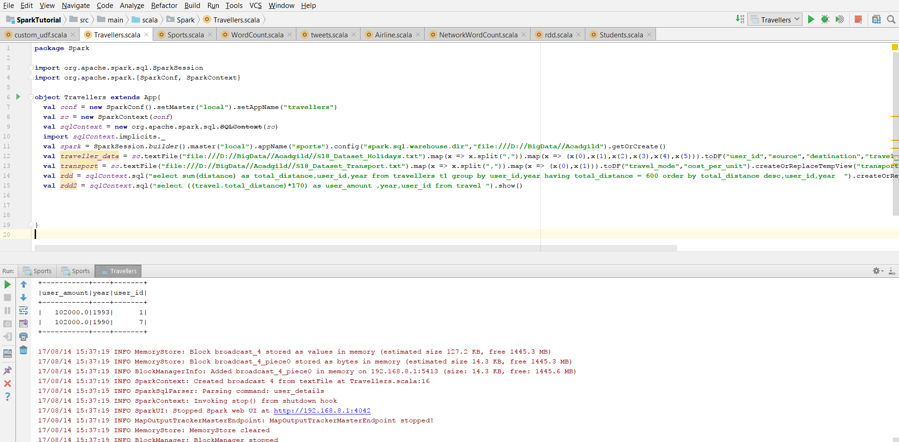

3) Considering age groups of < 20 , 20-35, 35 > ,Which age group is travelling the most

every year.

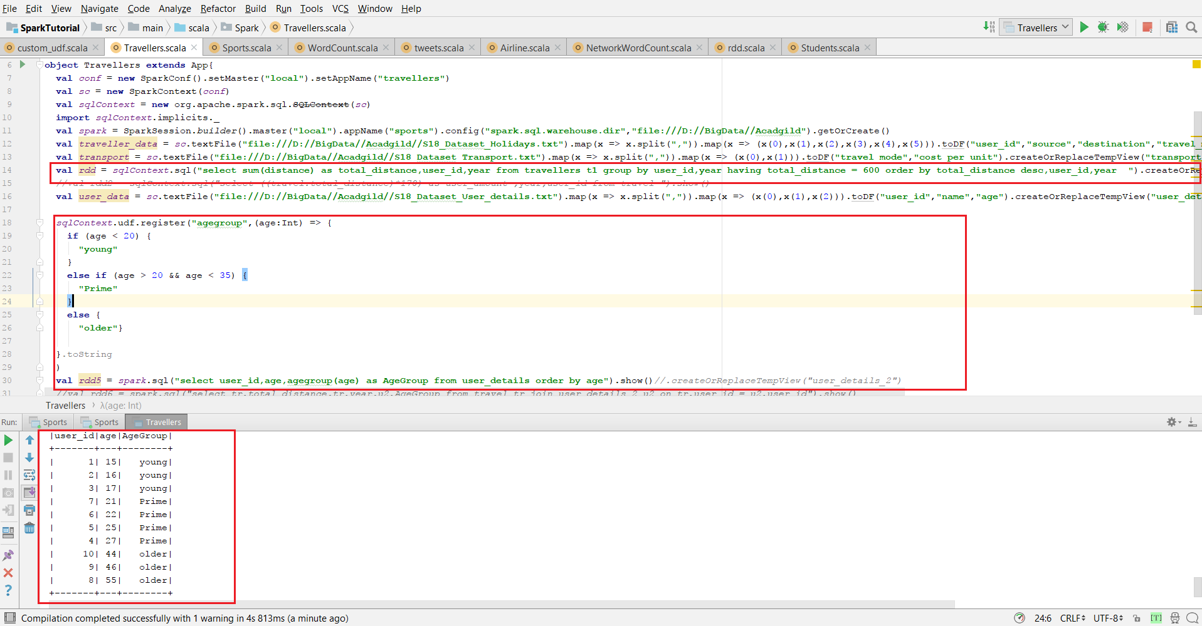

In the above screenshot we can see the users divided into age groups based on the criteria given as:

< 20 as young, 20-35 as Prime, 35 > as older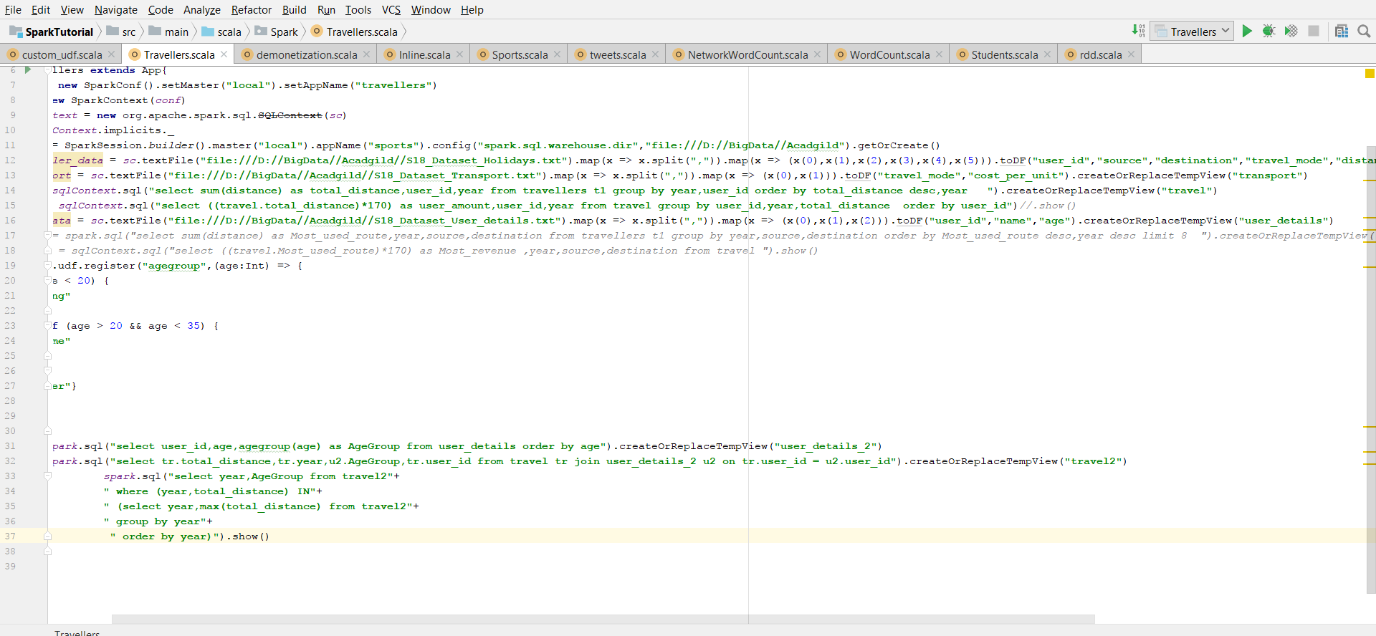

age group travelling the most every year.

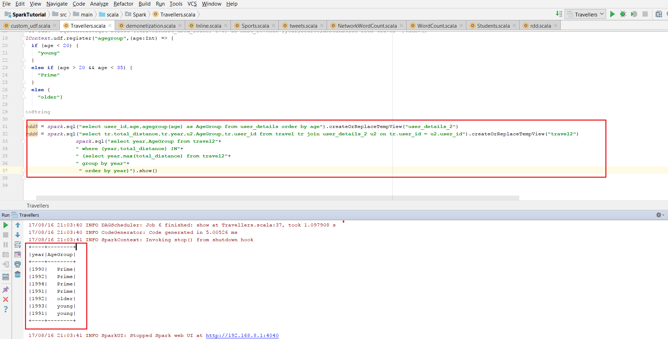

Here we got repetition of 2 years 1991,1992 because user 2,6 for 1991 and 5,9 for 1992 has travelled max distance and they fall under same age group.