**The java class :**

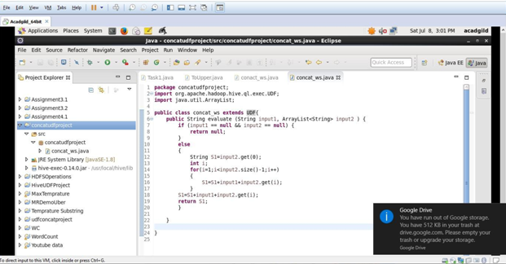

**Exporting the java class as jar file**

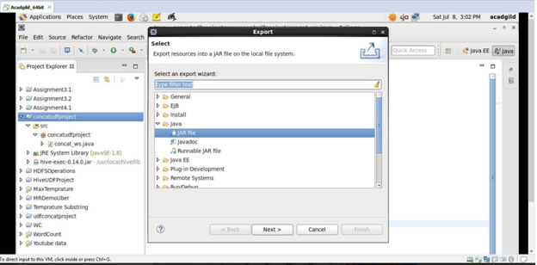

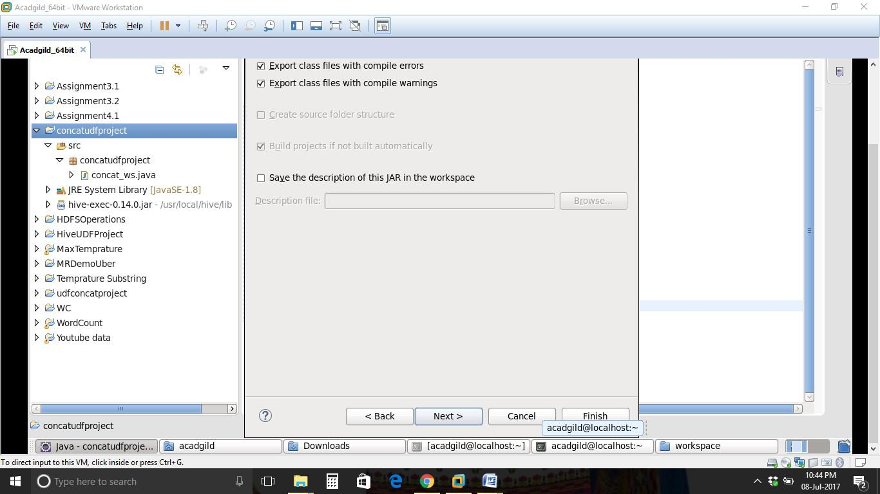

**Hiveconcatudf.jar file is there under /home/acadgild/workspace**

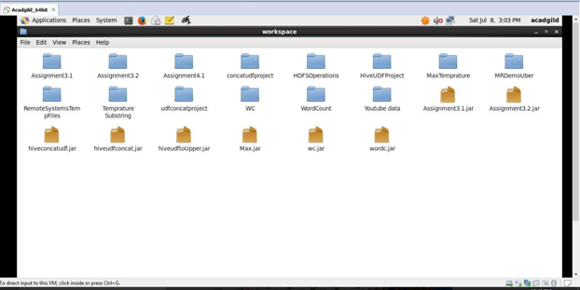

**Adding the jar file in hive**

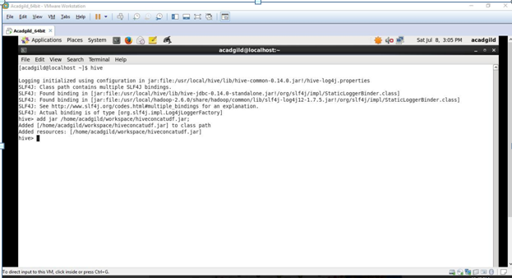

**Creating temporary function myconcat from the UDF java class in the Jar file added**

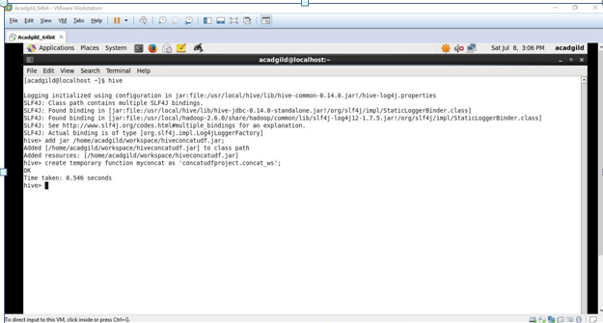

**Using the myconcat UDF passing separator as a string and a array of Strings which returns a String with the array elements separated by the separator.**

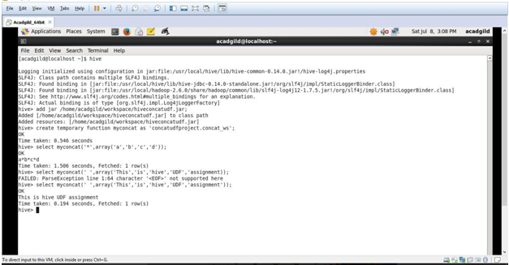

**Calling the same myconcat function with different separators and different size string arrays**

