## **Problem 1: Create an HBase table named 'clicks' with a column family 'hits' such that it should be able to store last 5 values of qualifiers inside 'hits' column family.**

create 'clicks',{NAME=>'hits' , VERSIONS=>5}

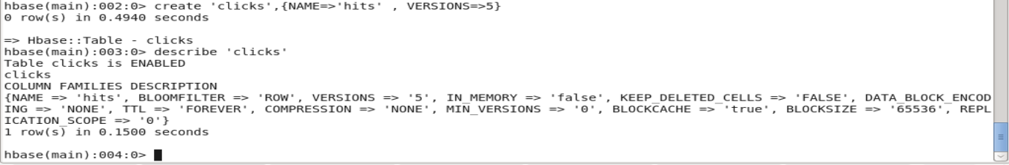

## **Problem 2: Add few records in the table and update some of them. Use IP Address as row-key. Scan the table to view if all the previous versions are getting displayed.**

**Adding records**

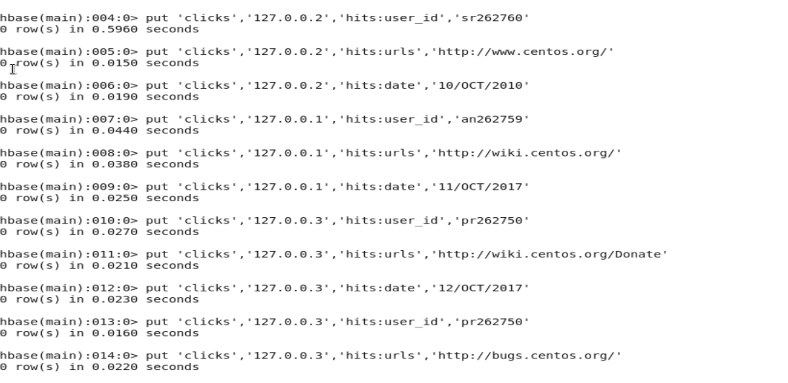

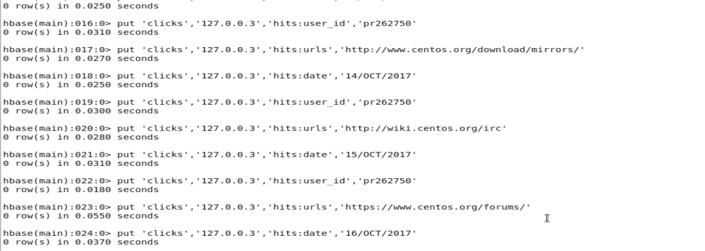

**If we just scan the table, we will get the last updated records**

scan ‘clicks’

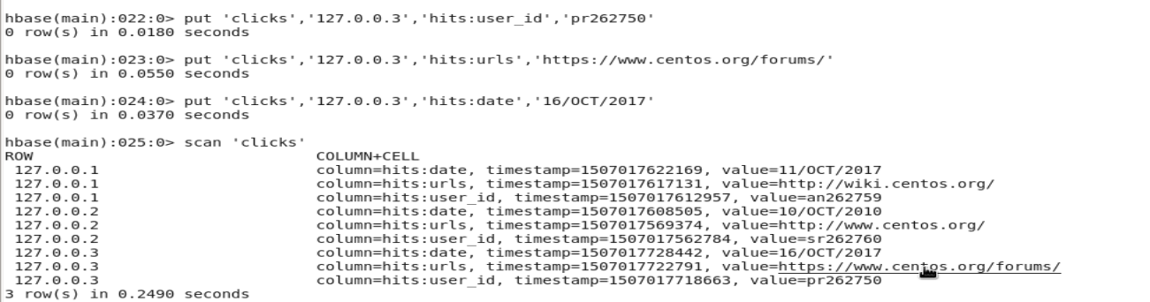

**To Get all records with Versions**

scan ‘clicks’, {VERSIONS=>5}

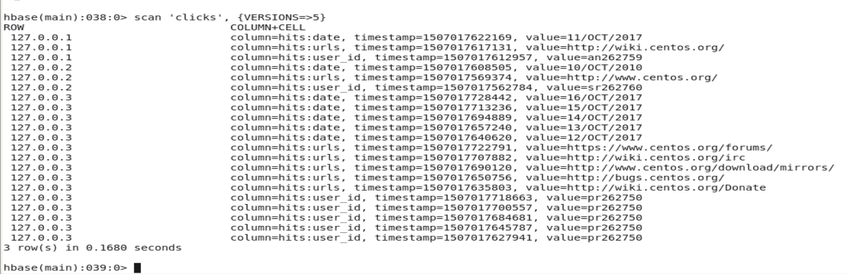

**Checking version for individual columns**

scan 'clicks' , {COLUMN =>'hits:date', VERSIONS => 5}

scan 'clicks' , {COLUMN =>'hits:user_id', VERSIONS => 5}

scan 'clicks' , {COLUMN =>'hits:urls', VERSIONS => 5}

