AI Hiring Intelligence System
Documentation Package
Capstone 2 — Technical Reference

Project | AI Hiring Intelligence System
Version | V104 (working)
Stack | n8n · OpenAI · Pinecone · Streamlit · GitHub
Agents | 5 insight agents + Routing + Evaluation + Optimization
Data | 200 candidates · Google Sheets source
Dashboard | Streamlit Community Cloud (GitHub-linked)

Created by | Viswa Nalam
Reviewed by | Prasanna Jayapal

Contents: (1) Architecture Diagrams, (2) Agent Contract Reference, (3) Evaluation Notes, (4) Setup Instructions.

1 — System Architecture
The system is a multi-agent n8n workflow that runs 5 specialised hiring agents in parallel, each grounded by Pinecone RAG and powered by OpenAI LLMs. Results are pushed to GitHub and rendered by Streamlit.

1.1 End-to-End Flow Diagram
The diagram below shows the complete workflow from input trigger to dashboard output. The Routing Agent fans out to 5 parallel agent pipelines, which fan back into the Aggregate tier before final output.

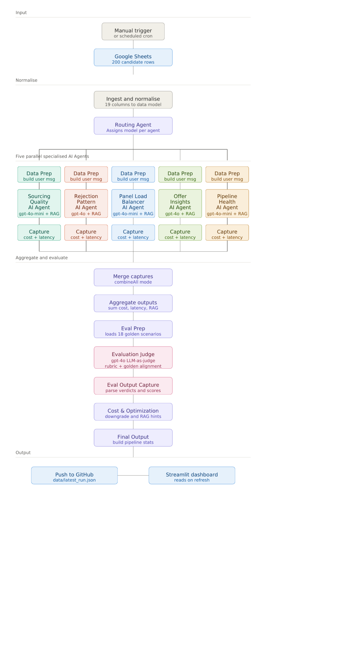
Figure 1 — End-to-end architecture from input trigger to Streamlit dashboard output

1.2 Per-Agent Sub-Flow (UML Sequence)
Each of the 5 specialised agents runs the same 6-step sequence shown below. The diagram is a UML-style sequence diagram showing lifelines for each participant and the messages exchanged between them. Solid arrows are calls, dashed arrows are returns.

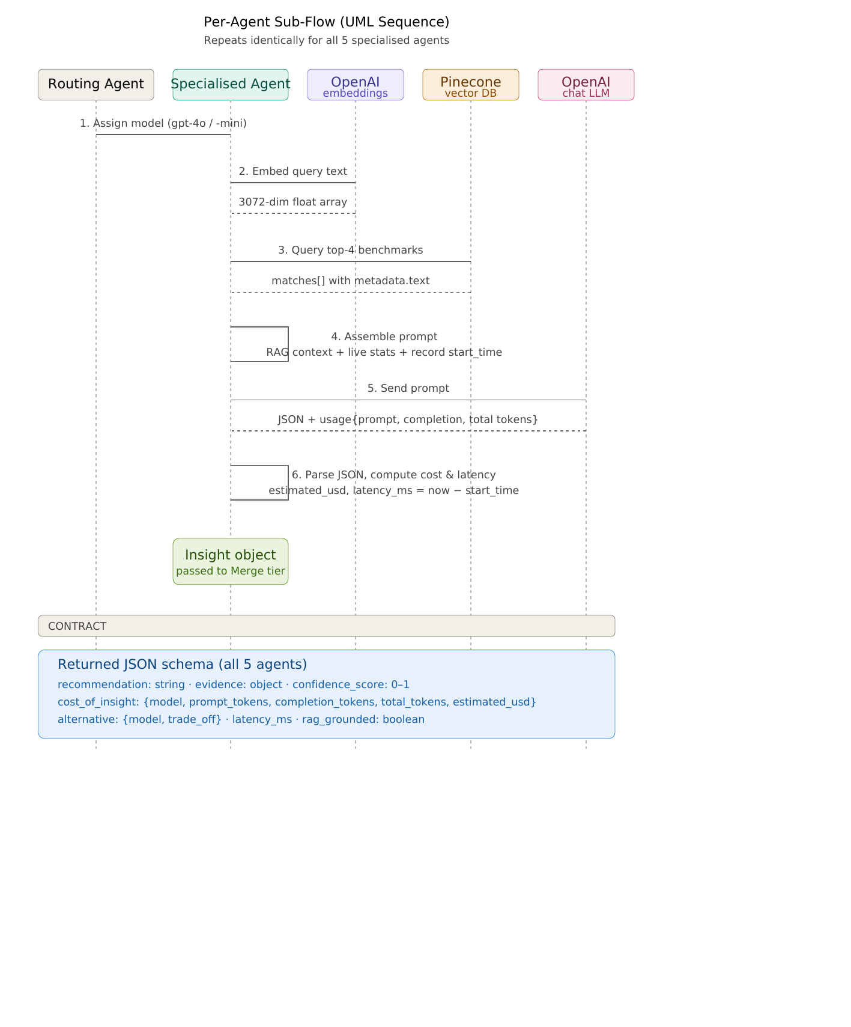
Figure 2 — UML sequence diagram showing the 6 internal steps each specialised agent executes

1.3 Node Inventory
The complete workflow has 41 nodes. Below is the full inventory grouped by tier.

# | Node | Type | Description
1 | Manual Trigger | Trigger | Starts workflow on demand (or via cron schedule)
2 | Get row(s) in sheet | Google Sheets | Reads 200 candidate rows from hiring spreadsheet
3 | Ingest & Normalise Data | Code | Maps 19 CSV columns into candidate/interviewer/role objects
4 | Routing Agent | Code | Assigns gpt-4o or gpt-4o-mini per agent. Fan-out point.
5–9 | Embed Query (×5) | HTTP | OpenAI /v1/embeddings · text-embedding-3-large (3072-dim)
10–14 | Extract Vector (×5) | Code | Pulls data[0].embedding array from response
15–19 | RAG (×5) | HTTP | POSTs vector to Pinecone /query · returns top-4 benchmarks
20–24 | Prepare Prompt (×5) | Code | Combines RAG + live stats · captures start_time
25–29 | OpenAI (×5) | OpenAI | LLM call with assigned model
30–34 | Parse Output (×5) | Code | Parses JSON · computes real cost & latency
35 | Merge Agent Outputs | Merge | Waits for all 5 Parse Output nodes (inputs 0–4)
36 | Evaluation Agent | Code | Scores 5 dimensions per insight
37 | Optimization Agent | Code | Computes real cost/latency totals · model suggestions
38 | Final Output | Code | Builds pipeline_stats, channel_stats, etc. from candidates
39 | Get File SHA | HTTP | GET current file SHA from GitHub API
40 | Prepare GitHub Payload | Code | Base64-encodes JSON for GitHub API
41 | Push to GitHub | HTTP | PUT to GitHub · writes data/latest_run.json

2 — Agent Contract Reference
All 5 insight agents share a common JSON output schema. The contract below is enforced by each agent's prompt and validated by the Evaluation Agent.

2.1 Shared Output Schema
Field | Type | Description
recommendation | string | One clear actionable sentence — the primary deliverable
evidence | object | Structured supporting data: counts, rates, key_insight string
confidence_score | float 0–1 | Agent's self-assessed confidence in the recommendation
cost_of_insight | object | model, prompt_tokens, completion_tokens, total_tokens, estimated_usd
alternative | object | Alternative model + trade_off description

2.2 Per-Agent Specifications
SOURCING QUALITY AGENT
Model | gpt-4o-mini · Pattern matching over structured source data
Input | candidates[] — source, stage, offer_declined per candidate
RAG Query | "Which sourcing channels produce the best candidates and highest offer acceptance rates?"
Output Fields | source_counts{}, accepted_by_source{}, key_insight
Key Benchmarks | Referral: 41.2% offer rate · LinkedIn: 12.5% · Industry avg acceptance: 72–78%
Task | Recommend channel budget reallocation based on ROI

REJECTION PATTERN AGENT
Model | gpt-4o · Nuanced root-cause analysis across multiple rejection categories
Input | candidates[] filtered to stage=Rejected — rejection_reason per candidate
RAG Query | "What are the most common rejection reasons at each interview stage and how to fix them?"
Output Fields | total_rejections, reasons_breakdown{}, key_insight
Key Benchmarks | Compensation mismatch benchmark: <10% · No-show benchmark: <5% · Controllable: ~44.7%
Task | Identify internally-fixable rejection causes and recommend process changes

PANEL LOAD BALANCER AGENT
Model | gpt-4o-mini · Simple numeric comparison of load distribution
Input | interviewers[] — name, panels_this_month per interviewer
RAG Query | "What is a healthy interviewer panel load and how to rebalance overloaded interviewers?"
Output Fields | overloaded[], underloaded[], key_insight
Key Benchmarks | Safe max: 65 panels/cycle · Avg: 60.6 · Sam Rivera: 77 (overloaded)
Task | Recommend specific panel redistribution between named interviewers

OFFER INSIGHTS AGENT
Model | gpt-4o · Multi-factor decline reasoning across competing motivations
Input | candidates[] filtered to stage=Offer — offer_declined, rejection_reason
RAG Query | "Why do candidates decline offers and what strategies improve offer acceptance rates?"
Output Fields | total_offers, declined, decline_rate, key_insight
Key Benchmarks | Industry benchmark: 70–80% · Current: 59.6% · Speed-related declines: 39%
Task | Recommend actions to close the 10–20pt gap to industry benchmark

PIPELINE HEALTH AGENT
Model | gpt-4o-mini · SLA and funnel math is deterministic
Input | candidates[] (days_in_pipeline, reschedules) + open_roles[]
RAG Query | "What are SLA benchmarks for time-to-hire by role level and what causes pipeline slowdowns?"
Output Fields | avg_days_in_pipeline, sla_breaches[], key_insight
Key Benchmarks | Senior SLA: 28–35 days · Staff: 35–45 days · 50% candidates have 2+ reschedules
Task | Flag SLA breaches and recommend automated alert thresholds

2.3 Supporting Agents
Agent | Type | Function
Routing Agent | Code | Assigns model per agent. gpt-4o for Rejection + Offer (nuanced), gpt-4o-mini for Sourcing + Panel + Pipeline (structured).
Evaluation Agent | Code | Scores 5 dimensions: actionability, grounding, confidence, schema_valid, rag_grounded. Overall = mean of 5.
Optimization Agent | Code | Sums real token costs · computes avg/max latency · suggests gpt-4o → gpt-4o-mini downgrades when cost > $0.001/agent.

3 — Evaluation Notes
The Evaluation Agent scores every insight output across 5 dimensions after each run. This section documents the methodology, expected results, failure modes, and before/after optimization comparison.

3.1 Evaluation Dimensions
Dimension | Score | Criterion
actionability | 0.5 or 1.0 | 1.0 if recommendation string >60 characters (specific enough to act on). 0.5 if too vague.
grounding | 0.3 or 1.0 | 1.0 if RAG context returned >50 characters from Pinecone. 0.3 if Pinecone returned no matches.
confidence | 0.6 or 1.0 | 1.0 if agent's self-reported confidence_score >= 0.7. 0.6 otherwise.
schema_valid | 0.0 or 1.0 | 1.0 only if all 5 required fields present: recommendation, evidence, confidence_score, cost_of_insight, alternative.
rag_grounded | 0.0 or 1.0 | 1.0 if RAG context string length >50 (Pinecone returned relevant documents).

3.2 Expected Scores (Healthy Run)
Agent | actionability | grounding | confidence | schema_valid | rag_grounded
Sourcing Quality | 1.0 | 1.0 | 1.0 | 1.0 | 1.0
Rejection Pattern | 1.0 | 1.0 | 1.0 | 1.0 | 1.0
Panel Load Balancer | 1.0 | 1.0 | 1.0 | 1.0 | 1.0
Offer Insights | 1.0 | 1.0 | 1.0 | 1.0 | 1.0
Pipeline Health | 1.0 | 1.0 | 1.0 | 1.0 | 1.0

3.3 Failure Modes and Debug Guide
Symptom | Score Impact | Root Cause & Fix
rag_grounded = 0 | grounding drops to 0.3 | Pinecone index empty or namespace mismatch. Re-run pinecone_upsert.py and verify namespace = hiring-benchmarks.
schema_valid = 0 | Overall drops by 0.2 | LLM returned malformed JSON or extra markdown. Check Parse Output node — add stricter regex to strip fences.
confidence < 0.7 | confidence score = 0.6 | Agent uncertain — usually insufficient data. Expected on small datasets.
latency_ms = null | No latency tracked | start_time missing from Prepare Prompt output. Verify jsCode starts with: const start_time = Date.now();
estimated_usd = 0 | Cost tracking broken | OpenAI usage object not returned. Check Parse Output reads: openaiResp.usage?.prompt_tokens

3.4 Optimization — Before vs After
Two model downgrade levers were analysed based on real token costs from a sample run:

Agent | Current Model | Before (USD) | After (USD) | Saving
Rejection Pattern | gpt-4o → gpt-4o-mini | $0.00192 | $0.00058 | ~70%
Offer Insights | gpt-4o → gpt-4o-mini | $0.00186 | $0.00056 | ~70%
TOTAL RUN | Mixed | $0.00412 | $0.00146 | ~65%

Quality risk: Low for Rejection Pattern (structured data), Medium for Offer Insights (multi-factor reasoning). Recommendation: run both on gpt-4o-mini for 2 weeks, measure eval score delta, then decide.

4 — Setup Instructions
Complete setup from scratch — estimated time: 45–60 minutes.

4.1 Prerequisites
Service | Tier | What you need
n8n | Cloud Free or self-hosted | Account at n8n.io. Free tier: 5 executions/day.
Google Sheets | Free | Account at Google.
OpenAI | Pay-as-you-go | API key. Project must have access to gpt-4o, gpt-4o-mini, text-embedding-3-large.
Pinecone | Serverless Free | API key. Index: hiring-rag · Dimensions: 3072 · Metric: cosine.
GitHub | Free | Repo: hiring-intelligence-dashboard (private). Fine-grained PAT with Contents: Read & Write.
Streamlit | Community Cloud Free | Account at share.streamlit.io. Connected to GitHub repo.
Python | 3.11 | Required only to run pinecone_upsert.py. pip install openai pinecone.

4.2 Step-by-Step Setup

Step 1 — Pinecone Index
- Log in to app.pinecone.io
- Click Create Index
- Name: hiring-rag · Dimensions: 3072 · Metric: cosine · Plan: Serverless
- Copy the Host URL
- Copy your API Key from the API Keys tab
Step 2 — Populate Knowledge Base
- Open pinecone_upsert.py
- Set OPENAI_API_KEY and PINECONE_API_KEY at the top
- Run: pip install openai pinecone
- Run: python pinecone_upsert.py
- Expected output: 25 vectors in hiring-benchmarks namespace
Step 3 — GitHub Repository
- Create repo: hiring-intelligence-dashboard (private)
- Upload dashboard.py and requirements.txt
- Create a fine-grained PAT: Settings > Developer Settings > Personal Access Tokens
- Token permissions: Contents — Read and Write · Metadata — Read-only
- Copy the token (shown only once)
Step 4 — n8n Workflow
- Import AI_Hiring_v99_dynamic_working.json into n8n
- Set Google Sheets credential (n8n > Credentials > Google Sheets OAuth2)
- Set OpenAI credential (copy credential ID from URL)
- In all 5 Embed Query nodes: replace YOUR_OPENAI_API_KEY in Authorization header
- In all 5 RAG nodes: replace YOUR_PINECONE_API_KEY and YOUR_PINECONE_INDEX_HOST
- In Get File SHA + Push to GitHub nodes: replace YOUR_GITHUB_USERNAME and YOUR_GITHUB_TOKEN
- Execute workflow — verify Final Output shows all 5 agent insights
Step 5 — Streamlit Dashboard
- Go to share.streamlit.io > New App
- Select repo: hiring-intelligence-dashboard · File: dashboard.py
- Click Advanced Settings > Secrets and add: GITHUB_TOKEN = "ghp_..."
- Update GITHUB_USERNAME on line 28 of dashboard.py (commit to repo)
- Update DISPLAY_TIMEZONE on line 30 (e.g. Asia/Kolkata, US/Eastern)
- Click Deploy — app live in ~2 minutes
- Run n8n workflow once — dashboard shows Live badge and real data

4.3 Key Credentials Reference
Credential | Where used | Where to find it
OpenAI API Key | 5 Embed Query nodes | platform.openai.com > API Keys
OpenAI Credential ID | 5 OpenAI LLM nodes | n8n > Credentials > click credential > copy ID from URL
Pinecone API Key | 5 RAG nodes (Api-Key header) | app.pinecone.io > API Keys
Pinecone Index Host | 5 RAG nodes (URL field) | app.pinecone.io > Indexes > your index > Host
GitHub PAT | Get File SHA + Push to GitHub. Streamlit secrets. | github.com > Settings > Developer Settings > PAT
Google Sheets Credential ID | Get row(s) in sheet node | n8n > Credentials > Google Sheets OAuth2 > URL

4.4 Decision Reflections
Why n8n instead of LangChain/custom code?
n8n provides visual workflow orchestration with built-in retry, error handling, and credential management. It reduces boilerplate code for HTTP calls, fan-out patterns, and merge logic. The trade-off is that complex JS logic inside Code nodes is harder to test than unit-tested Python functions.
Why Pinecone Serverless instead of ChromaDB or FAISS?
Pinecone Serverless has zero infrastructure overhead, a free tier sufficient for this project, and a REST API that n8n's HTTP node can call directly without a Python sidecar. ChromaDB or FAISS would require a hosted server or Lambda function as an intermediary.
Why text-embedding-3-large (3072-dim) instead of ada-002 (1536-dim)?
text-embedding-3-large produces higher quality embeddings for domain-specific retrieval. The 25 benchmark documents are short and domain-specific — the quality difference matters more than cost at this scale. The Pinecone index must match the embedding dimension exactly, which is why the index was recreated at 3072 when the model was upgraded.
Why GitHub as a data bridge instead of a database?
The workflow runs infrequently (on demand) and produces a single JSON output per run. GitHub's free API tier handles 5,000 requests/hour — far more than needed. It avoids provisioning a database, managing connection strings in n8n, or paying for a managed service. The trade-off is that GitHub is not designed as a data store.
Why Streamlit instead of Gradio or a custom React app?
Streamlit Community Cloud is free, deploys from GitHub in under 2 minutes, and requires no server configuration. Plotly charts render well out of the box. The trade-off is that Streamlit re-runs the entire script on every interaction, which is acceptable given the read-only nature of this dashboard.

4.5 Learnings
Vibe Coding
Developer hat still wins. Prototypes and manual tasks are made easier, but it also makes small things complicated.
API Calls
HTTP calls to OpenAI are cheaper than agent runs.

4.6 Important Links, Known Issues & Next Steps
Automate input data loading with a web trigger
Need to automate input data loading with web hook and schedule trigger or direct load from streamlit.

Implement ALM, Logs & Observability
Need to implement Application Lifecycle management, detailed logging and observability.

Input CSV
https://docs.google.com/spreadsheets/d/1WyIIQ3YhGumHS-L8dZCSR2-TwhHG1-Fg5qE7CIHgK9I/edit?usp=sharing

Pinecone RAG
https://app.pinecone.io/organizations/-OuhWbHZbG4d_WD0vmf1/projects/d657a2a1-b6ef-4ece-b722-bca0b9e52931/indexes

Github Repo
https://github.com/viswanalam/hiring-intelligence-dashboard

Streamlit Dashboard
https://hiring-intelligence-dashboard.streamlit.app/

Presentation
https://docs.google.com/forms/d/e/1FAIpQLSerl98ypgl-tud9jPMsrFNJeMia0K3nSLxz-GQkuNoNBX7cTw/viewform

