1.1 Spark Architecture (Driver, Executors, Cluster Manager)

1.1.1 Core Definition
Apache Spark follows a master–worker architecture coordinated by a Driver program, executed by multiple Executor processes, and managed by a Cluster Manager.
Each component has a non-overlapping responsibility.
Misunderstanding even one of them leads to incorrect assumptions about performance, failures, and scalability.

1.1.2 Why This Architecture Exists (The Real Reason)
Distributed systems must solve four problems simultaneously:
- Coordination — deciding what work to run
- Parallel execution — running work across machines
- Resource management — allocating CPU and memory
- Failure handling — recovering from partial crashes
Spark separates these concerns:
- Driver → coordination and planning
- Executors → execution and data processing
- Cluster Manager → resource allocation
This separation prevents tight coupling and enables Spark to run on multiple environments.

1.1.3 The Driver Program (The Brain)
The Driver is the process that:
- Parses your Spark code
- Builds the logical plan
- Creates the physical execution plan
- Splits work into tasks
- Schedules tasks on executors
- Tracks execution and failures
Critical facts:
- There is exactly one driver per Spark application
- If the driver dies, the application dies
- The driver does not process data partitions
The driver is a control plane, not a data plane.

1.1.4 Executors (The Workers)
Executors are long-lived JVM processes that:
- Execute tasks assigned by the driver
- Process data partitions
- Store intermediate results in memory or disk
- Report task status back to the driver
Key properties:
- Executors do the actual computation
- Executors do not talk to each other directly
- Each executor has its own memory and CPU cores
Data locality exists inside executors, not across them.

1.1.5 Cluster Manager (The Resource Authority)
The Cluster Manager is responsible for:
- Allocating CPU and memory to Spark
- Launching executors
- Monitoring node availability
Common cluster managers:
- Standalone
- YARN
- Kubernetes
- Databricks-managed infrastructure
The cluster manager:
- Does not understand Spark jobs
- Does not schedule Spark tasks
- Only manages resources

1.1.6 Execution Flow (End-to-End)
The execution flow is always:
- User submits Spark application
- Driver starts
- Driver requests resources from cluster manager
- Cluster manager launches executors
- Driver sends tasks to executors
- Executors process partitions and return results
- Driver tracks completion and failures
Every Spark job follows this sequence without exception.

🧩 2. Important Components

🔹 2.1 Cluster Manager
💡 What it does:
- Manages resources (CPU, Memory)
- Decides which worker runs which task
🧠 Examples:
- Standalone (Spark’s own)
- YARN
- Kubernetes
👉 Think of it as a resource allocator

🔹 2.2 Spark Session
spark = SparkSession.builder.appName("App").getOrCreate()
💡 What it is:
- Entry point to use Spark
- Used to create DataFrames, run queries
👉 Modern replacement for older APIs

🔹 2.3 Spark Context
sc = spark.sparkContext
💡 What it does:
- Connects your application to the cluster
- Responsible for:
  - Job scheduling
  - Task distribution
👉 Low-level API (SparkSession uses it internally)

🔹 2.4 Driver Node
💡 Role:
- Runs your main program
- Creates SparkSession & SparkContext
- Divides job → tasks
- Sends tasks to workers
👉 Brain of Spark 🧠

🔹 2.5 Worker Node
💡 Role:
- Executes tasks sent by driver
- Contains executors

🔹 Executor (inside worker)
- Runs tasks
- Stores intermediate data
👉 Worker = machine
👉 Executor = process inside machine

🧠 Simple Analogy
- Driver → Manager
- Cluster Manager → HR allocating employees
- Workers → Employees
- Executors → Workstations

🚀 3. Client Mode vs Cluster Mode

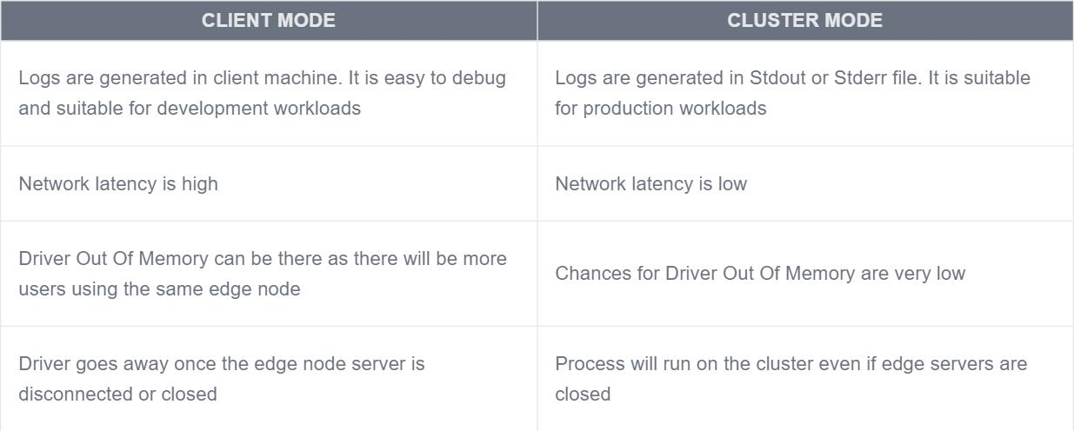

🔹 3.1 Client Mode
💡 How it works:
- Driver runs on your local machine
- Workers run on cluster
🧩 Flow:
- You submit job → driver runs locally
- Driver sends tasks to cluster
⚠️ Problem:
- If your system crashes → job fails

🔹 3.2 Cluster Mode
💡 How it works:
- Driver runs inside the cluster
- Fully managed by cluster manager
🧩 Flow:
- Job submitted → driver created in cluster
- Everything runs inside cluster
✅ Advantage:
- More reliable
- Better for production

⚖️ Client vs Cluster (Quick Table)
Feature | Client Mode | Cluster Mode
Driver runs on | Local machine | Cluster
Stability | Less | High
Use case | Testing / Development | Production

🎯 Final Summary
- Spark = distributed processing engine
- Driver → controls execution
- Workers → execute tasks
- Cluster Manager → allocates resources
- SparkSession → entry point
- Client mode → driver local
- Cluster mode → driver in cluster

