Introduction
Data has become the lifeblood of modern organizations. From financial institutions to social media platforms, every enterprise relies on efficient data storage and retrieval systems. Two dominant paradigms have emerged in the database world: SQL (Structured Query Language) databases and NoSQL (Not Only SQL) databases. While SQL has been the backbone of data management for decades, NoSQL has risen in response to the challenges posed by big data, scalability, and unstructured information. This chapter explores their differences, strengths, limitations, and the contexts in which each excels.

The SQL Model
SQL databases are relational systems that organize data into tables consisting of rows and columns. Each table has a predefined schema, ensuring consistency and structure. The relational model thrives on relationships between entities, making it ideal for applications where data integrity and complex queries are paramount.
- ACID Compliance: SQL databases guarantee Atomicity, Consistency, Isolation, and Durability, ensuring reliable transactions.
- Query Power: SQL offers a rich language for joins, aggregations, and nested queries, enabling sophisticated analytics.
- Maturity: With decades of refinement, SQL systems like MySQL, PostgreSQL, and Oracle provide stability, tooling, and community support.
Use Cases: Banking systems, enterprise resource planning (ERP), customer relationship management (CRM), and applications requiring strict consistency.

What is SQL?
SQL (Structured Query Language) is used to manage and manipulate relational databases.
These databases store data in tables (rows & columns).
Examples:
- MySQL
- PostgreSQL
- Oracle Database
Features of SQL:
- Structured format (tables)
- Fixed schema
- Uses relationships (foreign keys)
- Strong consistency (ACID properties)
The NoSQL Model
NoSQL databases emerged to address the limitations of relational systems in handling massive, diverse, and rapidly changing datasets. Unlike SQL, NoSQL embraces flexible schemas and supports multiple data models: document-based (MongoDB), key-value (Redis), column-family (Cassandra), and graph (Neo4j).
- Scalability: Designed for horizontal scaling, NoSQL databases distribute data across clusters of servers.
- Flexibility: Schema-less design allows developers to store JSON, XML, or other formats without restructuring.
- Performance: Optimized for high-volume reads and writes, making them suitable for real-time applications.
Use Cases: Social media platforms, recommendation engines, IoT data storage, and big data analytics.
What is NoSQL?
NoSQL (Not Only SQL) is used for non-relational databases.
It handles unstructured or semi-structured data.
Examples:
- MongoDB
- Cassandra
- Redis
🔹 Features of NoSQL:
- Flexible schema
- Scalable (handles big data)
- Faster for large-scale applications
- Supports multiple data formats

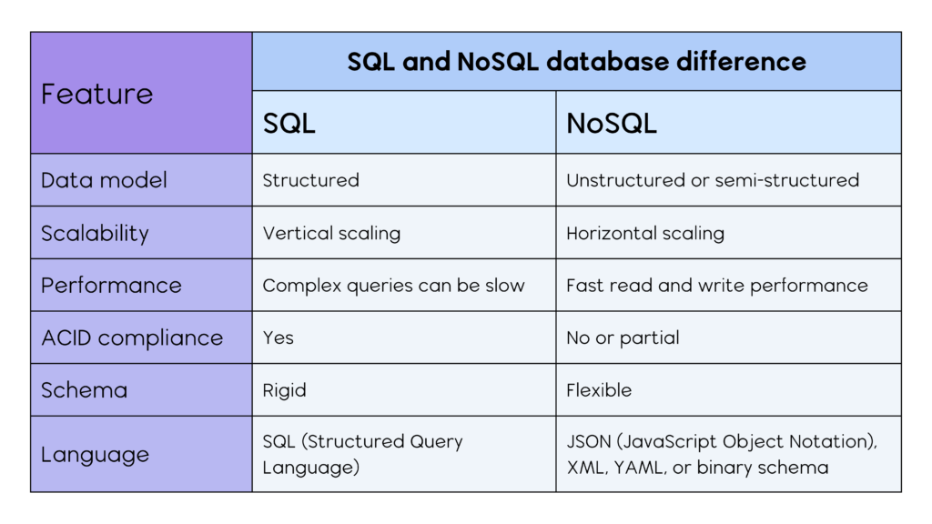
Advantages of SQL
- Structured and organized
- Strong data integrity
- Supports complex queries
- ACID compliance (reliable transactions)
Disadvantages of SQL
- Difficult to scale horizontally
- Not suitable for large unstructured data
- Schema changes are complex
Advantages of NoSQL
- High scalability
- Flexible schema
- Handles big data efficiently
- Fast performance for large datasets
Disadvantages of NoSQL
- Less consistency (eventual consistency)
- No standard query language
- Limited support for complex joins

When to Use SQL?
Use SQL when:
- Data is structured
- Relationships are important
- Transactions must be accurate
Examples:
- Banking systems
- E-commerce orders
- Employee management systems

When to Use NoSQL?
Use NoSQL when:
- Data is large and unstructured
- Need high scalability
- Real-time applications
Examples:
- Social media platforms
- Big data analytics
- IoT applications

Conclusion
Both SQL and NoSQL databases are important in modern applications.
- SQL is best for structured, consistent, and relational data
- NoSQL is best for scalable, flexible, and large datasets
In real-world systems, both are often used together to achieve the best performance.

