☁️ IaaS, PaaS, and SaaS — Detailed Theory Notes
Introduction to Cloud Service Models
Cloud computing has changed the way people and organizations use technology. Earlier, companies had to buy expensive computers, servers, networking devices, and software to run applications and store data. Managing these systems required a lot of money, technical knowledge, electricity, maintenance, and physical space.
With the growth of the internet and cloud computing, organizations no longer need to own all these resources physically. Instead, they can use computing services over the internet from cloud providers such as Amazon Web Services, Microsoft Azure, and Google Cloud Platform.
Cloud providers offer services in different forms depending on the needs of users. Some users may want complete control over servers and infrastructure, while others may only want ready-made software. To satisfy these different requirements, cloud computing services are divided into three major service models:
- Infrastructure as a Service (IaaS)
- Platform as a Service (PaaS)
- Software as a Service (SaaS)
These service models help users choose the level of control, flexibility, and management they need.

Infrastructure as a Service (IaaS)
Meaning of IaaS
Infrastructure as a Service, commonly called IaaS, is a cloud service model in which cloud providers offer basic computing infrastructure through the internet. This infrastructure includes:
- Virtual machines
- Servers
- Storage systems
- Networking resources
- Data center facilities
In IaaS, users rent these resources instead of purchasing physical hardware.
The cloud provider manages the physical infrastructure such as servers, storage devices, cooling systems, and networking hardware. The user manages the operating system, applications, and data.
In simple words, IaaS provides a virtual computer environment in the cloud.

Working of IaaS
In traditional computing, organizations purchase physical servers and install operating systems and applications manually. This process is expensive and time-consuming.
In IaaS, virtualization technology is used to create virtual machines on physical servers. Users can create and use these virtual machines whenever needed through the internet.
For example, if a company wants ten servers for testing software, it can create virtual servers within minutes using IaaS instead of buying physical machines.
The cloud provider takes care of:
- Hardware maintenance
- Power supply
- Security of data centers
- Networking infrastructure
The user is responsible for:
- Installing software
- Managing applications
- Updating operating systems
- Protecting application data

Characteristics of IaaS
1. On-Demand Resource Allocation
Users can create or remove resources whenever required.
2. Scalability
Resources can be increased or decreased based on workload.
3. Pay-as-You-Go Pricing
Users pay only for the resources they consume.
4. Virtualization
Physical hardware is divided into multiple virtual environments.
5. Internet-Based Access
Resources can be accessed from anywhere using the internet.

Advantages of IaaS
Cost Reduction
Organizations do not need to purchase expensive hardware.
Flexibility
Users can choose different operating systems and software.
Scalability
Infrastructure can be expanded quickly during high demand.
Faster Deployment
Servers can be created within minutes.
Better Resource Utilization
Cloud providers efficiently use hardware resources.

Disadvantages of IaaS
Technical Complexity
Users need technical knowledge to manage systems.
Security Responsibility
Users must secure applications and operating systems.
Dependency on Internet
Cloud resources require internet access.

Examples of IaaS
- Amazon Web Services EC2
- Microsoft Azure Virtual Machines
- Google Cloud Platform Compute Engine

Use Cases of IaaS
Website Hosting
Organizations host websites on virtual servers.
Big Data Processing
Data engineers use cloud clusters for processing large datasets.
Backup and Recovery
Cloud infrastructure is used for storing backup copies of data.
Software Testing
Developers create temporary environments for testing applications.

Platform as a Service (PaaS)
Meaning of PaaS
Platform as a Service (PaaS) is a cloud service model that provides a ready-made platform for application development and deployment.
In PaaS, the cloud provider manages:
- Infrastructure
- Operating systems
- Runtime environments
- Middleware
- Development tools
The user focuses mainly on:
- Writing application code
- Managing application data
PaaS simplifies application development because developers do not need to worry about hardware or operating system management.

Working of PaaS
In traditional software development, developers must:
- Install operating systems
- Configure servers
- Set up databases
- Manage runtime environments
In PaaS, these tasks are handled automatically by the cloud provider.
Developers simply upload their code to the platform, and the application runs in the cloud environment.
This greatly reduces development time and operational complexity.

Characteristics of PaaS
1. Development Environment
Provides tools for coding and application development.
2. Managed Infrastructure
Cloud provider manages servers and operating systems.
3. Collaboration Support
Multiple developers can work together on projects.
4. Automatic Scaling
Applications can scale automatically based on traffic.
5. Built-In Tools
Includes database management, testing tools, and deployment support.

Advantages of PaaS
Faster Development
Developers can focus directly on coding.
Reduced Complexity
No need to manage infrastructure manually.
Improved Productivity
Preconfigured tools speed up development.
Easy Deployment
Applications can be deployed quickly.
Cost Efficiency
Reduces infrastructure and maintenance costs.

Disadvantages of PaaS
Limited Control
Users have less control over system configuration.
Vendor Dependency
Applications may depend heavily on a specific cloud provider.
Customization Limits
Some platforms restrict advanced customization.

Examples of PaaS
- Microsoft Azure App Service
- Google Cloud Platform App Engine
- Heroku

Use Cases of PaaS
Web Application Development
Developers build websites and APIs quickly.
Mobile Application Backend
PaaS supports backend services for mobile apps.
Team Collaboration
Multiple developers can work in a common environment.
API Development
Organizations develop and host APIs efficiently.

Software as a Service (SaaS)
Meaning of SaaS
Software as a Service (SaaS) is a cloud service model in which complete software applications are delivered through the internet.
In SaaS, the cloud provider manages:
- Infrastructure
- Operating systems
- Software updates
- Security
- Data storage
Users simply access the software using:
- Web browsers
- Mobile applications
No installation or maintenance is required on the user’s device.

Working of SaaS
The software runs on cloud servers managed by the provider. Users connect to the software through the internet.
For example, when using Gmail, users do not install mail servers or manage infrastructure. Everything is handled by the provider.
Users only need:
- Internet connection
- Browser or app access

Characteristics of SaaS
1. Ready-to-Use Software
Applications are immediately available.
2. Internet Accessibility
Users can access software from anywhere.
3. Automatic Updates
Software updates happen automatically.
4. Subscription-Based Pricing
Users usually pay monthly or yearly subscriptions.
5. Multi-User Support
Many users can use the same application simultaneously.

Advantages of SaaS
Easy to Use
No installation or technical setup required.
Lower Costs
No need to buy expensive software licenses.
Accessibility
Accessible from multiple devices.
Automatic Maintenance
Provider handles updates and security.
Quick Availability
Applications can be used immediately.

Disadvantages of SaaS
Internet Dependency
Requires internet access.
Limited Customization
Users may not fully customize software.
Data Security Concerns
Data is stored on external servers.

Examples of SaaS
- Gmail
- Microsoft Office 365
- Google Docs
- Zoom

Use Cases of SaaS
Email Services
Users send and receive emails online.
Online Meetings
Organizations conduct virtual meetings.
Document Collaboration
Teams edit documents together in real time.
Customer Relationship Management
Businesses manage customer data using SaaS applications.

Comparison Between IaaS, PaaS, and SaaS
Feature | IaaS | PaaS | SaaS
Main Purpose | Infrastructure | Development Platform | Ready Software
User Control | High | Medium | Low
Technical Knowledge Required | High | Medium | Low
Managed by Provider | Hardware | Hardware + OS | Everything
Main Users | System Admins | Developers | End Users
Flexibility | Very High | Moderate | Limited
Examples | EC2, Azure VM | App Engine | Gmail

Conclusion
IaaS, PaaS, and SaaS are the three major cloud service models that provide different levels of cloud services to users.
- IaaS provides infrastructure resources such as servers and storage.
- PaaS provides development platforms for building applications.
- SaaS provides fully ready software applications through the internet.
These models help organizations reduce costs, improve scalability, and simplify technology management. Today, almost every modern organization uses one or more of these cloud service models for business operations, software development, communication, data storage, and analytics.
Understanding these service models is very important because they form the foundation of modern cloud computing systems and technologies.

☁️ Real-World Examples of IaaS, PaaS, and SaaS — Detailed Theoretical Explanation
1. Infrastructure as a Service (IaaS)
Example: Amazon Web Services EC2 (Elastic Compute Cloud)
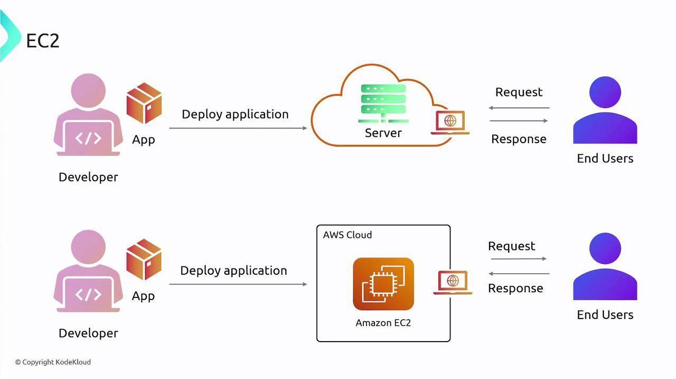

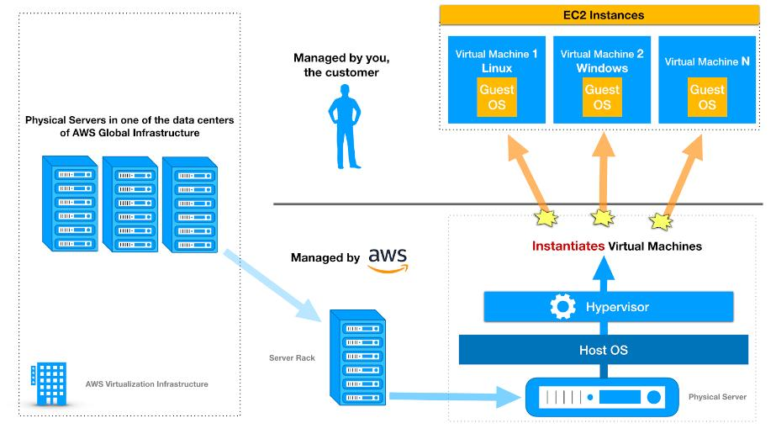


Introduction
Amazon EC2 is one of the most popular examples of Infrastructure as a Service (IaaS). It provides virtual servers through the internet. Instead of purchasing physical computers or servers, users can create virtual machines in the cloud and use them according to their needs.
EC2 is widely used by startups, software companies, e-commerce platforms, and large enterprises for running applications, websites, databases, and analytics systems.

How EC2 is Used
Suppose a company wants to host a website.
In traditional computing:
- The company must purchase physical servers.
- Install operating systems manually.
- Configure networking and storage.
- Maintain hardware regularly.
Using Amazon EC2:
- The company creates a virtual server online.
- Selects operating system such as Linux or Windows.
- Installs website applications.
- Accesses the server through the internet.
The server is created within minutes without buying any physical hardware.

What Users Manage in EC2
Users manage:
- Operating system
- Installed software
- Applications
- Security configurations
- Data
Amazon manages:
- Physical servers
- Data centers
- Networking hardware
- Power and cooling systems

Main Usage of EC2
Website Hosting
Companies host websites and web applications.
Application Deployment
Developers run backend applications and APIs.
Big Data Processing
Data engineers create clusters for Spark and Hadoop processing.
Testing Environments
Developers create temporary virtual machines for software testing.

Why Companies Use EC2
- No need to buy hardware
- Fast server creation
- Easy scalability
- Pay only for usage
- High availability

2. Platform as a Service (PaaS)
Example: Heroku
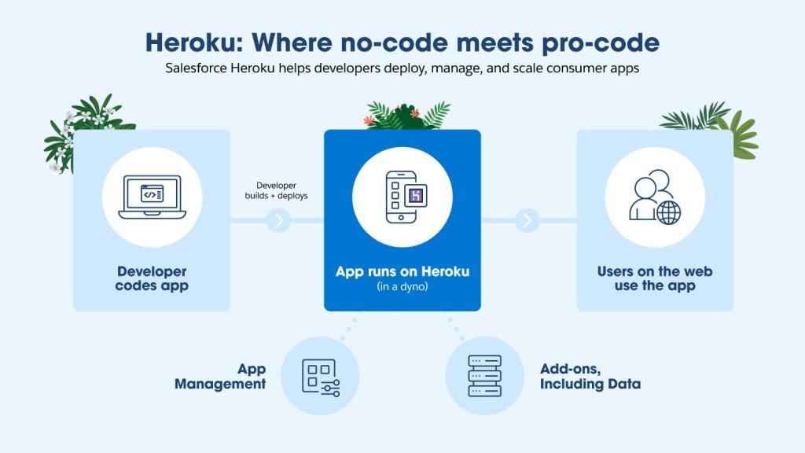

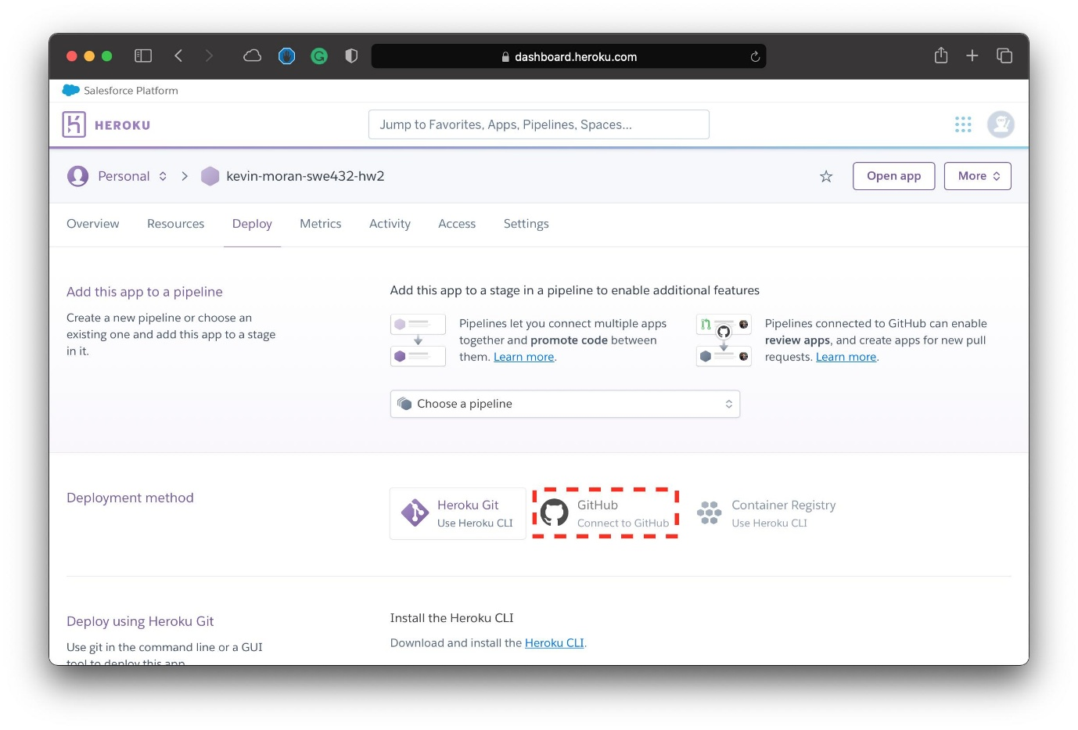

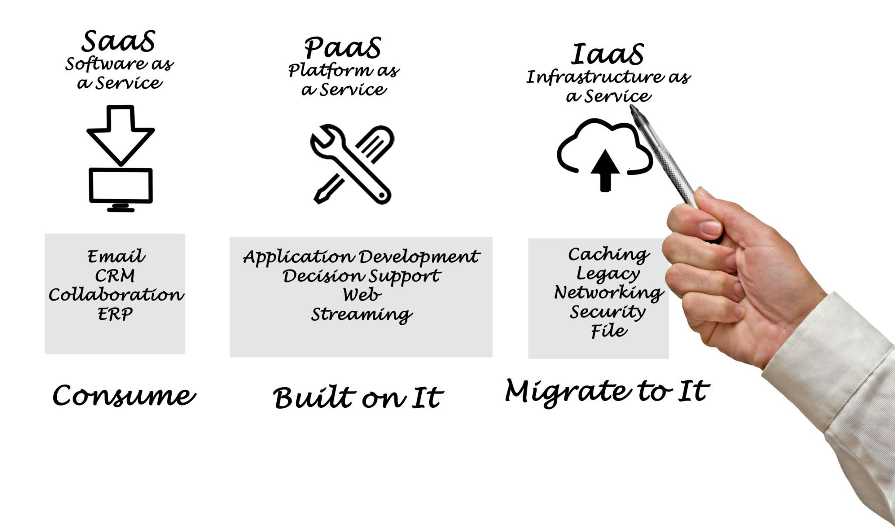
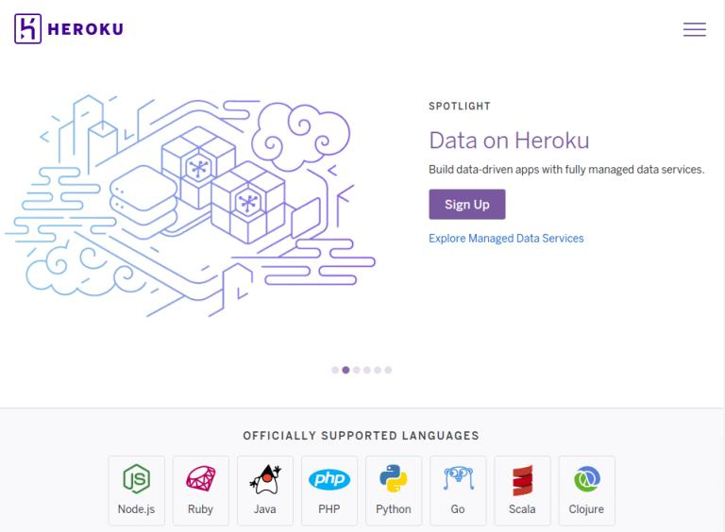
Introduction
Heroku is a popular example of Platform as a Service (PaaS). It provides a ready-made platform where developers can build, test, and deploy applications without managing infrastructure or operating systems.
Heroku is commonly used by students, startups, and developers because it simplifies application deployment.

How Heroku is Used
Suppose a developer creates a web application using Node.js or Python.
In traditional deployment:
- The developer must create servers.
- Install operating systems.
- Configure runtime environments.
- Install required software manually.
Using Heroku:
- The developer uploads application code.
- Heroku automatically handles:
  - Server setup
  - Runtime configuration
  - Deployment
  - Scaling
The developer focuses only on writing application code.

What Users Manage in Heroku
Users manage:
- Application code
- Database content
- Application settings
Heroku manages:
- Infrastructure
- Operating systems
- Runtime environments
- Server maintenance

Main Usage of Heroku
Web Application Development
Developers deploy websites quickly.
API Hosting
Backend services and APIs run easily.
Student Projects
Students host projects online without infrastructure management.
Startup Applications
Small companies quickly launch products.

Why Developers Use Heroku
- Simple deployment
- No server management
- Faster development
- Easy scaling
- Beginner friendly

3. Software as a Service (SaaS)
Example: Gmail

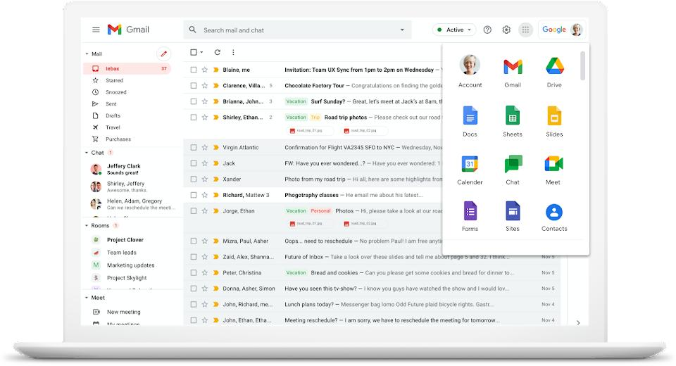

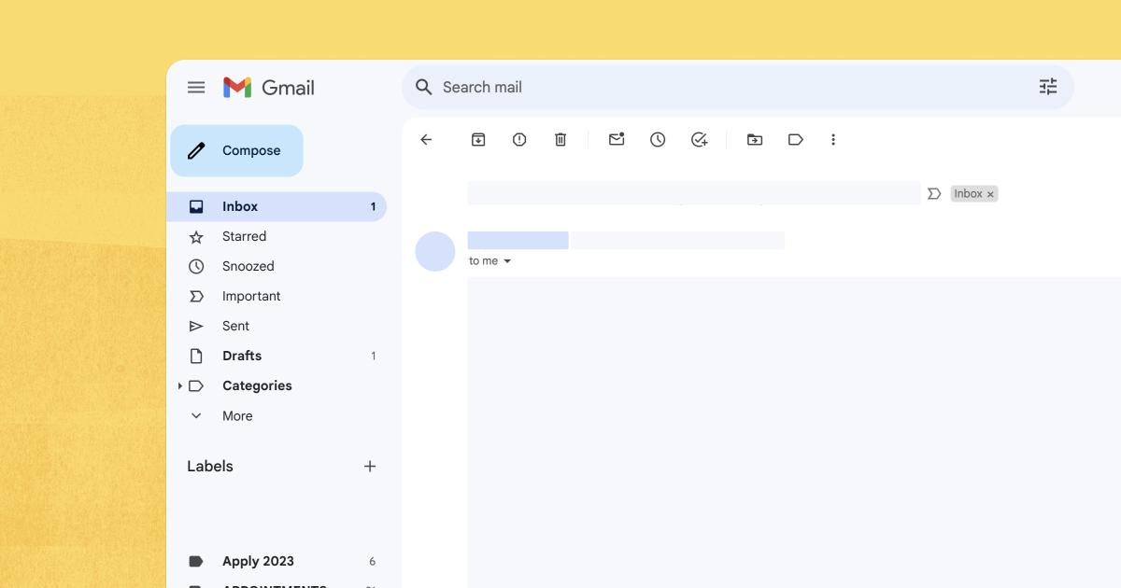

Introduction
Gmail is one of the best examples of Software as a Service (SaaS). It provides a complete email application through the internet. Users do not need to install mail servers or manage infrastructure.
Everything including storage, servers, security, and updates is handled by Google.
Users simply access Gmail using a browser or mobile application.

How Gmail is Used
Suppose a user wants to send emails.
In traditional systems:
- Organizations had to maintain their own email servers.
- Install mail software.
- Configure networking and security.
- Manage storage and backups.
Using Gmail:
- Users create an account.
- Open Gmail in browser or app.
- Send and receive emails directly.
No server management or technical setup is required.

What Users Manage in Gmail
Users manage:
- Their emails
- Contacts
- Personal settings
Google manages:
- Servers
- Storage
- Security
- Software updates
- Infrastructure

Main Usage of Gmail
Personal Communication
People send and receive emails daily.
Business Communication
Organizations use Gmail for official communication.
File Sharing
Users share documents and attachments.
Cloud Collaboration
Integrated with other Google services.

Why People Use Gmail
- Easy to use
- Accessible anywhere
- No installation required
- Automatic updates
- Secure cloud storage

Another SaaS Example: Google Docs
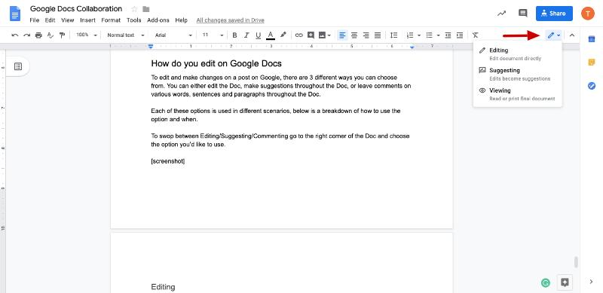

Introduction
Google Docs is a cloud-based document editing software. Users create, edit, and share documents online without installing software like Microsoft Word.

How Google Docs is Used
- Users open Google Docs in browser.
- Create or edit documents online.
- Multiple users work together in real time.
- Files are automatically saved in cloud storage.

Usage of Google Docs
Team Collaboration
Multiple users edit same document together.
Education
Students prepare assignments online.
Office Work
Companies create reports and documentation.

Final Understanding
These examples clearly show how each cloud service model works in real life.
Model | Real Example | Main Purpose
IaaS | AWS EC2 | Provides infrastructure and virtual servers
PaaS | Heroku | Provides platform for app development
SaaS | Gmail, Google Docs | Provides ready-to-use software

Simple Understanding
IaaS
“Give me infrastructure; I will manage software.”
PaaS
“Give me platform; I will develop applications.”
SaaS
“Give me ready software; I will directly use it.”

Conclusion
IaaS, PaaS, and SaaS are different cloud service models designed for different user needs.
- IaaS helps organizations rent infrastructure.
- PaaS helps developers build applications faster.
- SaaS helps users access software directly through the internet.
These models are widely used in modern industries because they reduce costs, improve scalability, simplify management, and increase accessibility.

