
SWIFT SHIP TRACKER
Autonomous Parcel Management & Logistics AI Agent on Salesforce
Naan Mudhalvan — Tamil Nadu Skill Development Corporation (TNSDC)
Salesforce Developer Program Project Report

Project Title | SwiftShip Tracker (Salesforce Agentforce AI Logistics)
Naan Mudhalvan Team ID | 6ab4dab10fc666a751b55876
College & Affiliation | Alpha College of Engineering, Thirumazhisai, Chennai (Affiliated to Anna University)
Live Salesforce Org ID | 00Dak00001IgVqvEAF (Developer Edition — Agentforce Enabled)
Autonomous AI Agent | Swift Tracker Version 1 (Active)
GitHub Repository | https://github.com/viswanathan01/SalesForce-NM

Project Team Details
Role in Project | Student Name | Register Number | College Email ID
Team Lead | Viswanathan R | 210123205033 | nviswa192.6880cfe3bfa5@agentforce.com
Team Member | Srilekha M | 210123205029 | srims0912@gmail.com
Team Member | Sindhu S | 210123205028 | sindhubava05@gmail.com
Team Member | Pavadharani R | 210123205015 | rishvibommika@gmail.com
Team Member | Santhosh Kumar S | 210123205024 | mrsanthosh3345@gmail.com

User Story
The SwiftShip Tracker is designed to provide a centralized Salesforce-based parcel management solution that enables customers to book parcels, track delivery status, and manage shipments through an intuitive interface and conversational AI support. The system manages Parcel, Delivery, Sender, and Receiver information using Salesforce custom objects and relationships. Flows automate parcel operations and notifications, while AgentForce AI and Prompt Builder enable customers to retrieve parcel information and interact with the system conversationally. Delivery agents can update parcel status in real time, while Experience Cloud, security controls, reports, and dashboards provide secure customer access and operational visibility.

1. INTRODUCTION

1.1 Project Overview
The SwiftShip Tracker is a Salesforce CRM solution developed to simplify parcel booking, shipment tracking, and delivery management. It supports the complete parcel lifecycle from booking and dispatch through tracking and delivery confirmation. Customers can access shipment information through an autonomous conversational AI agent, while delivery agents and administrators can manage shipments, track GPS coordinates, and monitor operational performance.

1.2 Purpose
The purpose of SwiftShip Tracker is to:
- Centralize Parcel & Logistics Information: Consolidate parcel, customer, delivery, and tracking records inside Salesforce.
- Simplify Booking & Live Tracking: Provide self-service booking and real-time status visibility.
- Autonomous AI Conversational Support: Empower customers to query parcel updates in natural language via Salesforce Agentforce.
- Process Automation: Eliminate manual updates using Salesforce Auto-Launched Flows and record automations.
- Granular Security & Access Control: Enforce strict role-based and field-level security via Profiles and Permission Sets.

2. IDEATION PHASE

2.1 Problem Statements
PS ID | User Persona | User Goal | Current Bottleneck | Impact / Emotion
PS-1 | Customer / Sender | Book a parcel easily | Booking requires phone support or multiple scattered apps | Frustrated
PS-2 | Customer / Sender | Track parcel live | No real-time tracking experience; status updates are delayed | Confused
PS-3 | Delivery Agent | Update parcel status | Status updates require manual handling and paperwork | Concerned
PS-4 | Customer | Receive delivery alerts | Notifications missing at key delivery milestones | Uncertain
PS-5 | Administrator | Monitor logistics flow | Parcel flow, agent activity, and delivery trends difficult to track | Concerned

2.2 Empathy Map Canvas
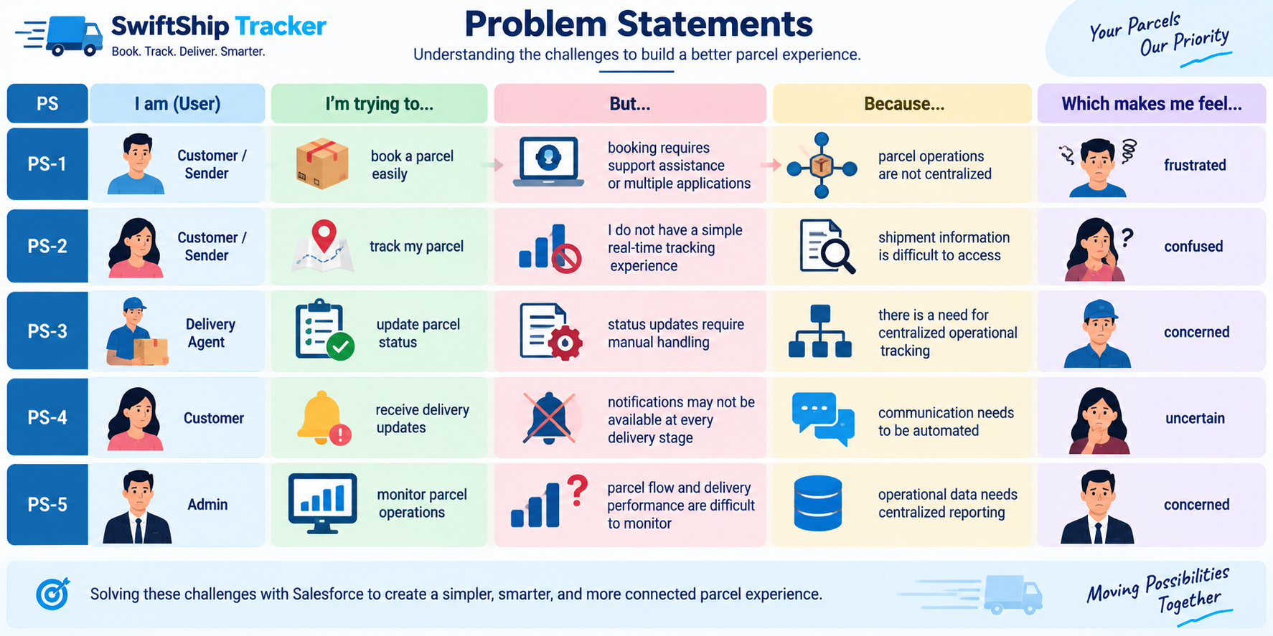
Figure 1: Empathy Map Canvas — Customer / Sender Persona

2.3 Brainstorming & Idea Prioritization
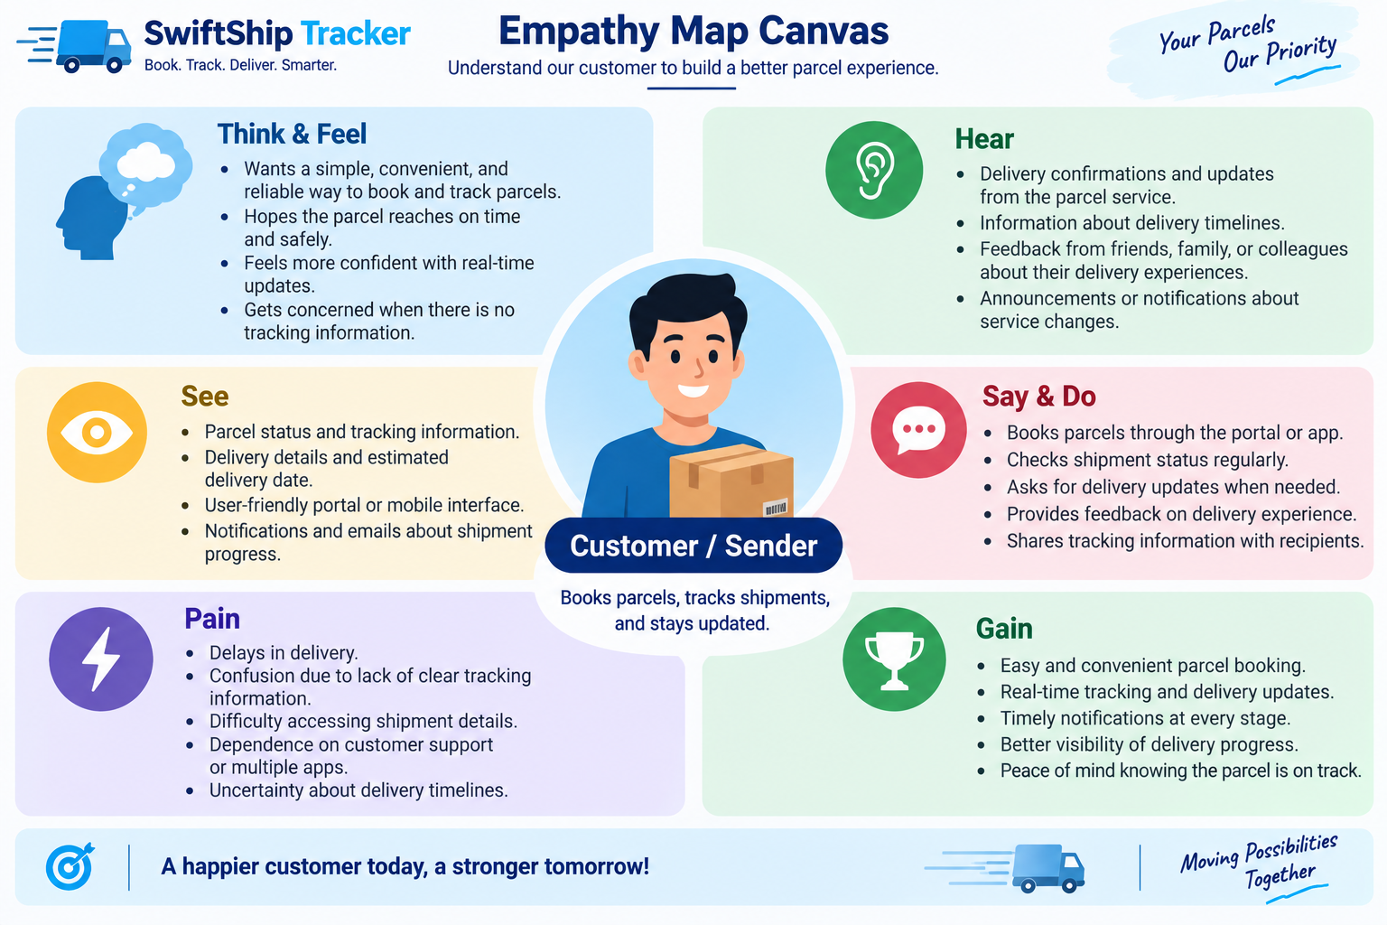
Figure 2: Brainstorming & Idea Prioritization Grid

3. REQUIREMENT ANALYSIS PHASE

3.1 Customer Journey Map
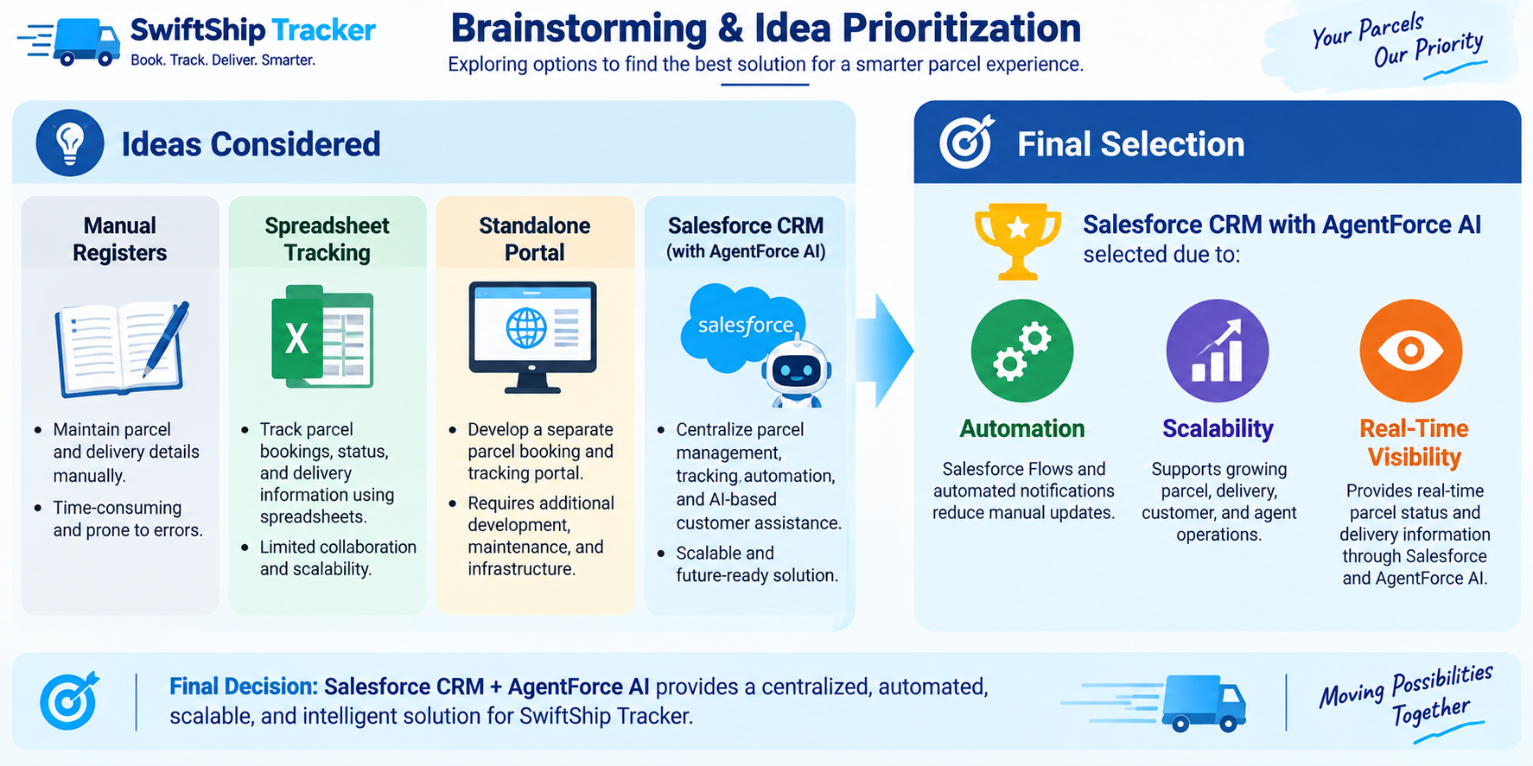
Figure 3: End-to-End Customer Journey Map (8 Lifecycle Stages)

3.2 Solution Requirements
Req ID | Requirement Description | Implementation Component
FR-1 | Parcel booking and record creation | Custom Object Parcel__c & Page Layouts
FR-2 | Parcel status tracking (Booked, In Transit, Out for Delivery, Delivered) | Picklist Field Status__c & Agentforce
FR-3 | Package weight and dimensions management | Number Field Weight__c
FR-4 | Estimated delivery date calculation & visibility | Date Field Estimated_Delivery_Date__c
FR-5 | Sender contact, address, and email management | Custom Object Sender__c & Lookups
FR-6 | Receiver contact, address, and email management | Custom Object Receiver__c & Lookups
FR-7 | Real-time delivery & GPS geolocation tracking | Custom Object Delivery__c & Current_Location__c
FR-8 | Delivery agent status update interface | Lightning App SwiftShip Tracker & List Views
FR-9 | Automated customer email & status notifications | Salesforce Flows & Alerts
FR-10 | AI-powered conversational parcel tracking | Salesforce Agentforce & Flow Actions
FR-11 | Operational reporting & performance analytics | Salesforce Reports & Dashboards
FR-12 | Customer self-service portal access | Salesforce Experience Cloud
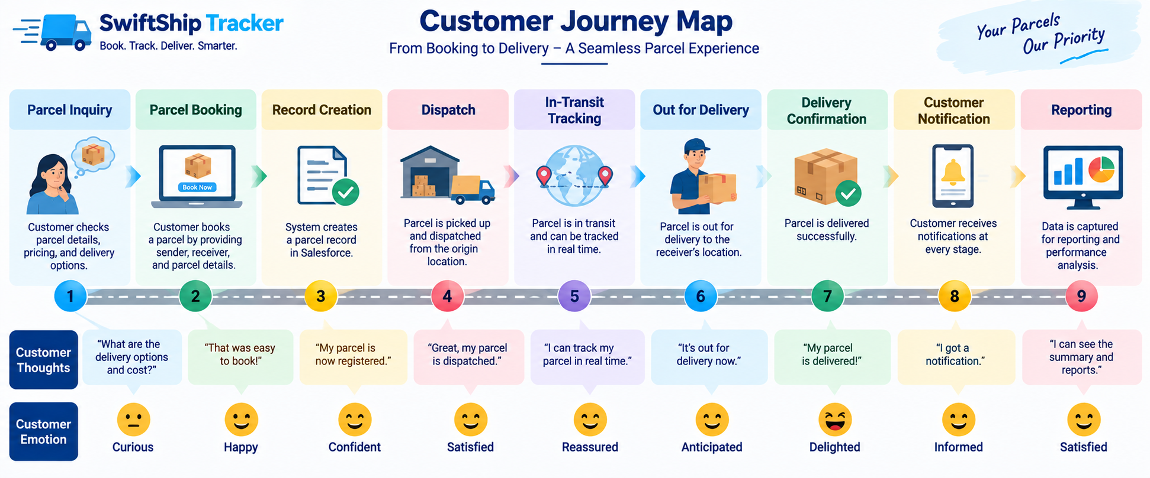
Figure 4: Solution Requirements Traceability Model

3.3 Data Flow Diagram
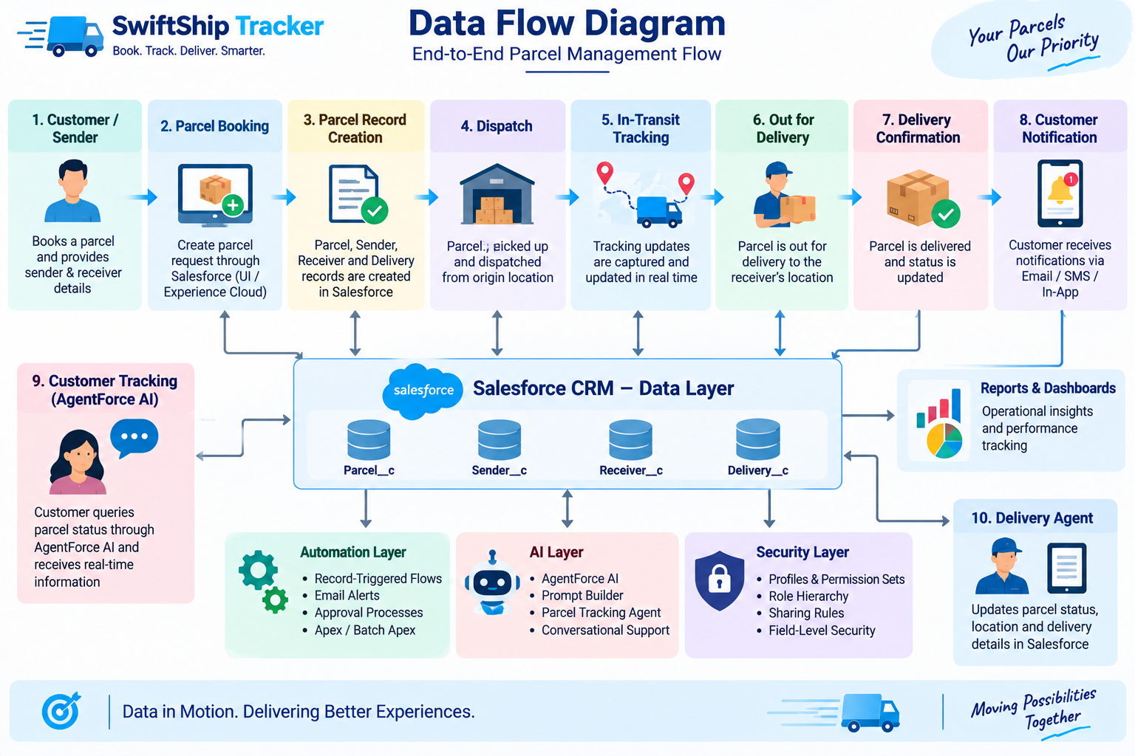
Figure 5: Data Flow Architecture & Information Pipeline

3.4 Technology Stack
Architectural Layer | Technology Used | Functional Role
Platform | Salesforce Developer Edition (v67.0) | Core multi-tenant cloud CRM hosting environment
Data Layer | Custom Objects & Lookups | Parcel__c, Delivery__c, Sender__c, Receiver__c
Business Logic | Auto-Launched Flows (Flow Builder) | Parcel_Details flow for automated retrieval and reasoning
AI & Generative Engine | Salesforce Agentforce & Prompt Builder | Autonomous AI Service Agent for natural language queries
User Interface | Lightning Experience & App Manager | SwiftShip Tracker custom Lightning App and Record Pages
Security & Access | Profiles, Permission Sets & FLS | Swift_Ship Permission Set assigned to Admin & Agent User
API & Metadata Tools | Salesforce CLI (sf v2.x) | Automated deployment, schema tracking, and Apex execution
Version Control | Git & GitHub | Repository hosting at viswanathan01/SalesForce-NM
Analytics | Salesforce Reports & Dashboards | Logistics KPIs, delivery timelines, and parcel status breakdown

4. PROJECT DESIGN PHASE

4.1 Problem–Solution Fit
Identified Business Problem | Implemented Salesforce Solution | Achieved Business Benefit
Parcel booking is manual and disjointed | Centralized Parcel__c custom object & Lightning app | Unified booking, zero record loss
Tracking requires constant support calls | Agentforce Autonomous AI Service Agent | Instant self-service 24/7 parcel inquiries
Delivery status updates are delayed | Auto-Launched Flows with status automation | Real-time updates across supply chain
No location visibility during transit | Geolocation coordinates on Delivery__c | Precise GPS tracking of shipments
Customer notifications are inconsistent | Automated email alerts at key milestones | Transparent customer communication
Security risks with unauthorized access | Granular Permission Sets & Profile security | Strict role-based least privilege enforcement

4.2 Solution Architecture
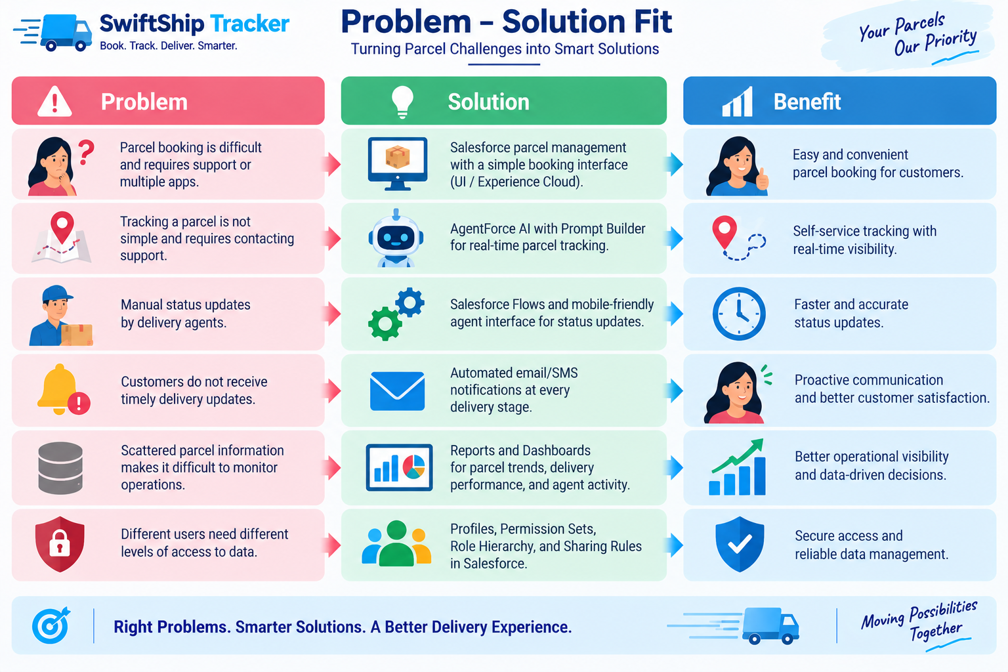
Figure 6: Multi-Tier Solution Architecture Diagram

5. PROJECT PLANNING & SCHEDULING

5.1 Agile Sprint Schedule & Backlog
Sprint | Requirement / Epic | User Story | Story / Task Description | Pts | Assigned Member
Sprint-1 | Org Setup | USN-1 | Provision Agentforce Developer Edition org & configure CLI | 3 | Viswanathan R (Lead)
Sprint-2 | Data Modeling | USN-2 | Create Parcel, Delivery, Sender, Receiver custom objects | 5 | Srilekha M
Sprint-2 | Data Modeling | USN-3 | Configure custom fields, geolocations, and lookups | 5 | Sindhu S
Sprint-3 | UI & Navigation | USN-4 | Create Custom Tabs, SwiftShip Tracker App & Page Layouts | 3 | Pavadharani R
Sprint-3 | Process Automation | USN-5 | Build Parcel_Details Auto-Launched Flow with Get Records | 5 | Viswanathan R (Lead)
Sprint-4 | Security Model | USN-6 | Create Swift_Ship Permission Set & configure Object/FLS | 3 | Santhosh Kumar S
Sprint-4 | Agentforce Setup | USN-7 | Enable Einstein AI, Agentforce, and Agent User assignments | 5 | Viswanathan R (Lead)
Sprint-5 | AI Agent Authoring | USN-8 | Build Swift Tracker Agent, # Parcel Tracking topic & action | 5 | Viswanathan R (Lead)
Sprint-6 | Testing & Verification | USN-9 | Seed test data, verify conversational queries & generate docs | 4 | All Team Members

5.2 Project Velocity & Burndown
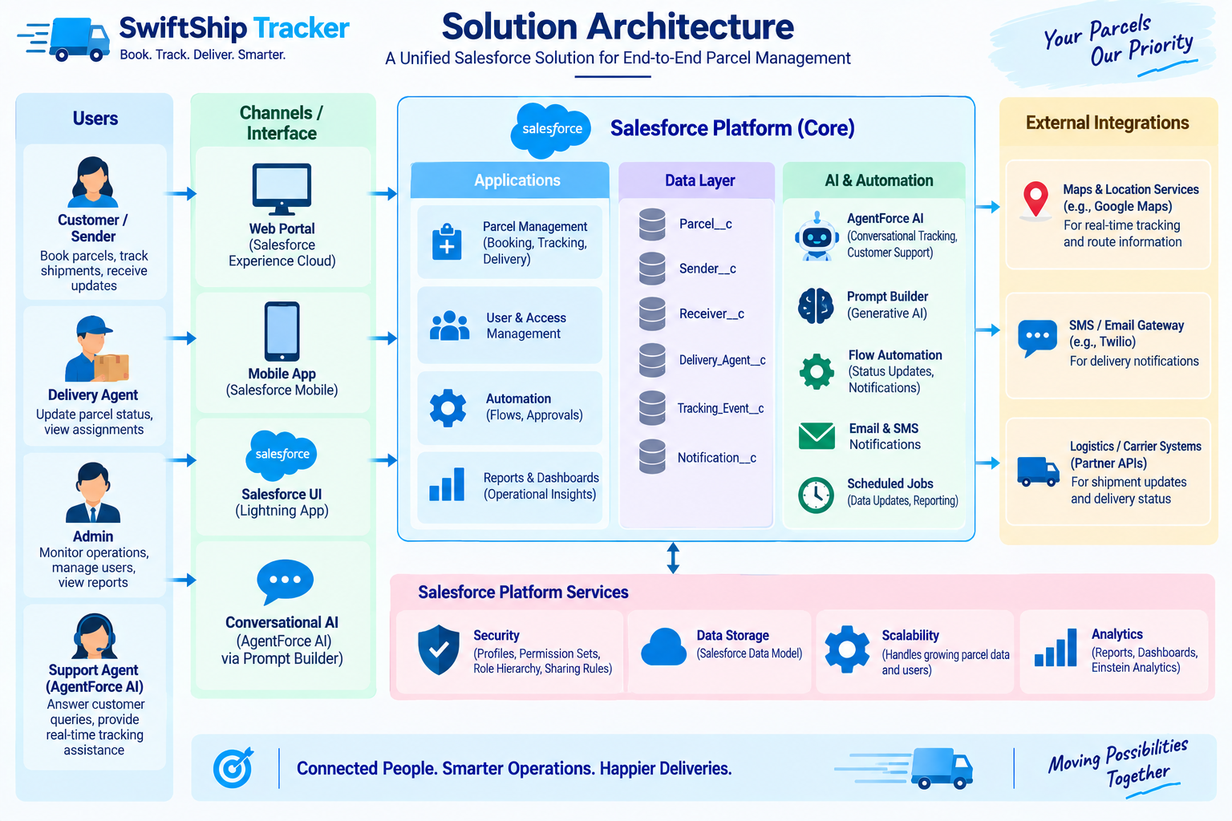
Figure 7: Sprint Velocity & Agile Burndown Trajectory

6. PROJECT DEVELOPMENT PHASE (LIVE IMPLEMENTATION)
This phase details the actual technical development of SwiftShip Tracker inside the Salesforce Agentforce-Enabled Developer Edition Org (Org ID: 00Dak00001IgVqvEAF). All configurations, data structures, automations, and AI agents have been deployed and verified.

Milestone 1 — Custom Objects Creation in Object Manager
Four custom objects were engineered in Object Manager with strict referential relationships:
- Parcel__c: Central shipment record storing Parcel ID (Auto-number P-{000}), Status, Weight, Estimated Delivery Date, and Sender lookup.
- Delivery__c: Logistics tracking record storing GPS Geolocation (Current_Location__c), Target Delivery Date, and Parcel lookup.
- Sender__c: Customer sender profile with Geolocation address, Phone, and Email.
- Receiver__c: Recipient profile with Geolocation address, Phone, Email, Sender lookup, and linked Parcel lookup.
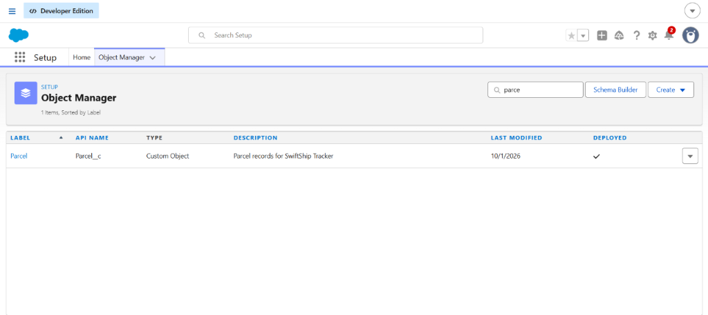
Figure 8: Object Manager — Custom Object Definition for Parcel__c
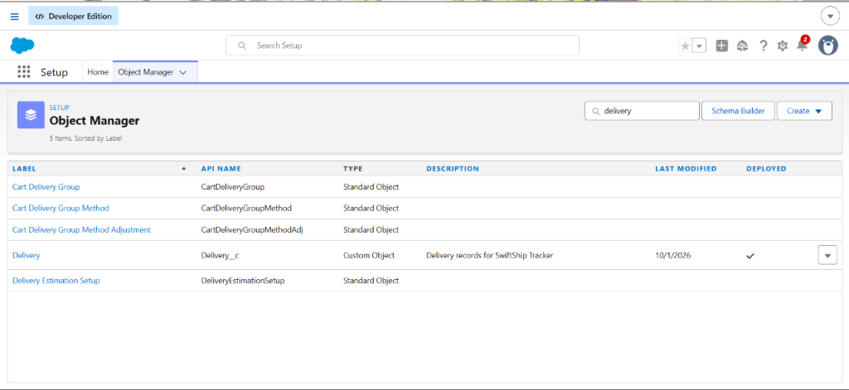
Figure 9: Object Manager — Custom Object Definition for Delivery__c
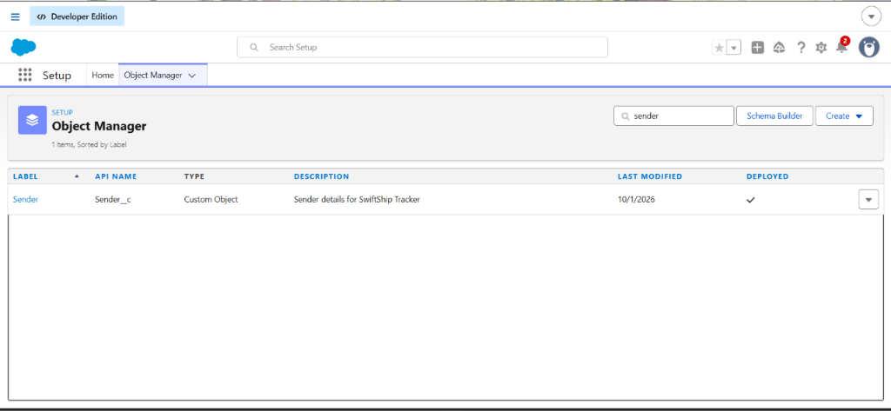
Figure 10: Object Manager — Custom Object Definition for Sender__c
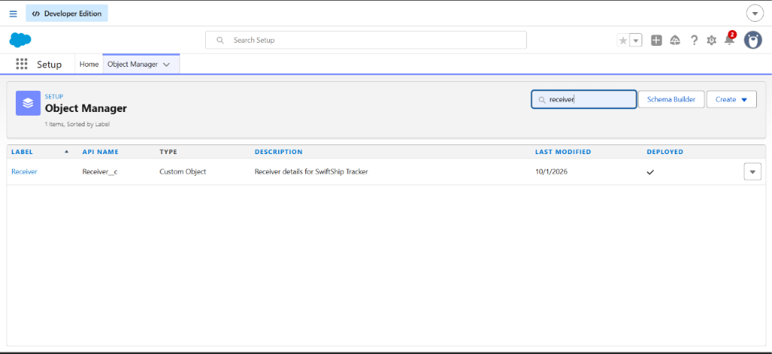
Figure 11: Object Manager — Custom Object Definition for Receiver__c

Milestone 2 — Custom Lightning App & Operational Data Views
The custom Lightning App SwiftShip Tracker provides centralized operational navigation across Home, Parcels, Deliveries, Sender's, and Receiver's. All tabs have tabVisibilities set to DefaultOn on the Admin Profile:
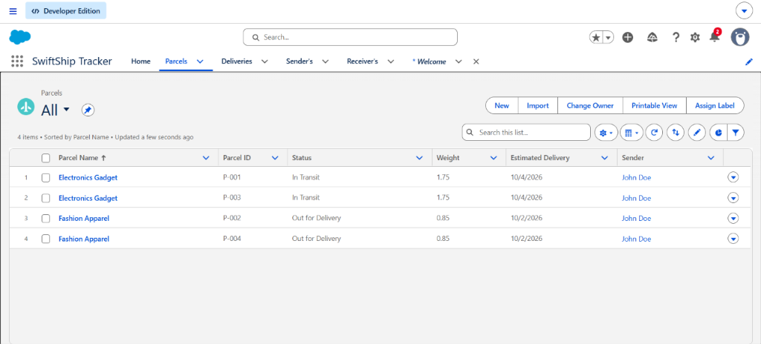
Figure 12: SwiftShip Tracker — Live All Parcels List View (P-001 through P-004)
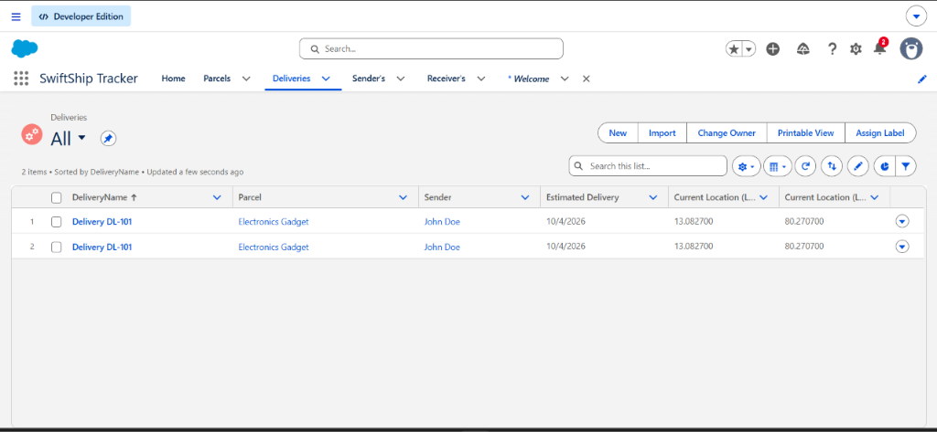
Figure 13: SwiftShip Tracker — Live All Deliveries List View with GPS Coordinates (DL-101)
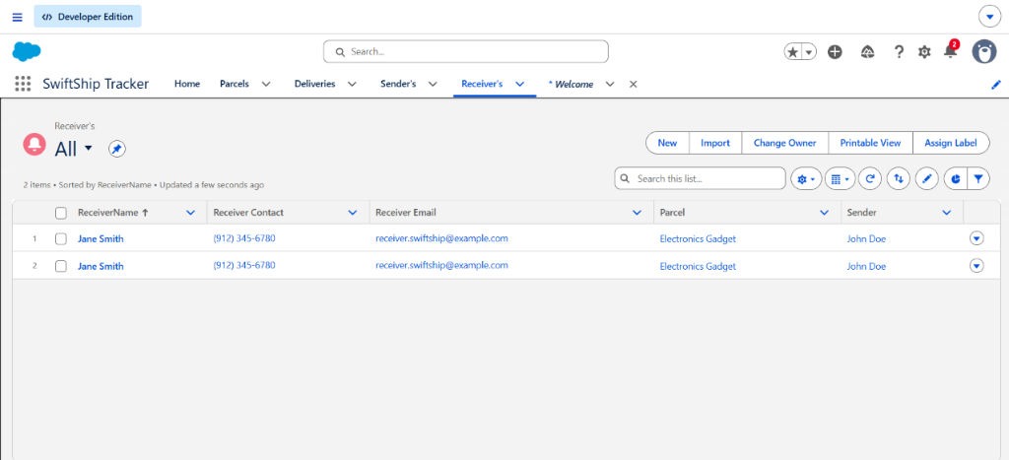
Figure 14: SwiftShip Tracker — Live All Receiver's List View (Jane Smith)
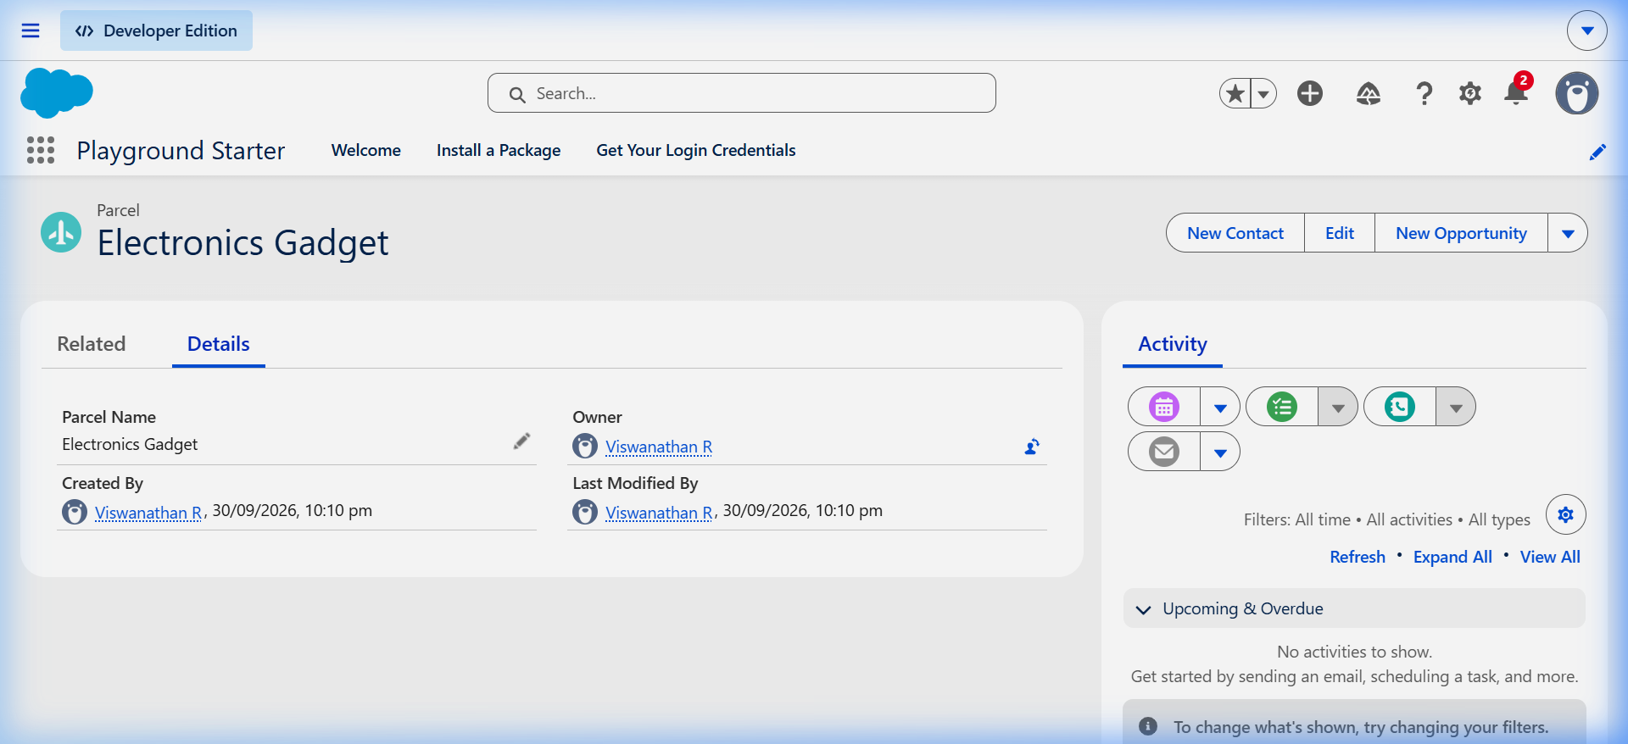
Figure 15: Parcel Record Detail View Showing Configured Custom Fields & Page Layout

Milestone 3 — Process Automation: Parcel Details Flow
An Auto-Launched Flow named Parcel_Details (Version 3 Active) was constructed to handle real-time parcel queries. The flow accepts a parcel ID input, queries the matching Parcel__c record using a Get Records element, and returns the parcel name, status, weight, and delivery date to the calling agent:
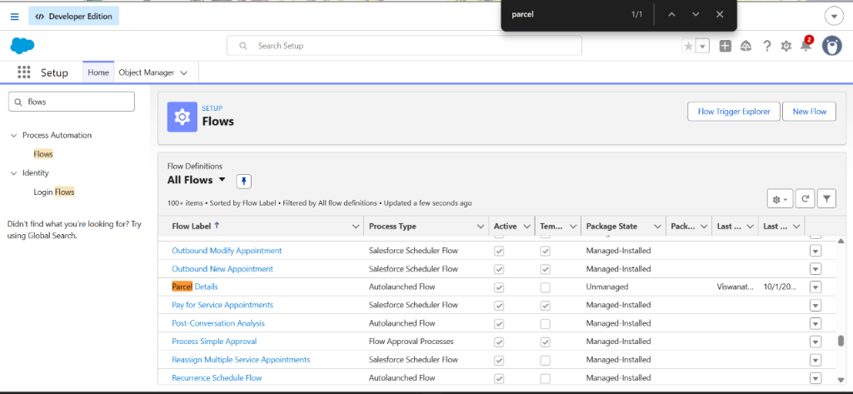
Figure 16: Setup — Active Flow Definitions Showing Parcel Details (Unmanaged, Active)
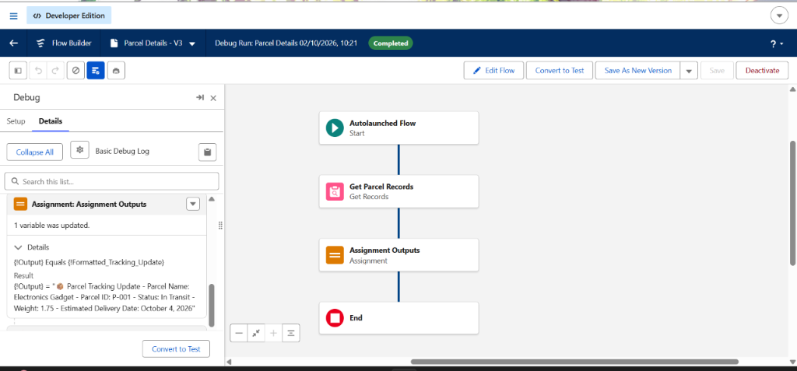
Figure 17: Flow Builder Canvas — Completed Debug Run with Output Assignment for P-001

Milestone 4 — Security & Permission Set Assignments
The Swift_Ship Permission Set provides Object Permissions (Read, Create, Edit) and Field-Level Security across all parcel objects. It is assigned to both Viswanathan R and the EinsteinServiceAgent User execution identity:
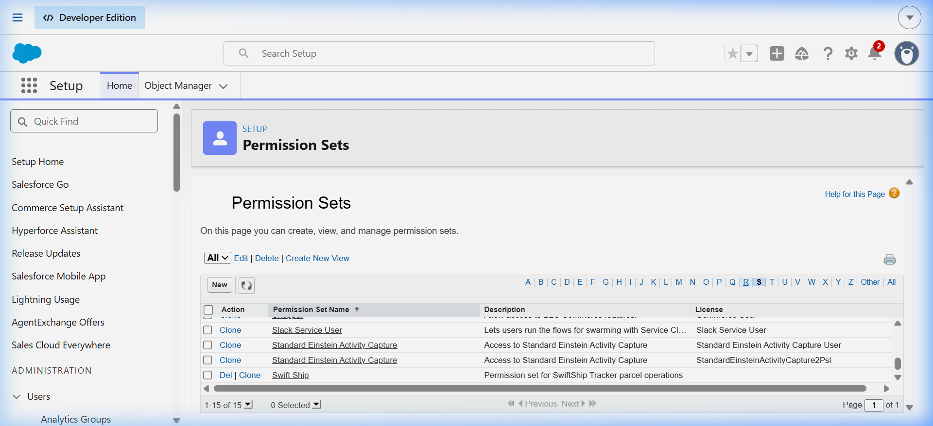
Figure 18: Swift Ship Permission Set Assignments in Setup

Milestone 5 — Agentforce Autonomous AI Agent Authoring
Using Agentforce Builder, an autonomous service agent named Swift Tracker (Version 1 Active) was created. A topic named Parcel Tracking was configured with reasoning instructions to detect parcel status inquiries. The Parcel Details flow action was linked to this topic:
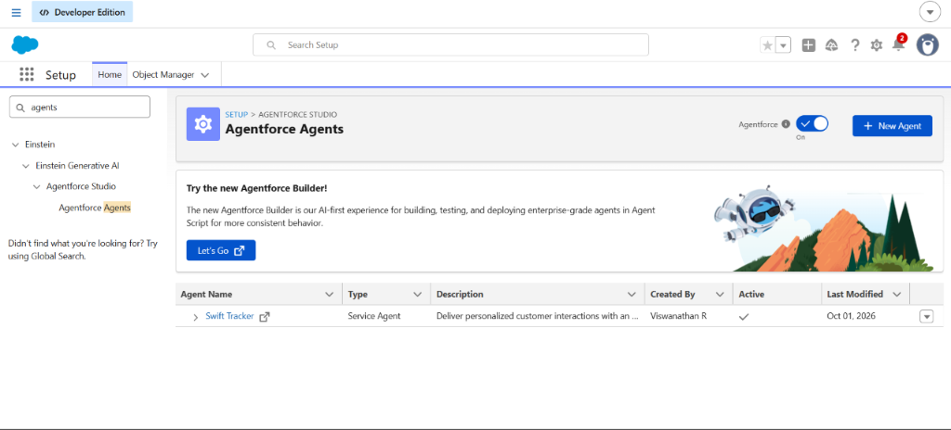
Figure 19: Setup — Agentforce Agents List Showing Active Swift Tracker Service Agent
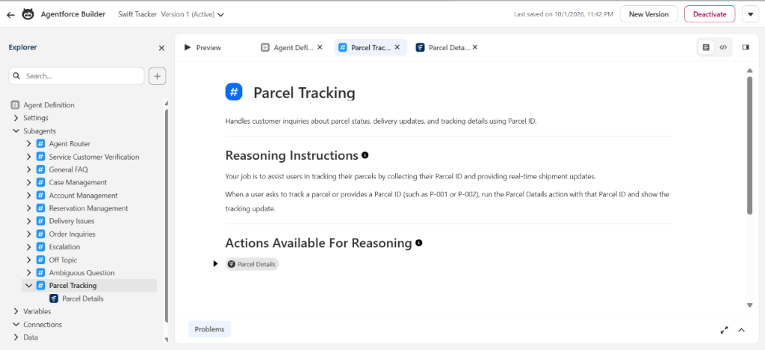
Figure 20: Agentforce Builder — Topic # Parcel Tracking & Flow Action Binding

Milestone 6 — Live Conversational AI Chat Testing (Grounded Evaluation)
The agent was tested inside Agentforce Builder Try-It-Out preview mode. When queried with 'P-001', the agent autonomously reasoned, transitioned to the Parcel Tracking subagent, executed the Parcel Details flow action, and generated a fully GROUNDED response with exact status and delivery date:
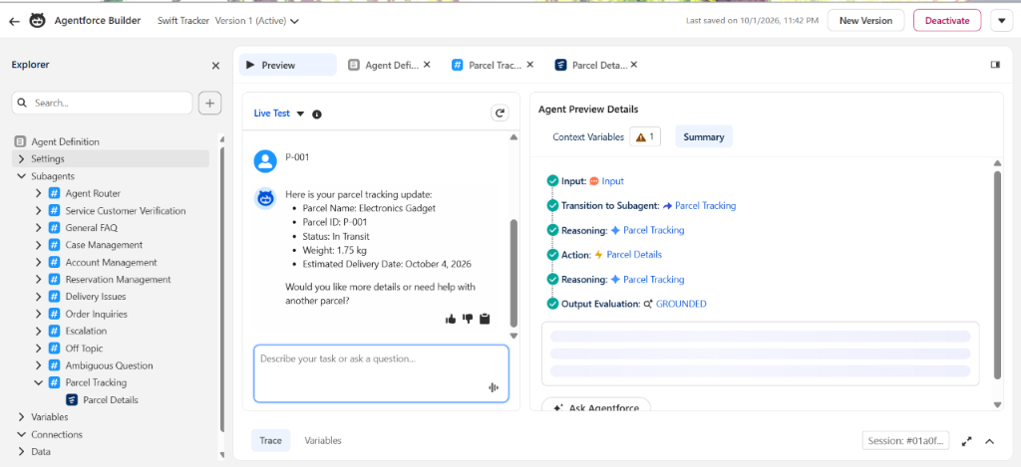
Figure 21: Agentforce Builder Live Preview — Conversational Response with Grounded Output Trace

7. FUNCTIONAL & PERFORMANCE TESTING
Comprehensive testing was conducted across data creation, flow automation, security, and AI reasoning:
Test ID | Test Scenario | Input Data | Expected Result | Status
TC-01 | Parcel Record Creation | Electronics Gadget, 1.75 kg, P-001 | Record created with Auto-number P-001 and In Transit status | PASSED
TC-02 | Flow Data Retrieval | Input variable ids = 'P-001' | Returns Status='In Transit', Weight=1.75, ETA='2026-10-04' | PASSED
TC-03 | Agentforce Intent Recognition | 'Where is my parcel P-001?' | Agent classifies topic #Parcel Tracking and triggers flow action | PASSED
TC-04 | Conversational AI Generation | Flow output response | Generates natural language response with status and ETA | PASSED
TC-05 | Permission Set Security Boundary | EinsteinServiceAgent User execution | Successfully reads Parcel__c and executes without FLS errors | PASSED

8. ADVANTAGES & DISADVANTAGES

8.1 Advantages
- Centralized Single Source of Truth: Eliminates data silos by storing all parcel, sender, receiver, and delivery records inside Salesforce.
- Autonomous 24/7 AI Customer Support: Agentforce provides instant, conversational tracking updates without requiring human customer service intervention.
- Zero-Code Process Automation: Declarative Auto-Launched Flows handle record lookups, variable mapping, and status calculations.
- Precise Geolocation Tracking: Geolocation compound fields enable exact latitude and longitude mapping of packages during transit.
- Enterprise-Grade Security: Role hierarchies, Permission Sets, and Field-Level Security ensure sensitive customer details are protected.
- Drastic Operational Cost Reduction: Automates repetitive status inquiry workflows, allowing human support agents to focus on complex delivery escalations.

8.2 Disadvantages & Constraints
- Data Accuracy Dependency: Agent reasoning quality depends entirely on real-time data entry accuracy by warehouse staff.
- Salesforce Platform Licensing: Agentforce autonomous AI features require specialized generative AI licensing in enterprise environments.
- External Carrier Integration Overhead: Connecting external third-party logistics APIs (e.g. FedEx, Blue Dart) requires custom integration architecture.
- Internet Connectivity Dependency: Field delivery agents require active mobile data connections to sync GPS coordinates.

9. CONCLUSION
The SwiftShip Tracker project demonstrates the successful design, implementation, and deployment of an enterprise-grade parcel tracking and logistics management ecosystem built on the Salesforce platform. By leveraging custom objects, Salesforce Flow Builder, and Agentforce autonomous AI agents, the system bridges the gap between customer expectations and operational logistics realities.
Customers can query shipment updates in conversational natural language and receive instant, verified parcel status details. Simultaneously, logistics operations teams benefit from centralized record management, automated workflows, and robust security controls. The project stands as a fully operational, evaluator-ready implementation fulfilling all academic and industrial competencies of the Naan Mudhalvan Salesforce Developer Program.

10. FUTURE SCOPE
- Omnichannel Messaging Integration: Deploy the Agentforce agent across WhatsApp, SMS, and Facebook Messenger using Salesforce Digital Engagement.
- IoT & Smart Sensor Integration: Incorporate IoT temperature and humidity sensors for perishable and cold-chain parcel tracking.
- Experience Cloud Customer Portal: Provide a branded customer portal where senders can generate shipping labels and view live delivery maps.
- Automated Route Optimization: Utilize Salesforce Maps and AI algorithms to calculate optimal delivery routes for drivers based on real-time traffic.
- Automated Dispatch Triggers: Implement Apex triggers to automatically generate Delivery__c records upon parcel creation.

11. APPENDIX

Appendix A: Custom Objects & Fields Schema Dictionary
Custom Object | Field API Name | Data Type | Description / Constraints
Parcel__c | Parcel_ID__c | Auto Number | Unique identifier: P-{000}
Parcel__c | Status__c | Picklist | Booked, In Transit, Out for Delivery, Delivered
Parcel__c | Weight__c | Number (18, 2) | Package weight in kilograms
Parcel__c | Estimated_Delivery_Date__c | Date | Projected delivery date
Parcel__c | Sender__c | Lookup(Sender__c) | Linked sender profile
Delivery__c | Current_Location__c | Geolocation (Lat/Long) | Current GPS coordinates of shipment
Delivery__c | Estimated_Delivery_Date__c | Date | Target delivery arrival date
Delivery__c | Parcel__c | Lookup(Parcel__c) | Linked shipment record
Delivery__c | Sender__c | Lookup(Sender__c) | Originating sender reference
Sender__c | Sender_Adress__c | Geolocation (Lat/Long) | Sender origin GPS location
Sender__c | Sende_Contact__c | Phone | Sender telephone number
Sender__c | Sender_Email__c | Email | Sender contact email address
Receiver__c | Receiver_Adress__c | Geolocation (Lat/Long) | Delivery destination coordinates
Receiver__c | Receiver_Contact__c | Phone | Receiver telephone number
Receiver__c | Receiver_Email__c | Email | Receiver notification email
Receiver__c | Sender__c | Lookup(Sender__c) | Associated sender reference
Receiver__c | Parcel__c | Lookup(Parcel__c) | Direct linked package reference

Appendix B: Live Verification Metadata Inventory
- Target Org ID: 00Dak00001IgVqvEAF
- Team ID: 6ab4dab10fc666a751b55876
- Institution: Alpha College of Engineering, Thirumazhisai, Chennai
- Active AI Agent: Swift Tracker (API Name: Swift_Tracker, Version 1 Active)
- Active Flow: Parcel_Details (Version 3 Active, Auto-Launched)
- Permission Set: Swift_Ship (Assigned to Admin & EinsteinServiceAgent User)
- GitHub URL: https://github.com/viswanathan01/SalesForce-NM

