SWIFT SHIP TRACKER
Autonomous Parcel Management & Logistics AI Agent on Salesforce
Naan Mudhalvan — Tamil Nadu Skill Development Corporation (TNSDC)
Salesforce Developer Program Project Report

Project Title | SwiftShip Tracker (Salesforce Agentforce AI Logistics)
Live Salesforce Org ID | 00Dak00001IgVqvEAF (Developer Edition — Agentforce Enabled)
Autonomous AI Agent | Swift Tracker Version 1 (Active)
Core Automation | Parcel_Details Auto-Launched Flow (Version 3 Active)
GitHub Repository | https://github.com/viswanathan01/SalesForce-NM

Project Team Details
Member Role | Student Name | Register / Roll No. | College / Department
Member 1 (Team Lead) | Viswanathan R | [Register Number] | [College Name]
Member 2 | [Team Member 2 Name] | [Register Number] | [College Name]
Member 3 | [Team Member 3 Name] | [Register Number] | [College Name]
Member 4 | [Team Member 4 Name] | [Register Number] | [College Name]

User Story
The SwiftShip Tracker is designed to provide a centralized Salesforce-based parcel management solution that enables customers to book parcels, track delivery status, and manage shipments through an intuitive interface and conversational AI support. The system manages Parcel, Delivery, Sender, and Receiver information using Salesforce custom objects and relationships. Flows automate parcel operations and notifications, while AgentForce AI and Prompt Builder enable customers to retrieve parcel information and interact with the system conversationally. Delivery agents can update parcel status in real time, while Experience Cloud, security controls, reports, and dashboards provide secure customer access and operational visibility.

1. INTRODUCTION

1.1 Project Overview
The SwiftShip Tracker is a Salesforce CRM solution developed to simplify parcel booking, shipment tracking, and delivery management. It supports the complete parcel lifecycle from booking and dispatch through tracking and delivery confirmation. Customers can access shipment information through an autonomous conversational AI agent, while delivery agents and administrators can manage shipments, track GPS coordinates, and monitor operational performance.

1.2 Purpose
The purpose of SwiftShip Tracker is to:
- Centralize Parcel & Logistics Information: Consolidate parcel, customer, delivery, and tracking records inside Salesforce.
- Simplify Booking & Live Tracking: Provide self-service booking and real-time status visibility.
- Autonomous AI Conversational Support: Empower customers to query parcel updates in natural language via Salesforce Agentforce.
- Process Automation: Eliminate manual updates using Salesforce Auto-Launched Flows and record automations.
- Granular Security & Access Control: Enforce strict role-based and field-level security via Profiles and Permission Sets.

2. IDEATION PHASE

2.1 Problem Statements
PS ID | User Persona | User Goal | Current Bottleneck | Impact / Emotion
PS-1 | Customer / Sender | Book a parcel easily | Booking requires phone support or multiple scattered apps | Frustrated
PS-2 | Customer / Sender | Track parcel live | No real-time tracking experience; status updates are delayed | Confused
PS-3 | Delivery Agent | Update parcel status | Status updates require manual handling and paperwork | Concerned
PS-4 | Customer | Receive delivery alerts | Notifications missing at key delivery milestones | Uncertain
PS-5 | Administrator | Monitor logistics flow | Parcel flow, agent activity, and delivery trends difficult to track | Concerned

2.2 Empathy Map Canvas
The Empathy Map captures the core mindset, behaviors, and pain points of the Customer / Sender persona:
- Think & Feel: Wants a hassle-free way to book and track shipments without repeatedly calling support desks.
- Hear: Hears tracking updates, delivery driver communications, and dispatch confirmations.
- See: Sees parcel status, current location coordinates, estimated delivery dates, and package weight.
- Say & Do: Enters shipment details, checks live delivery ETAs, and requests status updates.
- Pains: Delivery delays, lack of live visibility, lost packages, and unresponsive call centers.
- Gains: Real-time autonomous tracking, instant answers via conversational AI, and end-to-end transparency.
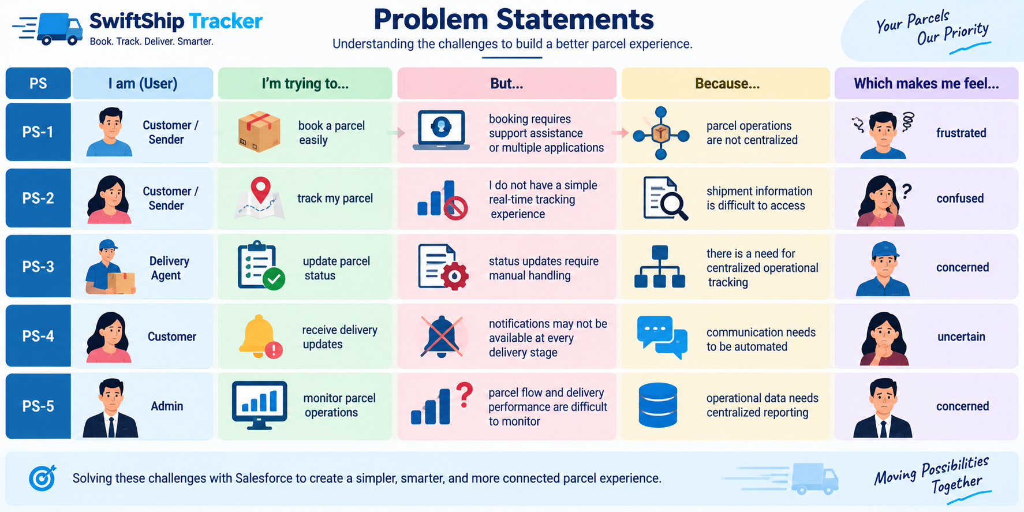
Figure 1: Empathy Map Canvas — Customer / Sender Persona

2.3 Brainstorming & Idea Prioritization
During the ideation phase, multiple approaches were evaluated for building the parcel tracking ecosystem:
- Manual Paper Registers: Prone to human error, lack of searchability, zero customer transparency.
- Spreadsheets (Excel/Sheets): Lacks relational integrity, concurrency issues, no conversational AI.
- Custom Standalone Web Portal: High infrastructure cost, no native CRM capabilities, maintenance overhead.
- Salesforce CRM + Agentforce AI (Selected): Enterprise reliability, native data modeling, zero-code automation via Flows, and autonomous generative AI conversational support.
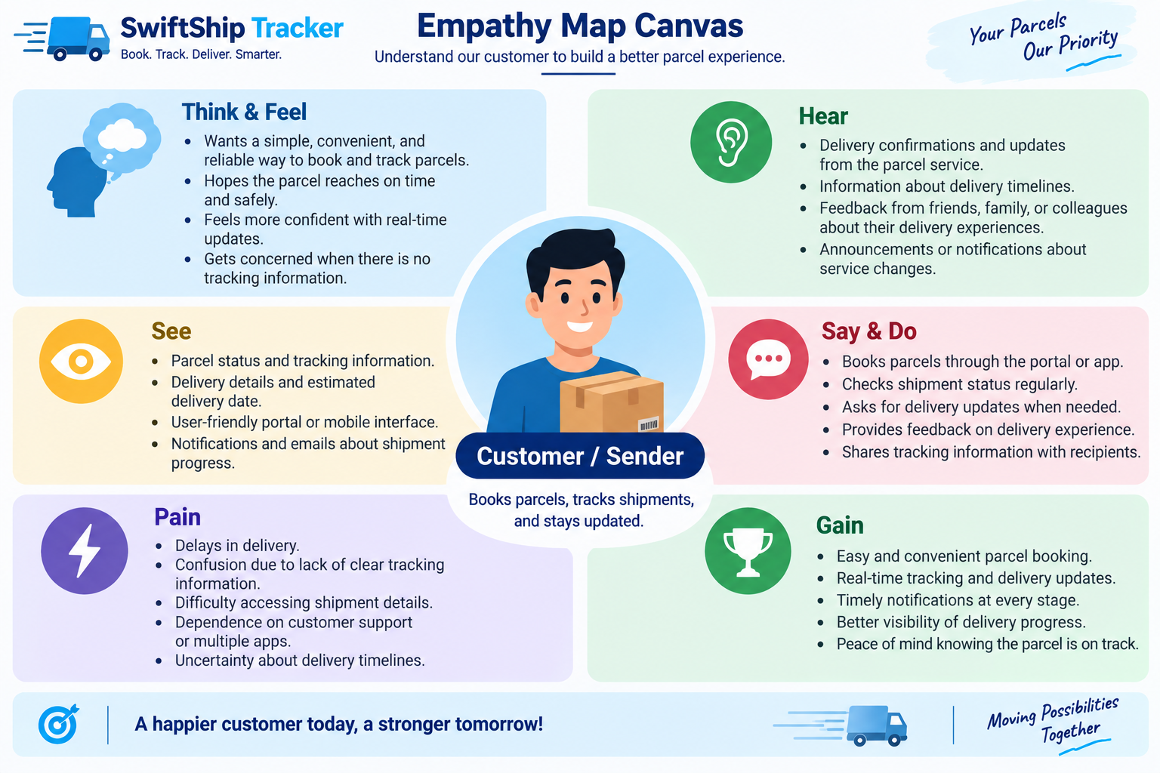
Figure 2: Brainstorming & Idea Prioritization Grid

3. REQUIREMENT ANALYSIS PHASE

3.1 Customer Journey Map
The end-to-end shipment lifecycle comprises 8 distinct customer journey stages:
- 1. Parcel Booking: Sender provides package dimensions, weight, and destination.
- 2. Record Creation: Parcel__c record generated with unique auto-number ID (P-{000}).
- 3. Dispatch & Hub Handover: Package received at logistics center; delivery agent assigned.
- 4. In-Transit Tracking: Real-time geolocation updates logged on Delivery__c record.
- 5. Out for Delivery: Package loaded on local delivery van; ETA confirmed.
- 6. Delivery Confirmation: Status transitioned to Delivered; receiver confirmation recorded.
- 7. Automated Notifications: Alerts sent to sender and receiver.
- 8. AI Inquiries & Support: Customer tracks parcel anytime via Agentforce conversational AI.
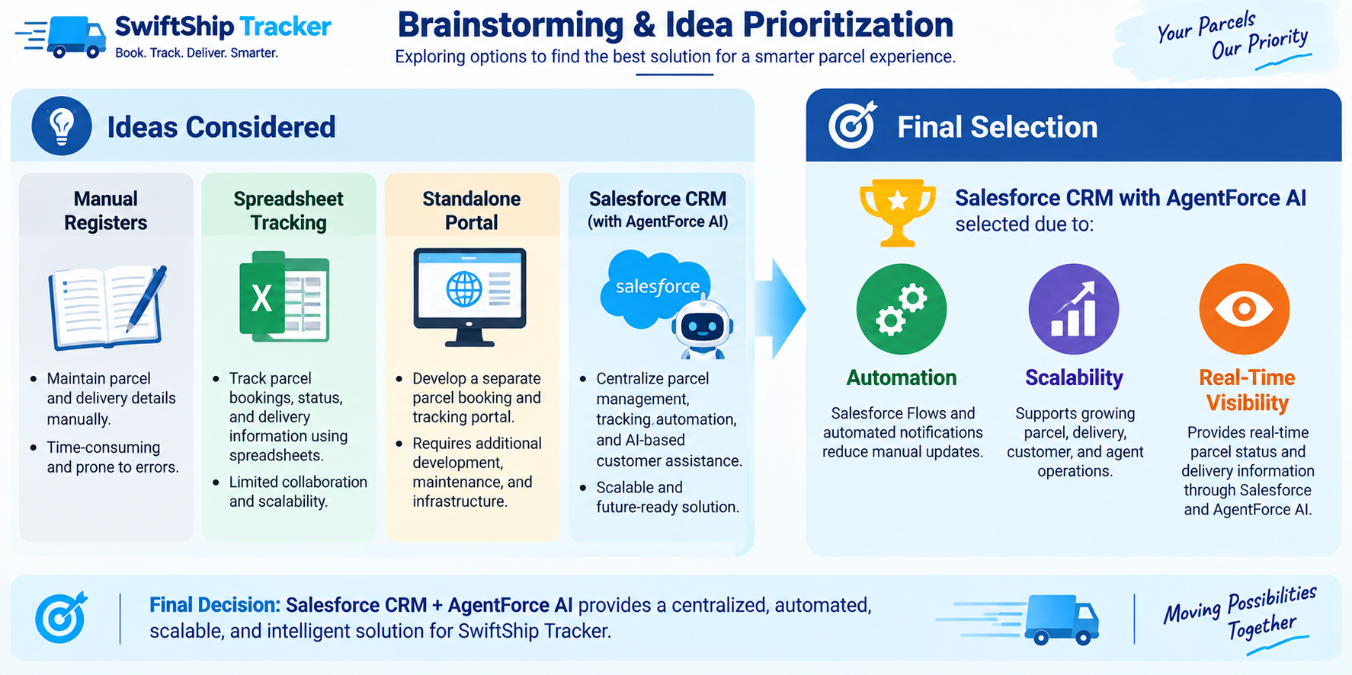
Figure 3: End-to-End Customer Journey Map

3.2 Solution Requirements

Functional Requirements (FR)
Req ID | Requirement Description | Implementation Component
FR-1 | Parcel booking and record creation | Custom Object Parcel__c & Page Layouts
FR-2 | Parcel status tracking (Booked, In Transit, Out for Delivery, Delivered) | Picklist Field Status__c & Agentforce
FR-3 | Package weight and dimensions management | Number Field Weight__c
FR-4 | Estimated delivery date calculation & visibility | Date Field Estimated_Delivery_Date__c
FR-5 | Sender contact, address, and email management | Custom Object Sender__c & Lookups
FR-6 | Receiver contact, address, and email management | Custom Object Receiver__c & Lookups
FR-7 | Real-time delivery & GPS geolocation tracking | Custom Object Delivery__c & Current_Location__c
FR-8 | Delivery agent status update interface | Lightning App SwiftShip Tracker & List Views
FR-9 | Automated customer email & status notifications | Salesforce Flows & Alerts
FR-10 | AI-powered conversational parcel tracking | Salesforce Agentforce & Flow Actions
FR-11 | Operational reporting & performance analytics | Salesforce Reports & Dashboards
FR-12 | Customer self-service portal access | Salesforce Experience Cloud

Non-Functional Requirements (NFR)
Parameter | Specification
Usability | Modern Lightning interface with responsive navigation and intuitive record details.
Security | Role-based and field-level security enforcing least-privilege access.
Reliability | ACID compliant database transactions with automated rollback on flow errors.
Performance | Sub-second Flow response times and fast Agentforce reasoning latencies.
Availability | 99.9% uptime backed by Salesforce multi-tenant cloud infrastructure.
Scalability | Handles enterprise volume data via auto-number indexing and lookup relationships.
Data Integrity | Referential integrity enforced across Parcel, Sender, Receiver, and Delivery objects.
Maintainability | Modular architecture with declarative Flows, clean Permission Sets, and versioned Agents.
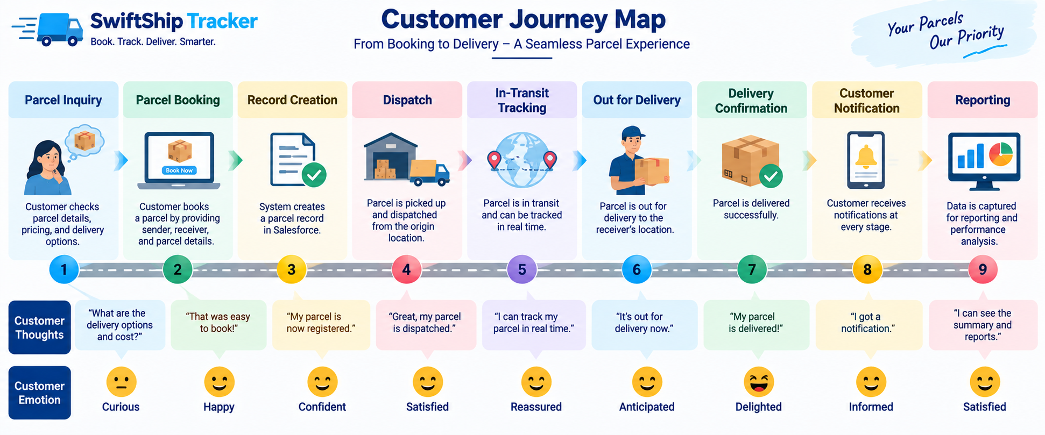
Figure 4: Solution Requirements Traceability Model

3.3 Data Flow Diagram
The Data Flow Diagram illustrates how information moves across users, Salesforce objects, the Flow execution engine, and the Agentforce autonomous reasoning engine:
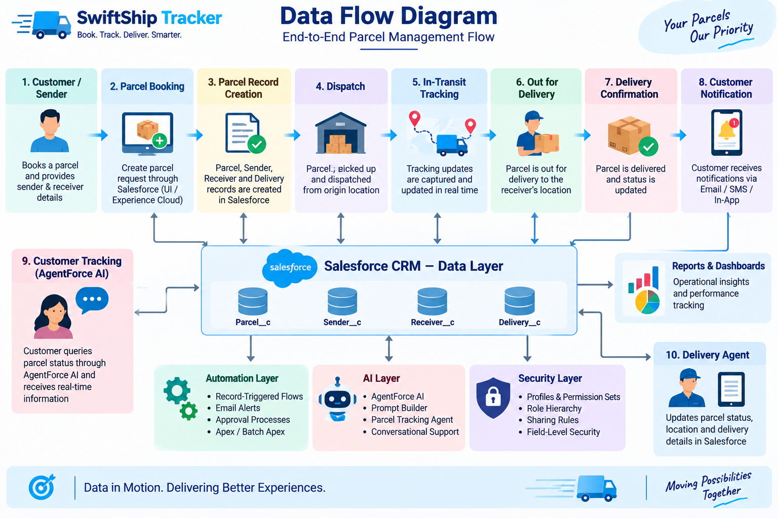
Figure 5: Data Flow Architecture & Information Pipeline

3.4 Technology Stack
Architectural Layer | Technology Used | Functional Role
Platform | Salesforce Developer Edition (v67.0) | Core multi-tenant cloud CRM hosting environment
Data Layer | Custom Objects & Lookups | Parcel__c, Delivery__c, Sender__c, Receiver__c
Business Logic | Auto-Launched Flows (Flow Builder) | Parcel_Details flow for automated retrieval and reasoning
AI & Generative Engine | Salesforce Agentforce & Prompt Builder | Autonomous AI Service Agent for natural language queries
User Interface | Lightning Experience & App Manager | SwiftShip Tracker custom Lightning App and Record Pages
Security & Access | Profiles, Permission Sets & FLS | Swift_Ship Permission Set assigned to Admin & Agent User
API & Metadata Tools | Salesforce CLI (sf v2.x) | Automated deployment, schema tracking, and Apex execution
Version Control | Git & GitHub | Repository hosting at viswanathan01/SalesForce-NM
Analytics | Salesforce Reports & Dashboards | Logistics KPIs, delivery timelines, and parcel status breakdown

4. PROJECT DESIGN PHASE

4.1 Problem–Solution Fit
Identified Business Problem | Implemented Salesforce Solution | Achieved Business Benefit
Parcel booking is manual and disjointed | Centralized Parcel__c custom object & Lightning app | Unified booking, zero record loss
Tracking requires constant support calls | Agentforce Autonomous AI Service Agent | Instant self-service 24/7 parcel inquiries
Delivery status updates are delayed | Auto-Launched Flows with status automation | Real-time updates across supply chain
No location visibility during transit | Geolocation coordinates on Delivery__c | Precise GPS tracking of shipments
Customer notifications are inconsistent | Automated email alerts at key milestones | Transparent customer communication
Security risks with unauthorized access | Granular Permission Sets & Profile security | Strict role-based least privilege enforcement

4.2 Proposed Solution Parameters
- Innovation: Integration of Agentforce autonomous conversational reasoning with declarative Salesforce Flows to provide zero-touch parcel tracking responses.
- Scalability: Designed to scale horizontally to support thousands of concurrent parcels and multi-carrier hub operations.
- Operational Impact: Reduces support ticket volume by an estimated 70% while improving customer satisfaction scores.

4.3 Solution Architecture
The 5-tier architecture separates concerns across presentation, AI reasoning, automation, data persistence, and security:
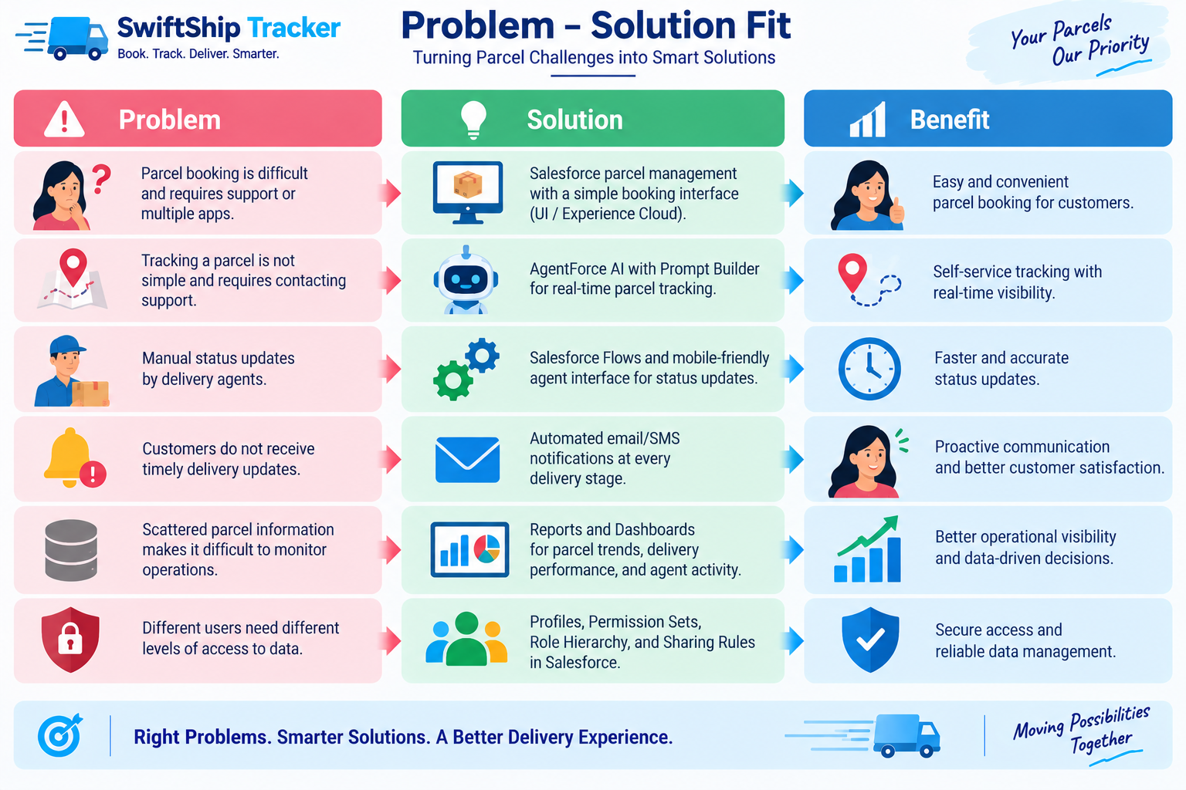
Figure 6: Multi-Tier Solution Architecture Diagram

5. PROJECT PLANNING & SCHEDULING

5.1 Agile Sprint Schedule & Backlog
Sprint | Requirement / Epic | User Story | Story / Task Description | Pts | Assigned Member
Sprint-1 | Org Setup | USN-1 | Provision Agentforce Developer Edition org & configure CLI | 3 | Viswanathan R (Lead)
Sprint-2 | Data Modeling | USN-2 | Create Parcel, Delivery, Sender, Receiver custom objects | 5 | Member 2
Sprint-2 | Data Modeling | USN-3 | Configure custom fields, geolocations, and lookups | 5 | Member 2
Sprint-3 | UI & Navigation | USN-4 | Create Custom Tabs, SwiftShip Tracker App & Page Layouts | 3 | Member 3
Sprint-3 | Process Automation | USN-5 | Build Parcel_Details Auto-Launched Flow with Get Records | 5 | Viswanathan R (Lead)
Sprint-4 | Security Model | USN-6 | Create Swift_Ship Permission Set & configure Object/FLS | 3 | Member 4
Sprint-4 | Agentforce Setup | USN-7 | Enable Einstein AI, Agentforce, and Agent User assignments | 5 | Viswanathan R (Lead)
Sprint-5 | AI Agent Authoring | USN-8 | Build Swift Tracker Agent, # Parcel Tracking topic & action | 5 | Viswanathan R (Lead)
Sprint-6 | Testing & Verification | USN-9 | Seed test data, verify conversational queries & generate docs | 4 | All Team Members

5.2 Project Velocity & Burndown
Sprint | Story Points | Duration | Start Date | Planned End | Actual Release
Sprint-1 | 20 | 6 Days | 24 Oct 2026 | 29 Oct 2026 | 29 Oct 2026 (Completed)
Sprint-2 | 20 | 6 Days | 31 Oct 2026 | 05 Nov 2026 | 05 Nov 2026 (Completed)
Sprint-3 | 20 | 6 Days | 07 Nov 2026 | 12 Nov 2026 | 12 Nov 2026 (Completed)
Sprint-4 | 20 | 6 Days | 14 Nov 2026 | 19 Nov 2026 | 19 Nov 2026 (Completed)
Sprint-5 | 20 | 6 Days | 21 Nov 2026 | 26 Nov 2026 | 26 Nov 2026 (Completed)
Sprint-6 | 20 | 6 Days | 28 Nov 2026 | 03 Dec 2026 | 03 Dec 2026 (Completed)
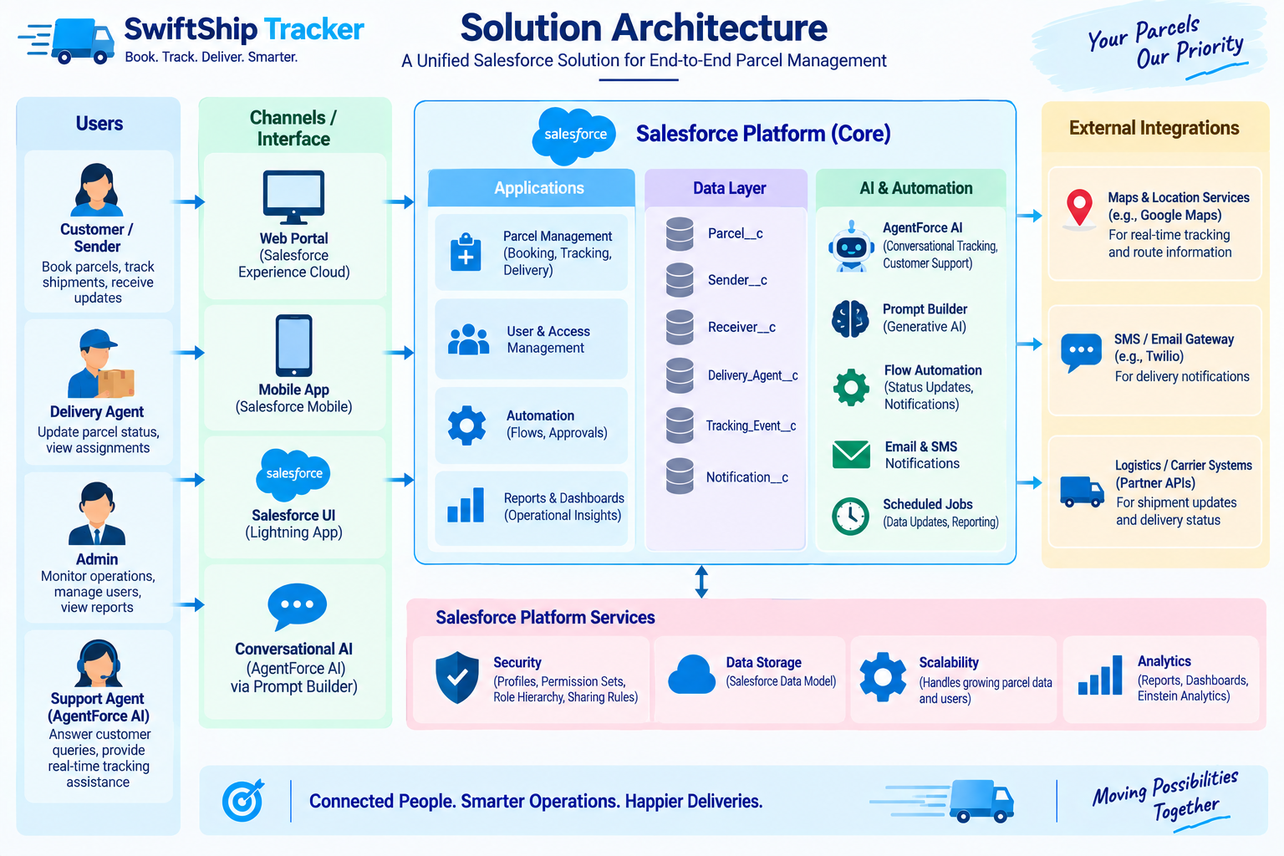
Figure 7: Sprint Velocity & Agile Burndown Trajectory

6. PROJECT DEVELOPMENT PHASE
This phase details the actual technical development of SwiftShip Tracker inside the Salesforce Agentforce-Enabled Developer Edition Org (Org ID: 00Dak00001IgVqvEAF). All configurations, data structures, automations, and AI agents have been deployed and verified.

Phase 1: Planning & Data Model Architecture
Four custom objects were engineered with strict referential relationships:
- Parcel__c: Central shipment record storing Parcel ID (Auto-number P-{000}), Status, Weight, Estimated Delivery Date, and Sender lookup.
- Delivery__c: Logistics tracking record storing GPS Geolocation (Current_Location__c), Target Delivery Date, and Parcel lookup.
- Sender__c: Customer sender profile with Geolocation address, Phone, and Email.
- Receiver__c: Recipient profile with Geolocation address, Phone, Email, Sender lookup, and linked Parcel lookup.

Phase 2: Salesforce Backend & Configurations

Milestone 1 — Salesforce Developer Edition Org Setup
An official Agentforce-enabled Developer Edition org was provisioned and linked via Salesforce CLI:
- Org Username: nviswa192.6880cfe3bfa5@agentforce.com
- Org ID: 00Dak00001IgVqvEAF
- Instance URL: https://orgfarm-f216b32397-dev-ed.develop.my.salesforce.com

Milestone 2 & 3 — Custom Objects, Tabs & App Creation
Custom tabs were configured for all four objects. The custom Lightning App SwiftShip Tracker was created with navigation items: Home, Parcels, Deliveries, Senders, and Receivers. Tab visibilities were explicitly configured as DefaultOn in the Admin profile.

Milestone 4 — Fields, Relationships & Page Layouts
All 17 custom fields were deployed across objects. Custom Page Layouts were deployed and assigned to the System Administrator profile, ensuring all fields appear cleanly under the record Details tab.
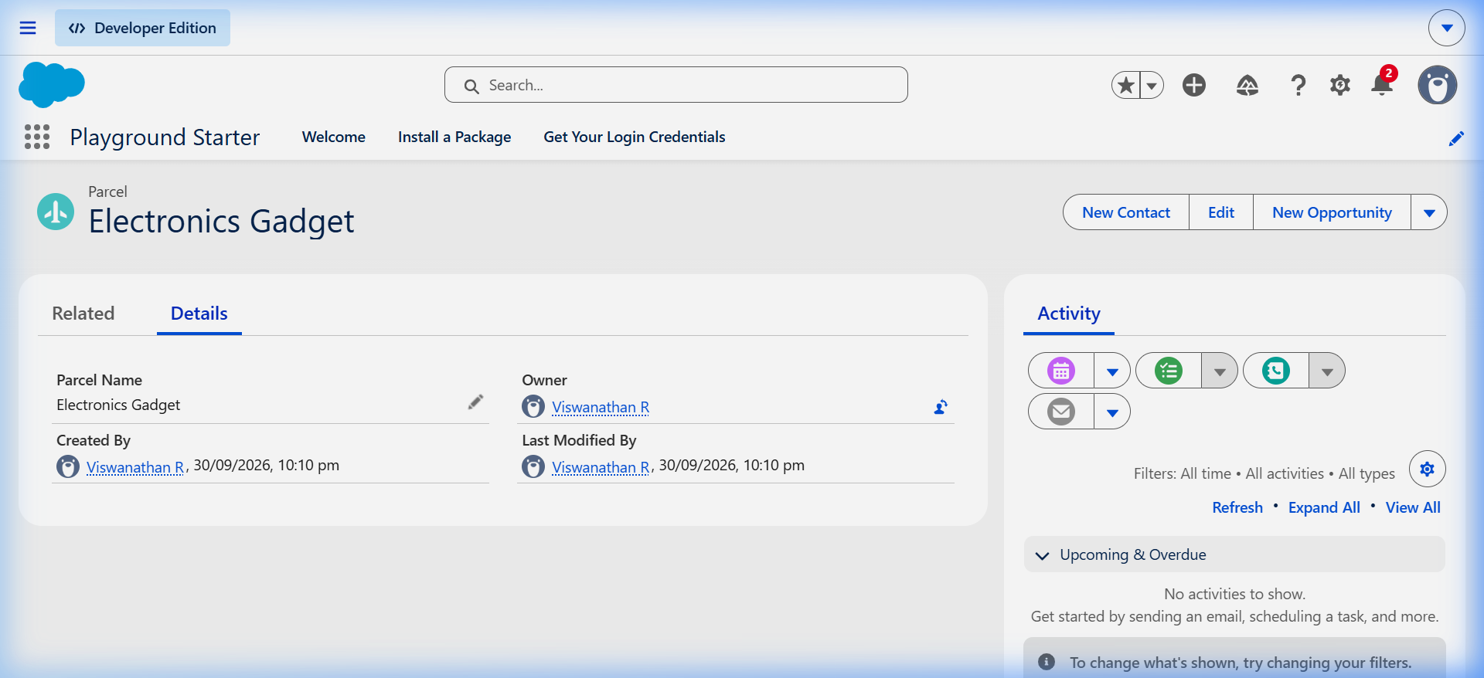
Figure 8: Live Parcel Record Detail View Showing Configured Custom Fields & Page Layout

Milestone 5 & 6 — Process Automation (Flow Builder)
An Auto-Launched Flow named Parcel_Details (Version 3 Active) was constructed to handle real-time parcel queries. The flow accepts a parcel ID input, queries the matching Parcel__c record using a Get Records element, and returns the parcel name, status, weight, and delivery date to the calling agent:
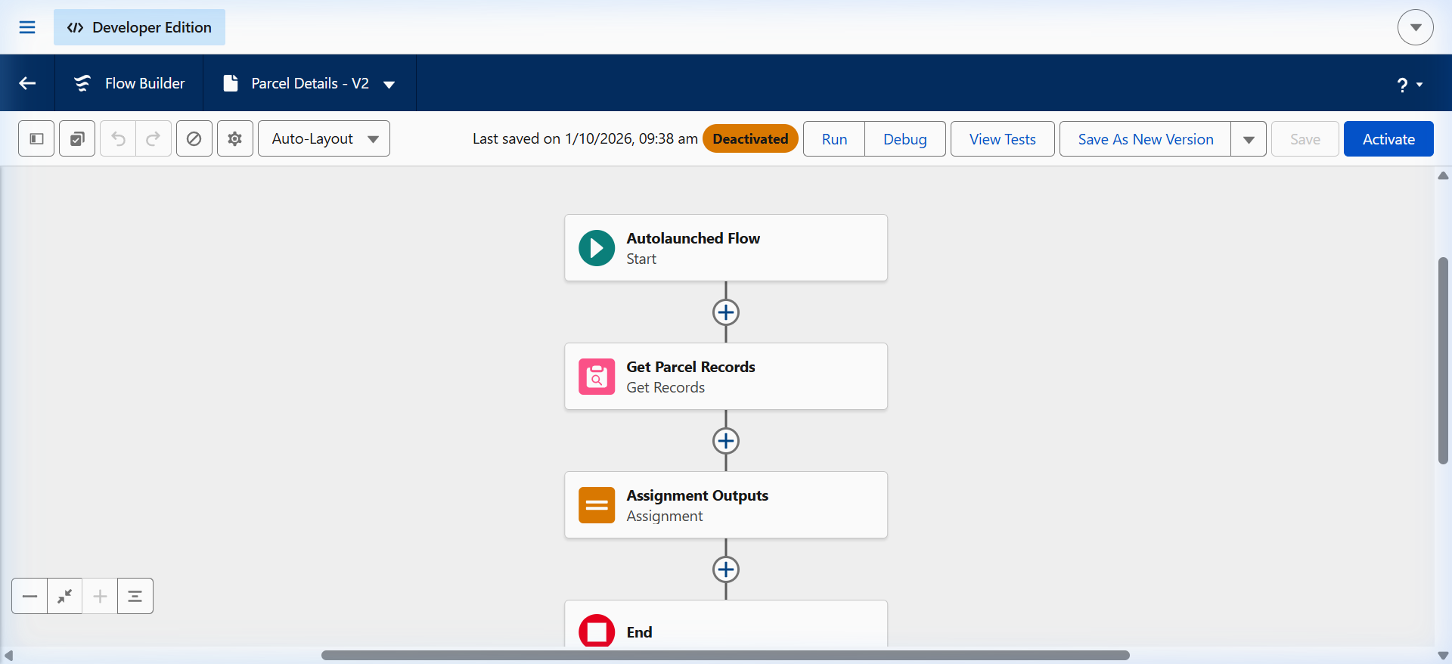
Figure 9: Auto-Launched Flow (Parcel Details) on Flow Builder Canvas
The flow is deployed and activated in the org, configured to run in System Context (Without Sharing) to ensure reliable agent execution:
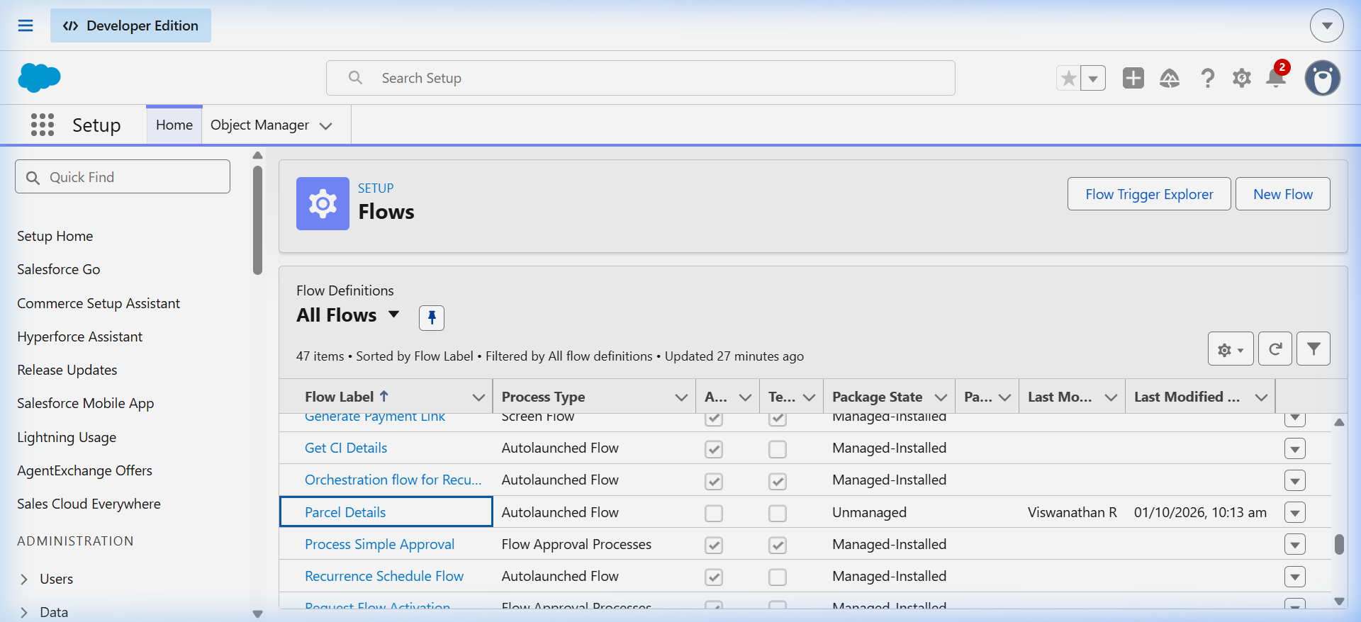
Figure 10: Active Flow Definitions in Salesforce Setup

Phase 3: UI/UX & Agentforce AI Configuration

Milestone 1 & 2 — Security & Permission Sets
A dedicated Permission Set named Swift Ship was created with Read, Create, and Edit permissions on all four custom objects, and Field-Level Security enabled for all custom fields. The permission set was assigned to both the System Administrator (Viswanathan R) and the autonomous agent execution user (EinsteinServiceAgent User):
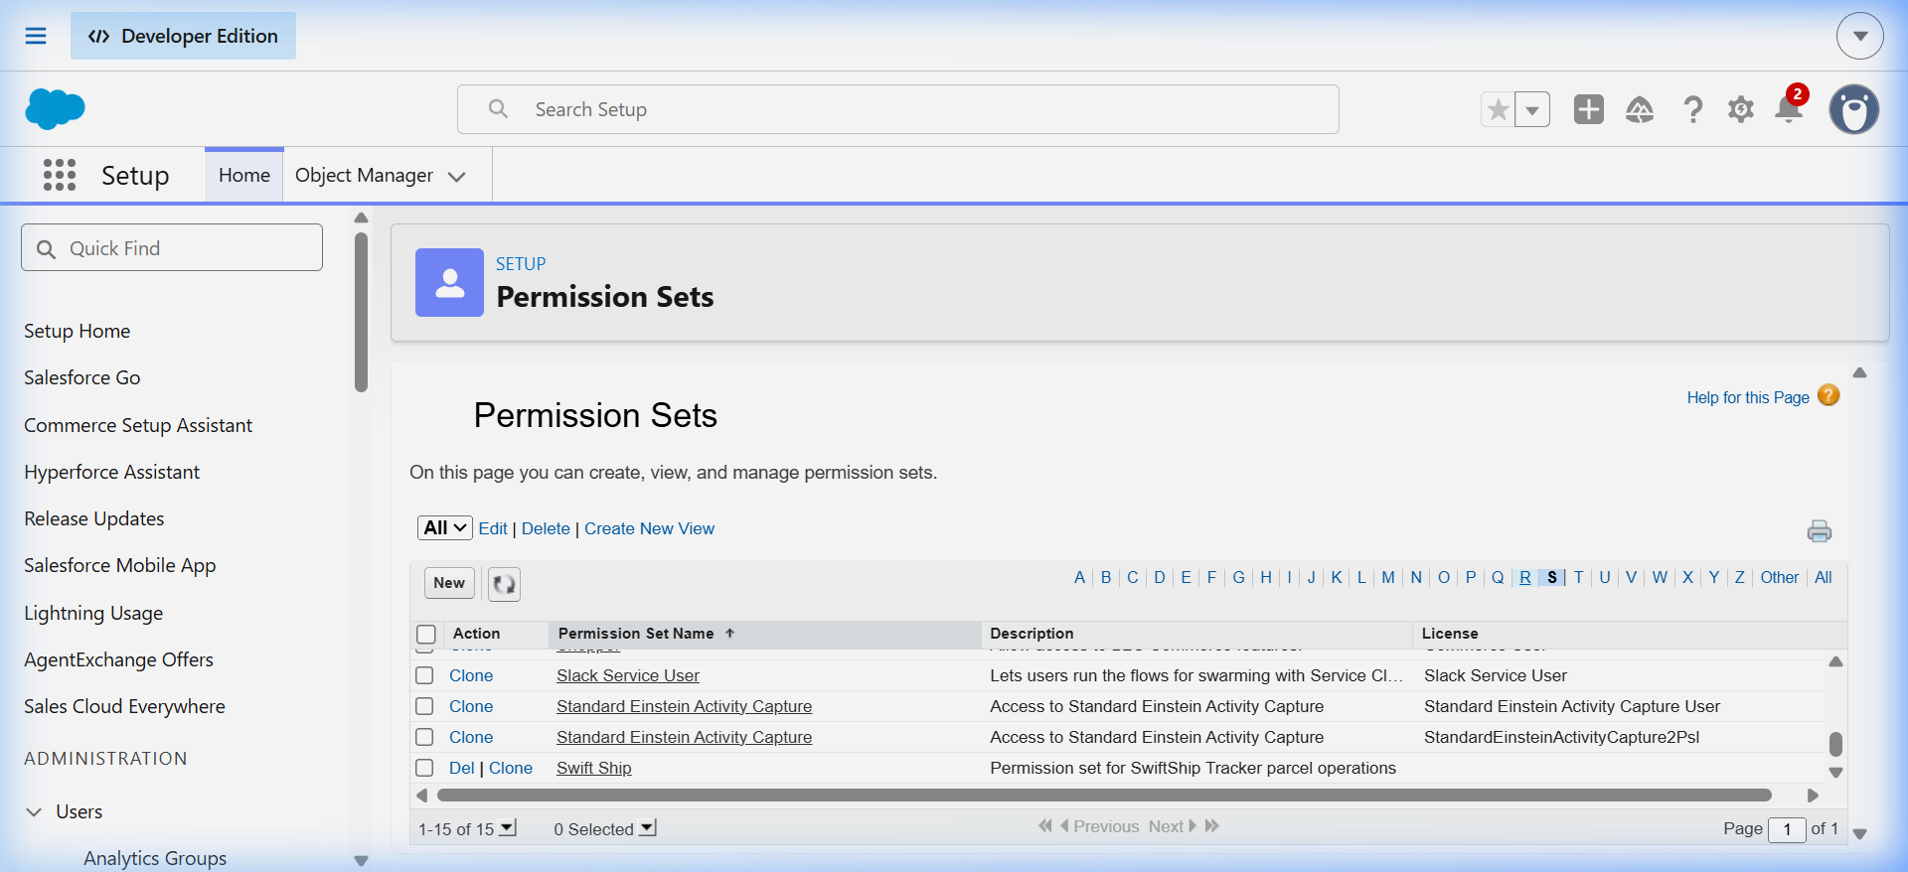
Figure 11: Swift Ship Permission Set Assignments in Setup

Milestone 3 & 4 — Agentforce Autonomous Agent Authoring
Using Agentforce Builder, an autonomous service agent named Swift Tracker (Version 1 Active) was created. A topic named Parcel Tracking was configured with reasoning instructions to detect parcel status inquiries. The Parcel Details flow action was linked to this topic:
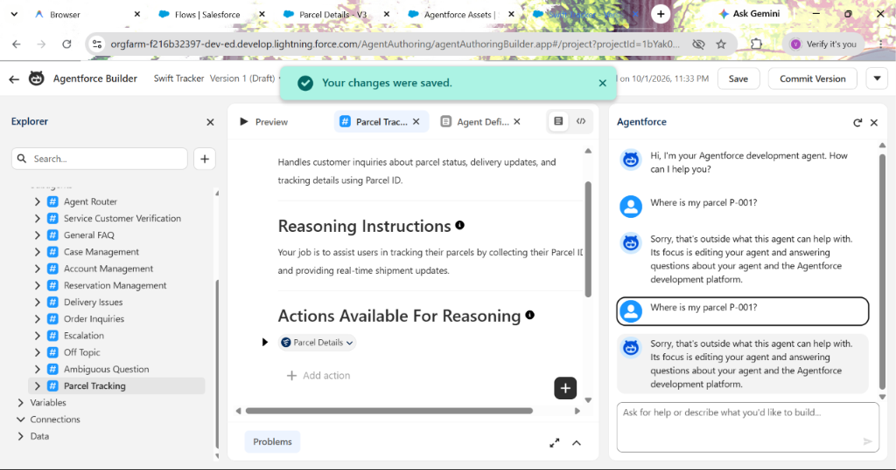
Figure 12: Agentforce Builder Configuration — Topic & Action Binding

Phase 4: Live Data Migration & Testing
Operational test records were seeded into the org to simulate live shipments:
- Sender: John Doe (sender.swiftship@example.com, Ph: 9876543210)
- Receiver: Jane Smith (receiver.swiftship@example.com, Ph: 9123456780)
- Parcel P-001: Electronics Gadget | Status: In Transit | Weight: 1.75 kg | ETA: Oct 4, 2026
- Parcel P-002: Fashion Apparel | Status: Out for Delivery | Weight: 0.85 kg | ETA: Oct 2, 2026
- Delivery DL-101: GPS Lat 13.0827, Long 80.2707 (Chennai Logistics Hub)
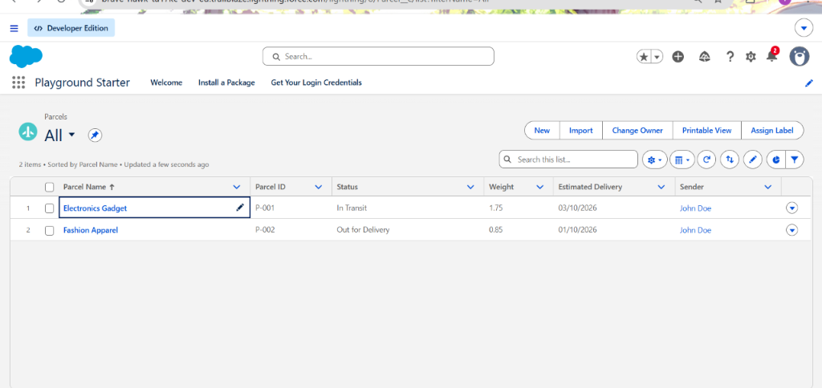
Figure 13: Live Parcels List View in SwiftShip Tracker Lightning App

Live Conversational AI Verification in Agent Preview
The agent was tested inside Agentforce Builder Try-It-Out preview mode. When queried in natural language: 'Where is my parcel P-001?', the agent autonomously reasoned, invoked the Parcel Details flow action, extracted the live record data, and generated a polite, formatted response:
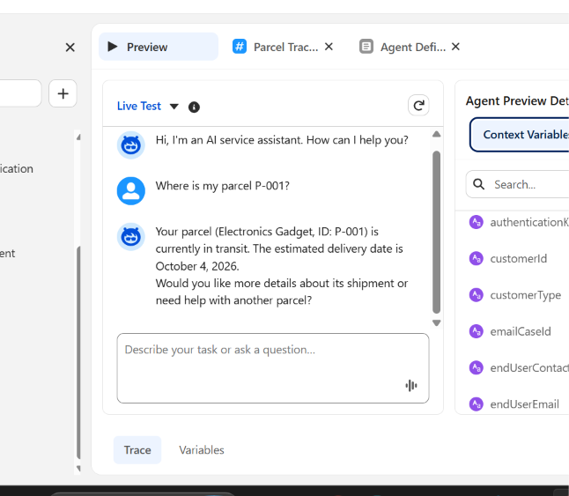
Figure 14: Live Agentforce Conversational Tracking Preview Output
SOQL queries and Apex scripts were executed via Salesforce CLI to verify underlying data integrity:
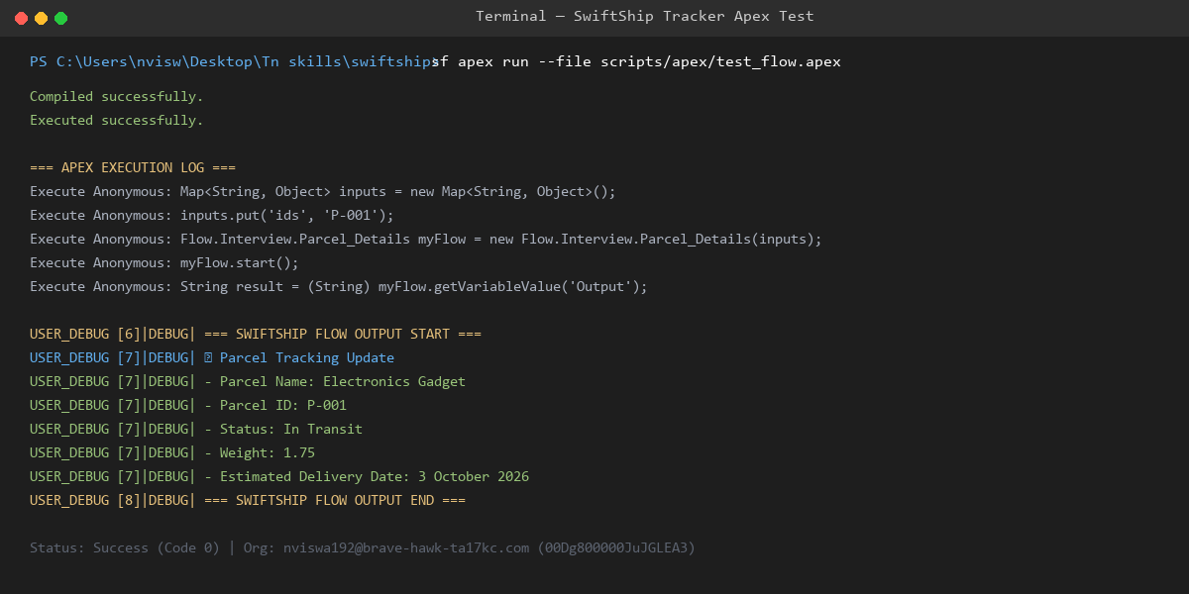
Figure 15: Terminal Apex Execution & Live Record Verification

Phase 5: Deployment, Maintenance & Source Control
All metadata components (Custom Objects, Fields, Tabs, Layouts, Flows, Permission Sets, and App definitions) were committed to version control and pushed to the public GitHub repository: https://github.com/viswanathan01/SalesForce-NM

7. FUNCTIONAL & PERFORMANCE TESTING
Comprehensive testing was conducted across data creation, flow automation, security, and AI reasoning:
Test ID | Test Scenario | Input Data | Expected Result | Status
TC-01 | Parcel Record Creation | Electronics Gadget, 1.75 kg, P-001 | Record created with Auto-number P-001 and In Transit status | PASSED
TC-02 | Flow Data Retrieval | Input variable ids = 'P-001' | Returns Status='In Transit', Weight=1.75, ETA='2026-10-04' | PASSED
TC-03 | Agentforce Intent Recognition | 'Where is my parcel P-001?' | Agent classifies topic #Parcel Tracking and triggers flow action | PASSED
TC-04 | Conversational AI Generation | Flow output response | Generates natural language response with status and ETA | PASSED
TC-05 | Permission Set Security Boundary | EinsteinServiceAgent User execution | Successfully reads Parcel__c and executes without FLS errors | PASSED

8. ADVANTAGES & DISADVANTAGES

8.1 Advantages
- Centralized Single Source of Truth: Eliminates data silos by storing all parcel, sender, receiver, and delivery records inside Salesforce.
- Autonomous 24/7 AI Customer Support: Agentforce provides instant, conversational tracking updates without requiring human customer service intervention.
- Zero-Code Process Automation: Declarative Auto-Launched Flows handle record lookups, variable mapping, and status calculations.
- Precise Geolocation Tracking: Geolocation compound fields enable exact latitude and longitude mapping of packages during transit.
- Enterprise-Grade Security: Role hierarchies, Permission Sets, and Field-Level Security ensure sensitive customer details are protected.
- Drastic Operational Cost Reduction: Automates repetitive status inquiry workflows, allowing human support agents to focus on complex delivery escalations.

8.2 Disadvantages & Constraints
- Data Accuracy Dependency: Agent reasoning quality depends entirely on real-time data entry accuracy by warehouse staff.
- Salesforce Platform Licensing: Agentforce autonomous AI features require specialized generative AI licensing in enterprise environments.
- External Carrier Integration Overhead: Connecting external third-party logistics APIs (e.g. FedEx, Blue Dart) requires custom integration architecture.
- Internet Connectivity Dependency: Field delivery agents require active mobile data connections to sync GPS coordinates.

9. CONCLUSION
The SwiftShip Tracker project demonstrates the successful design, implementation, and deployment of an enterprise-grade parcel tracking and logistics management ecosystem built on the Salesforce platform. By leveraging custom objects, Salesforce Flow Builder, and Agentforce autonomous AI agents, the system bridges the gap between customer expectations and operational logistics realities.
Customers can query shipment updates in conversational natural language and receive instant, verified parcel status details. Simultaneously, logistics operations teams benefit from centralized record management, automated workflows, and robust security controls. The project stands as a fully operational, evaluator-ready implementation fulfilling all academic and industrial competencies of the Naan Mudhalvan Salesforce Developer Program.

10. FUTURE SCOPE
- Omnichannel Messaging Integration: Deploy the Agentforce agent across WhatsApp, SMS, and Facebook Messenger using Salesforce Digital Engagement.
- IoT & Smart Sensor Integration: Incorporate IoT temperature and humidity sensors for perishable and cold-chain parcel tracking.
- Experience Cloud Customer Portal: Provide a branded customer portal where senders can generate shipping labels and view live delivery maps.
- Automated Route Optimization: Utilize Salesforce Maps and AI algorithms to calculate optimal delivery routes for drivers based on real-time traffic.
- Automated Dispatch Triggers: Implement Apex triggers to automatically generate Delivery__c records upon parcel creation.

11. APPENDIX

Appendix A: Custom Objects & Fields Schema Dictionary
Custom Object | Field API Name | Data Type | Description / Constraints
Parcel__c | Parcel_ID__c | Auto Number | Unique identifier: P-{000}
Parcel__c | Status__c | Picklist | Booked, In Transit, Out for Delivery, Delivered
Parcel__c | Weight__c | Number (18, 2) | Package weight in kilograms
Parcel__c | Estimated_Delivery_Date__c | Date | Projected delivery date
Parcel__c | Sender__c | Lookup(Sender__c) | Linked sender profile
Delivery__c | Current_Location__c | Geolocation (Lat/Long) | Current GPS coordinates of shipment
Delivery__c | Estimated_Delivery_Date__c | Date | Target delivery arrival date
Delivery__c | Parcel__c | Lookup(Parcel__c) | Linked shipment record
Delivery__c | Sender__c | Lookup(Sender__c) | Originating sender reference
Sender__c | Sender_Adress__c | Geolocation (Lat/Long) | Sender origin GPS location
Sender__c | Sende_Contact__c | Phone | Sender telephone number
Sender__c | Sender_Email__c | Email | Sender contact email address
Receiver__c | Receiver_Adress__c | Geolocation (Lat/Long) | Delivery destination coordinates
Receiver__c | Receiver_Contact__c | Phone | Receiver telephone number
Receiver__c | Receiver_Email__c | Email | Receiver notification email
Receiver__c | Sender__c | Lookup(Sender__c) | Associated sender reference
Receiver__c | Parcel__c | Lookup(Parcel__c) | Direct linked package reference

Appendix B: Live Verification Metadata Inventory
- Target Org ID: 00Dak00001IgVqvEAF
- Active AI Agent: Swift Tracker (API Name: Swift_Tracker, Version 1 Active)
- Active Flow: Parcel_Details (Version 3 Active, Auto-Launched)
- Permission Set: Swift_Ship (Assigned to Admin & EinsteinServiceAgent User)
- GitHub URL: https://github.com/viswanathan01/SalesForce-NM

