GROUP ACTIVITY
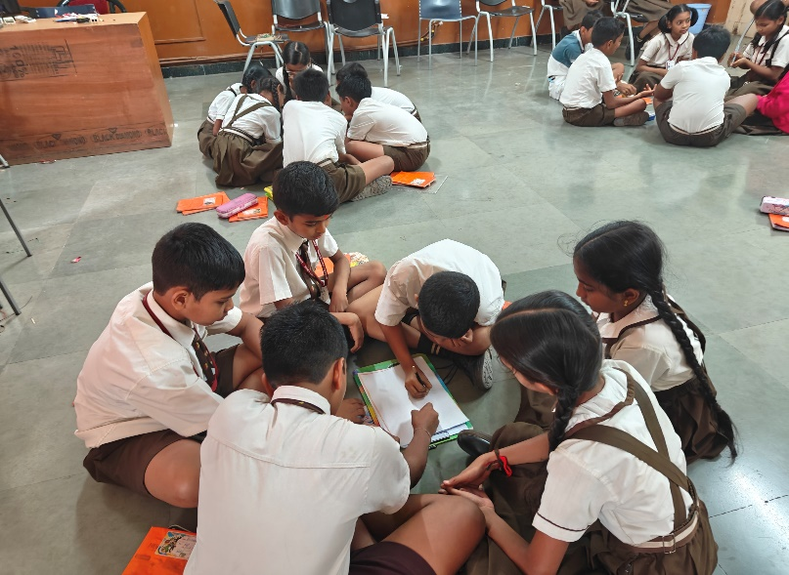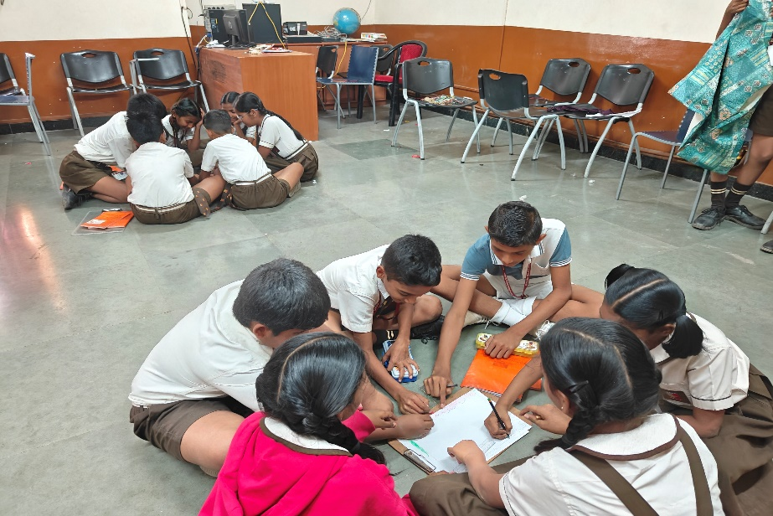

During group activity, diverse learner needs were addressed by dividing students into heterogeneous groups consisting of mixed abilities, varied language backgrounds, and different learning paces. During the discussion on the key learnings of the story, students supported and guided one another, promoting peer learning and collaborative understanding. The activity of creating a graphic organizer allowed students to express their understanding in different ways—through drawing, keywords, or short sentences—according to their ability level. The teacher facilitated the process by monitoring groups, providing additional support where needed, and ensuring equal participation of all learners.

