**Job Portal**

CA2 Open Source Technology

Karri Viswa Sai Teja Reddy

11609704

RKE007A21

Submitted to Ms.Richa Sharma

Job portal website is designed by PHP and MySql database.

In this file, the screen shots of the website will be shared and output of the project will be in the screen shots

There is no need for any user and password.

The job portal only you can use to search jobs by the bases of your skills and languages like c, python, java etc.

In the backend there will be only a table with the data of job suitable skills.

All the files and data base is shared in the folder.

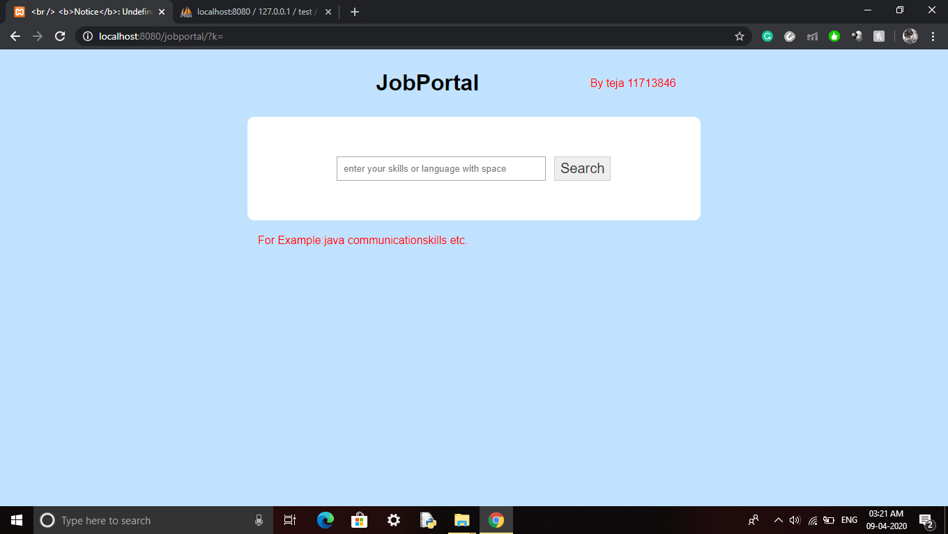

First page with a search engine .

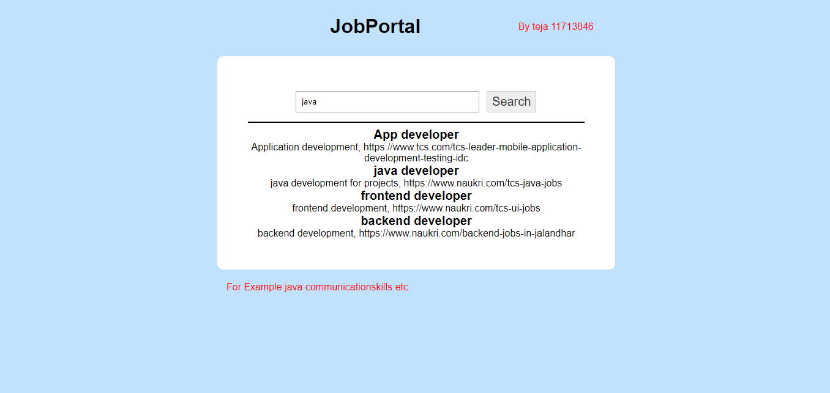

This screenshot is having a output of skill = java in the search engine

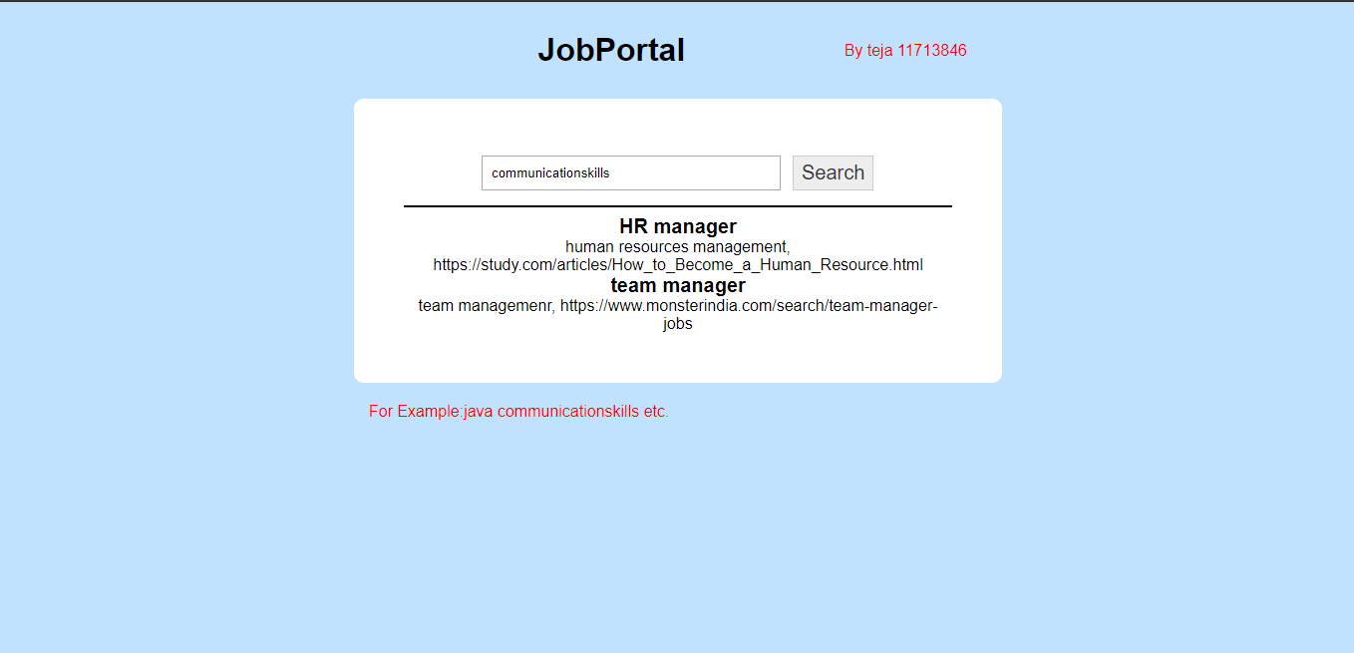

This screenshot is having a output of skill communication skill in the search engine