select sum(total_price) as Total_Revenue from pizza_sales



select (sum(total_price)/count(distinct(order_id))) as Average_Order_Value from pizza_sales



select sum(quantity) as Total_Pizzas_Sold from pizza_sales



select count(distinct(order_id)) as Total_Orders from pizza_sales



select (sum(quantity)/count(distinct(order_id))) as Average_Pizzas_per_order from pizza_sales



select datepart(hour,order_time) as order_hour,sum(quantity) as total_pizzas from pizza_sales

group by datepart(hour,order_time)

order by datepart(hour,order_time)

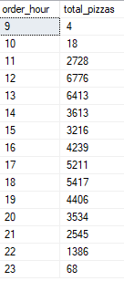

select datepart(iso_week,order_date) as order_week,year(order_date)as order_year,count(distinct(order_id)) as total_orders from pizza_sales

group by datepart(iso_week,order_date),year(order_date)

order by datepart(iso_week,order_date),year(order_date)

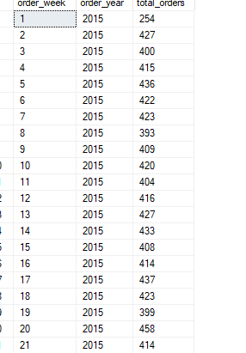

select pizza_category,sum(total_price) as total_revenue,(sum(total_price)*100/(select sum(total_price) from pizza_sales)) as PCT from pizza_sales

group by pizza_category

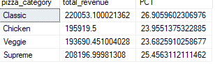

select pizza_size,sum(total_price) as total_revenue,(sum(total_price)*100/(select sum(total_price) from pizza_sales)) as PCT from pizza_sales

group by pizza_size

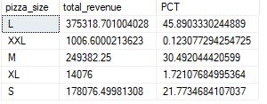

select pizza_category,sum(quantity) as total_pizzas_sold from pizza_sales

group by pizza_category

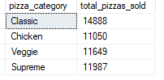

select Top 5 pizza_name,sum(total_price) as Total_Revenue from pizza_sales

group by pizza_name

order by Total_Revenue desc

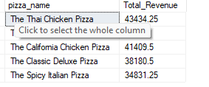

select Top 5 pizza_name,sum(quantity) as Total_Pizzas_Sold from pizza_sales

group by pizza_name

order by Total_Pizzas_Sold desc

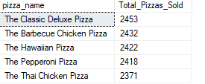

select Top 5 pizza_name,count(distinct(order_id)) as Total_Orders from pizza_sales

group by pizza_name

order by Total_Orders desc

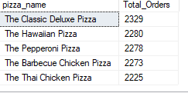

select Top 5 pizza_name,sum(total_price) as Total_Revenue from pizza_sales

group by pizza_name

order by Total_Revenue asc

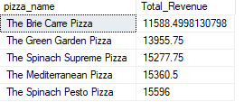

select Top 5 pizza_name,sum(quantity) as Total_Pizzas_Sold from pizza_sales

group by pizza_name

order by Total_Pizzas_Sold asc

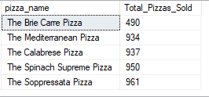

select Top 5 pizza_name,count(distinct(order_id)) as Total_Orders from pizza_sales

group by pizza_name

order by Total_Orders asc

