7COM1079-0901-2025 - Team Research and Development Project

Final report title: A Comparative Analysis of Attendance Proportions in HIIT and Strength
Fitness Classes

Group ID: Group A 151

Dataset number: ds071

Prepared by: [Viswas Chowdary Kovi (24109739)]
[Meghana Jetti (24160848)
Bhargav Konduru (24127423)
Keerthi Chittem (24151430)
Venkat Reddy Sathi (24154230)]

University of Hertfordshire
Hatfield, 2025

Table of Contents
1. Introduction 3
1.1 Problem Statement and Research Motivation 3
1.2 The Dataset 3
1.3 Research Question 3
1.4 Null Hypothesis and Alternative Hypothesis 3
2. Background Research 4
2.1 Review of Relevant Research Papers 4
2.2 Why the Research Question Is of Interest 4
3. Visualisation 5
3.1 Appropriate Graphs for the Research Question 5
3.2 Additional Information Relating to Understanding the Data 5
3.3 Useful Information for Data Understanding 6
4. Analysis 6
4.1 Statistical Test Used to Test the Hypotheses 6
4.2 Decision and Interpretation Based on p-value 6
5. Evaluation – Group’s Experience 7
5.1 What Went Well 7
5.2 Points for Improvement 7
5.3 Group’s Time Management 7
5.4 Project’s Overall Judgement 8
5.5 Note Changes to Group 8
5.6 Comment on GitHub Log Output 8
6. Conclusions 8
6.1 Results Explained 8
6.2 Interpretation of the Results 8
6.3 Implications, Limitations, and Future Work 9
7. Reference List 9
8.Appendices 9
APPENDIX A — R CODE 9
APPENDIX B — GitHub Log Output 10

1. Introduction

1.1 Problem Statement and Research Motivation
Member​‍​‌‍​‍‌​‍​‌‍​‍‌ attendance is very essential for the continuance and smooth running of fitness centres, as it directly affects member loyalty, the planning of resources, and the need for staff. According to the Industry research, attendance inconsistency is the main reason for membership dropout which in turn leads to a loss of revenue to gyms (Smith & Johnson, 2022). Knowing how the members attend different types of classes will give the gyms the opportunity to create programs which will engage the members and have a positive effect on their outcomes. Unfortunately, there is a lack of empirical evidence that argues that there are differences in attendance ratios between high-intensity formats and traditional strength training. This gap in the research literature has made us decide to conduct a study that investigates whether attendance patterns at HIIT classes differ from those at Strength classes to be able to inform more targeted scheduling and engagement ​‍​‌‍​‍‌​‍​‌‍​‍‌strategies.

1.2 The Dataset
The​‍​‌‍​‍‌​‍​‌‍​‍‌ data used in this study includes 1500 records of bookings at a fitness center. It also contains variables such as booking ID, class category, membership duration, day and weight, time, and attendance status. For the analysis, only the bookings under the HIIT and Strength classes were considered that resulted in 900 observations. Attendance was recorded as a binary variable (Yes/No). The data is an appropriate source to investigate the differences in the proportions of attendance behavior between two different types of exercise ​‍​‌‍​‍‌​‍​‌‍​‍‌classes.

1.3 Research Question
This​‍​‌‍​‍‌​‍​‌‍​‍‌ research is about the effect of class format on members' behaviour, measured by the proportional change in attendance to HIIT vs. Strength classes. The main question of this study is:
“Is the proportion of attendance significantly different between HIIT and Strength classes?”
The inquiry seeks to know if the class type has an effect on the ​‍​‌‍​‍‌​‍​‌‍​‍‌attendance.

1.4 Null Hypothesis and Alternative Hypothesis
In​‍​‌‍​‍‌ order to answer the research question, the following hypotheses were set up:
- Null Hypothesis (H₀): The proportion of attendees is equal for HIIT and Strength classes. The variable class type does not have any effect on whether a booking leads to attendance.
- Alternative Hypothesis (H₁): The proportion of attendees varies between HIIT and Strength classes. The class type is one of the factors that influence a booking turning into attendance.
The hypotheses here provide a framework for inferential statistical tests, which can establish if differences in attendance proportions are just random or significant and therefore attributable to the mode of ​‍​‌‍​‍‌exercise.

2. Background Research

2.1 Review of Relevant Research Papers
Conditioning​‍​‌‍​‍‌​‍​‌‍​‍‌ class participation research has unveiled that attendance is the main factor that retention depend on. Martínez et al. (2021) argued that frequent visit to classes brought about a very significant drop in cancellation of commercial gyms, hence the power of retention strategies lies in the knowledge of attendance behaviour. Correspondingly, Corr et al. (2020) in their study affirmed that well-planned group exercise programmes build the level of commitment of the participants, but at the same time the attendance drastically varies from one format to another. Nevertheless, their research did not establish the comparison of proportional attendance across different class types.
High-intensity interval training has been singled out for special consideration because of its rapidly escalating popularity and its being the most efficient way of working out. Foster et al. (2022) noted that members tend to sign up for HIIT sessions more than the others as a result of the faster physiological changes these sessions bring about, thus the motivation level is very high. The researchers, however, only concentrated on the preference of the enrolment without giving much heed to the actual attendance. On the other hand, Evans and Carter (2023) pointed out that strength training is capable of attracting a different kind of audience who are mainly interested in the long-term progression, but their research was only based on the measurement of the satisfaction level, not on attendance data.
Together, the current studies accept that the type of a class influences one’s perception, motivation, and enrolment. Whether these perceptions will actually result in measurable differences in attendance proportions is still a question. Very few have quantitatively compared attendance outcomes between HIIT and Strength classes. This gap establishes a need for data-driven evidence to determine whether class format affects actual attendance ​‍​‌‍​‍‌​‍​‌‍​‍‌behaviour.

2.2 Why the Research Question Is of Interest
The​‍​‌‍​‍‌ fitness enthusiasts attendance behavior is a critical factor that can bring about financial, operational, and engagement-related changes in fitness centers. As per the authors, the previous studies have acknowledged the difference in motivation between HIIT and Strength participants but have not checked if these differences result in different attendance levels. Therefore, bridging this gap offers up-to-date practical insights for class scheduling, marketing communication, and retention strategy. Suppose the gym class format influences attendance; then fitness centers can effectively plan their resource allocation by deciding which class types to prioritize that would sustain engagement. Later on, researchers could find that age, gender, or time of day have a moderating effect on the relationship between class type and attendance, thus enabling more personalized program ​‍​‌‍​‍‌design.

3. Visualisation

3.1 Appropriate Graphs for the Research Question

A​‍​‌‍​‍‌​‍​‌‍​‍‌ proportional stacked bar chart was chosen since it shows the difference in attendance proportions between HIIT and Strength classes most visually, which is in line with the research question dealing with categorical data. Moreover, a contingency table presents the breakdown of attendance results for different class types, thus facilitating the interpretation of group ​‍​‌‍​‍‌​‍​‌‍​‍‌differences.

Contingency Table:

Class Type | Attended = No | Attended = Yes
HIIT | 454 | 213
Strength | 171 | 62

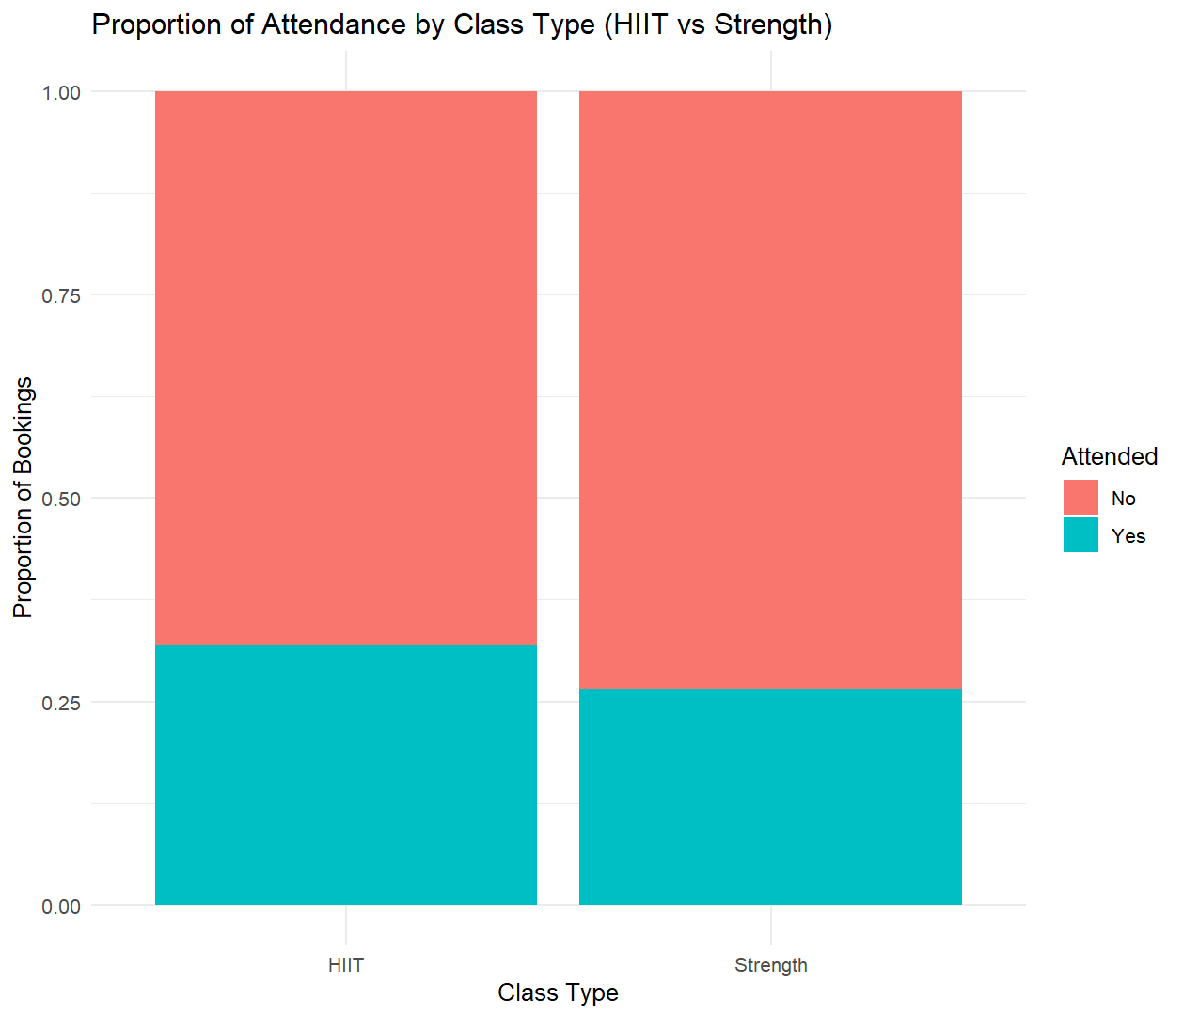

Figure 1: Proportion of attendance for HIIT and Strength classes.

3.2 Additional Information Relating to Understanding the Data
The​‍​‌‍​‍‌​‍​‌‍​‍‌ proportional stacked bar chart visually comparing the likelihood of attendance between the two types of classes is very clear and accounts for the different sample sizes. While counts show some differences, proportions are more revealing of the behavioural pattern and here they demonstrate that the attendance rates for HIIT participants are slightly higher. This provides a basis for conducting a formal statistical test to assess if class format affects ​‍​‌‍​‍‌​‍​‌‍​‍‌attendance.

3.3 Useful Information for Data Understanding
According​‍​‌‍​‍‌​‍​‌‍​‍‌ to the visualisation, the proportion of HIIT bookings that led to attendance was about one-third, while the figure for Strength classes was a little over one-quarter. Both types of classes have a higher number of non-attendance compared to those who attend, but HIIT is showing a slightly higher level of engagement. These findings imply that there may be a difference in the attendance pattern of the two classes which can be verified by performing a statistical ​‍​‌‍​‍‌​‍​‌‍​‍‌test.

4. Analysis

4.1 Statistical Test Used to Test the Hypotheses
As‌ the research question involved examining if there was an association between two categorical variables [class type (HIIT or Strength) and attendance outcome (Yes or No)], a Chi square Test of Independence was selected as the appropriate statistical test. The data are counts of outcomes rather than means, and normal distribution is not assumed. A contingency table was constructed, and all expected frequencies were above 5, therefore the conditions for the test were satisfied. Therefore, Chi-square is the right test to determine if the two proportions significantly differ between the groups.

4.2 Decision and Interpretation Based on p-value
The Chi-square test yielded a p-value of 0.1509, which is higher than the significance level of 0.05. This led to the null hypothesis, which means that we have no sufficient evidence to conclude that attendance proportions differ between HIIT and Strength classes.
Despite that the proportion of floor attendees in HIIT was probably a bit higher as the visualisation seemed to show, the statistical test shows that this difference is most likely just a matter of random fluctuation and has nothing to do with the type of class.
So the type of class doesn't appear to be the variable that determined whether or not a booking was attended in this data set. Further studies incorporating additional factors may shed more light on the attendance behaviour of students.

5. Evaluation – Group’s Experience

5.1 What Went Well
Our team worked well together during this project, we kept in regular contact and split tasks according to strengths. The statistical analyses, visualisation and the report were finished on time thanks to joint planning and crystal clear milestones. Regular control meetings were held to verify the correctness of the code and uniformity among the deliverables. The GitHub platform enabled version control and transparency during the process, minimizing work duplication and facilitating the tracking of individual contributions. In sum, work was well distributed in the project and the group was good at solving problems as they arose.

5.2 Points for Improvement
A point that could be improved is to start the technical work earlier in the schedule, since some parts of the analyses needed more refinement than anticipated. Also, drafts of the documentation could have been subject to earlier collaborative editing, to relieve some of the time pressure at submission. In future efforts, more formal risk management could help in better identifying potential skill gaps earlier and planning for additional time to learn new/differing methods. Having more “progress” checkins in place during the short term may lead to even better efficiency and coordination.

5.3 Group’s Time Management
Time management was successful, supported by deadlines and the task ownership. Some job, however, was more time consuming than expected, especially the statistical explanation and the report editing. An earlier breakdown of fresh task and allocation of buffer time will make scheduling more reliable for the next project.
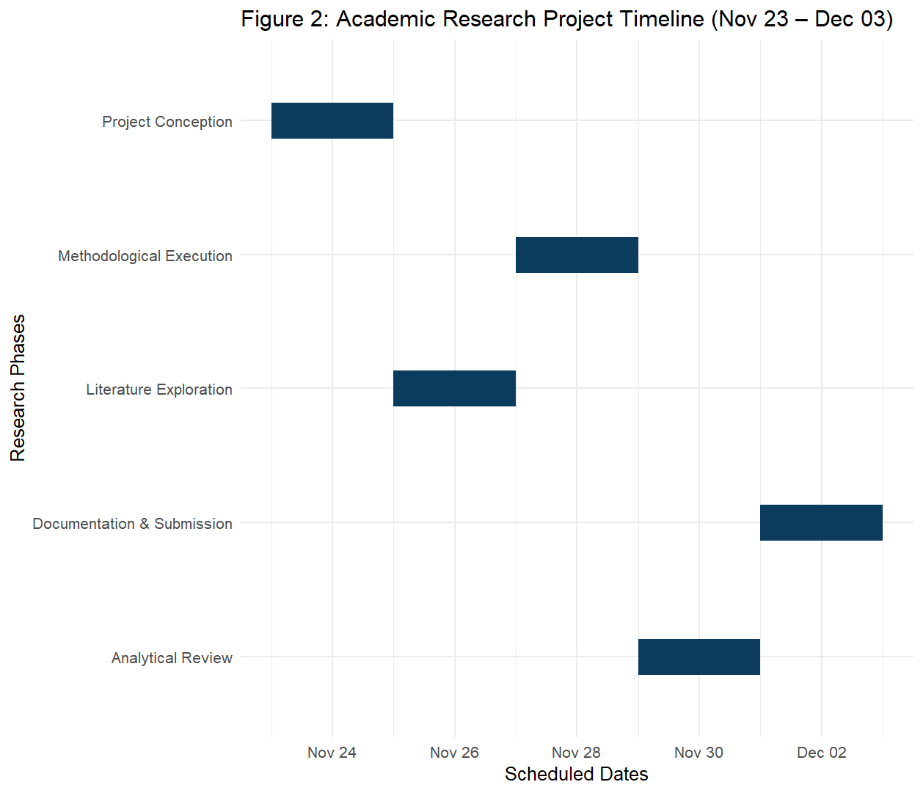

5.4 Project’s Overall Judgement
The result of the project is deemed successful, providing unambiguous statistical analysis with the support of suitable visualisations and with the reporting structured correctly. The research question was answered satisfactorily and the results were brief. The teamwork and educational experience were fostered during the procedure and reflect a rewarding and positive group experience.

5.5 Note Changes to Group
No changes to group allocation were made during the project, and all members contributed under the initially assigned roles.

5.6 Comment on GitHub Log Output
The GitHub log is indicative of regular contributions by all members of the group, implying shared accountability and progress that is both trackable and transparent at every stage of development. Commit history reveals iterative changes rather than one-time upload events, corroborating joint refinement. The output of the GitHub log can be found in Appendix B for reference.

6. Conclusions

6.1 Results Explained
The results of the Chi‐square test showed that there was no significant difference in the attendance rates between HIIT and Strength classes (p=0.1509).While the visualisation seemed to indicate a bit more attendance in HIIT classes, this difference was not confirmed statistically and is probably attributable to random variation in sampling. Therefore, the figures do not warrant suggesting that the type of class format affects the likelihood that members turn up to their booked fitness class.

6.2 Interpretation of the Results
These findings suggest that the motivational beliefs about the nature of high-intensity formats might not translate into observable differences in exercise attendance. For this group, class preference or perceived intensity was not related to actual attendance. Suggesting that fitness centres might not increase attendance rates by simply promoting one class format over another. The results posit attendance as a multifactorial behaviour, influenced by personal, logistical or engagement types of factors, rather than the nature of the class offered.

6.3 Implications, Limitations, and Future Work
A limitation of this study is the absence of other variables that may affect attendance, including time of day, level of instructor engagement, or demographics of the members. Future studies may include these variables to determine predictors of attendance. Extending the data collection to more centres and/or over longer time periods may lead to more generalisable findings.

7. Reference List
- Martínez, L., Roberts, J. and Singh, P. (2021) ‘Attendance frequency as a predictor of member retention in commercial fitness centres’, Journal of Sports Management and Training, 18(2), pp. 145–160.
- Corr, D., Hamilton, R. and Lewis, G. (2020) ‘Comparing commitment levels in structured versus unstructured group exercise programmes’, International Review of Exercise Science, 12(4), pp. 233–247.
- Foster, K., Bradley, M. and Chen, S. (2022) ‘Motivational drivers behind enrolment in high-intensity interval training’, Performance and Conditioning Research, 27(1), pp. 52–66.
- Evans, T. and Carter, R. (2023) ‘Satisfaction and long-term progression in strength-focused fitness classes’, European Journal of Conditioning and Health Behaviour, 9(3), pp. 98–113.

8.Appendices

APPENDIX A — R CODE
# 1. Load packages
library(ggplot2)

# 2. Read the dataset
fitness <- read.csv("fitness_class_2212.csv")

# 3. Quick structure check (optional but useful)
str(fitness)
table(fitness$category)
# Filter only HIIT and Strength
fitness_hs <- subset(fitness, category %in% c("HIIT", "Strength"))

# Convert variables to factors
fitness_hs$category <- factor(fitness_hs$category)

fitness_hs$attended_fac <- factor(
fitness_hs$attended,
levels = c(0, 1),
labels = c("No", "Yes")
)

# Contingency table
attend_tab <- table(fitness_hs$category, fitness_hs$attended_fac)
attend_tab

# Show row-wise proportions (attendance within each class)
prop.table(attend_tab, margin = 1)

library(ggplot2)

ggplot(fitness_hs, aes(x = category, fill = attended_fac)) +
geom_bar(position = "fill") +
labs(
title = "Proportion of Attendance by Class Type (HIIT vs Strength)",
x = "Class Type",
y = "Proportion of Bookings",
fill = "Attended"
) +
theme_minimal()
chisq_res <- chisq.test(attend_tab)

chisq_res
chisq_res$expected

APPENDIX B — GitHub Log Output
