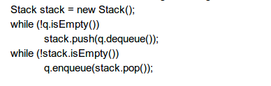

Stack stack = new Stack();

It creates a new stack object

While (!q.isEmpty()) checks if ques is empty or not . If q is not empty the loop iterates and pushes the first element of q into the stack.

While(!stack.isEmpty()) checks if stack is empty or not. If stack is not empty the loop iterates and pushes the last element of stack into q.

The overall theme of program is reversing a stack.