Viswatara Kalamsetty, 210905170, LAB-2, DS LAB, Roll no 29

import pandas as pd
import numpy as np
s=pd.Series([3,9,-2,10,5])
print(s.sum())
print(s.min())
print(s.max())

data = [['Dinesh',10],['Nithya',12],['Raji',13]]
df = pd.DataFrame(data,columns=['Name','Age'])
print(df)

data = {'Name':['Kavitha', 'Sudha', 'Raju','Vignesh'],'Age':[28,34,29,42]}
df = pd.DataFrame(data, index=['rank1','rank2','rank3','rank4'])
print(df)

df1=pd.DataFrame({'A':pd.Timestamp('20130102'),'B':np.array([3]*4,dtype='int32'),
'C':pd.Categorical(['Male','Female','Male','Female'])})
print(df1)
print(df1.shape)
print(df1.dtypes)
print(df1.head())
print(df1.tail())
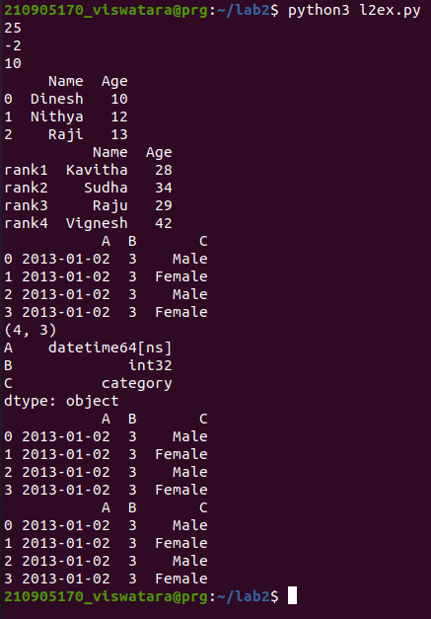

import numpy as np
import pandas as pd
dates=pd.date_range('20130101', periods=10)
df = pd.DataFrame(np.random.randn(10,4), index=dates, columns=list('ABCD'))
print(df.head())
print(df.tail())
print(df.index)
print(df.columns)
print(df.T)
print(df.sort_index(axis=1, ascending=False))
print(df.sort_values(by='B'))
print(df[0:3])
print(df['20130105':'20130110'])
print(df.iloc[0])
print(df.iloc[0,:2])
print(df.iloc[0,0])
print(df['A'])
print(df[['A','B']])
print(df[['A','B']][:5])
print(df.loc['20130101':'20130105',['A','B']][:5])
print(df[df.A>0])

df.loc[:,'D']=np.array([5]*len(df))
print(df)
df[‘F’]=[‘Male’,’Female’,’Female’,’Male’,’Female’,’Female’]
print(df)
df.loc[:,’D’]=np.array([5]*len(df))
print(df)
df.drop (‘col_name’, axis =1, inplace=True)
print(df)
df.drop (‘row_index’, axis =0, inplace=True)
print(df)
Df_new= pd.concat (df1, df2, axis=1)
print(Df_new.shape)

