Viswatara Kalamsetty, 210905170 DSL, Roll no 29, LAB-3

import numpy as np
A = np.array ([2,5,10])
print(A.dtype)
import numpy as np
B=np.array ([2.4,10.6,5.2])
print(B.dtype)
import numpy as np
A=np.array([(3,4,5),(12,6,1)])
Z=np.zeros((2,4))
C=np.ones((3,3))
print(A)
print(Z)
print(C)
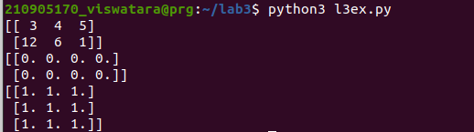
import numpy as np
S=np.arange(10,30,5)
print(S)
Z=np.arange( 0, 2, 0.3 )
print(Z)
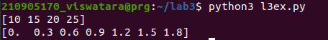

import numpy as np
S=np.linspace(0,2,9)
print(S)

import random
print(random.choice([1,2,3,4,5]))
print(random.choice('python'))
print(random.randrange(25,50))
print(random.randrange(25,50,2))
print(random.random())
print(random.uniform(5,10))
print(random.shuffle([1,2,3,4,5]))
print(random.seed(10))
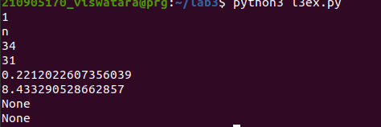

import numpy as np
a = np.arange(15).reshape(3, 5)
print(a)
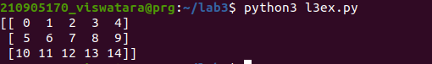
import numpy as np
a = np.arange(15).reshape(3, 5)
print(a.shape)
print(a.size)
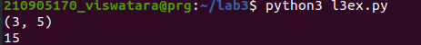

import numpy as np
a = np.arange(15).reshape(3, 5)
print(a.T)
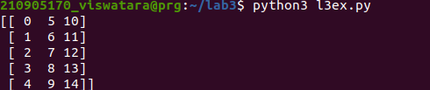

import numpy as np
c = np.arange(24).reshape(2,3,4)
print(c)
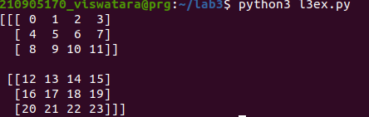

import numpy as np
c = np.arange(24).reshape(2,3,4)
print(c)
print(c.shape)
print(c[1,...])
print(c[1,:,:])
print(c[...,2])
print(c[:,:,2])
a = np.array( [20,30,40,50] )
b = np.arange( 4 )
print(b)
c = a-b
print(c)
print(b**2)
print(10*np.sin(a))
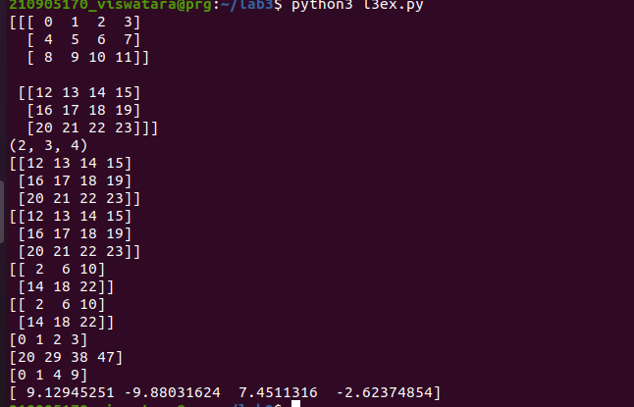
import numpy as np
a = np.array( [20,30,40,50] )
print(a<35)

import numpy as np
A = np.array( [[1,1],[0,1]] )
B = np.array( [[2,0],[3,4]] )
print(A*B)
print(A.dot(B))
print(np.dot(A, B))
b = np.arange(12).reshape(3,4)
print(b)
print(b.sum(axis=0))
print(b.sum(axis=1))

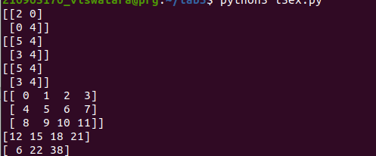
import numpy as np
a = np.arange(10)**3
print(a)
print(a[2:5])
print(a[0:6:2])
b=np.array([[ 0, 1, 2, 3],
[10, 11, 12, 13],
[20, 21, 22, 23],
[30, 31, 32, 33],
[40, 41, 42, 43]])
print(b[2,3])
print(b[0:5,1])
print(b[:5,1])
print(b[:,1])
print(b[-1,:])
print(b[:,-1])
for row in b:
print (row)
for element in b.flat:
print (element)
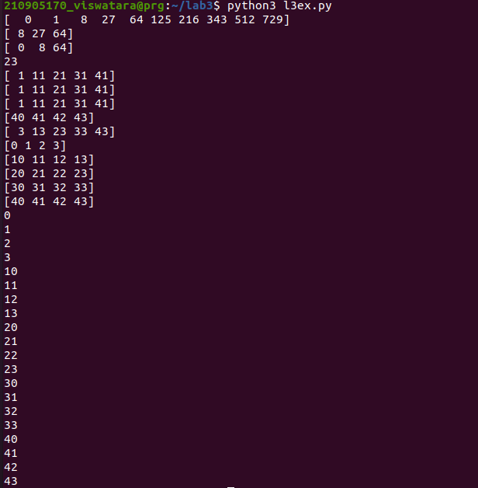

import numpy as np
b=np.array([[ 0, 1, 2, 3],
[10, 11, 12, 13],
[20, 21, 22, 23],
[30, 31, 32, 33],
[40, 41, 42, 43]])
print(b.ravel())
B1=b.reshape(4,5)
print(B1)
A1=np.array([(3,4,5),(12,6,1)])
print(A1)
A2=np.array([(1,2,6),(-4,3,8)])
print(A2)
D1=np.vstack((A1,A2))
print(D1)
D2=np.hstack((A1,A2))
print(D2)
a = np.array([4.,2.])
b = np.array([3.,8.])
print(np.column_stack((a,b)))
print(np.hstack((a,b)))
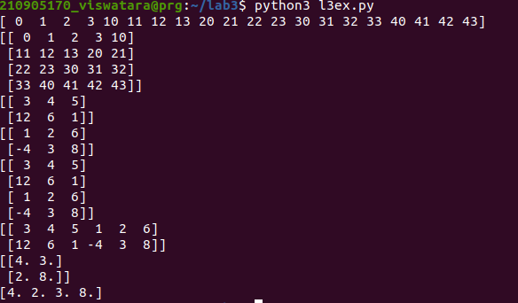
import numpy as np
a = np.arange(12)**2
print(a)
i = np.array( [ 1,1,3,8,5 ] )
print(i)
print(a[i])
j = np.array( [ [ 3, 4], [ 9, 7 ] ] )
print(a[j])

a=np.array([(3,2,9),(1,6,7)])
s1=0
for row in a:
for col in row:
s1+=col
print(s1)

a=np.array([(3,2,9),(1,6,7)])
s=0
for i in range(a.shape[0]):
for j in range(a.shape[1]):
s+=a[i,j]
print(s)

