Assessment of Urban Regreening Areas (AURA)
Greening cooled Bengaluru, but its parks are not where the heat is

1. Introduction
Urban heat is a growing health and liveability concern in Indian cities, and urban greening is one of the main responses in heat action plans. Earlier work in Bengaluru has shown that green spaces are cooler than their surroundings [1], but most such evidence compares different places at one point in time, which cannot separate the effect of vegetation from other differences between places. We instead follow the same places over two decades, test individual parks before and after they were built, and ask whether the city's existing parks are located where surface heat is highest. Three research questions, for Bengaluru (BBMP area, ~710 km²):
- RQ1. Did places that greened between 2000 and 2025 cool relative to their surroundings?
- RQ2. Did individual new parks cool their own sites relative to their neighbourhoods?
- RQ3. Are BBMP parks located in the hotter and more populous wards?

2. Data and methods
Satellite processing in Google Earth Engine [2]; analysis in Python (code and data in the supplementary material). Land surface temperature (LST) and NDVI come from Landsat Collection 2 Level-2 [3], dry season (Jan–Apr), cloud- and shadow-masked median composites. Built-up share is from GHSL GHS-BUILT-S [4].
- RQ1. About 25,000 points sampled across the city at 90 m, compared between 2000–04 (Landsat 5/7) and 2022–26 (Landsat 8/9); water points removed. Temperature change is measured relative to the city median of each period (removing sensor and weather differences) and relative to each point's own 1 km neighbourhood (a local control, as in RQ2). We compare points that greened (NDVI +0.10 or more), stayed stable (within ±0.03) or lost green, and regress temperature change on NDVI change and built-up change (GHSL 2000→2025). Checks: points with little new building only; matching on starting NDVI and starting built-up share; ~2 km blocks; and a rank-based version insensitive to sensor differences in NDVI.
- RQ2. For each of four parks, each Landsat scene (Landsat 5–9) gives the difference between park LST and LST in a 1–2 km ring around it, so weather cancels out. A difference-in-differences regression compares this difference before and after construction, with standard errors clustered by year. JB Kaval Tree Park is excluded: the outline used covers only 2.2 ha of the 84-acre park. Park dates were checked against news and official sources.
- RQ3. The 198 BBMP wards (2009 delimitation) with Census 2011 population and the BBMP Parks Map 2023 (870 unique park locations) from OpenCity [5–7]. Ward LST is the mean of land pixels inside each ward. Wards were drawn to hold similar populations (median ~40,000), so parks per ward is a fair comparison. We compare parks per ward across ward-temperature quarters and fit log(parks + 1) ~ log(population) + log(area) + LST, with checks within wards of similar size and within inner, middle and outer rings of the city.
- Data quality. Satellite population products (GHS-POP 2025, WorldPop 2020) were rejected: both place about 2,000 people/km² in Jayanagar and Koramangala against about 46,000 in the equally built-up Malleshwaram.

3. Results

RQ1: places that greened cooled; places that lost green warmed
Of 24,735 land points, 4,489 greened and 4,029 lost green. Among points with little new building, those that greened cooled by 1.16 °C relative to stable points, measured against their own 1 km neighbourhoods, and those that lost green warmed by 1.66 °C (Fig. 1). Holding building change fixed, each +0.1 NDVI goes with 0.80 °C cooling relative to the neighbourhood (±0.02) and 1.22 °C relative to the city. The result holds when comparing only points that started alike: greened points cooled 1.1–1.5 °C more than stable ones in every band of starting NDVI except the barest, and 0.6–1.4 °C more in every band of starting built-up share, including points already more than half built-up in 2000. It also holds on 2 km blocks (−2.0 ± 0.2 °C per +0.1 NDVI, city-relative) and in rank terms (Spearman −0.35).  A comparison across places at one time agrees: among 500 m squares of equal built-up share, each +10% green cover goes with 0.56 °C lower LST. | 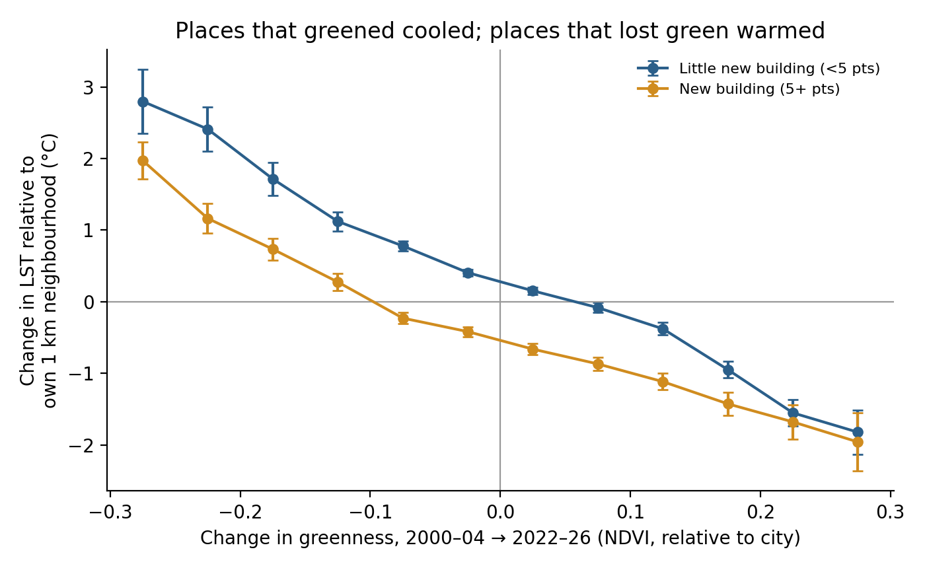  Fig. 1. Change in LST relative to each point's own 1 km neighbourhood vs change in NDVI, 2000–04 to 2022–26 (24,735 points; means with 95% CI per 0.05 NDVI bin), split by new building (GHSL built-up change).

RQ2: a park cooled only where it added green
Freedom Park, built on the former Central Jail (work started 2006, opened November 2008), is the only park whose greenness rose substantially (NDVI +0.138), and the only one that cooled: −1.32 °C relative to its neighbourhood (95% CI −2.66 to +0.01, p = 0.052; Fig. 2a). JP Park (NDVI change 0.000; −0.48 °C, p = 0.75) and Kadugodi Tree Park (+0.024; +0.10 °C, p = 0.63) show no effect. Kadugodi, like JB Kaval, is a tree park set up inside existing forest or plantation land, so it added little vegetation. Applying the city-wide NDVI–LST model to each park's NDVI change predicts −1.36 °C for Freedom Park, close to the measured −1.32 °C (Fig. 2b), and Freedom Park's cooling per unit NDVI (about −1.0 °C per +0.1) matches RQ1.
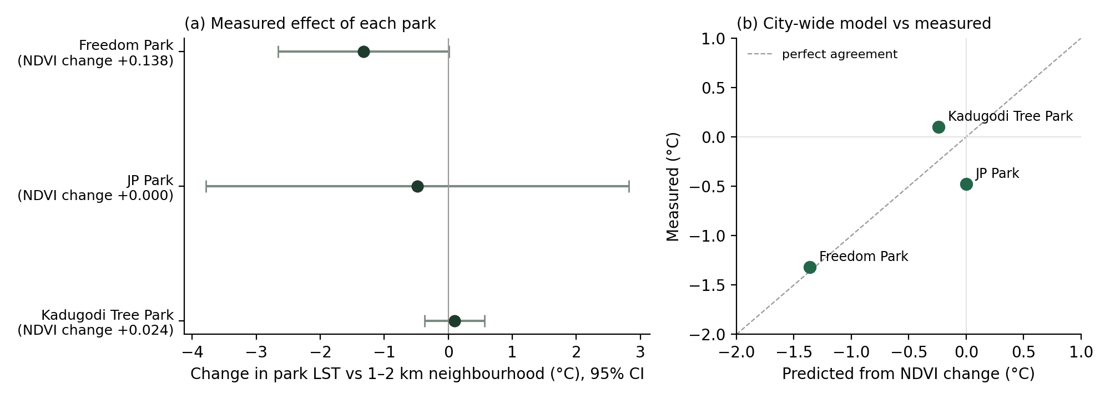
Fig. 2. (a) Change in park LST relative to a 1–2 km ring after vs before construction, with 95% CI (scene-level difference-in-differences, standard errors clustered by year). (b) Measured change vs change predicted from the city-wide NDVI–LST model. JB Kaval Tree Park excluded (incorrect outline). Source: regreening_parks.ipynb and site_selection.ipynb.

RQ3: parks are concentrated in the cooler wards
The coolest quarter of wards has on average 7.2 BBMP parks per ward; the hottest quarter has 1.5, and 20 of its 50 wards have no listed park (Fig. 3). Holding population and ward area fixed, each +1 °C of ward LST goes with about 41% fewer parks (coefficient −0.52 ± 0.15 on log scale). The pattern holds within wards of similar size (Spearman −0.34 to −0.66) and within the inner, middle and outer city separately (−0.52, −0.48, −0.44). Parks do not follow population: among wards of similar size, more populous wards do not have more parks (log-population coefficient +0.11 ± 0.50).  This is unlikely to be because parks cool their own wards: even at 1 ha each, parks cover a median 1.5% of a ward's area, and park-rich wards are not greener (Spearman −0.03 between parks per km² and green cover). | 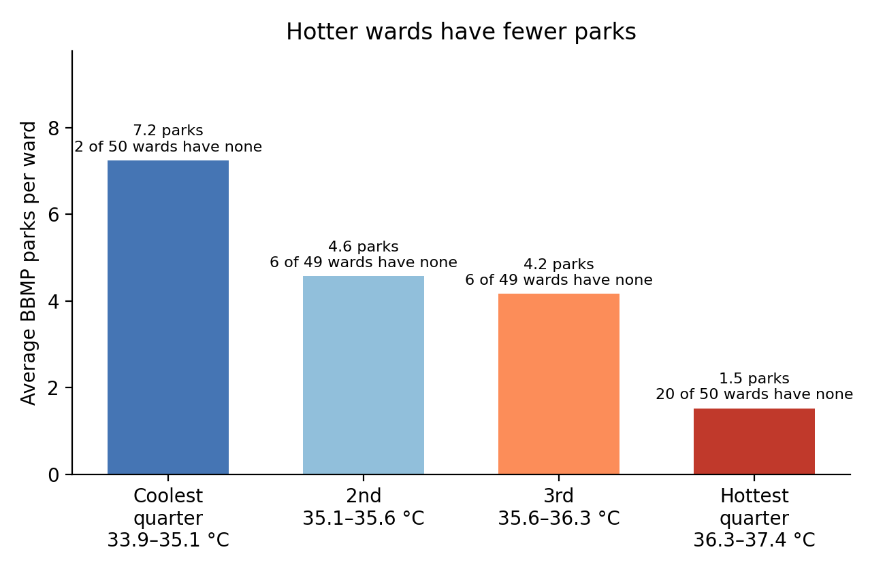  Fig. 3. Mean number of BBMP parks per ward by ward-temperature quarter (198 wards). Parks: BBMP Parks Map 2023; LST: land pixels only, Jan–Apr 2022–26.

4. Discussion
Following the same places over two decades, greening in Bengaluru went with cooling (1.2 °C) and loss of green with warming (1.7 °C), each relative to places that stayed the same. Three independent approaches agree on the size of the effect: change over time (RQ1), a park built on non-green land (RQ2), and comparison across places. A park label on its own does not cool: tree parks created within existing forest showed no change. Bengaluru's existing BBMP parks, meanwhile, are concentrated in its cooler wards and do not follow population; the parks list has no dates, so this describes where parks are, not whether recent investment was targeted. Two widely used global population products misplace Bengaluru's population by an order of magnitude in large parts of the city, so heat-exposure studies in Indian cities should validate them against census data.
Limitations. Results are associations, not controlled experiments. LST measures surfaces (roofs, roads, ground), not the air temperature people feel, and covers the dry season only. RQ1 combines Landsat 5/7 and 8/9; city-relative measures and the rank check address sensor differences, but cannot remove them entirely. Population is from Census 2011. Parks are counted, not measured by size, and the 2023 list is incomplete. The park study rests on three usable parks, and JP Park's start year could not be confirmed.

References
[1] Shah, A., Garg, A., Mishra, V. (2021). Quantifying the local cooling effects of urban green spaces: Evidence from Bengaluru, India. Landscape and Urban Planning, 209, 104043. [verify before submitting]
[2] Gorelick, N. et al. (2017). Google Earth Engine: Planetary-scale geospatial analysis for everyone. Remote Sensing of Environment, 202, 18–27.
[3] U.S. Geological Survey. Landsat 5, 7, 8 and 9 Collection 2 Level-2 Science Products.
[4] European Commission, Joint Research Centre. GHS-BUILT-S R2023A, Global Human Settlement Layer.
[5] OpenCity. Bengaluru Ward-wise Census Data – 2011. data.opencity.in
[6] OpenCity. BBMP Ward Map – 2015 (198 wards). data.opencity.in
[7] OpenCity. BBMP Parks Map (2023). data.opencity.in
Supplementary material: AURA.zip (this report plus notebooks, scripts, data and figures, organised by research question).

