# FitFlex: Your Personal Fitness Companion

## 1. Introduction

• Project Title: FitFlex: Your Personal Fitness Companion

• Team ID: NM2025TMID39552

• Team Leader: VISWAK T

• Team Members:

– VIGNESH N

– ASWIN P

– ABDUL RASHED DHARIK

## 2. Project Overview

• Purpose: FitFlex is a responsive fitness companion web application designed to provide structured workouts by muscle group, categorized by difficulty levels. It helps users start their fitness journey with guided exercises, even without access to gym equipment.

• Features:

– Hero landing page with motivational message and call-to-action button

– Muscle group categorization (Chest, Back, Legs, Core, Shoulders, Arms)

– Difficulty-based workout plans (Beginner, Intermediate, Advanced)

– Interactive hover effects and animations for engaging user experience

– Fitness stats dashboard (exercise count, muscle groups, difficulty levels)

– Responsive design for mobile and desktop devices

## 3. Architecture

• Frontend: HTML, CSS (with gradients, animations, and responsive design), JavaScript for interactivity

• Tools: Visual Studio Code, GitHub for version control, Browser Developer Tools for testing

## 4. Pre-Requisites

• A modern web browser (Google Chrome, Edge, or Firefox)

• Visual Studio Code or any text editor

• Basic knowledge of HTML, CSS, and JavaScript

## 5. Setup Instructions

• Download or clone the project folder from GitHub/SmartInternz portal

• Extract the files if downloaded as ZIP

• Open the project folder in Visual Studio Code

• Open the index.html file with a web browser

• The application will launch and be fully functional in the browser

## 6. Folder Structure

FitFlex/  
|-- index.html # Main HTML file  
|-- style.css # Styling for the web app  
|-- script.js # JavaScript interactivity  
|-- assets/ # Images, icons, and other resources

## 7. Application Features

• User Interface:

– Hero section with background image, motivational text, and CTA button

– Scroll indicator and smooth scrolling

• Workout Plans:

– Exercises grouped by muscle category

– Workouts labeled with difficulty levels (Beginner, Intermediate, Advanced)

• Animations & Interactivity:

– Hover effects for workout cards and exercises

– Parallax effect for hero section

• Fitness Stats Section:

– Shows number of exercises, muscle groups, difficulty levels, and availability

• Responsive Design:

– Optimized for both desktop and mobile screens

## 8. Running the Application

• Open the index.html file directly in any modern browser

• Alternatively, use a local development server (e.g., Live Server in VS Code) for smoother testing

## 9. Testing

• Manual testing across different browsers and screen sizes

• Responsive testing using Chrome Developer Tools (mobile and tablet viewports)

• Cross-browser compatibility testing

## 10. Screenshots

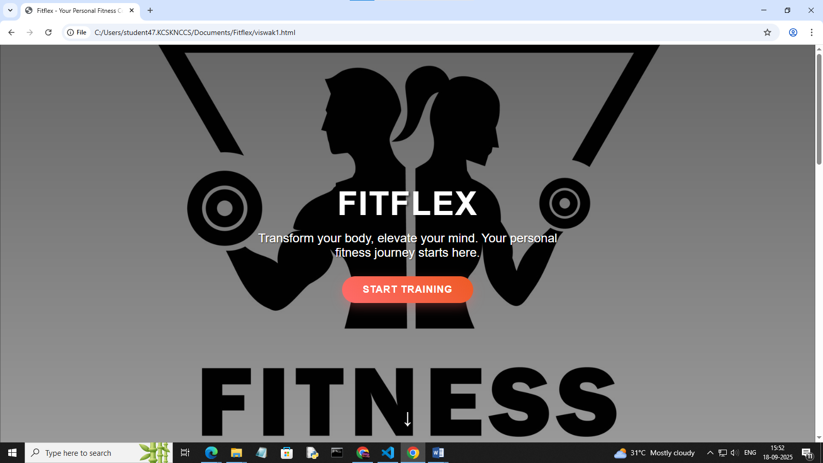

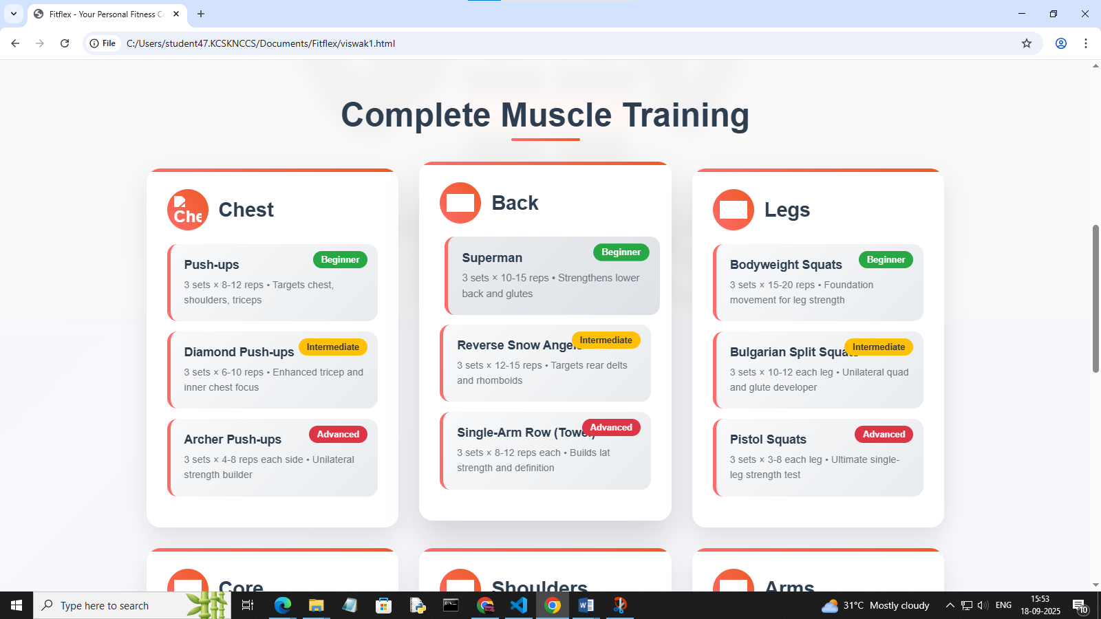

## 11. Future Enhancements

• Adding user login and personalized workout tracking

• Integration with a backend to save workout progress

• Nutrition and diet recommendation section

• Integration with wearable fitness devices for real-time tracking

• Deployment to a cloud platform for public access