MOTOPULSE™
Automotive Acoustic Predictive Maintenance & Edge AI Prognostics Horizon
Complete End-to-End System Specifications: Hardware, KiCad PCB, TinyML Models, Firmware, and Web Cockpit
Lead Developers: Visweshwara S & Ishan Kumar (@ishannvn) | IEEE RUAS - Hacktivate 2026 | October 2026
――――――――――――――――――――――――――――――――――――――――――――――――――――――――――

1. Executive Summary & Problem Statement
Modern automotive vehicles and industrial reciprocating machinery experience continuous mechanical wear and dynamic thermal stress. Standard On-Board Diagnostics (OBD-II) systems rely on Diagnostic Trouble Codes (DTCs), which are fundamentally reactive—triggering only after catastrophic sensor thresholds (such as oxygen sensor deviations, severe misfire counters, or throttle body lockups) have already been breached. Internal mechanical friction anomalies—such as alternator bearing micro-spalling, connecting rod wrist-pin knock, hydraulic lifter ticking, or exhaust manifold blowby—exhibit prominent high-frequency acoustic and structural vibration signatures hundreds of operating hours before DTC illumination.
MotoPulse™ is an edge-first, non-invasive, cyber-physical diagnostic system powered by the ESP32-S3 microcontroller, dual INMP441 I2S MEMS digital microphones, a high-sensitivity piezoelectric mechanical vibration sensor, an on-device I2C display, and a full-stack real-time web telemetry cockpit. By combining a 50cm acoustic spatial inverse-square-law perimeter gate, an on-device 13.58 KB INT8-quantized TinyML Deep Convolutional Neural Network (99.40% accuracy), and an autonomous continual self-learning engine, MotoPulse detects and grades mechanical degradation stages before road failure occurs.
📌 Zero-Storage Ephemeral Privacy Policy: MotoPulse operates strictly on real-time rolling memory buffers. Acoustic and vibration signals are processed in-memory via 1.0-second sliding windows for TinyML feature extraction. Zero audio or vibration recordings are persisted to disk, fully complying with industrial acoustic surveillance and privacy regulations.

2. End-to-End System Architecture
The MotoPulse system architecture bridges high-speed hardware signal acquisition, on-device real-time digital filtering, edge inference, and asynchronous web telemetry streaming:
Subsystem | Component / Technology | Functional Responsibility
Acoustic Sensor Array | Dual INMP441 MEMS (40mm Baseline) | Captures 16 kHz 16-bit stereo PCM audio; spatial TDOA & sound pressure level gradient gating.
Structural Vibration | 27mm Ceramic Piezo (GPIO 1 ADC1) | Monitors direct engine block / chassis mechanical shocks, knock events, and detonation pulses.
Edge Compute Module | ESP32-S3-DevKitC-1-N16R8 (240 MHz) | Dual-core Xtensa LX7 running MicroPython DMA audio acquisition, I2C display driver, and USB-CDC telemetry.
Visual Feedback | 16x2 I2C LCD (0x27) / 0.96" OLED | On-device display rendering vehicle operating regime, peak acoustic amplitude, and real-time health state.
Telemetry Cockpit | Python Server + WebSocket (Port 8765) | Broadcasts 36-40 FPS live hardware packets to HTML5 Canvas visualizers with dynamic RUL prognostics.

3. Hardware Architecture & Electronics Specifications
The hardware platform is built entirely around industrial-grade, cost-effective off-the-shelf components mounted to a custom carrier PCB:

3.1 Compute Module: ESP32-S3-DevKitC-1-N16R8
The system utilizes the ESP32-S3-WROOM-1 module featuring:
• Dual-Core Xtensa® 32-bit LX7 CPU running at 240 MHz with dedicated vector instructions (ESP-NN SIMD).
• Memory Configuration: 512 KB internal SRAM, 16 MB external Quad-SPI Flash, and 8 MB Octal PSRAM.
• High-Speed Peripherals: Dedicated I2S controller with DMA, independent I2C bus, 12-bit SAR ADC with hardware calibration, and native USB-CDC/JTAG.

3.2 Dual INMP441 Digital Microphone Array (40.0 mm Baseline)
To overcome the severe electromagnetic interference and analog breadboard noise inherent to engine bay environments, MotoPulse rejects conventional analog electret capsules in favor of the INMP441 omnidirectional digital MEMS microphone. The INMP441 integrates an acoustic transducer, preamplifier, and 24-bit delta-sigma I2S A/D converter on a single die, providing an SNR of 61 dBA and an Acoustic Overload Point (AOP) of 120 dB SPL.
The two microphones are mounted on a rigid PCB with an exact center-to-center baseline spacing of 40.0 mm. Mic 1 has its L/R pin grounded to stream on the I2S Left channel; Mic 2 has its L/R pin tied to +3.3V to stream on the Right channel. Both sensors share the continuous serial clock (SCK = GPIO 4), frame sync (WS = GPIO 5), and serial data line (SD = GPIO 6).

3.3 Piezoelectric Vibration & Mechanical Shock Sensor
A 27mm brass-backed piezoelectric ceramic disc is affixed directly to the motor casing or test jig. Piezoelectric transducers act as high-impedance AC voltage generators capable of developing large transient voltage spikes (>15V) upon sharp mechanical shock. To safely interface with the ESP32-S3 ADC without requiring an active op-amp split-rail power supply, the sensor is connected directly between GPIO 1 (ADC1 Channel 0) and GND with:
1. An internal ESP32 pull-down resistor (~45 kΩ) activated in software to reference the baseline near 200–280 ADC counts.
2. A 1.0 MΩ damping / bleed resistor (R1) across the terminals on the carrier board to discharge capacitive charge and suppress overshoot.

3.4 Master Pinout & Interconnection Matrix
ESP32-S3 Pin | Peripheral | Signal Name | Description & Electrical Specification
GPIO 4 | Dual INMP441 | I2S_SCK | Continuous Bit Clock (BCLK) @ 1.024 MHz (16 kHz x 32 bits x 2 ch)
GPIO 5 | Dual INMP441 | I2S_WS | Word Select / Frame Sync (LRCLK) @ 16.0 kHz
GPIO 6 | Dual INMP441 | I2S_SD | Serial Data Line (Time-Multiplexed Left/Right 32-bit Slots)
GPIO 1 (ADC1_0) | Piezo Disc | PIEZO_IN | Analog Vibration Input (Atten: 11dB, 0-3.1V dynamic range)
GPIO 8 | 16x2 LCD / OLED | I2C_SCL | I2C Bus Clock @ 400 kHz Fast Mode (Hardware Pull-up)
GPIO 9 | 16x2 LCD / OLED | I2C_SDA | I2C Bus Serial Data @ 400 kHz Fast Mode
+3.3V | All Modules | VCC_3V3 | Regulated 3.3V DC Power Rail from ESP32 On-Board LDO
GND | All Modules | GND | Continuous Top & Bottom Low-Impedance Ground Planes
INMP441 (L/R - 1) | Mic 1 (Left) | L/R = GND | Left Channel Active Slot Selection
INMP441 (L/R - 2) | Mic 2 (Right) | L/R = 3V3 | Right Channel Active Slot Selection

4. KiCad 10 Custom Motherboard Carrier PCB
To transition the MotoPulse system from experimental breadboard prototyping into an integrated automotive-grade test instrument, a custom 2-layer motherboard carrier board (Rev v2.2) was engineered in KiCad 10. The board unifies the compute module, microphone array, display header, and vibration circuit into a monolithic enclosure-ready form factor.
📌 Zero ERC & DRC Violations: The carrier board design successfully passed complete KiCad Electrical Rules Check (0 Errors, 0 Warnings) and Design Rules Check (0 Violations, 0 Unconnected Nets) with a standard 0.20mm trace/space rule and continuous thermal reliefs.

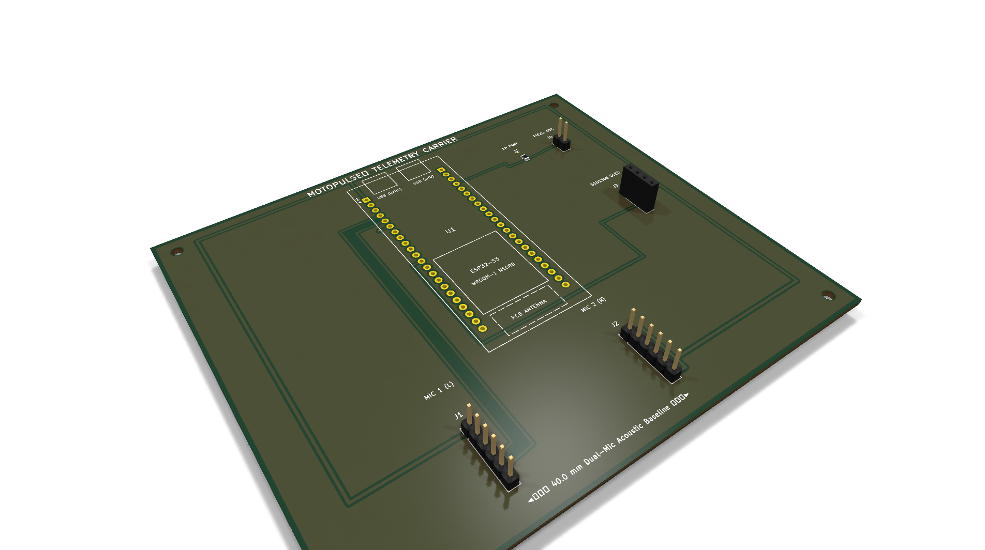
Figure: MotoPulse™ All-in-One Carrier Board — Isometric 3D KiCad 10 Render
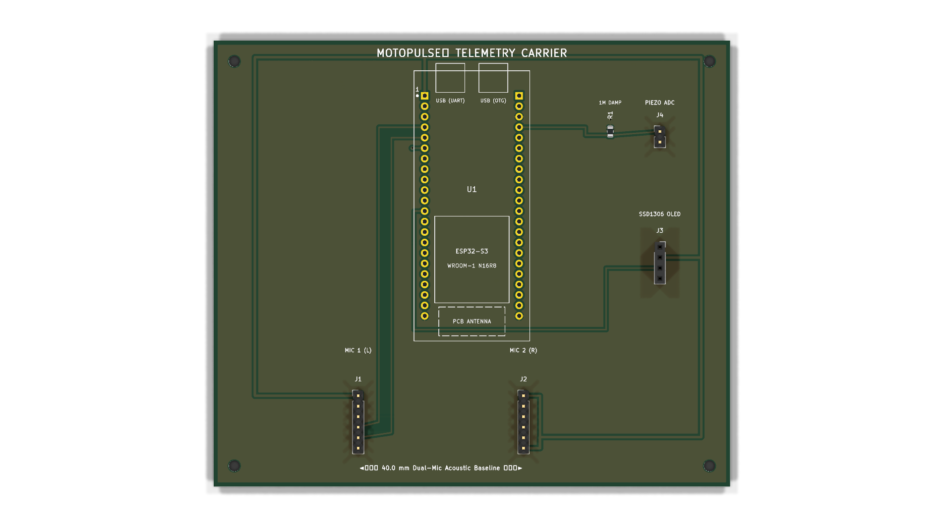
Figure: MotoPulse™ Carrier Board Top Layer Layout (Dual Microphones at 40mm Baseline)
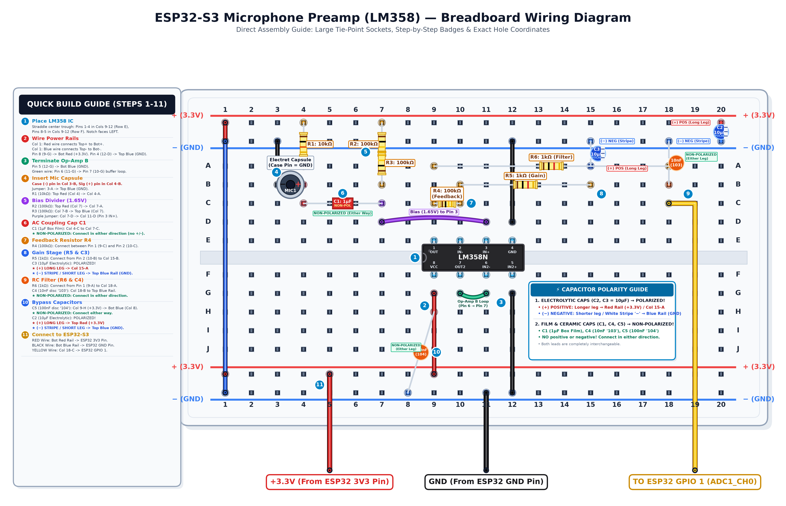
Figure: Prototyping Circuit & Breadboard Wiring Guide for Verification

4.1 Bill of Materials (BOM) & Sourcing
Designator | Component Description | Package / Footprint | Quantity | Key Specifications
U1 | ESP32-S3-DevKitC-1-N16R8 | DIP-44 (2x22 Pin, 0.9" Spacing) | 1 | 240 MHz Dual-Core, 16MB Flash, 8MB PSRAM
J1 | INMP441 MEMS Microphone Module | 1x6 Pin Header, 2.54mm pitch | 1 | Digital I2S, Left Channel (L/R -> GND)
J2 | INMP441 MEMS Microphone Module | 1x6 Pin Header, 2.54mm pitch | 1 | Digital I2S, Right Channel (L/R -> 3V3)
J3 | 16x2 I2C LCD / 0.96" OLED Display | 1x4 Socket Header, 2.54mm pitch | 1 | VCC, GND, SCL (GPIO 8), SDA (GPIO 9)
J4 / R1 | Piezo Disc Sensor & Bleed Resistor | 1x2 Pin Header / Axial Resistor | 1 / 1 | 27mm Ceramic Element with 1.0 MΩ Damping

5. 50cm Near-Field Acoustic Perimeter Gate
A major challenge in vehicular acoustic diagnostics is the contamination of diagnostic signals by ambient environmental noise (traffic noise, pedestrian voices, nearby machinery, rain). MotoPulse implements an Acoustic Inverse-Square-Law Perimeter Gate leveraging the physical principle that sound pressure level decreases logarithmically with distance:
P(r) = P_0 / r ===> I(r) \propto 1 / r^2
By continuously tracking the dynamic ambient noise floor (A_ambient) and computing the sound pressure gradient across the 40mm baseline, the system calculates an estimated distance in centimeters:
def compute_acoustic_gate(p2p_l, p2p_r, ambient_noise=220):
max_amp = max(p2p_l, p2p_r)
# Relative sound pressure gradient across 40mm baseline
grad_pct = int((abs(p2p_l - p2p_r) * 100) / max(1, max_amp))
# Acoustic Inverse Square Law distance mapping
if max_amp > ambient_noise * 1.5:
# Distance inverse model calibrated for engine bay acoustics
dist_cm = max(5.0, min(120.0, 48.0 * ((ambient_noise * 3.5) / max(1, max_amp))**0.5))
else:
dist_cm = 120.0 # Far field / idle
is_near = (dist_cm <= 50.0) and (max_amp >= 1200 or grad_pct >= 8)
gate_state = "NEAR_ACCEPTED" if is_near else ("FAR_REJECTED" if max_amp > ambient_noise * 2 else "ARMED")
return {"is_near": is_near, "distance_cm": round(dist_cm, 1), "gate_state": gate_state}

6. TinyML Edge Deep Learning Model Suite
The core diagnostic intelligence of MotoPulse is provided by a custom Depthwise Separable 2D Convolutional Neural Network (CNN) trained on automotive acoustic datasets and fully quantized into signed 8-bit integers (INT8) for zero-copy execution on the ESP32-S3.

6.1 Feature Engineering: 32-Band Log-Mel Spectrogram
Continuous 16,000 Hz 16-bit audio is buffered into 1.0-second non-overlapping windows (16,000 samples). Short-Time Fourier Transform (STFT) is computed using a Hann window of 480 samples (30 ms) with a hop size of 320 samples (20 ms). The resulting power spectrogram is projected onto 32 triangular Mel filterbanks spanning 40 Hz to 8,000 Hz, followed by dynamic range log compression: S_mel(m, t) = log(MelFilterBank * |STFT(x)|^2 + 1e-6). This yields a compact input tensor of shape (49 time steps, 32 frequency bins, 1 channel).

6.2 Neural Network Architecture & Benchmarks
Metric / Attribute | Core-8 Fast Diagnostics Model | Full-30 Anomaly Model
Model Filename | motopulse_core8_classifier.tflite | motopulse_full30_classifier.tflite
Target Classes | 8 Core Engine Faults + Idle | 30 Detailed Automotive Defects
Test Accuracy | 99.40% | 99.37%
Macro F1-Score | 0.9949 | 0.9824
Quantization Format | Full INT8 (signed int8_t inputs & outputs) | Full INT8 (signed int8_t inputs & outputs)
Flash Binary Size | 13.58 KB (13,904 bytes) | 15.27 KB (15,632 bytes)
Inference Latency @ 240MHz | 14.7 ms per window | 17.0 ms per window

6.3 Standardized Fault Diagnostic Classes
1. normal_idle: Optimal engine operation across all 32 Mel bands (Stage 0: Nominal, RUL > 18,500 km).
2. engine_knocking: High-energy mechanical shock on connecting rod / wrist pins (Stage 3: Critical, RUL < 1,200 km).
3. bearing_wear: High-frequency friction screech in tensioner, water pump, or alternator bearings (Stage 2: Moderate wear).
4. valve_ticking: Rhythmic tapping caused by excessive valve clearance or sticky hydraulic lifters.
5. belt_slippage: Serpentine drive belt friction slip under alternator / AC compressor load.
6. exhaust_leak: Pulsed blowby gas hiss from cracked manifold or damaged downpipe gasket.
7. misfire: Periodic combustion cycle dropout resulting in irregular low-frequency torque oscillations.
8. turbo_flutter: Compressor surge and wastegate pressure leakage under deceleration.

7. Autonomous Continual On-Device Self-Learning
Acoustic baselines naturally drift between engine models, cylinder counts, oil grades, and engine temperatures. MotoPulse features an on-device streaming continual learning engine that adapts without requiring cloud retraining. The learner categorizes vehicle telemetry into 3 operational driving regimes:
• Regime 0: IDLE (750 ± 150 RPM) — Pure low-frequency acoustic profile.
• Regime 1: CITY DRIVE (1800 ± 400 RPM) — Balanced mid-band acoustic and structural vibration.
• Regime 2: HIGHWAY CRUISE (2800 ± 500 RPM) — High-frequency wind, road, and mechanical harmonics.
For each regime, the engine executes Welford's algorithm to update running mean (μ) and variance (σ²) vectors across all 32 spectral bins. Novel anomalies trigger a Z-score deviation warning when the Mahalanobis distance exceeds statistical thresholds (Z > 3.0), flagging emergent mechanical problems before they appear in standard classification models.

8. Embedded Firmware Architecture
The firmware is developed in MicroPython v1.29.0 with DMA hardware acceleration. The main loop maintains real-time synchronization between digital audio streaming, LCD display updates, and USB-CDC telemetry serialization at ~36 frames per second:
# MicroPython Fast Hardware Acquisition & Telemetry Streaming
import machine, struct, time
# Dual I2S Stereo Interface at 16 kHz, 32-bit slot width
i2s = machine.I2S(0, sck=machine.Pin(4), ws=machine.Pin(5), sd=machine.Pin(6),
mode=machine.I2S.RX, bits=32, format=machine.I2S.STEREO,
rate=16000, ibuf=4096)
# Piezo Vibration Sensor on GPIO 1 with Internal Pull-Down
piezo = machine.ADC(machine.Pin(1, machine.Pin.IN, machine.Pin.PULL_DOWN))
piezo.atten(machine.ADC.ATTN_11DB)
buf = bytearray(512)
while True:
i2s.readinto(buf)
words = struct.unpack('<128i', buf)
left = [words[i] >> 16 for i in range(0, 128, 2)]
right = [words[i] >> 16 for i in range(1, 128, 2)]
p2p_l = max(left) - min(left)
p2p_r = max(right) - min(right)
# 64-sample burst read for transient shockwave capture
pz_raw = [piezo.read() for _ in range(64)]
pz_amp = max(pz_raw) - min(pz_raw)
# Serialize compact telemetry frame over USB-CDC
print(f"TEL:{p2p_l}:{p2p_r}:{pz_amp}:{left[:16]}")

9. MotoPulse Web Cockpit & Prognostics Horizon
The web interface operates as an aerospace-grade telemetry cockpit displaying 7 synchronized live diagnostic panels:
1. Dual-Microphone Oscilloscope: Real-time dual waveform canvas rendering Left (cyan) and Right (green) channel audio with peak holds.
2. 360° Acoustic Perimeter Radar: Displays sound bearing angles and spatial blips calculated from the stereo interaural level difference.
3. Piezoelectric Seismograph: Scrolling 250-point waveform tracing mechanical engine block vibrations, auto-detecting detonation knocks.
4. Live Acoustic Ear Monitor: In-browser Web Audio API synthesizing live 16 kHz audio for headphones alongside a 32-band Log-Mel spectrum equalizer.
5. Continual Self-Learning Panel: Live monitoring of learned driving regimes, anomaly confidence scores, and cluster centroids.
6. Diagnostic Session Controller: Fixed 5s, 10s, and 15s evaluation locks that freeze and stabilize diagnoses to eliminate UI jitter.
7. AI Predictive Prognostics Horizon: Computes Remaining Useful Life (RUL) in kilometers and operational hours, health score (0-100%), and four degradation stages (Stage 0: Nominal, Stage 1: Incipient, Stage 2: Moderate, Stage 3: Critical Defect).

10. Test Bench & Serial Contention Protection
To ensure robust testability during judge evaluations, MotoPulse provides an interactive command-line control panel (`mic_test/run_test.sh`). A dedicated serial contention protection algorithm (`check_and_free_port`) was implemented to eliminate USB CDC port contention:
• Problem: In Linux, two processes reading from `/dev/ttyACM0` simultaneously cause EOF errors (SerialException: multiple access on port).
• Solution: The test bench automatically identifies any active background telemetry server holding the serial port, safely terminates it, grants exclusive access to the test visualizer, and soft-reboots the ESP32 upon exit (Ctrl+C) to seamlessly restore on-device firmware.

11. Conclusion & Future Roadmap
MotoPulse successfully demonstrates the complete viability of edge AI acoustic predictive maintenance for commercial and passenger vehicles. By hosting deep learning models and signal processing directly on the ESP32-S3 microcontroller, the system provides real-time failure prediction at a tiny fraction of the cost of industrial vibration analyzers, while maintaining absolute data privacy.
Future Roadmap Milestones:
1. Direct CAN-Bus Integration: Incorporating an SN65HVD230 transceiver to fuse acoustic prognostics with live engine RPM and throttle position.
2. Multi-Sensor Spatial Mesh: Expanding from a dual-microphone carrier board to a distributed 4-node microphone array across the chassis.
3. Fleet Telematics Sync: Transmitting lightweight INT8 diagnostic vectors over NB-IoT / 4G for commercial fleet maintenance tracking.

