Acceptance Form
Please fill out this form to confirm the details of your order. Please find the products that you have requested listed in the table below along with relevant prices.
Product Code | Description | Quantity | Unit Price (GBP) | Amount (VAT ex)
productnumber | productidname | quantity | priceperunit | extendedamount

±10% variation may apply to the final manufactured quantity due to normal production and filling tolerances.
Customer Information
Name: | billto_contactname
Email: | emailaddress
Phone: | billto_telephone
Company Name: | customeridname
Invoice Address: | billto_composite
Delivery Address: | shipto_composite

☐ | I understand that before label printing, Production Specification Sheets must be signed, and label designs must be reviewed and approved. Placing an order initiates the development phase, during which Product Specification Sheets are finalized, and label guidelines are provided to facilitate label design, review, and approval.
☐ | I understand that manufacturing lead times commence once the Product Specification Sheet(s) are signed with packaging approved and not before.
☐ | I understand that R&D, sample preparation, flavour development, reformulation, and additional iterations are governed by Vita Manufacture’s Research & Development, Sampling and Formulation Terms. I understand that complimentary R&D is limited to the stated allowance, and that additional R&D samples, reformulations, flavour trials, or iterations may be chargeable.
☐ | I have read the terms and Conditions which can be found below.

Please complete this form to agree to the Terms & Conditions and confirm the above:

Date:…………………………………………….
Signature:………………………………………

customeridname
billto_composite

Ref: – quotenumber - customeridname
Dear billto_contactname,
We hereby confirm receipt of your request regarding your supplement contract manufacture, and we would like to thank you for your confidence in us.
This formula would require a laboratory development phase, and its manufacturing process validated. Nevertheless, a lead time of around 2-3 weeks will be needed to:
- Reserve relevant raw material(s) needed to manufacture your product
- Develop formulation(s) to meet required specification
- Validate your formulation and its manufacturing process
- Prepare some samples for your visual approval
- Register your product in our production database
- Validate and regulatory review of your label(s)
A deposit of at least more than 30% is required to commence this process.
Timelines
The first industrial batch lead-time will be confirmed at the end of the above steps. An additional lead time of around 6 - 12 weeks has to be taken into account.
Phase | Duration
Development (as stated above) | 2-3 weeks
Production Material Reception and Validation | 2-4 weeks
Manufacturing | 6-8 weeks
Quality Assurance Checks | 1-2 weeks
Delivery | Based on UK location
Please find below our commercial price for the manufacture of your product(s) according to the formula agreement enclosed or attached as Product Technical Document:

Product Code | Description | Quantity | Unit Price (GBP) | Amount (VAT ex)
productnumber | productidname | quantity | priceperunit | extendedamount
Conditions:
- Delivery: DAP UK location only, EXW International
- Payment: Prepayment for the 1st order, then 30 days net, date of invoice (submitted for acceptance by our Accounting Department)
Description
No other services or analytical services
Offer Validity and Pricing
This offer is valid for 14 days. Prices are subject to change due to fluctuations in raw material costs, which are beyond our control. If raw material costs increase, prices will be recalculated accordingly.
Raw Materials and Product Quality
Made from natural components, some products may exhibit slight colour variations between batches. These variations are a natural characteristic of the materials used and do not affect the quality of our products.
Each product is assigned a unique Batch Number that is tracked through all stages of manufacturing and delivery. This ensures accuracy during production and at Quality Control checks.
Formulation and Product Stability
Vita Manufacture can provide advice concerning formulation stability. If full stability testing is required, additional charges will apply. You are legally responsible for your product’s formulation and stability. A "best before" date will be provided after the development stage as part of the label guidelines and approval process.
Research & Development and Sampling
Where a product requires formulation development, flavour development, sample preparation, reformulation, technical review, dossier preparation, or manufacturing validation, Vita Manufacture’s R&D terms shall apply.
Complimentary Basic R&D (Free) may be included with a confirmed production order and is limited to two (2) R&D iterations per product and a maximum of two flavour options per product, where flavour development is relevant.

The Full R&D Package (optional) is charged at £1,750 + VAT per product and includes up to seven (7) R&D iterations, product dossier preparation, Commercial playbook, Extensive label guidance, and Vita Manufacture expert list on client website where applicable and approved by Vita Manufacture.
The Diamond R&D Package (optional) is charged at £3,500 + VAT per product and includes reasonable sample support within the agreed project scope, up to twelve R&D iterations, up to four flavour options, product dossier preparation, draft Product Specification Sheet, basic label guidance, expert website listing where applicable, and priority R&D scheduling where capacity allows.
Additional R&D samples, reformulations, flavour options, or iterations outside the agreed allowance may be charged at £250 + VAT per additional R&D sample or iteration per product.
“Reasonable sample support” means a commercially reasonable level of sampling and development support within the agreed product concept, formula direction, dosage format, target market, and product brief. It does not mean unlimited reformulation, unlimited flavour development, unlimited ingredient changes, unlimited dosage format changes, unlimited courier dispatches, unlimited product concepts, or unlimited SKUs.
Only the R&D scope, sample allowance, pricing, timelines, and deliverables stated in the written quotation, signed proposal, invoice, Product Specification Sheet, or written agreement shall be binding. Verbal discussions, informal assurances, or sales representations shall not amend the R&D scope unless confirmed in writing by an authorised representative of Vita Manufacture.
Manufacturing lead times shall not begin until the final Product Specification Sheet has been approved and signed, label requirements have been satisfied, required payments have been received, and all production-critical matters have been finalised.
Responsibilities for Product Legality and Labelling
Vita Manufacture Ltd, as the manufacturer, assumes no responsibility for the legality of your product's formulation, labelling, presentation, promotion, or marketing. Your product label must not include Vita Manufacture's name or address. We strongly recommend seeking professional guidance from relevant regulatory authorities, such as: Health Food Manufacturers Association, Medicines and Healthcare Regulatory Agency, Food Standards Agency and Trading Standards.
Terms and conditions
Vita Manufacture terms and conditions apply for all orders. Vita Manufacture General Terms and Conditions (T&C’s) are available on https://www.vitamanufacture.co.uk/termsandcondition. Extract of T&C’s is included in this document. In the event of a conflict between this offer and the T&C’s, the T&C’s will prevail and control.
If you decide to contract with us, we kindly ask you to return this offer, and the formula agreement (Draft Product Specification Sheet) countersigned and dated to us. Upon receipt of these documents, planning for preparation of the samples will be confirmed.
The information included in this document is established according to the current European Regulation. It’s our customer’s responsibility to check that the use and conditions of use of their product are conforming to their activities segment and geographical sales areas. Vita Manufacture manufactures and releases batches for further operations. The batches are produced according to ISO 22000:2018 standards, Good Manufacturing Practice (GMP) standards, the European legislation for Food Supplements and Food Safety Agency UK. For one year, as of the date of your first order, Vita Manufacture shall be the exclusive manufacturer of the products and references mentioned in this offer.
Vita Manufacture will apply VAT to all commercial products delivered to any UK address where VAT is applicable.
We will be pleased to assist you with any additional questions or queries.
Yours sincerely,
Matthew Bowden
Vita Manufacture Sales Team

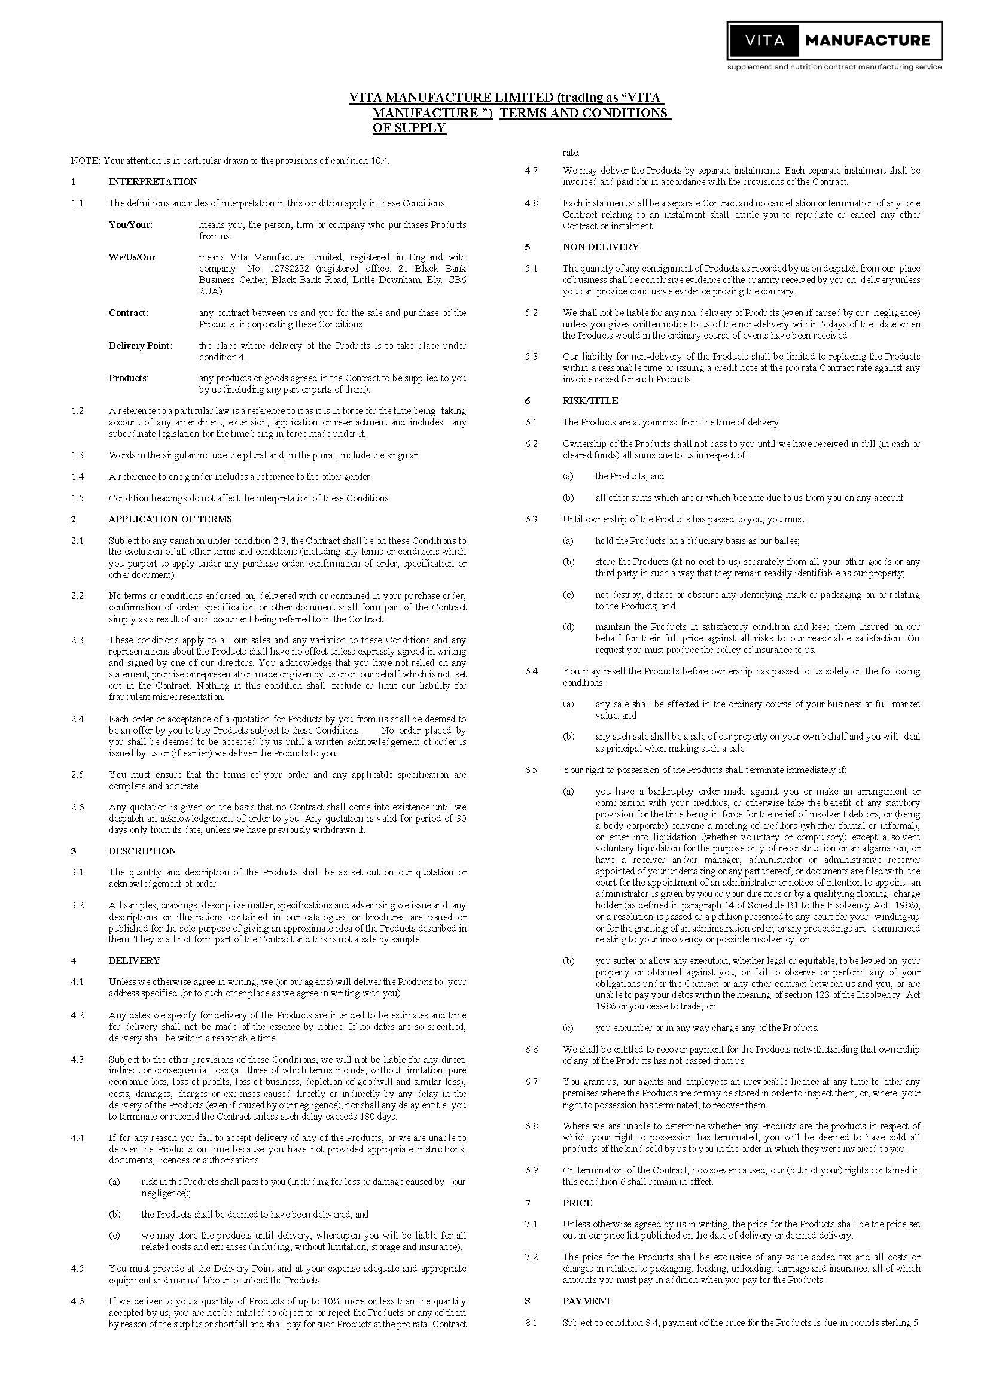
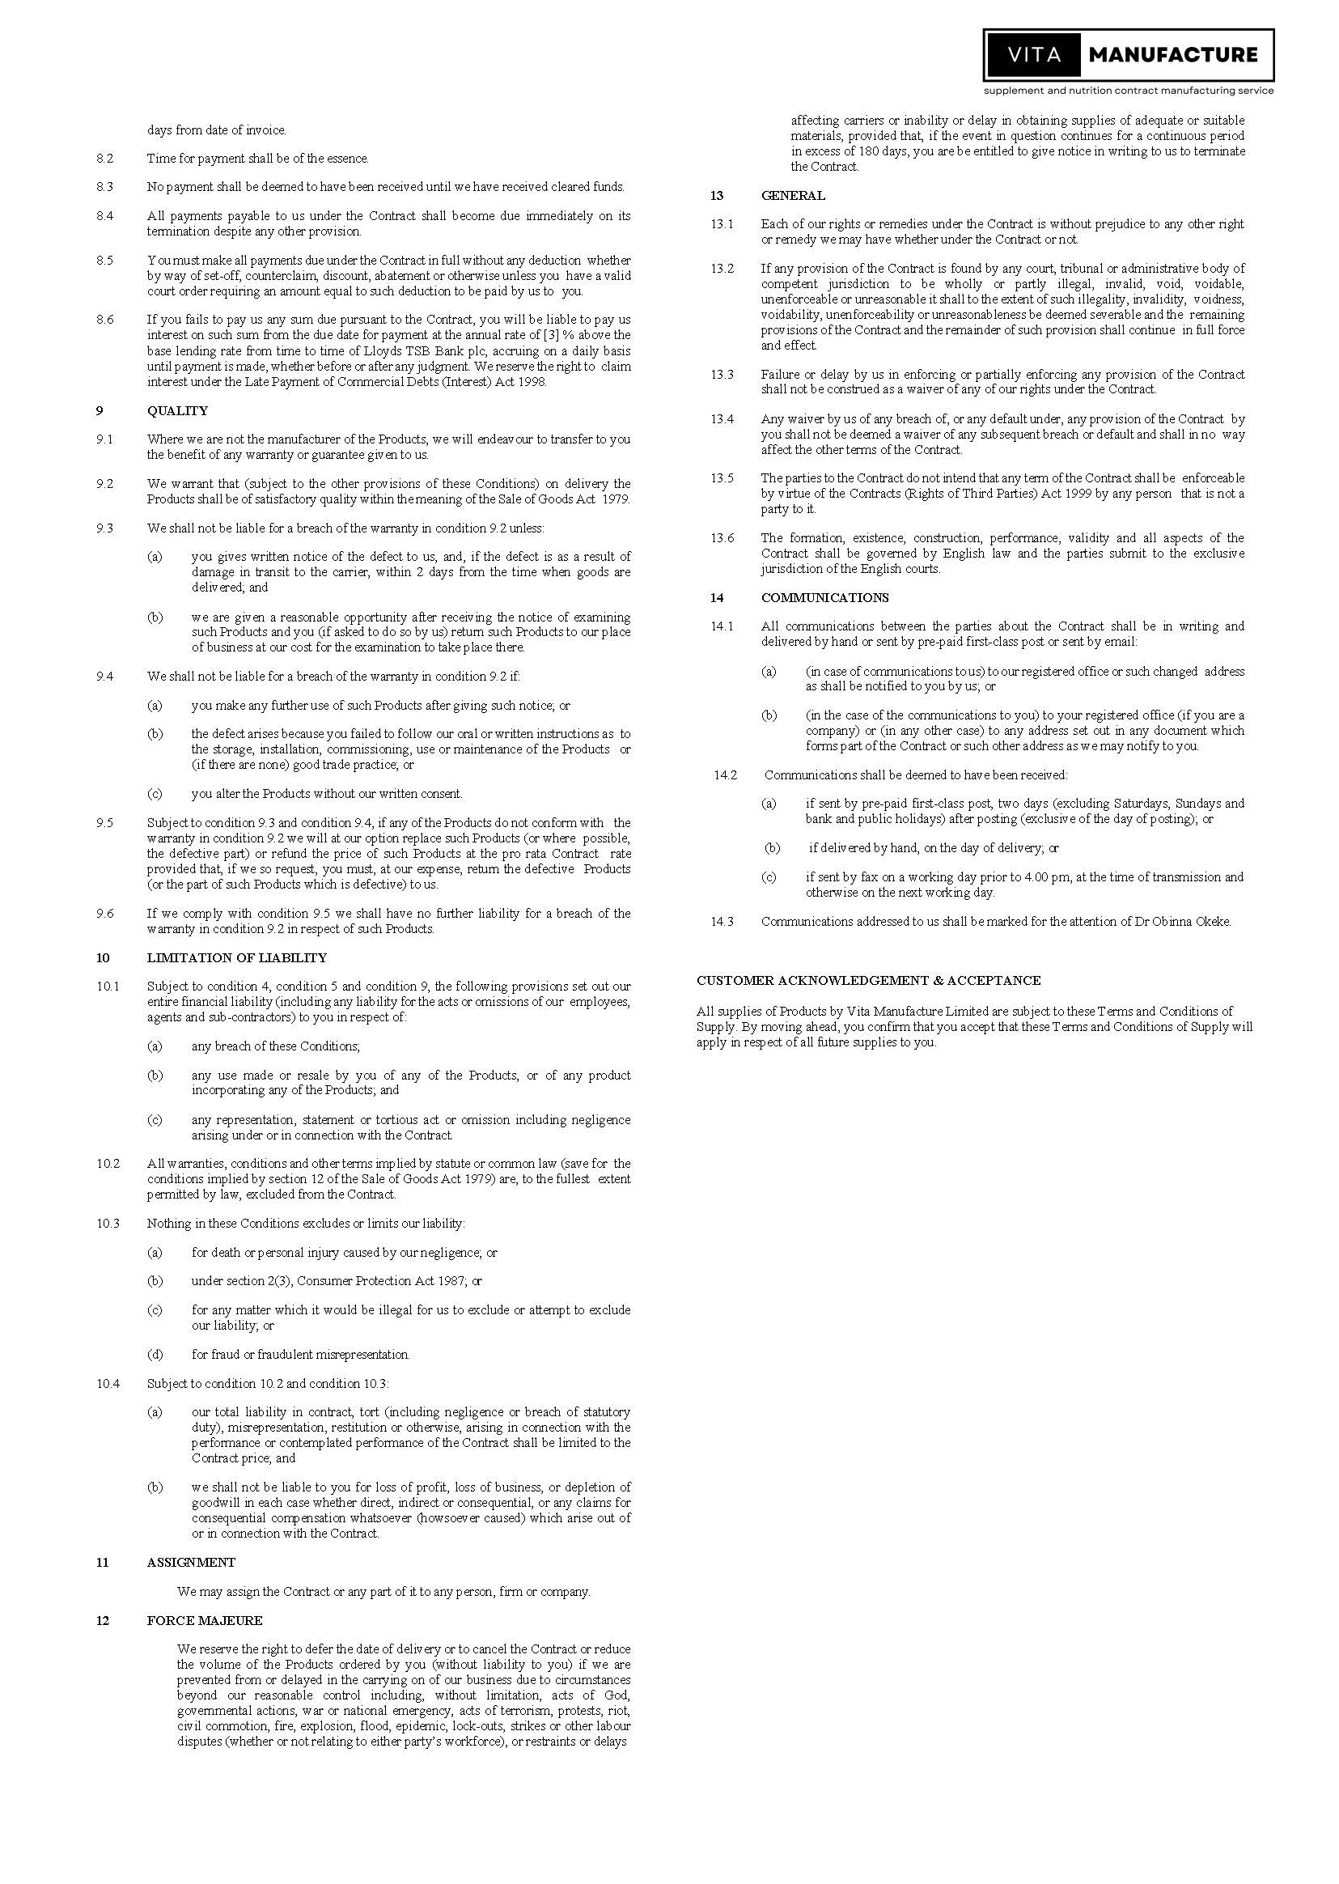

Appendix 1 - Research & Development, Sampling and Formulation Terms
Where a product requires formulation development, flavour development, sample preparation, reformulation, technical review, dossier preparation, or manufacturing validation, the following Research & Development, Sampling and Formulation Terms shall apply unless otherwise agreed in writing by Vita Manufacture Limited.
These terms are intended to ensure that the customer, Sales team, R&D team, Production team, and Quality team are fully aligned before development, or manufacturing work begins.
1. Purpose of the R&D Phase
The purpose of the R&D phase is to develop a commercially viable product formulation that can be manufactured within Vita Manufacture’s production capabilities.
R&D work may include, where applicable:
- formulation development;
- formulation adjustment;
- flavour development;
- taste, texture, colour, aroma, and mouthfeel optimisation;
- ingredient compatibility review;
- technical feasibility review;
- manufacturing feasibility review;
- sample preparation;
- review of active ingredient levels;
- review of dosage format and serving size;
- draft Product Specification Sheet preparation;
- basic label guidance based on the agreed formulation;
- product dossier preparation, where included in the agreed package.
R&D is a development process and does not guarantee that every requested taste, texture, colour, cost target, active level, claim, ingredient combination, or dosage format will be achievable.
Some formulations may require compromise due to regulatory, technical, stability, solubility, palatability, manufacturing, raw material, capsule size, powder density, cost, or commercial limitations.
2. R&D Packages
Unless otherwise stated in the quotation, Vita Manufacture offers the following R&D options.
A. Complimentary R&D with Confirmed Production Order
Complimentary R&D may be offered where the customer places a confirmed production order and pays the required deposit.
Complimentary R&D includes:
- formulation support for one agreed product concept;
- up to two R&D iterations per product;
- a maximum of two flavour options per product, where flavour development is relevant;
- sample preparation within the agreed product brief;
- reasonable technical input required to finalise the Product Specification Sheet for production.
Complimentary R&D is provided on a goodwill and production-linked basis. It is only available where the customer proceeds with a confirmed production order.
If the customer cancels, delays, materially changes, or does not proceed to production after R&D work has started, Vita Manufacture reserves the right to charge for R&D work already completed, including sample preparation, technical time, raw materials, courier costs, supplier costs, and administrative costs.

Additional samples, reformulations, flavour options, or iterations outside the complimentary allowance shall be charged at £250 + VAT per additional R&D sample or iteration per product, unless otherwise agreed in writing.
B. Full R&D Package
Where the customer purchases Vita Manufacture’s Full R&D Package, the fee shall be £1,750 + VAT per product, unless otherwise stated in the quotation.
The Full R&D Package is suitable for customers who require structured product development before committing to production.
The Full R&D Package includes:
- formulation development for one product concept;
- up to seven R&D iterations;
- sample preparation within the agreed development scope;
- technical formulation review;
- ingredient compatibility review;
- manufacturing feasibility review;
- product dossier preparation;
- draft Product Specification Sheet;
- basic label guidance based on the agreed formulation;
- expert product listing on Vita Manufacture’s website, where applicable and approved by Vita Manufacture.
For clarity, one product means one product type, one dosage format, one primary formula direction, and one primary product concept.
Different dosage formats, substantially different ingredient profiles, different flavour families, different target markets, or separate SKUs may be treated as separate products and may require separate R&D fees.
Additional samples, reformulations, flavour options, or iterations outside the Full R&D Package shall be charged at £250 + VAT per additional R&D sample or iteration per product, unless otherwise agreed in writing.
C. Diamond R&D Package
Where the customer requires a more flexible development process, Vita Manufacture may offer the Diamond R&D Package at £3,500 + VAT per product, unless otherwise stated in the quotation.
The Diamond R&D Package is designed for premium, complex, investor-ready, flavour-sensitive, or highly customised products where additional development flexibility may be required before production.
The Diamond R&D Package includes:
- formulation development for one product concept;
- reasonable sample support within the agreed project scope;
- up to twelve R&D iterations;
- up to four flavour options per product, where flavour development is relevant;
- technical formulation review;
- ingredient compatibility review;
- manufacturing feasibility review;
- sample preparation within the agreed development scope;
- product dossier preparation;
- material specification sheet;
- basic label guidance based on the agreed formulation;
- Vita Manufacture expert list on client website where applicable and approved by Vita Manufacture;
- priority R&D scheduling where capacity allows.

For clarity, “reasonable sample support” means a commercially reasonable level of sampling and development support within the agreed product concept, formula direction, dosage format, target market, and product brief.
Reasonable sample support does not mean unlimited reformulation, unlimited flavour families, unlimited ingredient changes, unlimited dosage format changes, unlimited courier dispatches, unlimited product concepts, or unlimited SKUs.
Additional samples, reformulations, flavour options, or iterations outside the Diamond R&D Package may be charged at £250 + VAT per additional R&D sample or iteration per product, unless otherwise agreed in writing.
3. R&D Package Summary
R&D Option | Price | Included Support | Best For
Complimentary R&D with Production Order | Included with confirmed production order | Up to 2 iterations and max 2 flavour options per product | Simple products proceeding directly to production
Full R&D Package | £1,750 + VAT per product | Up to 7 iterations, product dossier, draft Product Specification Sheet, expert website listing where approved | Standard custom product development
Diamond R&D Package | £3,500 + VAT per product | Reasonable sample support, up to 12 iterations, up to 4 flavour options, dossier, expert listing, priority R&D scheduling where capacity allows | Premium, complex, investor-ready, or flavour-sensitive products
4. Additional Samples and Extra Iterations
Any R&D sample, reformulation, flavour option, technical adjustment, or iteration outside the included allowance shall be charged at £250 + VAT per additional R&D sample or iteration per product, unless otherwise agreed in writing.
- Additional charges may apply where the customer requests:
- further flavour trials beyond the included allowance;
- changes to the active ingredient profile;
- changes to the dosage format;
- changes to the serving size;
- replacement of key ingredients;
- reformulation due to customer preference rather than technical failure;
- reformulation due to new claims, target markets, or regulatory requirements;
- repeat samples due to delayed, unclear, or inconsistent feedback;
- samples requiring specialist, premium, rare, custom, or high-cost raw materials;
- courier or international delivery of samples;
- third-party laboratory analysis;
- full stability testing;
- specialist regulatory submissions;
- additional dossier work outside the agreed scope.
Vita Manufacture may pause R&D work until any additional R&D fees, sample charges, raw material charges, or courier charges are paid.
5. Customer Feedback and Approval
The customer must provide clear, consolidated feedback after each sample round.
Feedback should be specific and commercially actionable, including comments on taste, sweetness, texture, colour, aroma, mouthfeel, dosage format, serving size, and any desired changes.
Where feedback is unclear, contradictory, subjective, or provided in stages by multiple people, Vita Manufacture may request clarification before continuing development.
Where additional samples are required because of unclear, delayed, contradictory, or changing customer feedback, the next sample may be treated as an additional iteration and may be chargeable.
The customer is responsible for ensuring that all relevant internal stakeholders review the sample before feedback is submitted.
Once Vita Manufacture proceeds based on customer feedback, any later change of direction may be treated as a new iteration and may be chargeable.
6. Meaning of “Reasonable Sample Support”
Where reasonable sample support is included, it means Vita Manufacture will provide a commercially reasonable level of sample development support within the agreed product brief.
Reasonable sample support is limited by:
- the agreed product concept;
- the agreed dosage format;
- the agreed formula direction;
- the agreed target market;
- the agreed flavour direction;
- the agreed commercial brief;
- technical feasibility;
- manufacturing feasibility;
- raw material availability;
- R&D capacity;
- regulatory suitability;
- cost parameters.
Reasonable sample support does not include:
- unlimited reformulation;
- unlimited flavour development;
- unlimited flavour families;
- unlimited ingredient changes;
- unlimited dosage format changes;
- unlimited active level changes;
- unlimited courier dispatches;
- unlimited third-party testing;
- unlimited product concepts;
- unlimited SKUs;
- repeated changes in customer direction;
- work outside the agreed product brief.
Any sample support outside the agreed scope may be quoted separately or charged at the additional R&D sample rate.
7. Material Formula Changes
A material formula change may be treated as a new R&D project and may require a new quotation.
Material formula changes include, but are not limited to:

- changing the dosage format, for example from capsules to powder, gummies, liquids, tablets, sachets, or softgels;
- changing the main active ingredients;
- changing the intended product function;
- changing the product’s target market;
- changing the regulatory market or sales territory;
- changing from one flavour family to another after development has started;
- changing the product from standard to vegan, allergen-free, organic, halal, sugar-free, natural-only, clean-label, or similar positioning where this affects formulation;
- changing the required claims or active ingredient levels;
- changing the target cost after ingredients have been sourced or samples prepared;
- creating additional SKUs, variants, strengths, pack sizes, or flavour families.
8. Technical, Regulatory and Manufacturing Limitations
All formulations are subject to technical, regulatory, quality, manufacturing, and raw material feasibility checks.
Vita Manufacture may refuse, amend, or recommend alternatives to any ingredient, claim, dosage, flavour, colour, capsule size, serving size, excipient, sweetener, dosage format, or product format where Vita Manufacture considers the request unsuitable, impractical, non-compliant, unstable, unsafe, commercially unrealistic, or incompatible with its manufacturing processes.
The customer acknowledges that some ingredients may not be suitable for the requested dosage format, serving size, flavour profile, target market, claim, or manufacturing process.
The customer remains responsible for confirming that the final product, formulation, label, claims, presentation, marketing, advertising, and sale are suitable and lawful for the customer’s intended sales channels, customer base, and sales territories.
9. R&D Timelines
Any R&D timelines provided are estimates only.
R&D timelines may vary depending on:
- complexity of the formulation;
- number of products;
- dosage format;
- flavour complexity;
- raw material availability;
- supplier lead times;
- flavour house lead times;
- speed and clarity of customer feedback;
- number of iterations required;
- regulatory review requirements;
- courier timelines;
- internal R&D capacity;
- whether additional samples or reformulations are required.
Manufacturing lead times shall not begin until:
- the final Product Specification Sheet has been approved and signed;
- label requirements have been satisfied;
- required payments have been received;
- production-critical materials have been confirmed;
- all production-critical matters have been finalised.
10. Sample Approval and Production Scale-Up
Samples are prepared for evaluation purposes only and may not be sold, distributed, marketed, supplied to third parties, or used for consumer testing unless Vita Manufacture gives written approval.
Sample approval by the customer confirms approval of the product’s general taste, appearance, format, and development direction.
The customer acknowledges that small-scale R&D samples and full-scale production batches may not be identical.
Minor differences may occur in:
- taste;
- colour;
- texture;
- aroma;
- density;
- solubility;
- mouthfeel;
- fill weight;
- capsule appearance;
- powder flow;
- finished product appearance.
Such differences may occur due to scale-up, raw material variation, manufacturing tolerances, processing conditions, and natural ingredient variation.
These differences shall not constitute a defect where the product remains within agreed specification and normal manufacturing tolerances.
11. Ownership of Formulations and R&D Work
Unless otherwise agreed in writing, all technical know-how, manufacturing methods, supplier knowledge, production processes, process knowledge, and formulation development work created by Vita Manufacture remain the intellectual property and confidential know-how of Vita Manufacture.
Where a customer provides its own pre-existing formulation, the customer remains responsible for its ownership, suitability, legality, safety, and right to use that formulation.
Where Vita Manufacture develops a formulation for the customer, the customer receives the right to purchase finished goods manufactured by Vita Manufacture using the approved formulation.
The customer does not automatically receive ownership of Vita Manufacture’s manufacturing know-how, supplier information, technical process methods, internal R&D records, or confidential development documentation unless this is separately agreed in writing.
12. Cancellation, Delay or Non-Proceeding After R&D
If the customer cancels the project, delays the project, fails to provide feedback, fails to pay the required deposit or balance, materially changes the project, or chooses not to proceed to production after R&D work has started, Vita Manufacture reserves the right to charge for work and costs already incurred.
- This may include:
- R&D time;
- sample preparation;
- raw materials;
- supplier costs;
- courier costs;
- technical review;
- administrative work;
- formulation work;
- dossier work;
- third-party costs;
- any other project-specific costs incurred.

Where complimentary R&D was offered on the basis of a confirmed production order, but the customer does not proceed to production, Vita Manufacture may charge the customer the standard R&D rate or a reasonable proportion of the R&D work completed.
13. Sales Representations and Written Agreement
Only the R&D scope, sample allowance, pricing, timelines, and deliverables stated in the written quotation, signed proposal, invoice, Product Specification Sheet, or written agreement shall be binding.
No verbal statement, sales discussion, call note, meeting note, email comment, WhatsApp message, or informal assurance shall amend the R&D scope unless confirmed in writing by an authorised representative of Vita Manufacture.
Where there is any conflict between a verbal discussion and the written proposal, the written proposal shall prevail.
This clause is intended to ensure that customer expectations, Sales commitments, R&D deliverables, Production requirements, and Quality obligations remain aligned before work begins.

