**Search strategy**

Pubmed:

1.(((((("remimazolam" [Supplementary Concept]) OR (CNS 7056[Title/Abstract])) OR (methyl 3-(8-bromo-1-methyl-6-(2-pyridinyl)-4H-imidazo(1,2-a)(1,4)benzodiazepin-4-yl)propanoate[Title/Abstract])) OR (ONO 2745[Title/Abstract])) OR (ONO-2745[Title/Abstract])) OR (ONO2745[Title/Abstract])) AND (((((((((((((("Dexmedetomidine"[Mesh] ) ) OR (Dexmedetomidine Hydrochloride[Title/Abstract])) OR (Hydrochloride, Dexmedetomidine[Title/Abstract])) OR (MPV-1440[Title/Abstract])) OR (MPV1440[Title/Abstract])) OR (MPV 1440[Title/Abstract])) OR (Precedex[Title/Abstract])) OR (Igalmi[Title/Abstract])) OR (Sedadex[Title/Abstract])) OR (Sileo[Title/Abstract])) OR (Cepedex[Title/Abstract])) OR (Dexdor[Title/Abstract])) OR (Dexdomitor[Title/Abstract]))

2.remimazolam[ti] AND propofol[ti] NOT (comment[ti] OR letter[ti] OR meta-analysis[ti] OR 'observational study'[ti] OR correction[ti] OR retrospective[ti] OR endoscopy[ti] OR gastroscopy[ti] OR ERCP[TI] OR reply[ti] OR 'a case'[ti])

___________

Embase:

1.('remimazolam'/exp OR 'remimazolam') AND dexmedetomidine:ti,ab,kw AND 'randomized controlled trial'/de

2.('remimazolam'/exp OR 'remimazolam') AND propofol:ab,ti AND 'general anesthesia' AND 'randomized controlled trial':ab,ti

______

WEB OF SCIENCE

1. ((((((((((((TS=(Dexmedetomidine)) OR TS=(Dexmedetomidine Hydrochloride)) OR TS=(Hydrochloride, Dexmedetomidine)) OR TS=(MPV-1440)) OR TS=(MPV1440)) OR TS=(MPV 1440)) OR TS=(Precedex)) OR TS=(Igalmi)) OR TS=(Sedadex)) OR TS=(Sileo)) OR TS=(Cepedex)) OR TS=(Dexdor)) OR TS=(Dexdomitor) AND ((((TS=(remimazolam)) OR TS=(CNS 7056)) OR TS=(methyl 3-(8-bromo-1-methyl-6-(2-pyridinyl)-4H-imidazo(1,2-a)(1,4)benzodiazepin-4-yl)propanoate)) OR TS=(ONO-2745)) OR TS=(ONO2745) and Preprint Citation Index (Exclude – Database) AND TS=(remimazolam)

2. (((TS=(randomized controlled trial)) AND TI=(remimazolam)) AND TI=(propofol)) AND TS=(general anesthesia)

_____________

Springer link :

1.remimazolam for

dexmedetomidine AND "randomized controlled trial" AND NOT (report OR letter)

2.

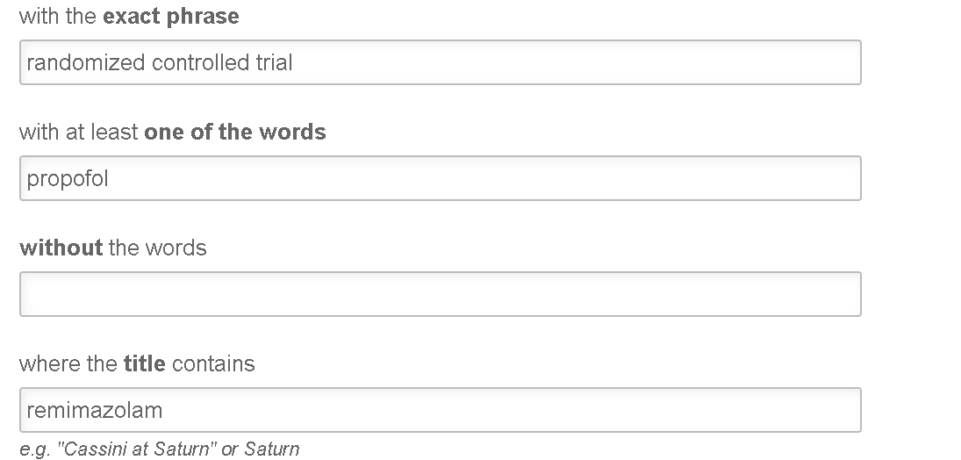

clinicaltrials.gov:

1.

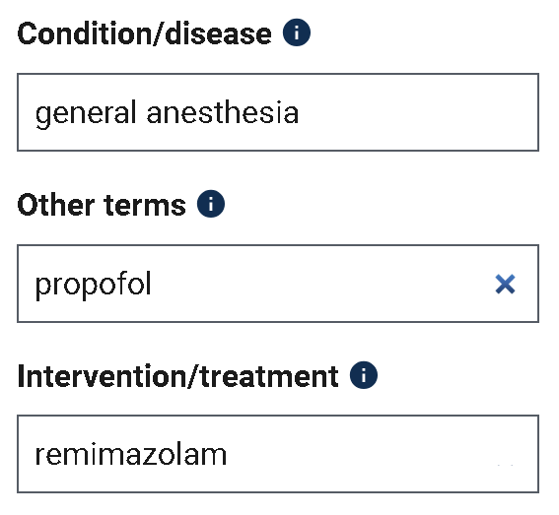

2.

