To date 2025/12/18
Pubmed: 16
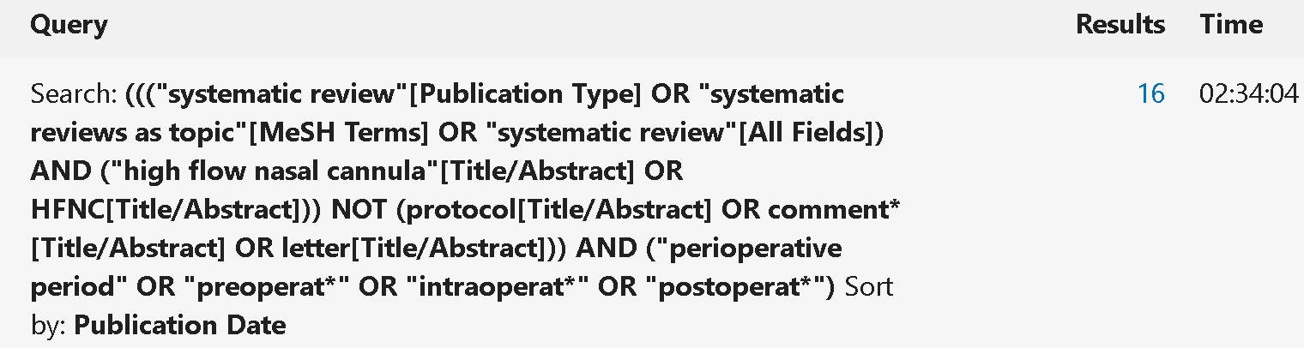
Cochrane library: 8
Web of science:15

SPRINGER LINK: 4
("high flow nasal cannula" OR hfnc) AND ("perioperative period" OR perioperat* OR intraoperat* OR postoperat*)
Embase: 57
GOOGLE SCHolar: 1290
high flow nasal HFNC perioperat* preoperat* postoperat* systematic review---1290

