Report Week 5

For this assignment I worked with 4 datasets. Iris, Automobile MPG, Student Performance and Car Evaluation.
GitHub: https://github.com/vitali-karmanov/CS450-BYUI/tree/master/week05

Iris

5% for test and 5 of max-depth:

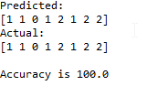
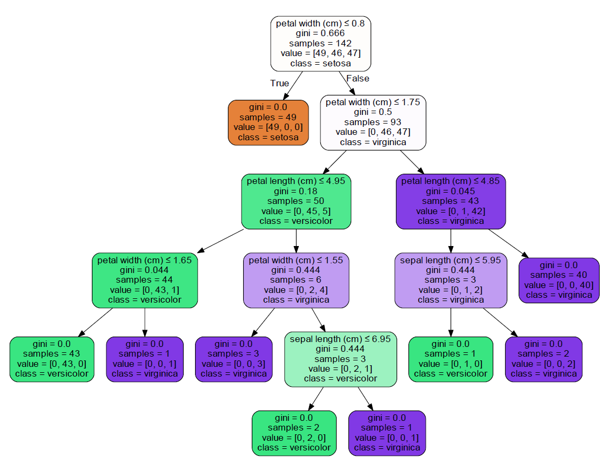
Bigger version in GitHub

5% for test and 2 of max-depth:
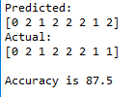

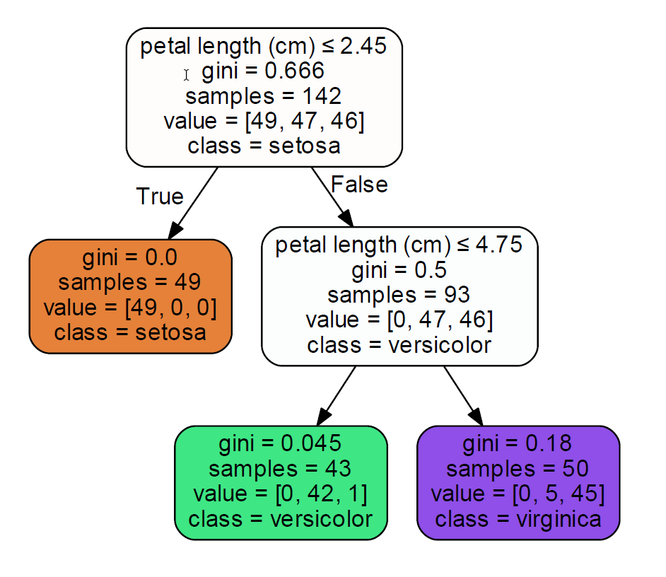

Notes: Less effective with less depth. Classification.

Automobile MPG

10% for test and 5 of max-depth:

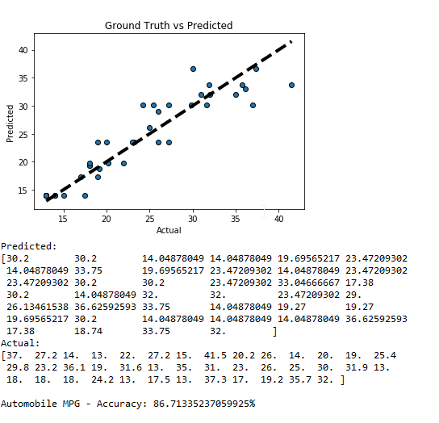
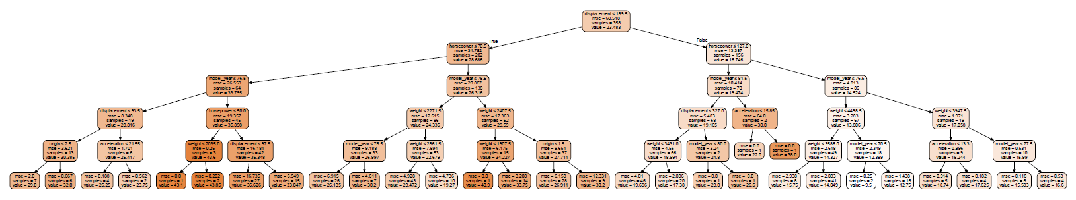
Bigger version in GitHub

Notes: Handling missive data, regression classifier, numerical data.

Student Performance

10% for test and 5 of max-depth:

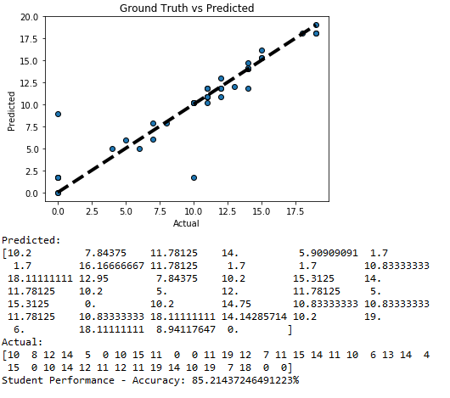

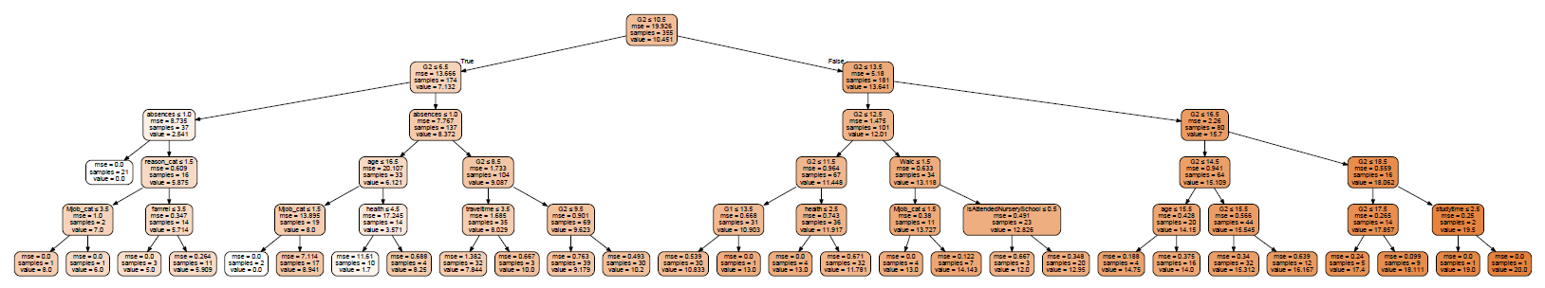
Bigger version in GitHub

Notes: Regression classifier, one-hot encoding, numerical data.

Car Evaluation

2% for test and 5 of max-depth:

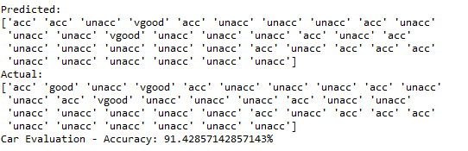
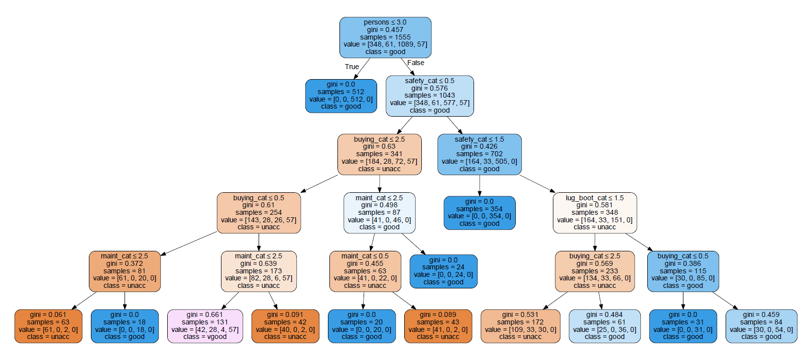
Bigger version in GitHub

Notes: Regression classifier, label encoding, numerical data.

Final Notes:
I believe that my assignment goes beyond the requirements. Because I implemented 4 datasets, I used Numerical Data, Categorical data (label and one-hot encoding), Missing data, and using Regression and Classification.
In the program you can choose to specify the percentage of test data, and the depth of the tree.
Finally, the visual representation of a tree, is dynamically created and for regression I’m also showing the plots.

