1. Deploy Bridge and ERC20Handler Contract on Binance, Verify and Configure.

Here, the parameters are currently base on Binance Smart Chain.

1. Bridge Contract

Compiler version: 0.64

Source code:

[https://github.com/vitalikvaraksa/avaBscCross/blob/master/solidity/lockMint-lockMint/Bridge.sol](https://github.com/vitalikvaraksa/avaBscCross/blob/master/solidity/lockMint-burnRelease/Bridge.sol)

Parameter: 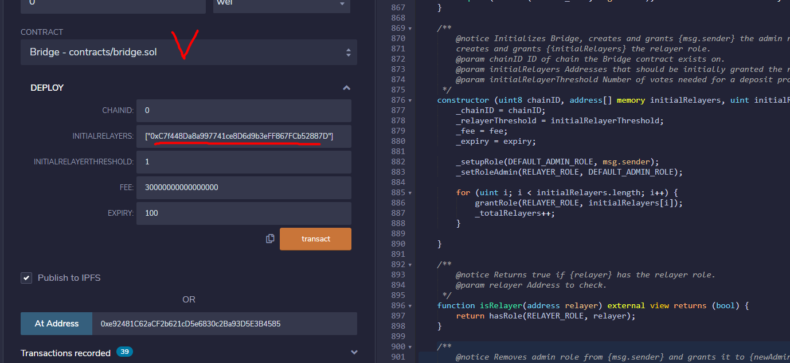

Set the parameters like above. INITIALRELAYER: wallet address that will be used for relayer.

1. ERC20Handler Contract

Compiler version: 0.64

Source code:

https://github.com/vitalikvaraksa/avaBscCross/blob/master/solidity/lockMint-lockMint/ERC20Handler.sol

Parameter: 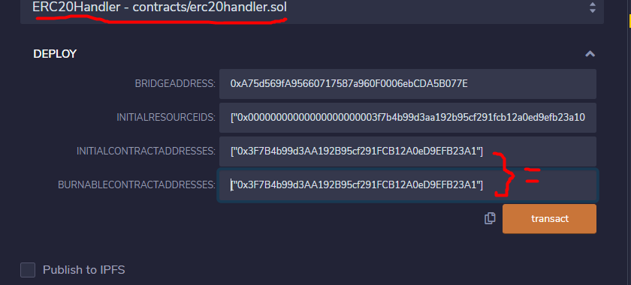

BRIDGEADDRESS: bridge contract address on Binance

INITIALRESOURCEIDS: array of resourceids on Binance, token resource id can be one element of this array.

INITIALCONTRACTADDRESS: array of contract address on Binance, token address can be one element of this array, e.x OPUS token

BURNABLECONTRACTADDRESSES: array of contract address that will be burnable

1. Verify them with details of above
2. Configure on Bridge contract

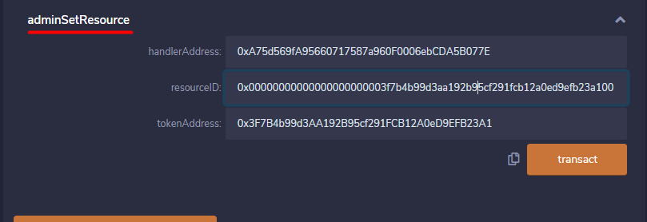

handlerAddress: ERC20Handler Contract address

resourceID: OPUS token resourceID (IT WILL BE SAME ON ALL CHAIN)

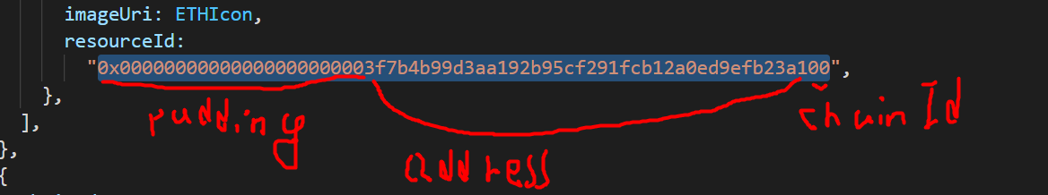

tokenAddress: OPUS token address

1. Give mint privilege to ERC20Handler contract

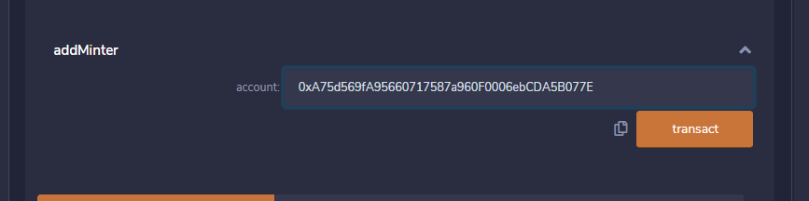

Account: ERC20Handler contract address

1. Deploy Bridge and ERC20Handler Contract on Avalanche, Verify and Configure.

Here, the parameters are currently base on Binance Smart Chain.

1. Bridge Contract

Compiler version: 0.64

Source code:

<https://github.com/vitalikvaraksa/avaBscCross/blob/master/solidity/lockMint-lockMint/Bridge.sol>

Parameter: 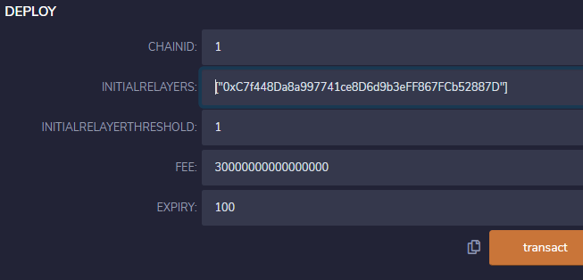

Set the parameters like above. INITIALRELAYER: wallet address that will be used for relayer.

1. ERC20Handler Contract

Compiler version: 0.64

Source code:

https://github.com/vitalikvaraksa/avaBscCross/blob/master/solidity/lockMint-lockMint/ERC20Handler.sol

Parameter: 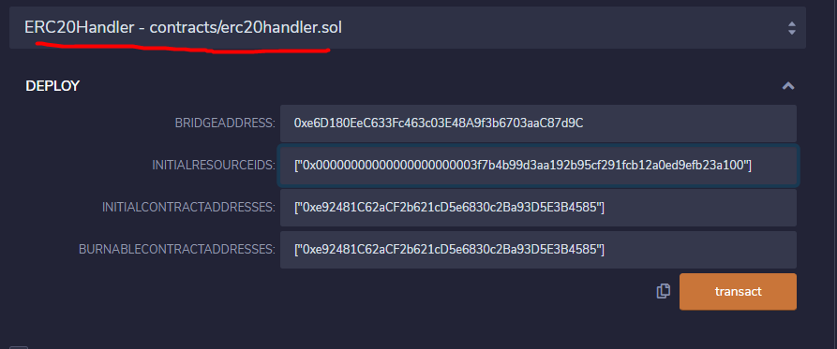

BRIDGEADDRESS: bridge contract address on Avalanche

INITIALRESOURCEIDS: array of resourceids on Avalanche, token resource id can be one element of this array.

INITIALCONTRACTADDRESS: array of contract address on Avalanche, token address can be one element of this array, e.x OPUS token

BURNABLECONTRACTADDRESSES: array of contract address that will be burnable

1. Verify them with details of above
2. Configure on Bridge contract

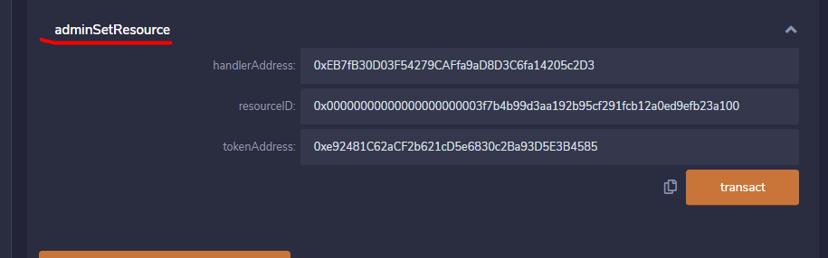

handlerAddress: ERC20Handler Contract address on Avalanche

resourceID: OPUS token resourceID



tokenAddress: OPUS token address on Avalanche

1. Give mint privilege to ERC20Handler contract

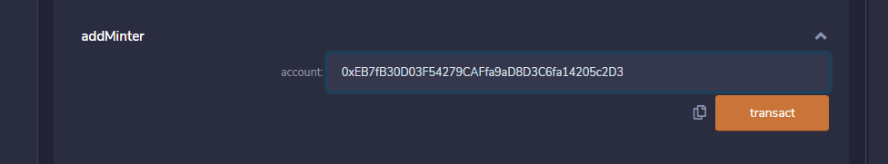

Account: ERC20Handler contract address on Avalanche

1. Create Relayer and Run it.

Relay wallet address should be one that was used to deploy contracts

1. Make /work/chainbridge-deploy/cb-sol-cli/chainbridge/run.sh
2. Edit it like following and save it

***********************run.sh***********************

#!/bin/sh

rm config.json

RELAY_ADDR="<Relayer wallet address>"

SRC_BRIDGE="<Bridge Contract Address on Binance>"

SRC_HANDLER="<ERC20Handler Contract Address on Binance>"

DST_BRIDGE="<Bridge Contract Address on Avalanche c-chain>"

DST_HANDLER="<ERC20Handler Contract Address on Avalanche c-chain>"

echo "{

\"chains\": [

{

\"name\": \"Binance\",

\"type\": \"ethereum\",

\"id\": \"0\",

\"endpoint\": \"wss://bsc-ws-node.nariox.org:443\",

\"from\": \"$ RELAY_ADDR\",

\"opts\": {

\"bridge\": \"$SRC_BRIDGE\",

\"erc20Handler\": \"$SRC_HANDLER\",

\"genericHandler\": \"$SRC_HANDLER\",

\"gasLimit\": \"1000000\",

\"maxGasPrice\": \"23000000000\"

}

},

{

\"name\": \"Avalanche\",

\"type\": \"ethereum\",

\"id\": \"1\",

\"endpoint\": \"wss://api.avax.network/ext/bc/C/ws\",

\"from\": \"$ RELAY_ADDR\",

\"opts\": {

\"bridge\": \"$DST_BRIDGE\",

\"erc20Handler\": \"$DST_HANDLER\",

\"genericHandler\": \"$DST_HANDLER\",

\"gasLimit\": \"1000000\",

\"maxGasPrice\": \"23000000000\"

}

}

]

}" >> config.json

1. Run “chmod 777 run.sh” and launch “run.sh” on “/work/chainbridge-deploy/cb-sol-cli/chainbridge”
2. On terminal, run following command

PK=”<Relayer wallet Private key>”

./build/chainbridge accounts import --privateKey $PK

./build/chainbridge --config config.json --verbosity trace –latest &