ACT REPORT



*By – Vitalis Dexter*

# Introduction

Raw data when collected does not always come clean. The data I will be analyzing in this report is the tweet archive of Twitter user WeRateDogs® with user ID @dog_rates.

WeRateDogs® is a Twitter account that shares and rates dogs pictures, with a humorous comment about the dog. The dog ratings system is on a denominator of 10 and a numerator that is from 0 to a maximum of 15. The Twitter account of WeRateDogs® as at the time writing have 9.3 million followers and the account have received several international media recognitions.

# Analysis Report

The tweet archive of WeRateDogs® was analyzed for the following questions.

### 1. Most popular Dog Breeds

The most popular dog breed in Golden Retriever followed by Labrador Retriever. Maybe these retriever dogs are popular because they help human retrieve things? I don’t know. However, these dog breeds have the most tweets on WeRateDogs® Twitter account.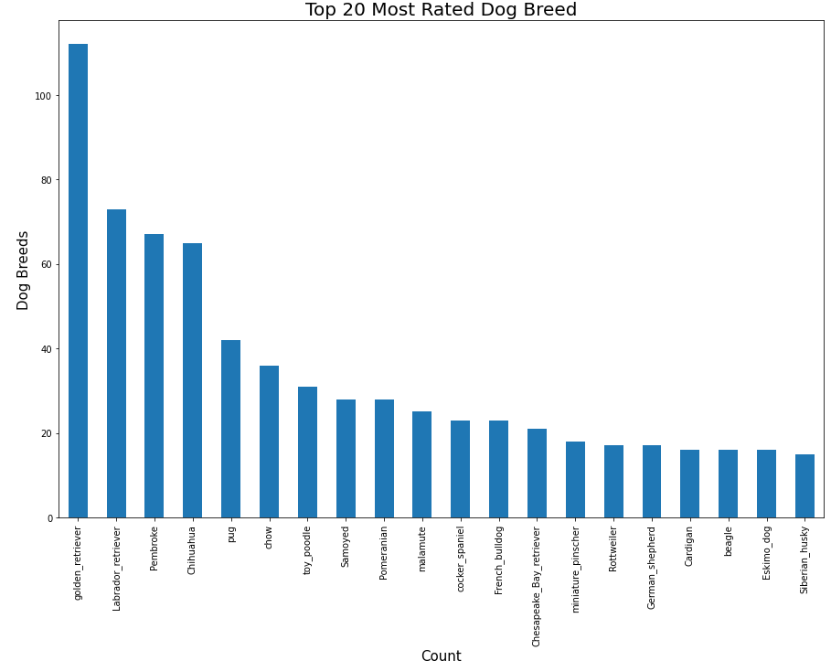

### 2. Most used Twitter source for tweeting

It is not a surprise that Twitter for iPhone is the most used source for posting on WeRateDogs® Twitter account followed by Twitter Web Client which posted less than 3% of the total tweets in our analysis.

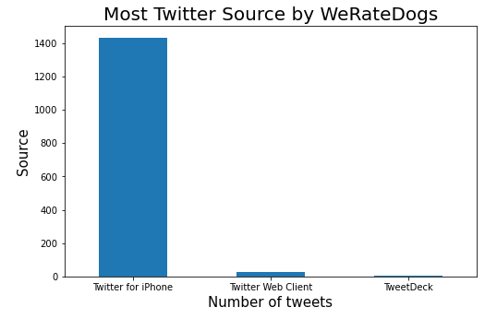

### 3. Popular Dog Names

The most common dog names in out analysis are Charlie and Penny, both appearing 8 times followed by Daisy which appeared 7 times, Tucker and Winston (6), then 9 names appeared 5 times in the list also.

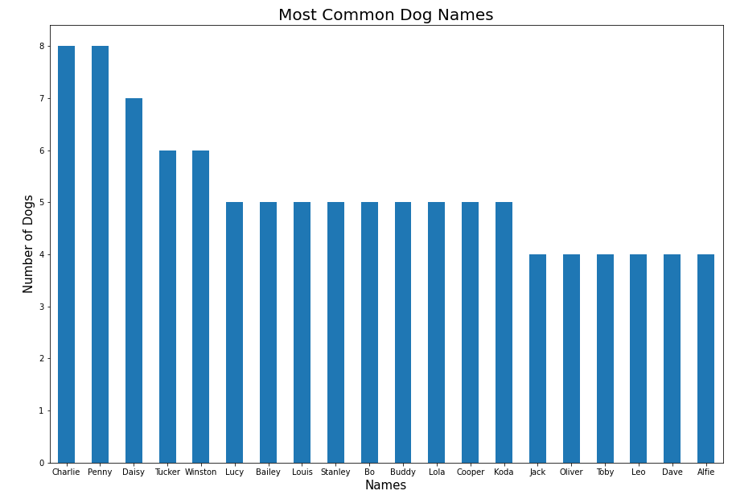

### 4. Correlation between Retweet, Favorites and Ratings

I tried to find the correlation on how the WeRateDogs® dog Ratings affects how people Retweet and Favorite the tweet using a Correlation plot. I generated a Seaborn Heatmap using the correlation data.

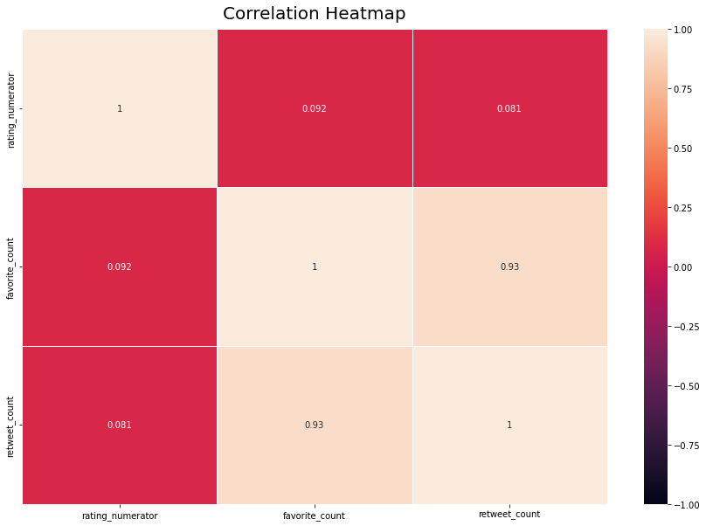

My findings are that there is no relationship between the Retweet counts and Favorite counts with the Dog ratings. However, there is a strong correlation between Retweet counts and Favorite counts.

