Phase-4 Project

Quiz-App-OutPuts

GitHub Link: https://github.com/vitalnaik/Phase_4_trainer_AmarjeetArora.git

* UI of Quiz-Application

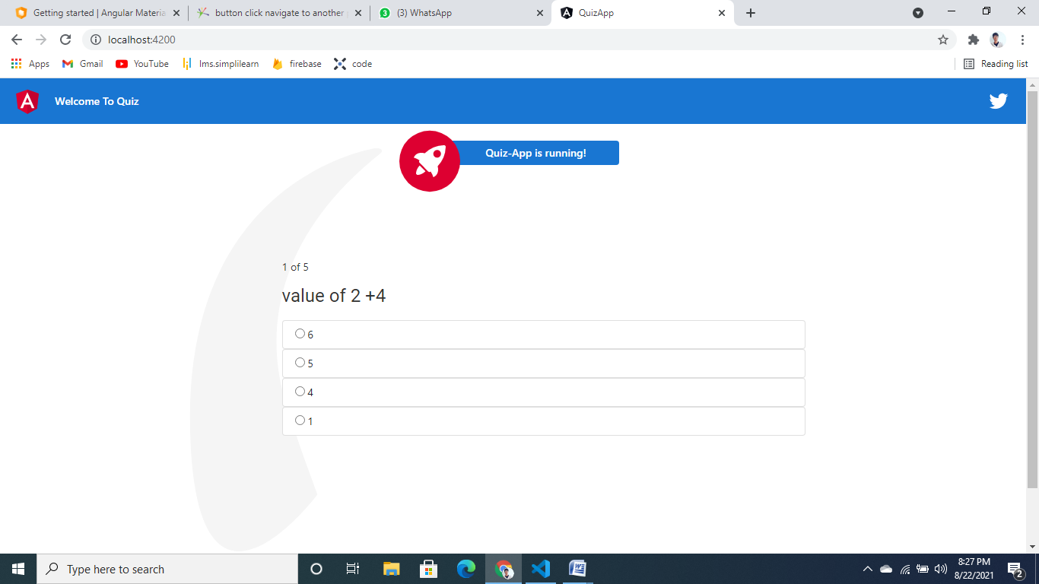

* Selected Correct answers displaying with green background

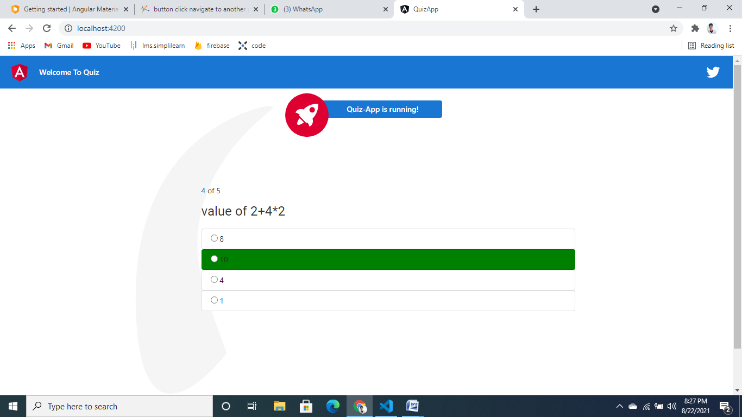

* If User selects wrong answer it displayed with red Back-Ground

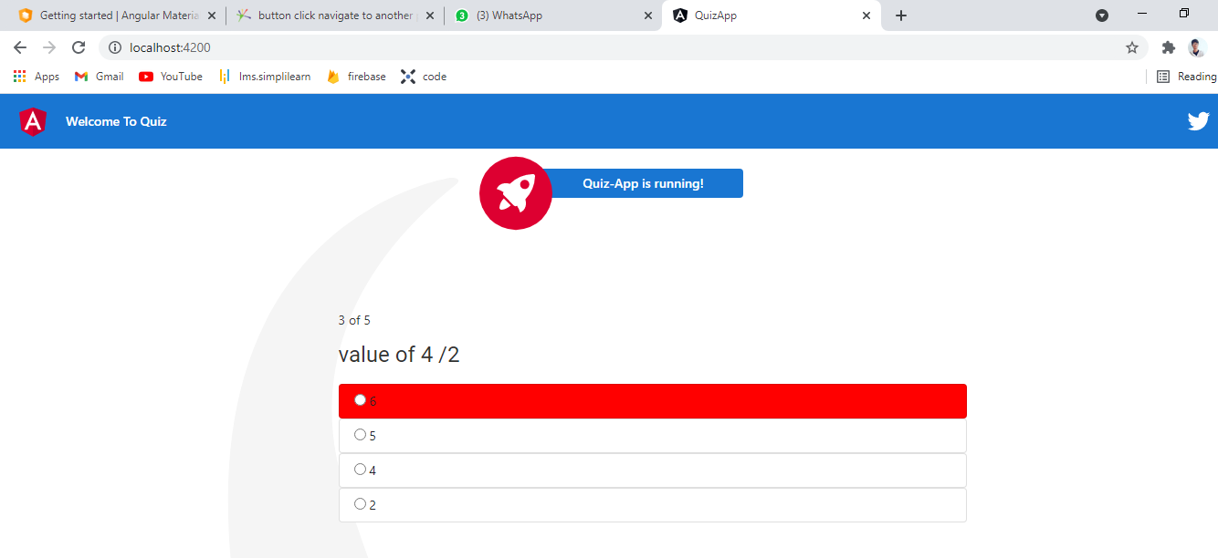

* After completing Quiz User navigated to results section of Application

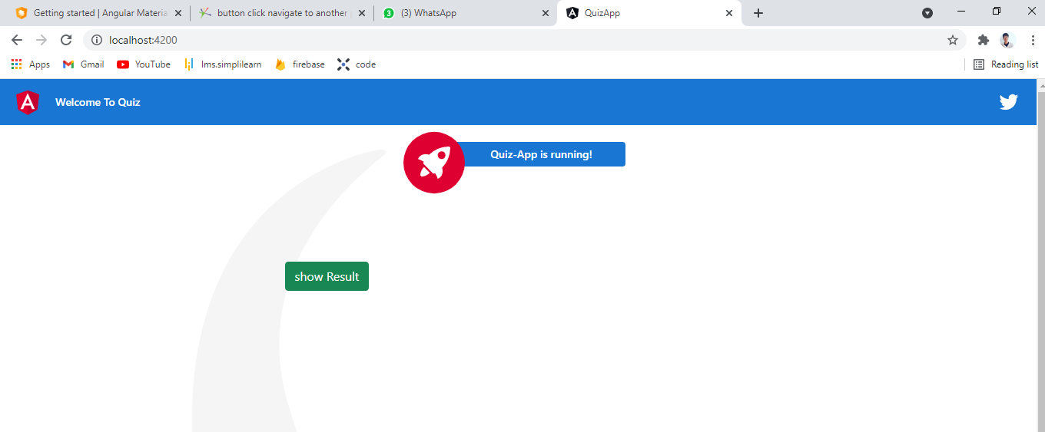

* After clicking on show results button Results will be Displayed with no.of correct and Wrong Answers That User has Entered..

