Result of files in directory and create file option

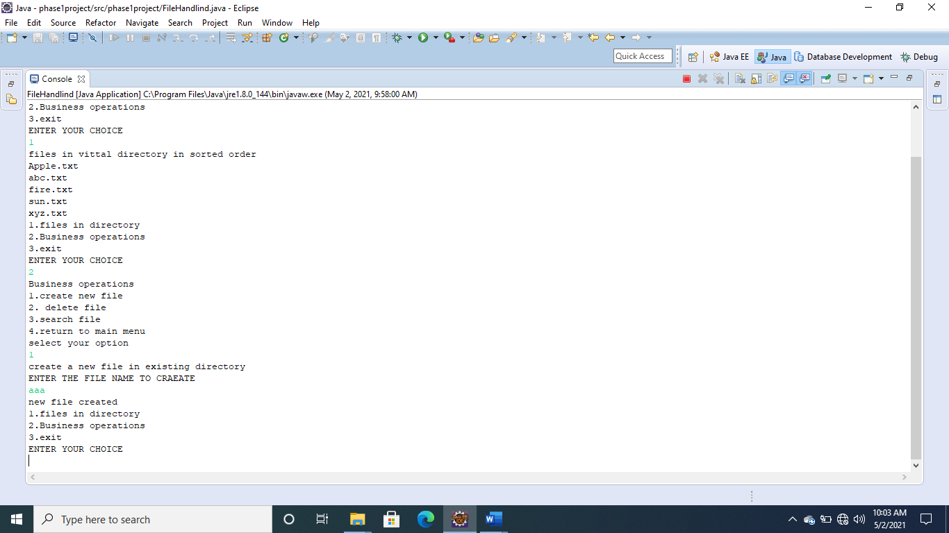

RESULT OF DELETE AND SEARCH OPERATIONS:

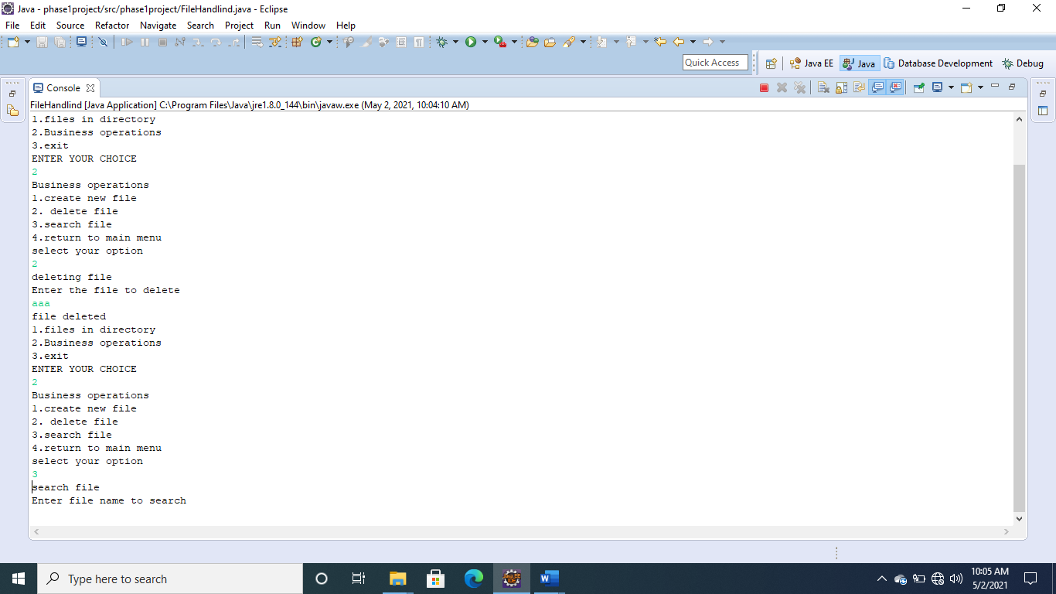

RESULT OF EXIT FROM MAIN MENU:

