Assignment-03

**Problem Statement:**

Customers who are Accessing the storefront out from Karnataka they shouldn’t able to place orders (There should no Shipping methods).

**Solution Statement**:

* In Business Manager navigate to merchant tools > Customer Groups
* Make a Dynamic Customer Group with Include Condition should like, Region code != KA
* Navigate to Merchant tools > Shipping Methods

in each and every Shipping Method at Customer Group Section Add Dynamic Customer Group which we have Configured with our Conditions that are Geo Locating

* Test the Storefront, you will witness that under shipping methods no method will be appeared.
* Thus, we can achieve Solution for the Problem Statement.

**Screen-Shot**:

* Dynamic Customer Group

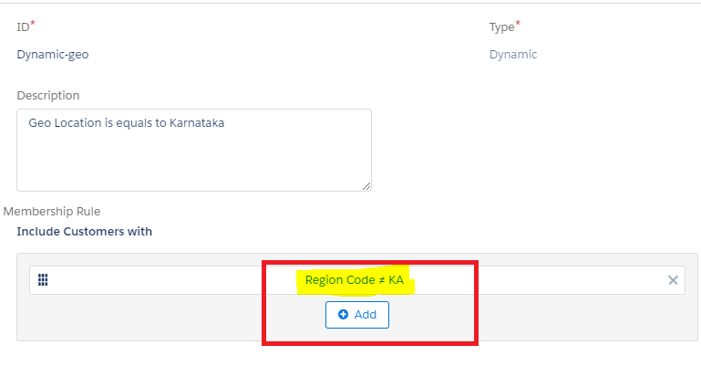

* No Shipping Methods for Customers who are out Accessing site from Outside of Karnataka

