**Assignment-01**

**Problem :**

* Define Pre-Order and Post-Order with Appropriate Example..?

**Solution:**

**Pre-order :**  If a New Product is not in Stock at Present but going to launch on Some of following Dates then we can Mark that product as Pre-order.

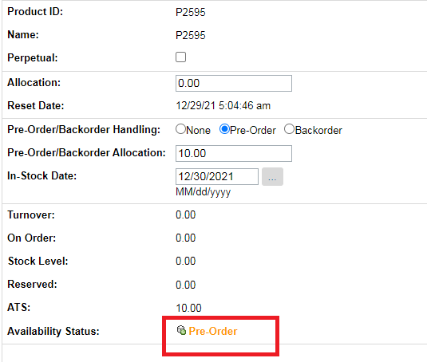

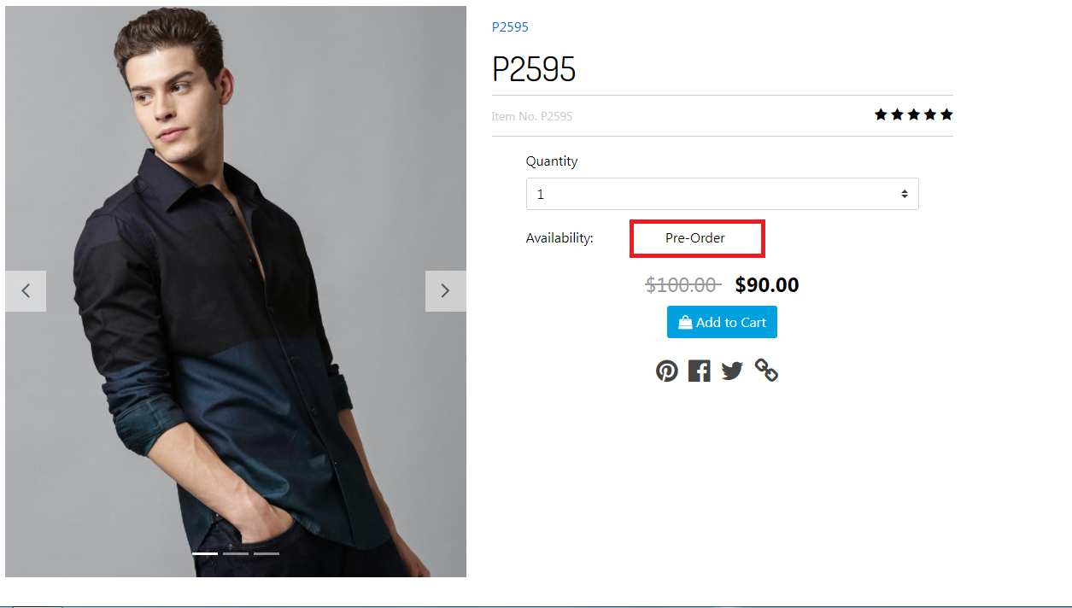

**Post-order:**

If an Existing Product is Out of stock at present but going to launch on following Dates then we can Mark that product as Back-order.

