Assignment-02

Problem:

Create a Product with ID =Employee ID, Image, Name, Description, Inventory,

Product list Price =100 and Sale Price=90

**Solution:**

* Merchant-tools > Products > new

And Create Product add Image, ID=2595

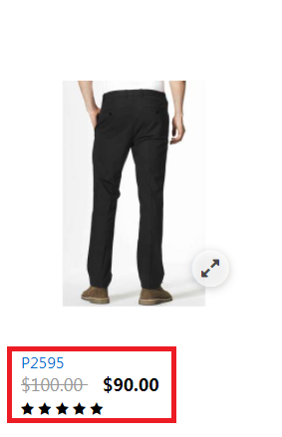

Product Details in Business-Manager :

