**Assignment-03**

Problem:

* Create a Product with ID =Employee ID, Image, Name, Description, Inventory,

Product list Price =100 and Sale Price=90

* Create a Category and assign Product you have created
* Show Category in Mega-Menu
* At Checkout “Shipping Charge should be ‘0’” for product that you have Created.

Solution:

**Solution:**

* Merchant-tools > Products > new

And Create Product add Image, ID=2595

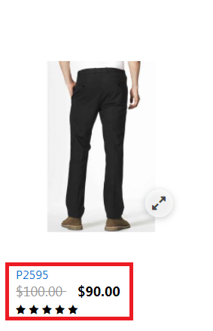

Product Details in Business-Manager :

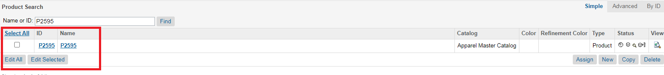

* Created a category with Name =P2595 and Showed it in Mega-menu

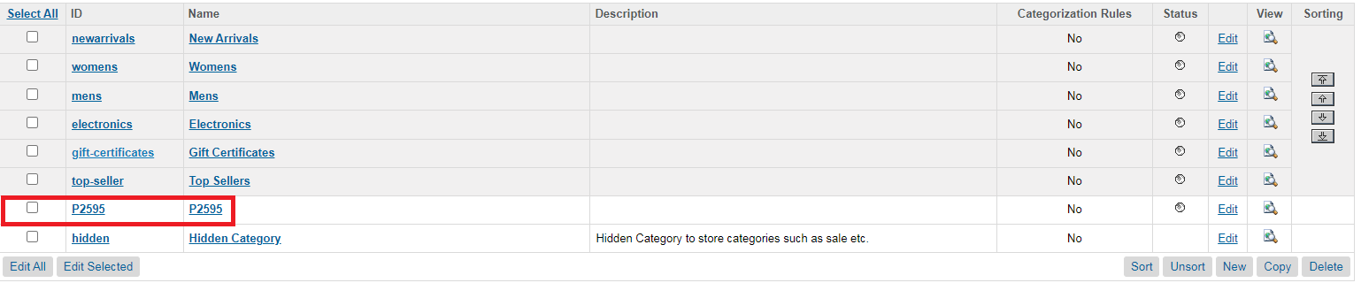

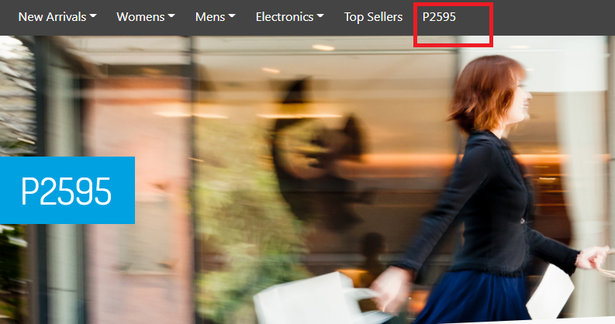

* I have made Shipping Cost=0 for Product with ID=P2595 (Which I have Created).

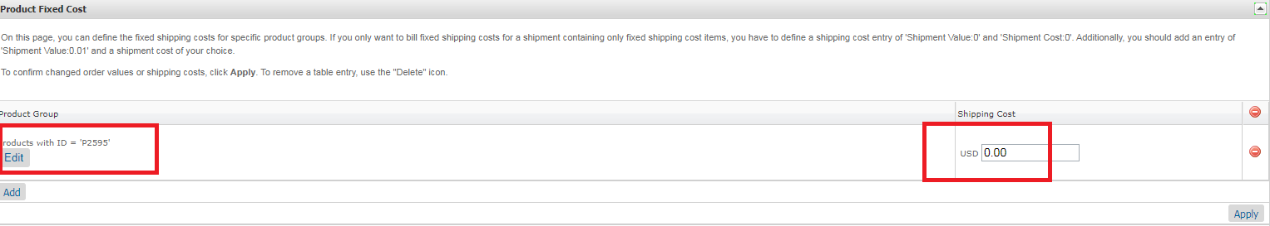

* Cart at Store Front with Shipping Charges=0

