Assignment-1

**Problem:**

**Create a Shipping level Promotion which will give Free-Shipping for more than 1000 USD , However your Shopping Bag should show the Approaching discount message Starting from 900USD**

**Solution:**

* Create a Promotion of shipping class and Check the Alert and enter Promotion Condition as 100 USD

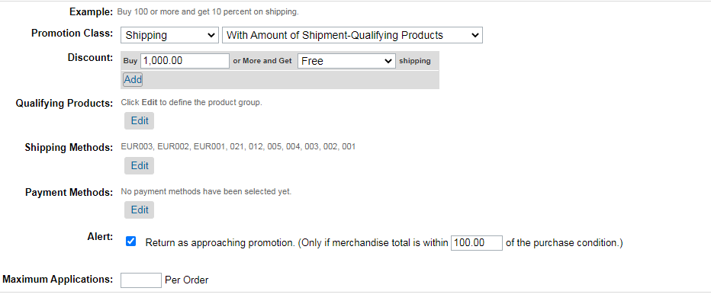

* Showing Promotion Shipping-Pro with alert Message on Store-front Starting from 900 USD.

