Assignment-01

**Problem:**

* Create a Custom Cookie with EdiThisCookie Tool
* Read that Cookie with the help of Controller
* Render to the Website, which you valued in Cookie , using <redirect> Tag and Http Message For the Rendering should be “302”

**Solution:**

* Create a Cookie with EditThisTool in Browser

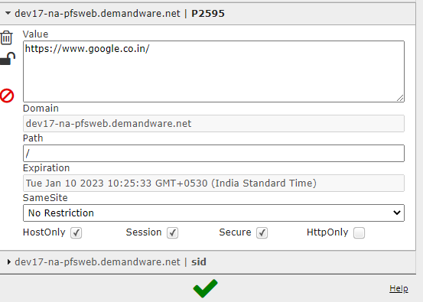

* Create a Controller Cookie.js

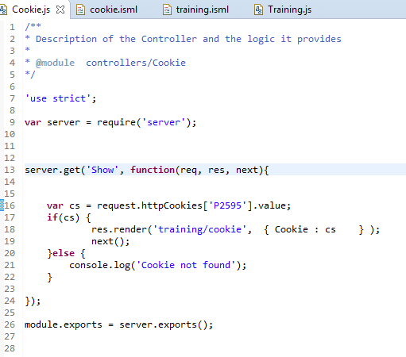

* Create an ISML cookie.isml with redirect tag. It will navigate to the website which we valued under Cookie Creation

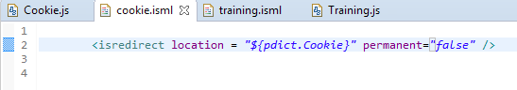

* Controller Redirected to the google website with Http Message “302”
* To see the Http message Copy the Controller URL in Store-Front and paste it in Browser then will witness the HTTP message = “302”