**Assignment-02**

­Problem:

* Create a Content-Asset
* Read this Content Content-Asset through the Controller and Render it to Store-Front using Custom Tag <iscontentasset>

**Solution:**

* Create an Content asset in B.M

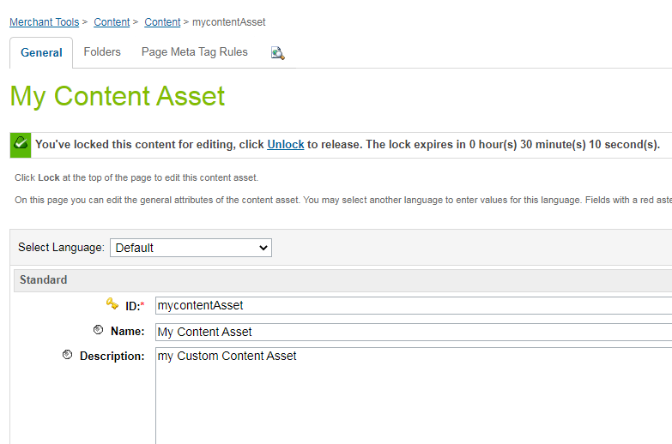

* Create a Controller ContrentAsset.js

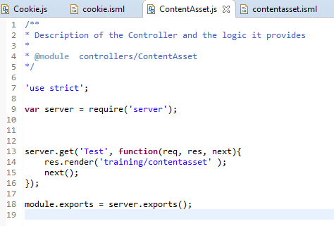

* In rendering Template Contentasset.isml

1. For header and Footer <isdecorate template="common/layout/page">
2. <isInclude template = “ /components/modules“> for custom Tag <iscontentasset> for Custom Tag <iscontentasset>

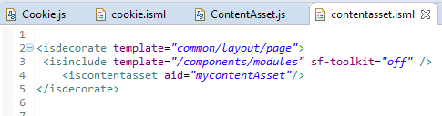

* Open Store-Front and Enter Your Controller&Route, you will able to see rendered ContentAsset on webpage.

