Assignment-01

**Problem:**

* **Take at-least Two Screen shots of Tags isIf, iselseIf, isElse, isSet, isRemove**
* **Mention Route and Controller From which the ISML is being called that consisting of these Tags**

**Solution:**

1. Isif

**Example-01:**

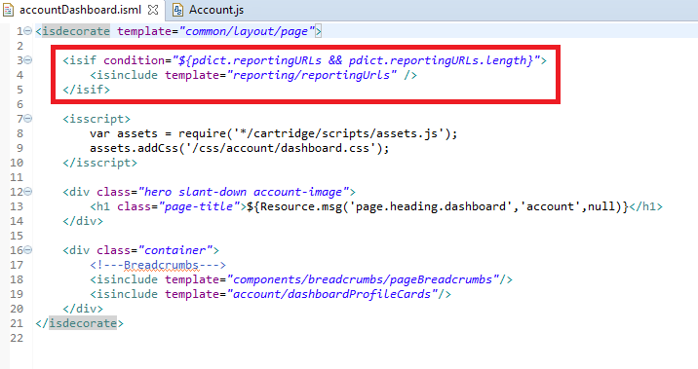

**Conclusion:**

* This ISML is Called by Controller-accountDashboard
* Route – Home

**Example-02:**

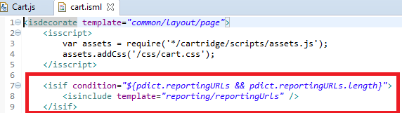

**Conclusion:**

* This ISML is Called by Controller-Cart
* Route – show

1. **iselse:**

**Example-01**

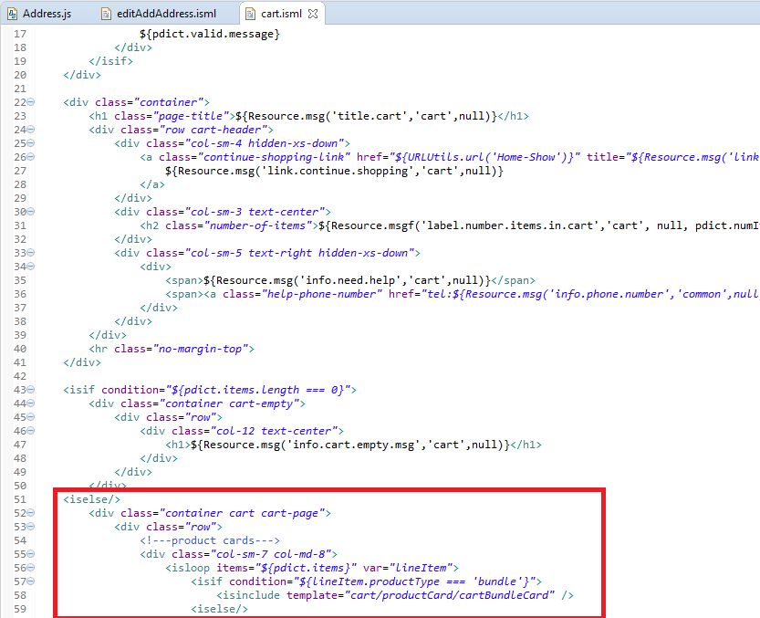

**Conclusion:**

* This ISML is Called by Controller-Cart.js
* Route – show

**Example-02:**

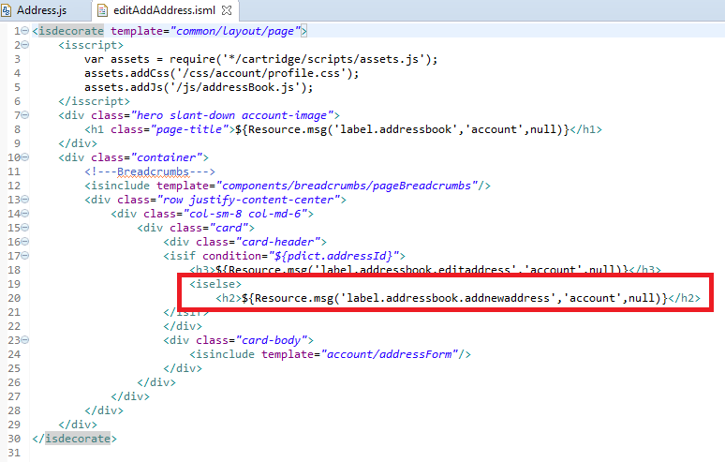

**Conclusion:**

* This ISML is Called by Controller- Address.js
* Route – AddAddress

1. is-else-if:

Example-01:

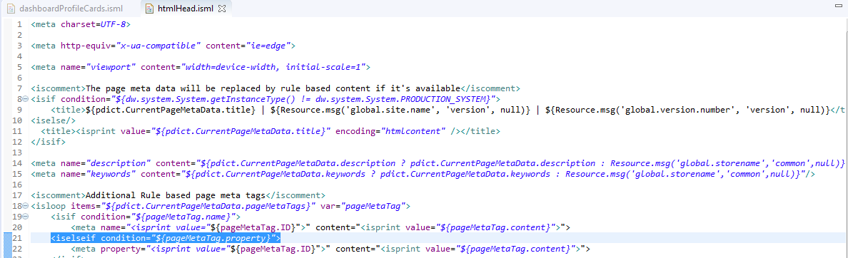

**Conclusion:**

* No Controller found.

1. isSet:

Example-01:

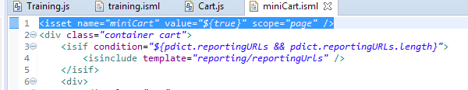

**Conclusion:**

* This ISML is Called by Controller- cart.js
* Route – MiniCartShow

Example-02:

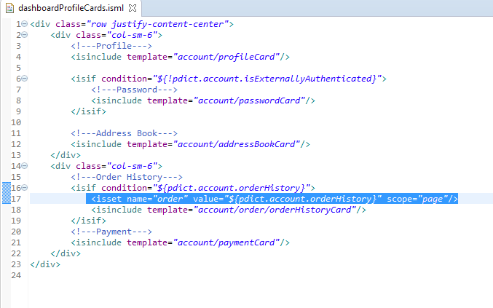

**Conclusion:**

* No Controller found.