Assignment-01

Problem:

* Read The Data From Product Object Through Controller and render the Product Details to Your Store-Front

Solution:

* Code in Training.js Controller

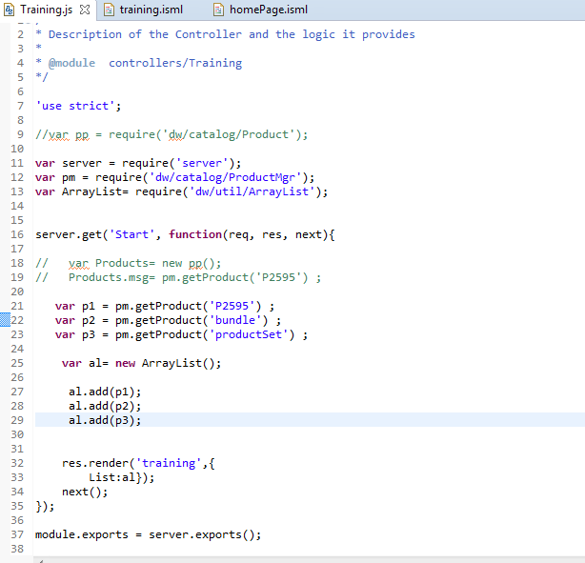

* Code in training.isml

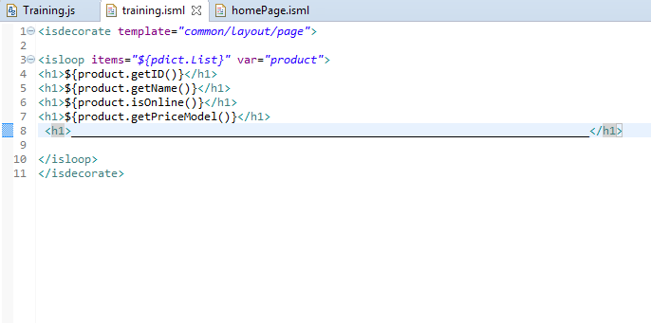

* Product Details at Store-Front

