Assignment-02

Problem:

* Your Product Details Page is Subjected to Have the Header and Footer Sections

Solution:

* Code in Your Product Details Page that is training.isml

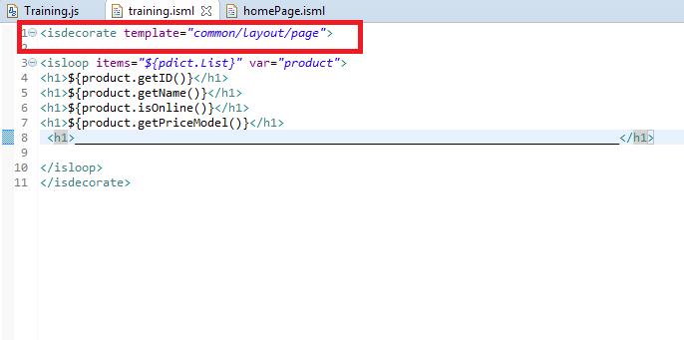

* Store-Front Screen shot with Header and Footer

