**Assignment-02**

**Problem:**

* **Create a Decorator and use it for your Custom Slot**

**Solution:**

* In catlanding.isml add Tag <isdecorator>

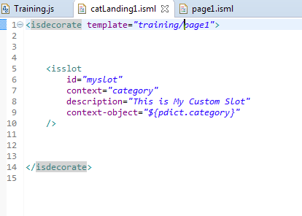

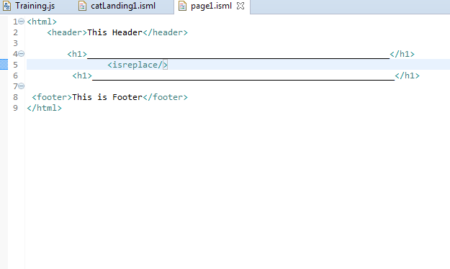

* On Store-Front you will able to find Header and Footer

