Assignment-03

**Problem:**

* Create a Cookie with name = your Name and ID = Your EmployeeID

**Solution:**

* Create a Controller which redirects to an ISML

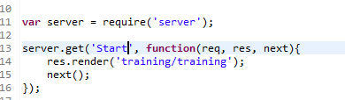

* Create Cookie is ISML Using <iscookie> Tag



* In Store-Front you will able to see Cookie Created with name and ID = P2595 and value = Sabavat Vittal Naik

