# Intro

Project 365scores-test

Domain: Sport, Gambling, High-Load

POC Link: <https://github.com/vitalybibikov/365scores-test>

Short notice: all the numbers below might differ from reality, as I remember, that it’s still a test, so the analysis was short.

# Short Description

The system that is going to be developed, should work with multiple sources, that own sports activities, parses them or retrieves the information from them on a scheduled basis. The data, from the system, should be parsed and stored, for further user access via REST API. The sources are being queried on a scheduled basis (e.g., every 10 minutes/hour/day) for an upcoming match and every second for a living match, in order to show to the end users, the most up-to-date info.

# Requirements:

Each game in the list should contain the following fields:

• Date and Time

• Sport Type

• Competition’s Name

• Team Names

The system needs to store the games and identify a unique game and avoid duplications

The unique identification of a game should be using the sport, competition, teams

(regardless of their order) in a time frame of 2 hours

The list of games should be exposed via an API for querying

## Performance requirements:

• The system needs to be distributed

• It should be designed to support high scale (with potential of growth) :

* It should support high throughput of incoming messages and always be available to get more updates, even if it’s currently busy handling them
* The API need to support growing number of concurrent users

## Sources:

# <http://www.livescores.com/>

# <https://superplacar.com.br/>

# <https://futbolme.com/>

# Initial Domain Analysis

1. The amount of sources: 50 + (ballpark) and might grow.
2. The amount of sources per one live match: at least 10, 10-20.
3. The amount of events per 1 game: 2500 on average, calculated based on 365scores site.
4. 1 event every 2 seconds on avg.
5. **30-50 types of events** per one game type (based on soccer and tennis)
6. **12 types of sports** is supported at the moment, might be 2 times more with the development of the system.
7. Types of Apis: expected both HTML parsing and API calls to sources.
8. 60-150 soccer games happen during the 2021 Jan a day
9. Ballparking around 100 games per day for a sport type (might change after COVID or in High Season).
10. Around 50-80 games might be online simultaneously.
11. Around 1000 games a day should be handled, with a possibility to support more.
12. Some games need to be tracked, e.g. 180 days prior to it’s start.
13. Checking interval for not-running game is 10 minutes.
14. 1 000 000 active users, a day.
15. Spikes up to 5 000 000 users simultaneously.

# System:

There are 2 types of applications here, that can and should scale independently from each other.

1. **Parsing Engine:** System, that loads, parses the data has a scheduled number of calls that should not depend on user’s activity. It only depends on the number of matches per day in the system as well as on the amount of sources that are being handled by the system.

So its growth relates to:

* 1. Number of matches per day.
  2. Number of sources per a competition.
  3. Amount of handled Sport Types.

1. **API:** An API that provides users with the newest information regarding that matches.

Its load is dependent on:

* 1. The number of users (popularity and amount of sport’s handled)
  2. Daily activity (which region prevails)
  3. Major Competitions, like Cups, Olympics and so on.

**Concluding:**

Two types of applications, that consequently depend on each other, but scale independently, thus different technologies can be used to handle the load.

# Load:

Estimated number of requests/events, handled by the system:

## Parsing System Load:

1. ~ 10 000 000 calls to query the upcoming matches a month
2. ~ 81,000,000 calls to running games a month
3. ~ 100 000 000 calls to sources in total a month
4. 100kb – 10mb - memory footprint to parse 1 page, depending on the page.

## API System Load:

1. ~80 000 000 messages from Parsing System, after deduplication.
2. 30,000,000 active users a month
3. 3* 10(9) of events per month - Let’s say 1 user is interested in 1 match, querying the site every 5 minutes, each event triggers 5 another events (sockets, message bus, http calls, logs, etc.)
4. The system must be resilient and fail tolerant, thus duplication of nodes is required.
5. The system might be geo-redundant

# High-level system diagram:

As we have to different types of systems, that scale differently, the best option is to separate them not only logically, but also physically. We will gain in the amount of time, spent on the development – as 2 independent systems, can be developed in parallel, without any common setup phase, but also in the amount of money saved.

[Chart](https://lucid.app/lucidchart/invitations/accept/d9000bcf-87eb-41f0-a441-1acc3f55b9bf)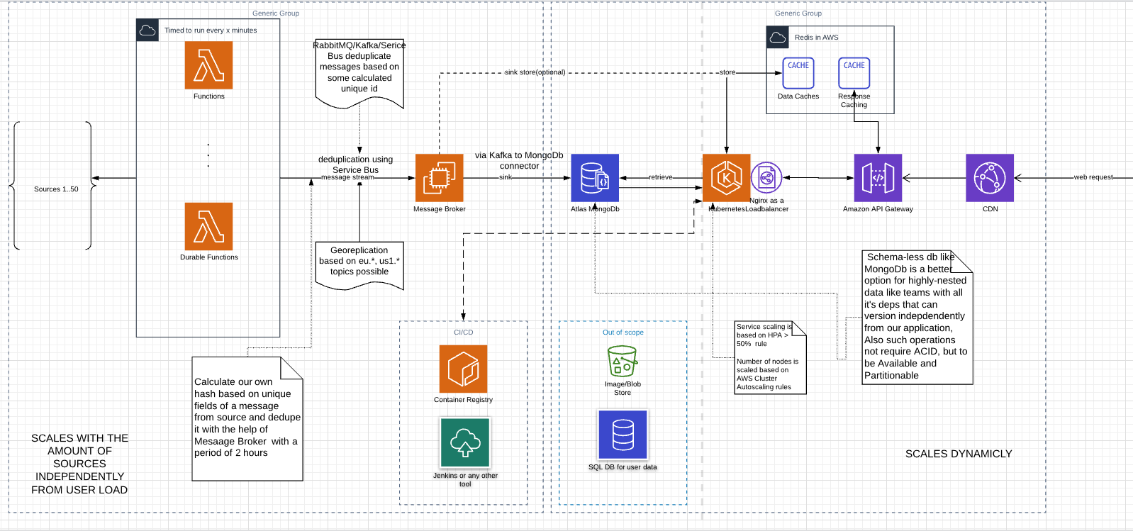

1. **Functions** – any type of highly-scalable FAAS solutions, e.g., Azure Functions in this case.
   * Possibility to develop locally
   * Ideal for streaming of large volumes of data from multiple sources.
   * Highly scalable, fault tolerant
   * Ability to schedule many jobs, without using Schedulers.
   * There is no need in **string.Intern()** and other optimizations related to LOH (Large Object Heap), when working with strings, that > 85kb, due to the short-live.
   * Native support of RabbitMQ/Kafka/Service Bus brokers.
   * Ability to host and to use them in your own cluster if required – KEDA Initiative, e.g. during architecture evolution.
   * 1 function might call all the sources, if required.

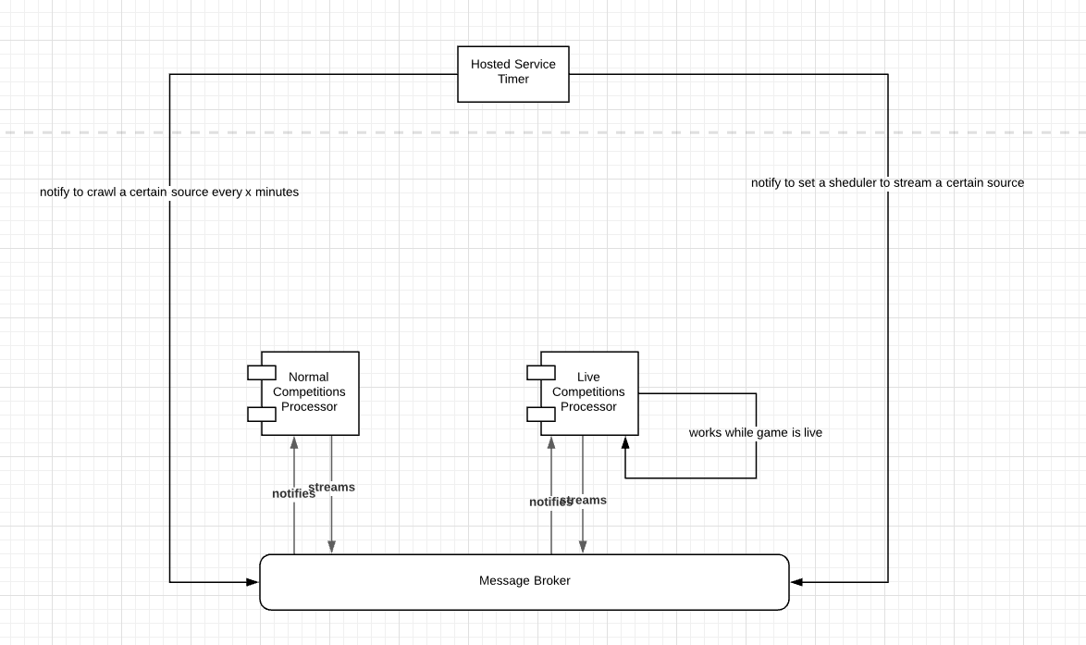

1. **Message Broker: Service Bus** (RabbitMQ/Kafka has this kind of functionality, while Amazon MQ lacks) – Message Broker here is used to stream messages asynchronously to its processors, that might schedule independently from Functions. As during this phase, we will parse and retrieve enormous amount of duplicates (same event, same event from another source), Broker will serve here not only to balance the load, but also to de-duplicate. (1. <https://docs.microsoft.com/en-us/azure/service-bus-messaging/duplicate-detection>, 2. <https://github.com/noxdafox/rabbitmq-message-deduplication> ).

This is important as **all not-live data expected to be duplicates**, while only some live-data might be them. This mechanism can be extended and implemented manually, and will be described later. In this case, we can store MessageId up to 7 days out of the box.

1. **Database: Mongo DB,** hosted in Atlas. DAAS are easier to use and maintain, when we have relatively small teams.

Here we have several factors to choose NoSQL over SQL:

1. We are not the owners of the source data, thus they might change, inflicting changes on our side.
2. Requirement to replicate database under load – it is far cheaper on NoSQL DBs, as they are AP/CP type.
3. We have different almost same data, while they might have minor differences in the structure. In that case best suitable is document-oriented types, as we might not change the schema, while adding multiple newly supported types of sports and events, or we can version them quite easily.

**Alternative:** Another option here would be to use **RavenDB:**

1. Same benefits as MongoDB, but natively supports C# - linq as a default query language would cost less on development time.
2. If we are going to save 1 competition not as a document, but as a set of events (which it might be), it’s the better option over MongoDb, as it’s natively supports Event Sourcing. - match is a series of events.
3. DDD compatible.
4. **Kubernetes cluster. -** is used to host APIs, actually, pretty the same as a set of owned VMs, but has an ability to replicate/duplicate/handle failures out of the box. As well as an ability scale VMs or pods (services) under load automatically, using HPA and Cloud Apis. Pricing is the same as for VM Scale Group, but required additional configuration.
5. **Nginx** –known Load Balancer, the simplest solution here, can serve as a Reverse Proxy, might be replaced with Azure API Management/Kong/Tyk or any other engine. Will load balance the load between hosted API services, if Service Mesh is not used. Can be replaced by Istio as well later on.
6. **CDN, Redis Caches, Gateways** might be used if required to deliver the functionality faster to the end user.

# Pricing Considerations:

## Functions:

Bases on preliminary analysis, calculated for Azure Cloud, the initial assumptions are as follows:

Memory consumption: **128-256 MB** per function app.

## Normal Competitions

Running time per call: call to the source around 200ms-300ms, processing and parsing around 200ms, pushing to the queue depends on the amount of messages, about 1.**5 sec in avg**.

3 sources per 1 upcoming match.



Number of calls to analyze upcoming competitions: ~80 000 000

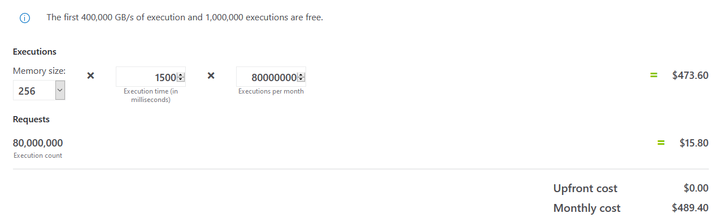

## Live Competitions:

Number of Sources: 20

Number of Live competitions runs: 81 000 000

Number of Functions Involved 3

Average running time (40 ms + 210ms + 30ms) /3 : ~100ms

Total calls:

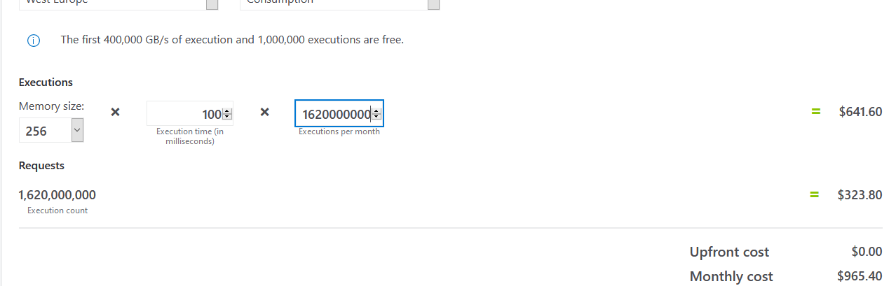

We can start from 7 nodes default configuration, that can scale up and down dynamically, depending on the load.

## Cluster:

Minimally we need (approximated):

3 nodes – to support Production environment when not under load.

2 nodes – to support QA/Staging environments.

1 node – to handle Istio, Pilot and other Service Mesh staff.

1 node – Monitoring and Observability tools, like Grafana, and load balancer.

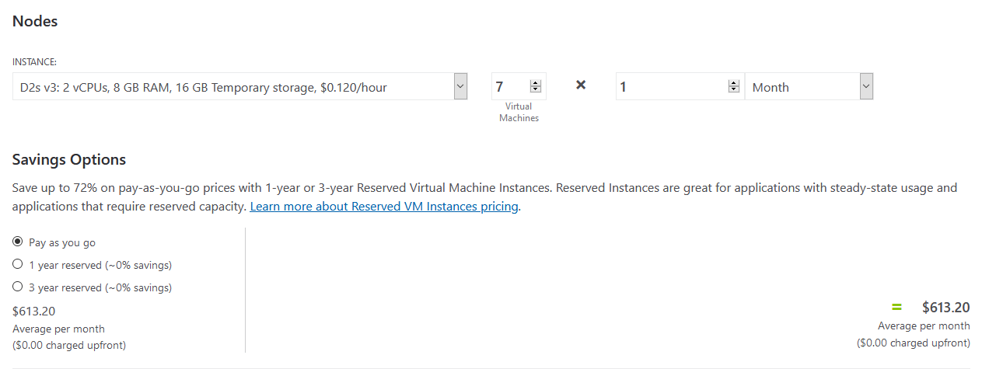

**Compute: $1,168.20**

## The Rest:

MongoDb, CDN, DNS, KeyVault if required, Redis Cache, CI/CD, Container Registry, Package Regeistry, Blob Storages, Service Bus, Logging and Monitoring might be approximated as Total compute load / 2

QA Environment should be added as well in the pricing afterwards.

**~2000 USD + QA + Operations Cost + CI/CD VMs =**

**Total: ~3000**

# Parsing Engine:

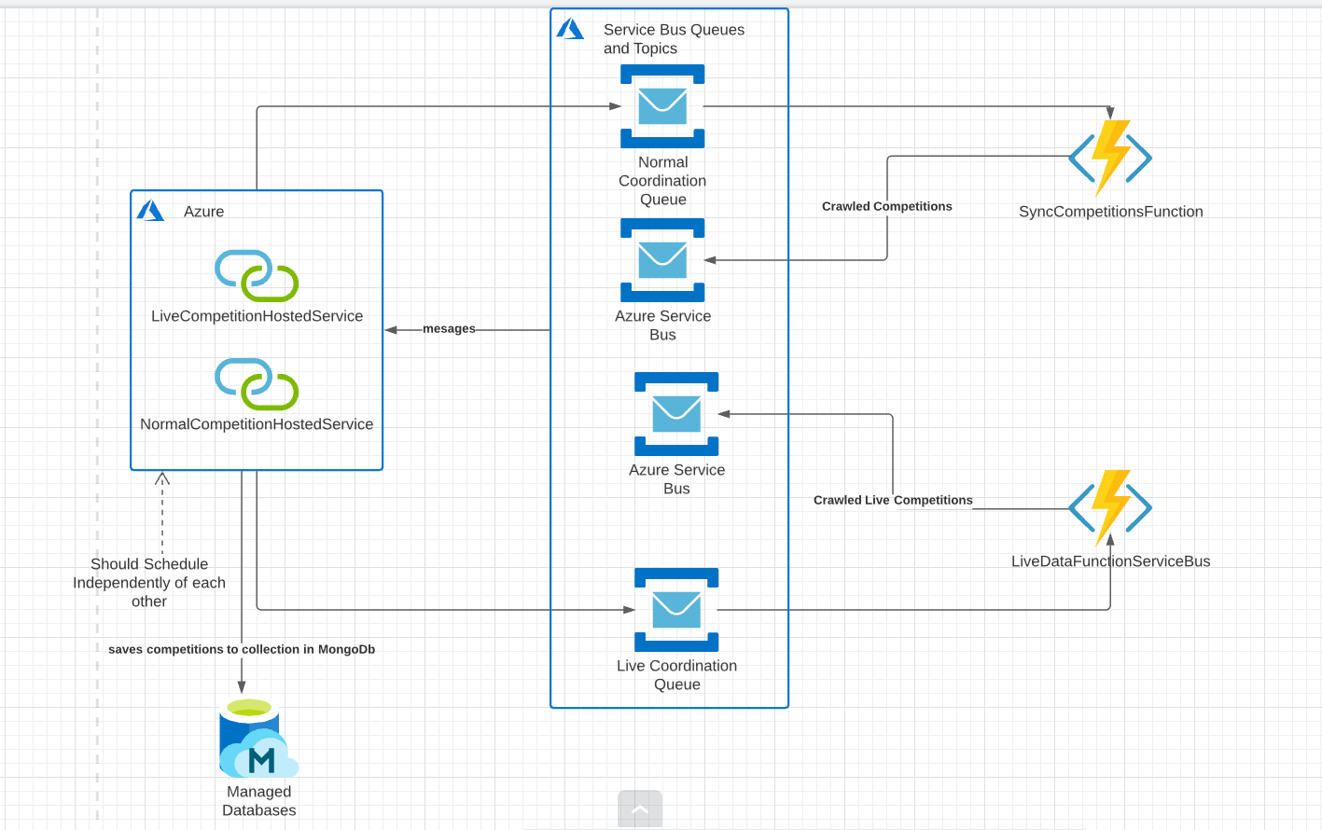

Currently, we have two models of behavior here:

1. Matches in the future, that changes rarely, but should be observed on periodically, let us say every 10min, 1hour or day. These periods are different from those one that we need to have in the app that tracks live matches, so they scale differently and have different logical model.

Can be performed by a normal Serverless Function that can scale almost indefinitely.

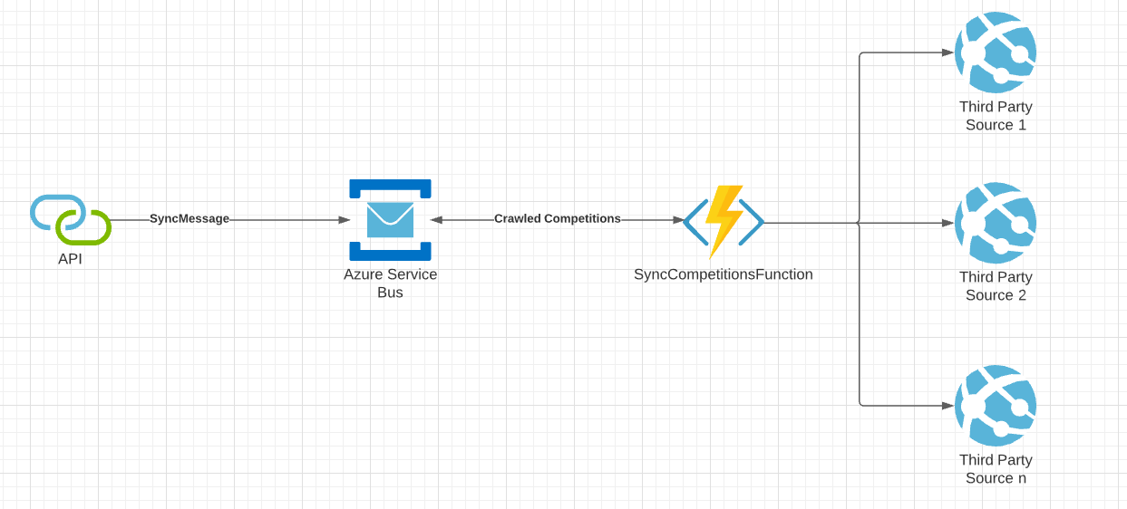

1. Live matches, that are currently ongoing, should be observed every 1-5 seconds with usage of multiple sources. Should be run by Durable function, that triggers, itself, after the signal to do the job was consumed from the broker. Should sleep while waiting. Can be triggered and put to sleep without any external scheduling.

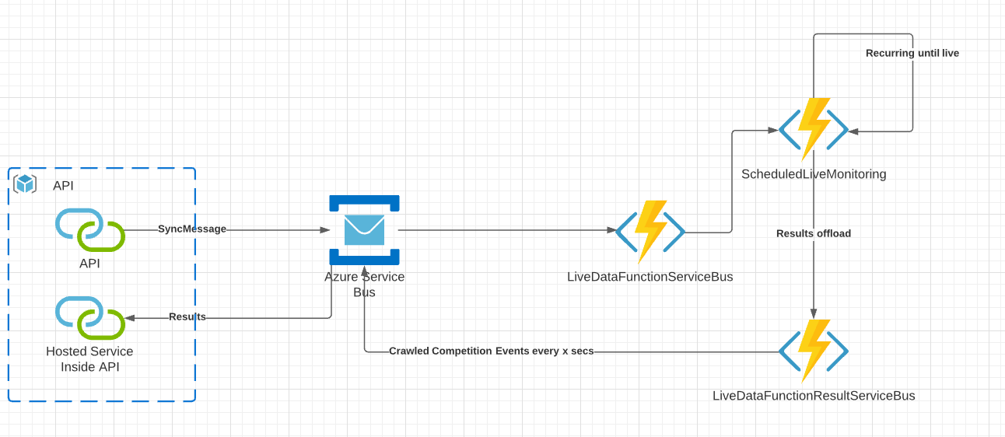

# API:

The application intended to be dockerized and hosted in a set of VMs or Kubernetes cluster. Usage of Kubernetes at the moment if by far the most easiest and common way to work with Highly Available and loaded systems.

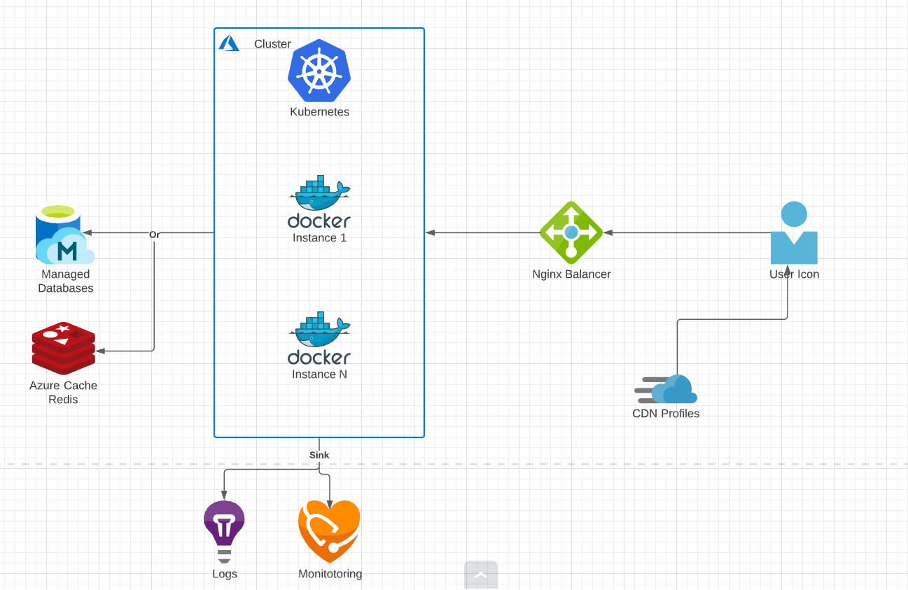

**Scalability** – obtained by HPA’s from Kubernetes when we are speaking about pod scaling, by Autoscaling group rules, when we need to scale the amount of the VMs currently run.

**Reliability** – obtained by usage of Readiness and Liveness health checks in the application, that utilized by the Kubernetes.

**HA/Fault Tolerance** – configuration of the kubernetes Deployment in order to be durable, thus to have replication of the application in different nodes, or even regions, availability also includes an external Gateway/Reverse Proxy, that will balance the load between the pods in K8s.

At the moment, the API should be logically split into 3 applications:

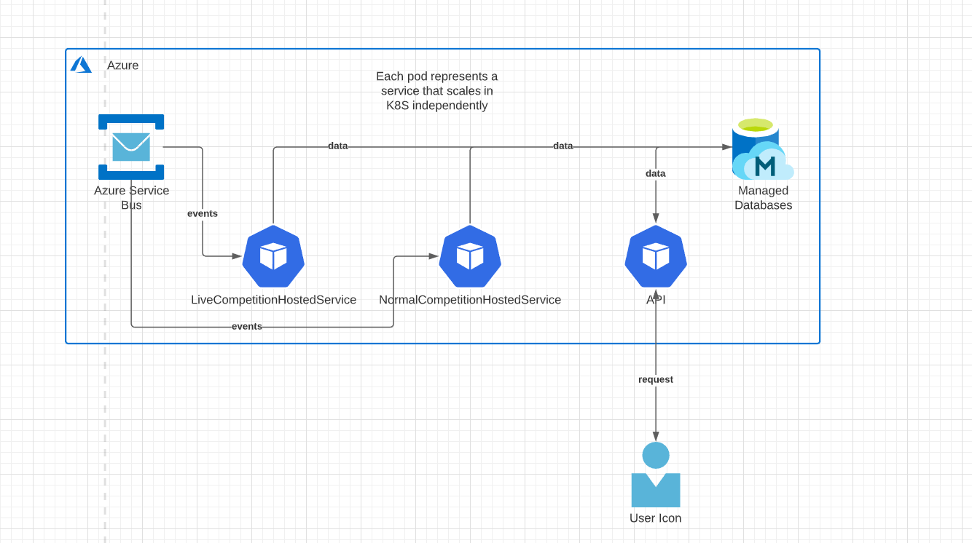

1. LiveCompetitionHostedService – there would be around 80kk of the messages, so this should be placed in a separate pod.
2. NormalCompetitionHostedService – this hosted service won’t be handle lot’s of messages, normally can be placed together with the API.
3. API – the api itself, should spike when under user load.

All the applications should communicate with 1 database, as logically they are 1 microservice, even that physically are split and containerized separately.

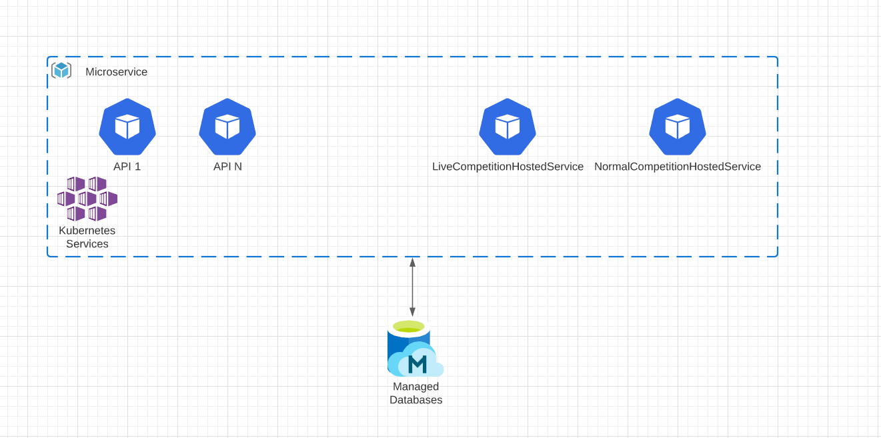

# Development Spec:

## Processing:

Both Processing functions can be triggered by a message from Broker, that owns basic information regarding what has to be triggered and where:

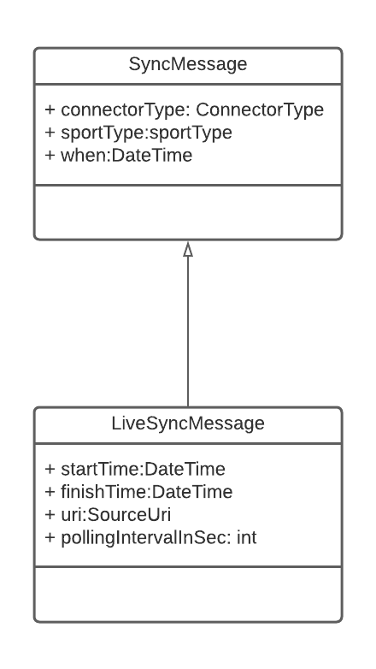

Both functions can utilize the same logic, abstracts of which can be shared via Nuget package. As the apps are relatively small, it’s possible not to split the logic at the moment, for the simplicity of development and refactor it later, when the abstractions will lay down.

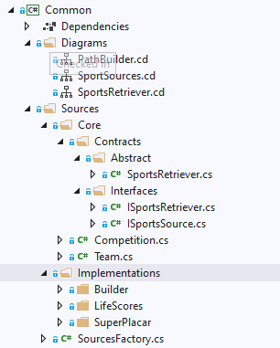

1. Each source, which information should be retrieved should have it’s own SportsRetriever. Here we have 2 implemented for LifeScores and SuperPlacar.

2. Each Retriever can have a set of sports, that it only knows, how to retrieve and process – as one html (or API) parsing logic can be different from another one.

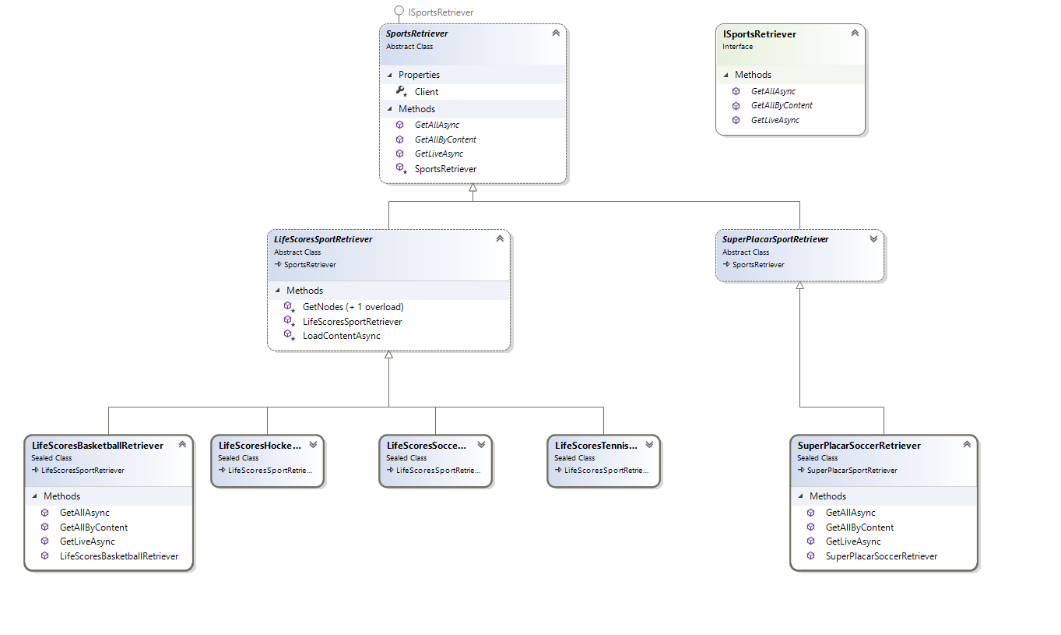

As every sport and retriever implements its own logic of parsing, we need to implement a way to encapsulate Path Building behavior into the retriever.

As one sport usually occupies different page on a different url.

IPathBuilder – path builder interface that implements only 2 methods, 2 build Concrete object of Retriever in dependence of the sport specified. Diagram can be viewed below.

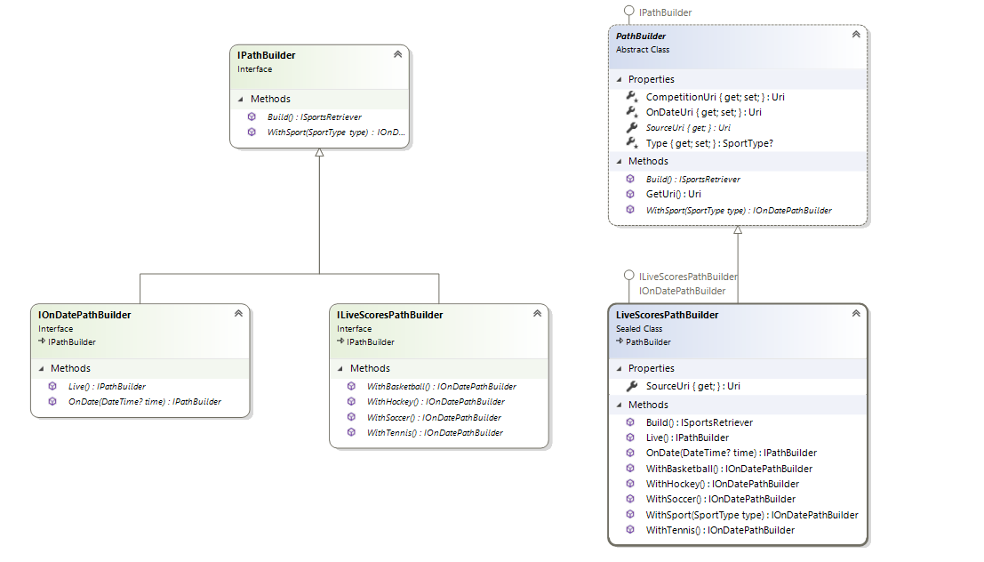

SourceFactory should be injected in Functions ctor and create the source, based on a message from the broker:

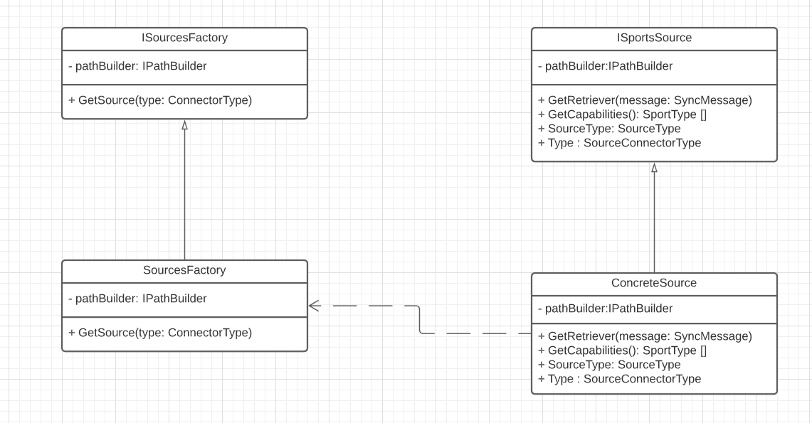

The basic project structure and and example can be found in the POC.

While Normal Competition processing is pretty obvious and is a simple message – result pattern, the live app function requires additional details to be described.

Live Function Sequence Diagram describes the behavior of the function app itself:

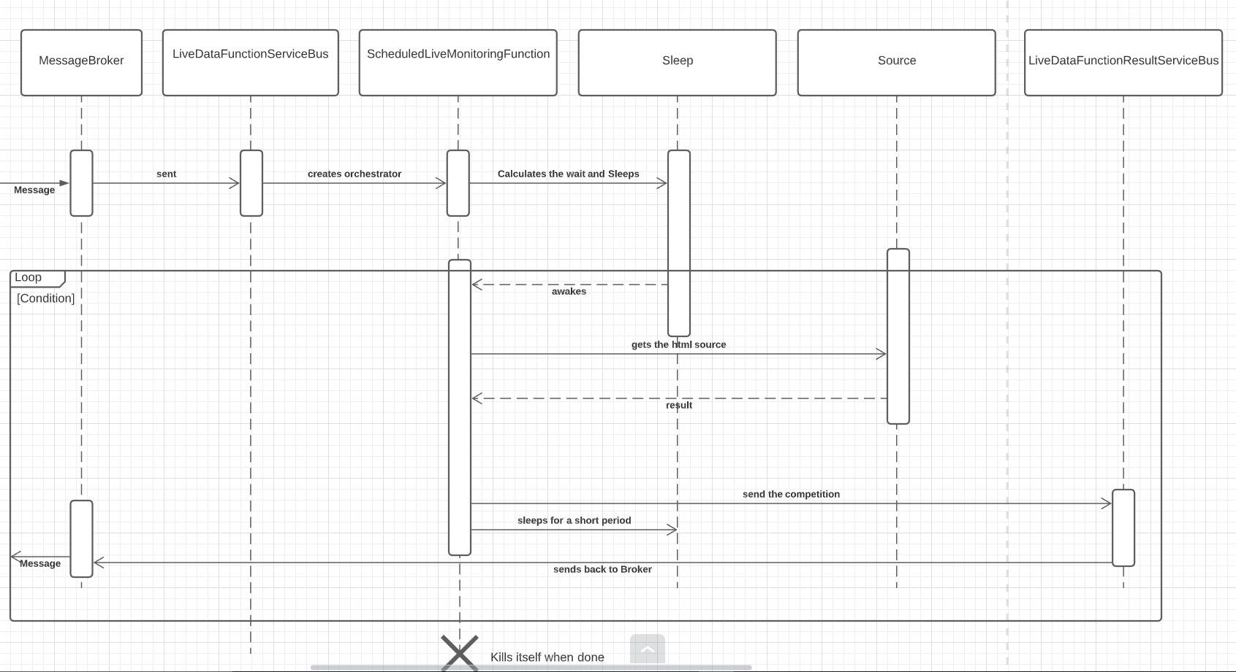

[Source](https://lucid.app/lucidchart/invitations/accept/2d28f1d0-6485-42d2-9578-152f78997db6)

Deduplication:

Currently, we have large volumes of messages from both Normal and Live Processing functions. Each of which might and will send duplicates. We can reduce the amount of them taken by Hosted Services by adding a hashing function to our messages. So, if we believe that Uniqueness is a matter of those fields of **Competition** object: Teams, SportType, Time and Name.

We can implement a solution to obtain some kind of uniqueness, below is a naïve implementation that has to be changed prior usage in production:

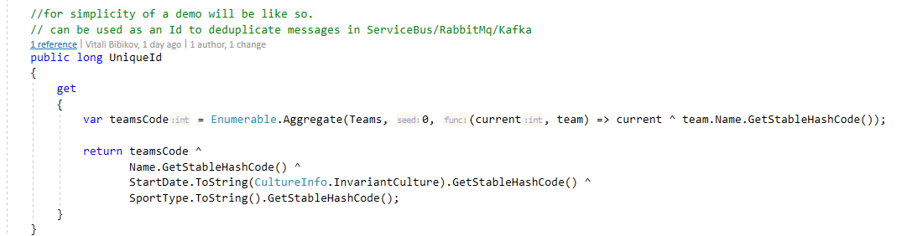

# API:

## Project structure:

Should be organized with accordance to [Clean Architecture](https://docs.microsoft.com/en-us/dotnet/architecture/modern-web-apps-azure/common-web-application-architectures#clean-architecture):

So, the basic structure have to be as follows:

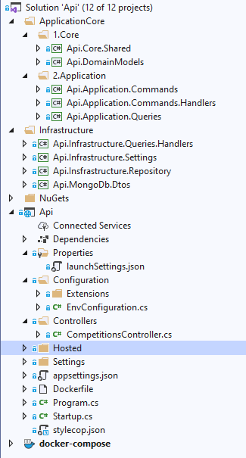

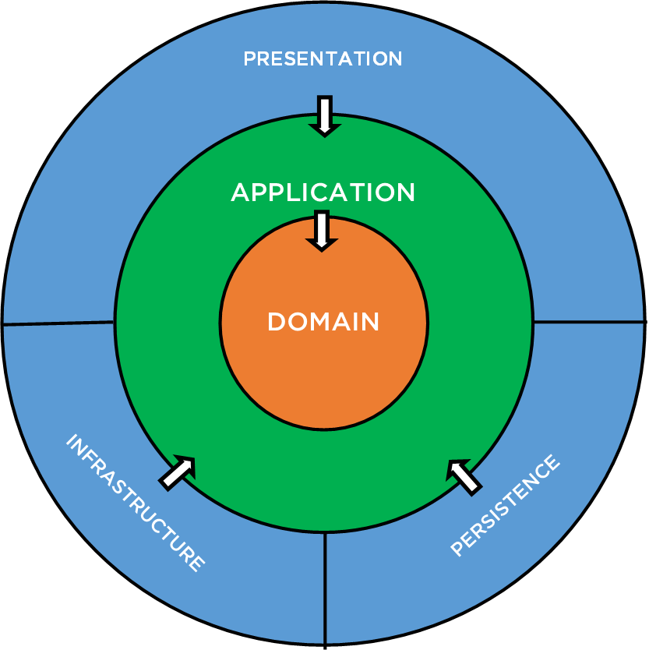

Also, there is no any sense to support CQRS from the start, but the structure of the app will separate Reads (via Queries) and Writes (via Commands and Repositories), in order to have an ability to migrate later to a different write/read databases.

1. Api.Core.Shared– an owner of all the ErrorCodes in Domain/Core, Basic Enums and Domain Exceptions.
2. Api.DomainModels – all the domain logic is placed here. Something later might be placed in a Api.Domain.Services assembly. Also, here belongs all the interfaces (ports) to obtain data –Repositories.
3. Domain Models should guard it’s logic via incapsulating fields, thus removing parameterless constructor and all the setters.

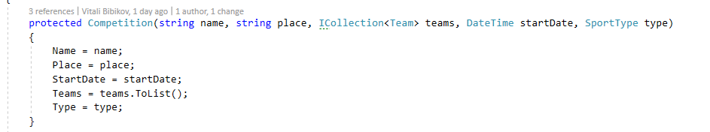

1. Api.Application.Commands, Api.Application.Queries own the Commands and Queries respectively.
2. Api.Application.Commands.Handlers – belongs to Application Layer, as it Command.Handlers should not reference Infrastructure directly, but inject an Interface (ISpecificRepository)
3. Api.Insfrastructure.Repository – implements data access logic.
4. Api.MongoDb.Dtos – stores basic dtos, which we should use to store the data in the db. Should be mapped directly from DomainModels.
5. Api – all the UI Adapters (Controllers), Configurations, Startup logic, HealthChecks should be here.

# Nuget Sharing:

Some deps can be shared between hosted services, Api and Azure functions, and thus has to be versioned and placed in a common Nuget Server.

This server can be deployed as a Free Tier Application in Azure or as a part of CI/CD (if provided).

Below is a basic structure, offered to be shared via packages, 1 foder – 1 package in order to follow CCP principle.

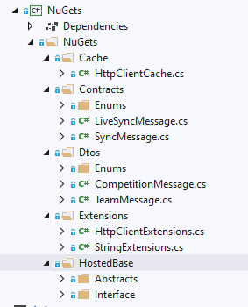

# Hosted Services:

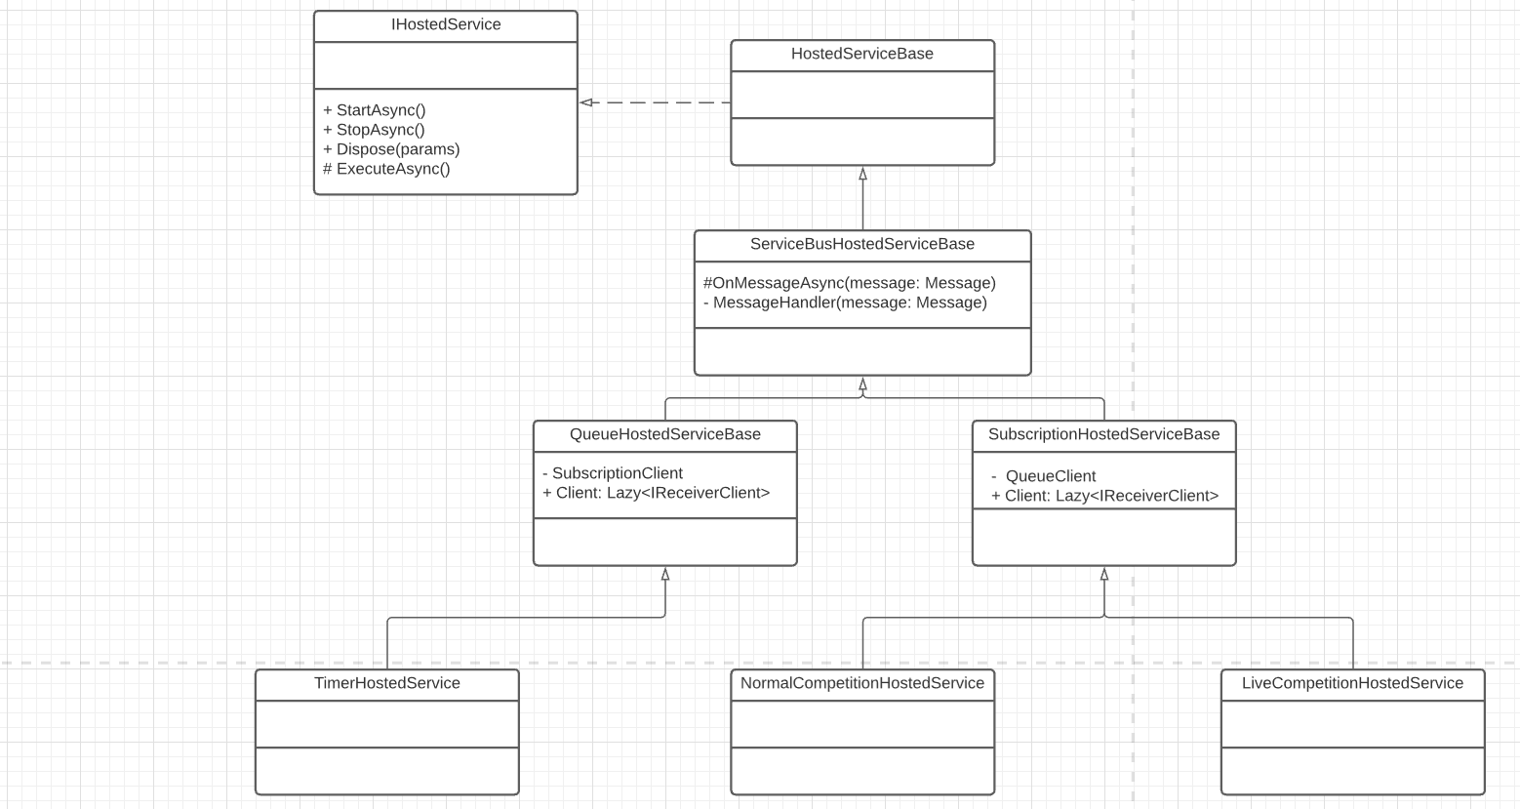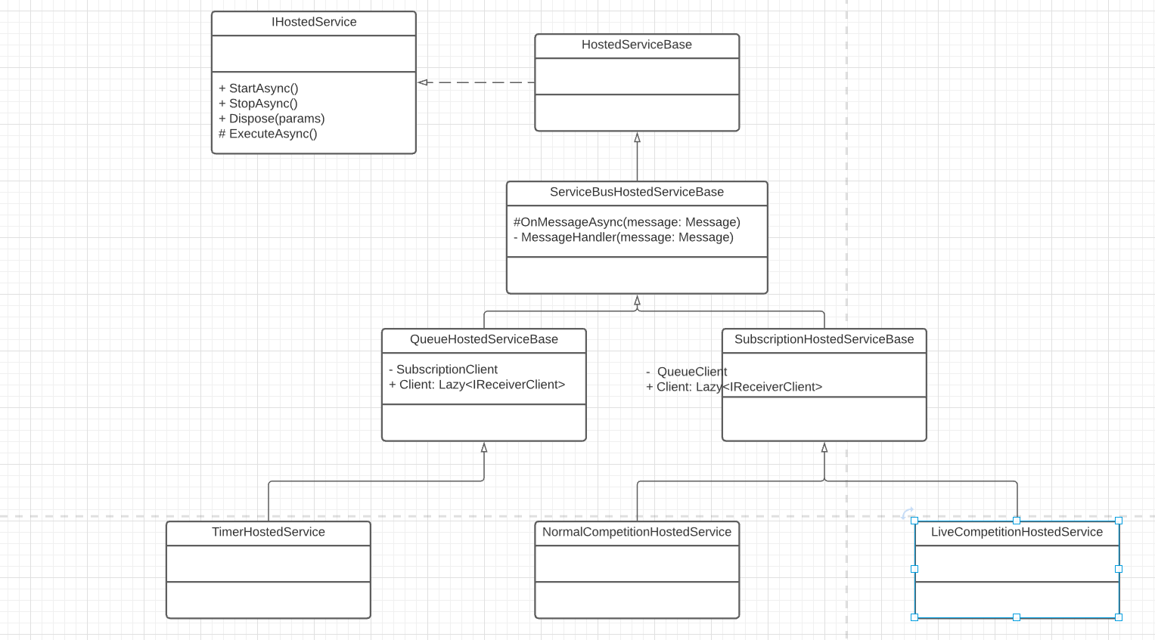

[Source](https://lucid.app/lucidchart/invitations/accept/d4ea913a-9c2c-47f7-a05c-800242189d19)

We should have 3 types of processors/schedulers that are working with our broker:

Output:

**TimerHostedService**: Schedules the events of when to process the message and sends them via Message Broker to Processing Functions;

Input:

**NormalCompetitionHostedService**: Processes and stores events from a normal message processor – function app and persists them in the db. Does not subjected to big volumes of messages, as they are de-duped when sent via Service Bus, thus might be a part of API docker image.

**LiveCompetitionHostedService**: Processes and stores events from a live message processor – function app and persists them in the db. Subjected to big volumes of messages, as the amount of duplicates should be drastically lower, while the amount of messages is excessively big. Should be originally placed as a separate app.

# Dockerization:

Application should be dockerized in order to be used in CI/CD, installed by the QA team easily.

* For the local development Docker-compose is offered, instead of minikube or any other alternatives to K8S to be used, as it is much lighter does not require any knowledge to be configured on a local machine.
* Alpine Images should be used to dockerize the app, as they are lighter, thus faster to deploy, test and scale.

Below is the example of the image configuration, can be found in API POC:

FROM mcr.microsoft.com/dotnet/core/aspnet:3.1-alpine3.12 AS base

WORKDIR /app

RUN echo -e "http://nl.alpinelinux.org/alpine/v3.12/main\nhttp://nl.alpinelinux.org/alpine/v3.12/community\nhttp://nl.alpinelinux.org/alpine/edge/testing" > /etc/apk/repositories

RUN apk update && apk add libgdiplus && apk --update add --no-cache icu-libs

ENV DOTNET_SYSTEM_GLOBALIZATION_INVARIANT=false

FROM mcr.microsoft.com/dotnet/core/sdk:3.1-alpine3.12 AS builder

LABEL stage="intermediate"

WORKDIR /src

COPY . .

WORKDIR "/src/Api"

FROM builder AS publish

RUN dotnet publish "Api.csproj" -c Release -o /app

FROM base AS final

WORKDIR /app

COPY --from=publish /app .

LABEL project="365scores"

ENTRYPOINT ["dotnet", "Api.dll"]

Intermediate container must be used in order to have minimal runnable image in runtime.