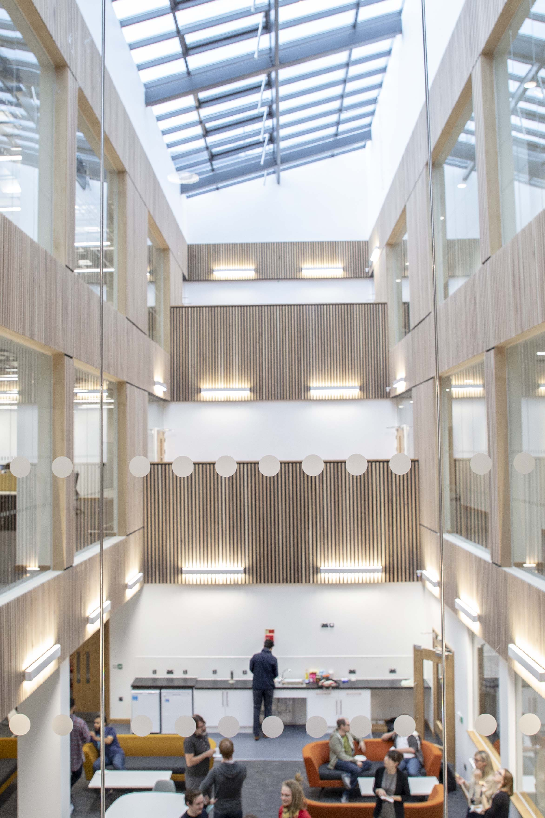

Swansea Summer School in Nonlinear PDEs

1 – 5 July 2024, Swansea University

Minicourse lecturers

Martino Bardi (Università degli Studi di Padova, Italy)
Fully nonlinear degenerate elliptic equations: qualitative properties of viscosity solutions
Serena Dipierro (University of Western Australia)
Nonlocal equations and applications
Louis Jeanjean (Université de Franche-Comté, France)
On nonlinear quantum graphs
Enrico Valdinoci (University of Western Australia)
Nonlocal minimal surfaces and phase transitions
Jean Van Schaftingen (UCLouvain, Belgium)
Sobolev mappings into manifolds

Guest lecturers
John Ball (Heriot-Watt University)
Juan Davilla (University of Bath)
Nicolas Dirr (Cardiff University)
Xue-Mei Li (Imperial College London)
Florian Theil (University of Warwick)
Zoe Wyatt (University of Cambridge)

Organizers



Elaine Crooks (Swansea), Federica Dragoni (Cardiff), Vitaly Moroz (Swansea)

