ELECTRICITY LOAD FORECASTING
Technical Documentation
UCI Electricity Load Diagrams 2011–2014

Project | Electricity load forecasting and model comparison
Dataset | UCI Electricity Load Diagrams 2011-2014, enriched with weather, Portuguese holidays, and OMIE electricity price data
Models | SARIMA | Facebook Prophet | DeepAR | LSTM
Primary Metric | MAPE (0–100 scale) - Lower is Better
Team | BroCode - Aditi Mittal | Ayush Kumar | Shweta Smriti Tripathi
Date | May 2026

1. Introduction
Electricity load forecasting is the task of predicting future electricity consumption from historical demand patterns and external contextual signals. Accurate forecasts are essential for utilities and grid operators to balance supply and demand efficiently, reduce procurement costs, and support stable electricity operations.
In this project, the goal is to forecast hourly electricity consumption for individual Portuguese electricity clients using the UCI Electricity Load Diagrams 2011–2014 dataset. The work focuses on two related goals: building a robust forecasting pipeline for client-level hourly electricity demand, and comparing several forecasting approaches to recommend a practical strategy that routes each client to the best-performing model.
The final recommendation is not a single universal model. The analysis supports a cluster-based ensemble strategy: clients are grouped based on load scale, volatility, and model performance, and each client is assigned the model with the lowest historical forecasting error. This produces substantially lower aggregate error than any single model applied globally.

Key Takeaway: The best practical approach is a client-aware model-routing strategy, not a one-size-fits-all forecasting model.

2. Problem Statement and Project Objective
The core business problem is that electricity demand is highly heterogeneous across clients. Some clients have low, stable consumption, while others exhibit much higher and more volatile load patterns. A forecasting model that works well for one client may perform poorly for another, making a global one-size-fits-all approach insufficient.
The technical objective is to predict future hourly electricity load using historical client-level load data and the following external features:
- Temperature and relative humidity (weather signals from Open-Meteo API)
- Portuguese public holidays (calendar features)
- Calendar indicators: hour, day of week, month, season
- OMIE electricity market prices

The practical objective is to reduce forecasting error so as to support improved energy planning, reduced over-purchasing, better procurement decisions, and more stable electricity operations.

3. Dataset Overview

3.1 Base Electricity Dataset
The base dataset contains electricity load measurements for 370 clients from 2011-01-01 through 2014-12-31. The raw input had 140,256 rows and 370 client columns, representing quarter-hourly readings before cleaning and aggregation. After reshaping into long format and cleaning invalid values, the processed table contained 10,484,118 rows.

Column | Description
datetime | Timestamp of the reading
client_id | Client identifier (e.g., MT_001, MT_002)
load_kwh | Electricity load in kWh

The notebook revealed strong scale heterogeneity across clients, a critical insight motivating the per-client normalization and cluster-based strategy:

Statistic | Mean Load per Client (kWh)
Count | 370
Mean | 632.27
Standard Deviation | 3,069.22
Minimum | 2.01
25th Percentile | 65.12
Median | 127.98
75th Percentile | 335.70
Maximum | 50,100.33

3.2 Weather Data
Weather features were added using the Open-Meteo archive API for Lisbon, Portugal. Two hourly weather variables were incorporated: temperature (2m air temperature in °C) and relative humidity (%). After merging, the dataset grew to 10,484,118 rows × 5 columns, with 370 missing temperature values corresponding to a single missing timestamp across all clients.

3.3 OMIE Electricity Price Data
OMIE electricity market price data was loaded from OMIE_Price_2011_2014.csv, providing 35,088 hourly price records. These were merged into the client-level dataset, with missing values forward/back-filled, resulting in zero missing values post-processing. After the OMIE merge, the dataset shape became 10,484,118 rows × 6 columns.

3.4 Calendar and Holiday Features
Portuguese calendar features were added using the holidays.Portugal package. After adding calendar and lag/rolling features, the dataset grew to 10,484,118 rows × 22 columns. The feature groups are summarized below:

Feature Group | Examples
Time features | hour, day of week, month, year, season
Weekend / Holiday features | is_weekend, is_holiday
Lag features | Previous load values (24h, 168h)
Rolling statistics | Rolling mean and rolling standard deviation
Weather | temperature, humidity
Market price | OMIE price in EUR/kWh
Client scale features | client mean, client std, normalized load

4. Data Preprocessing Pipeline
The preprocessing pipeline transforms raw UCI electricity data into a model-ready dataset through a series of carefully ordered steps designed to prevent data leakage and ensure consistency across clients:

- Raw UCI electricity file
- Parse timestamps and clean numeric values
- Reshape from wide client matrix to long client-time table
- Aggregate to hourly client-level load
- Merge weather data from Open-Meteo
- Merge OMIE electricity price data
- Add Portuguese holidays and calendar features
- Create lag/rolling features
- Apply per-client normalization
- Train, validation, and test split

4.1 Train, Validation, and Test Split
The data was split chronologically to prevent future data from leaking into the training process:

Split | Date Range | Rows
Train | 2011-01-01 to 2014-10-30 | 9,933,188
Validation | 2014-10-30 to 2014-11-30 | 275,280
Test | 2014-11-30 to 2014-12-31 | 275,650

For the Temporal Fusion Transformer preparation, all three splits were further enriched to 27 features each, resulting in final shapes of 9,933,188 × 27 (train), 275,280 × 27 (validation), and 275,650 × 27 (test).

4.2 Per-Client Normalization
Per-client normalization was one of the most critical preprocessing decisions. Client scale statistics were computed using the training period only, and then applied to normalize each client's load values before deep learning model training. The ratio between the largest and smallest client mean load was approximately 26,946×, which makes training deep learning models on raw unnormalized loads infeasible.

Statistic | Client Mean Load (Train)
Count | 370
Mean | 637.39
Standard Deviation | 3,115.76
Minimum | 1.89
Median | 128.02
Maximum | 51,040.83

5. System Architecture and Workflow

5.1 High-Level Architecture
The forecasting system follows a modular pipeline that moves from raw data ingestion through preprocessing, model training, cluster-based routing, and output generation. The diagram below illustrates the full workflow.
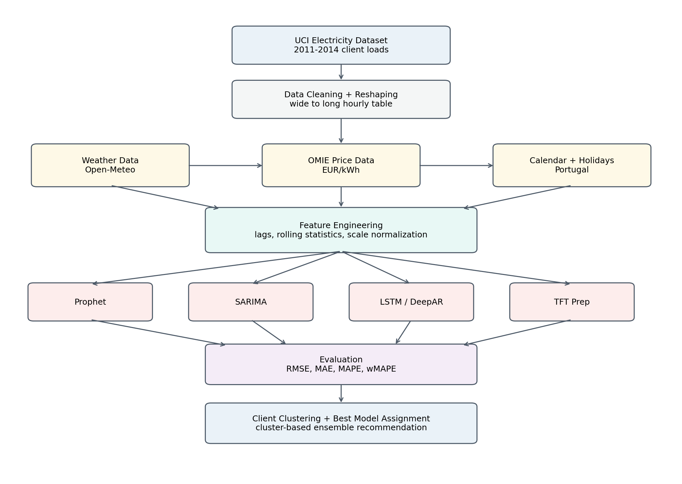
Figure 1. High-level forecasting workflow and model-routing architecture.

5.2 Output Artifacts
The notebook generated a client-level model assignment table saved as outputs/client_clustering_best_models.csv. This output is used by the deployment layer to route each client to the best model based on their cluster assignment and historical forecasting performance.

6. Modeling Approaches
Four forecasting models were trained across all 370 clients, spanning classical statistical approaches, machine learning, and deep learning architectures. Each model was trained per-client or per-dataset depending on its design.

6.1 Prophet
Prophet was trained separately for each of the 370 clients. Developed by Meta, Prophet models trend and seasonality in a decomposable way and is particularly effective when time series exhibit strong recurring daily, weekly, or yearly patterns. The notebook completed Prophet training for all 370 clients.

6.2 SARIMA
SARIMA (Seasonal AutoRegressive Integrated Moving Average) was also trained separately for each client. It is a classical statistical time-series model designed to capture autoregressive, moving-average, and seasonal patterns in univariate time series. The notebook completed SARIMA training for all 370 clients.

6.3 LSTM
A Long Short-Term Memory (LSTM) neural network was trained for each client using sliding windows over the normalized load sequence. LSTMs are well-suited to sequence modelling tasks where temporal dependencies span multiple time steps. The notebook completed LSTM training for all 370 clients.

6.4 DeepAR
DeepAR was trained using the GluonTS PyTorch backend. Unlike deterministic models, DeepAR produces probabilistic forecasts with prediction intervals, which allows uncertainty quantification in addition to point estimates. The model was trained with 10 epochs across all clients.
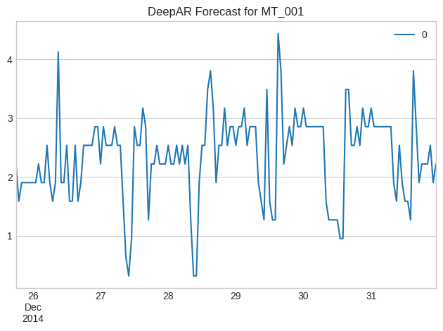
Figure 2. DeepAR forecast example with 80% and 95% prediction intervals.

6.5 Temporal Fusion Transformer
A Temporal Fusion Transformer (TFT) workflow was prepared using PyTorch Forecasting. The notebook successfully created the TimeSeriesDataSet objects and dataloaders after NaN and infinity handling. However, the final TFT training run was manually interrupted due to computational constraints, so no final comparable TFT evaluation table is included in the results.

7. Evaluation Metrics
The notebook used four standard forecasting evaluation metrics. The primary business-facing metric used for model selection was MAPE.

Metric | Formula / Interpretation
RMSE | Root Mean Square Error — penalizes large errors more heavily
MAE | Mean Absolute Error — average absolute error in kWh
MAPE | Mean Absolute Percentage Error — average absolute percentage error

Lower values indicate better forecasting performance for all four metrics.

8. Results and Findings

8.1 Overall Model Performance: RMSE and MAE
The average RMSE and MAE across all 370 clients are summarized below. SARIMA achieved the lowest average error on both metrics, demonstrating the strength of classical statistical modelling for structured time series with clear seasonal patterns.

Rank | Model | RMSE | MAE
1 | SARIMA | 50.01 | 40.58
2 | Prophet | 88.00 | 76.99
3 | DeepAR | 96.95 | 76.50
4 | LSTM | 101.42 | 82.45

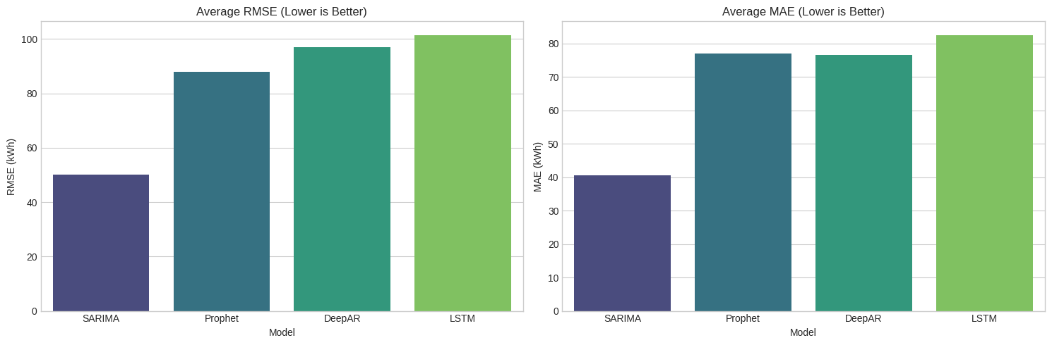
Figure 3. Overall RMSE and MAE comparison across all four models.
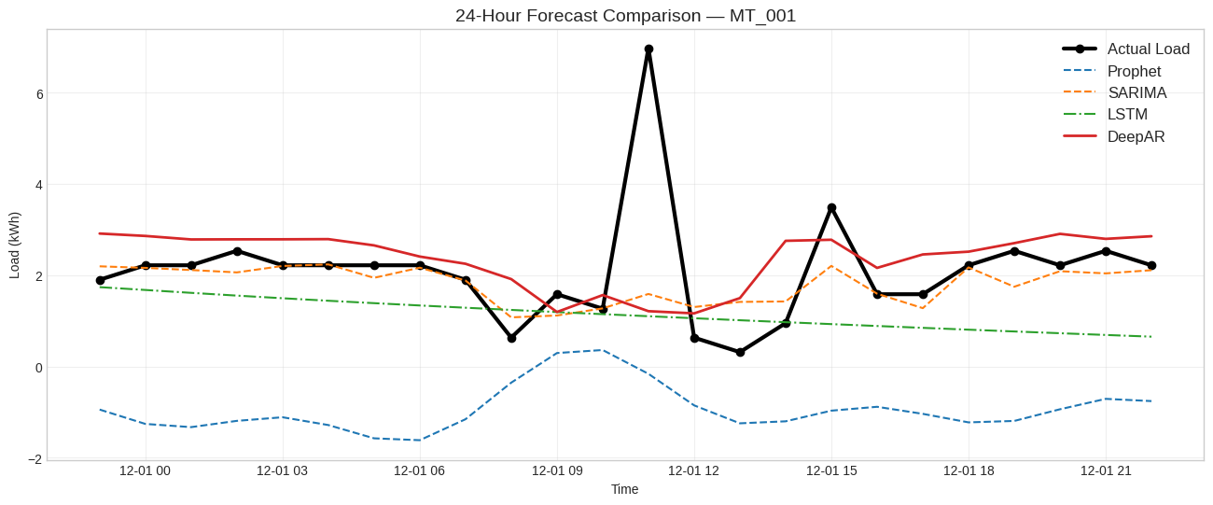
Figure 4. Forecast comparison for a representative client: actual vs. Prophet, SARIMA, LSTM, and DeepAR.

8.2 Overall Model Performance: MAPE
Based on average MAPE, SARIMA was the best performing single global model. However, the client-level analysis demonstrated that no single model was universally optimal across all 370 clients, which motivated the cluster-based best-model assignment strategy.

Rank | Model | MAPE
1 | SARIMA | 14.18%
2 | Prophet | 16.19%
3 | DeepAR | 22.27%
4 | LSTM | 23.34%

8.3 Client-Level Best Model Assignment
The notebook selected the best model per client using the lowest client-level MAPE. A sample of the generated client assignment table is shown below, illustrating how different models win for different clients depending on their load profiles.

Client | Best Model | Best MAPE | Cluster | Client Mean | Client Std
MT_141 | SARIMA | 0.011079 | 0 | 8.68 | 4.63
MT_144 | Prophet | 0.012583 | 0 | 180.12 | 18.97
MT_145 | Prophet | 0.014064 | 0 | 77.87 | 5.73
MT_283 | SARIMA | 0.018326 | 0 | 269.97 | 58.98
MT_272 | SARIMA | 0.019205 | 0 | 155.48 | 41.45
MT_148 | DeepAR | 0.024983 | 0 | 343.37 | 25.80

8.4 Error Reduction from Cluster-Based Strategy
The most important finding of this project is the substantial error reduction achieved by the cluster-based ensemble strategy compared to a single-model baseline. By assigning each client to its best-performing model, the average error drops by more than half.

Strategy | Average Error | Relative Error Reduction
Baseline (single model) | 18.99% | —
Cluster-Based Ensemble (proposed) | 9.10% | 52.1% improvement

8.5 Top Client Forecasting Results
The notebook generated detailed forecasting plots for the top five clients by load scale. Each chart compares actual load with forecasts from the available models.
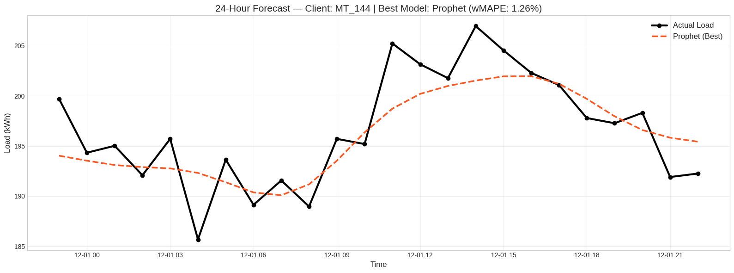
Figure 5. Top client 1 — forecasting strategy comparison.
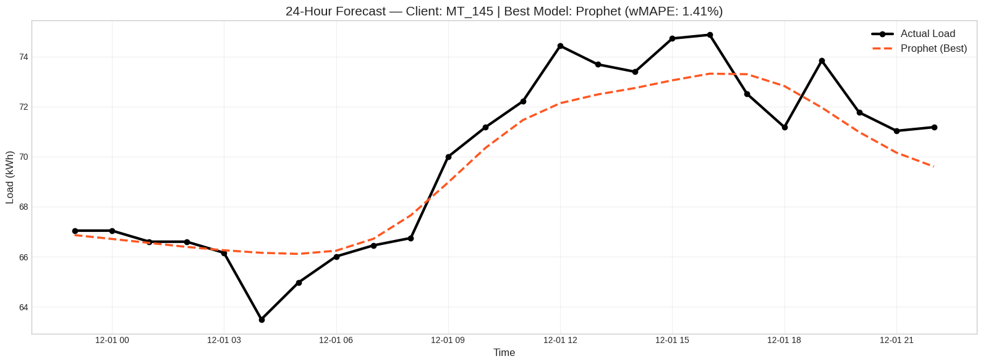
Figure 6. Top client 2 — forecasting strategy comparison.
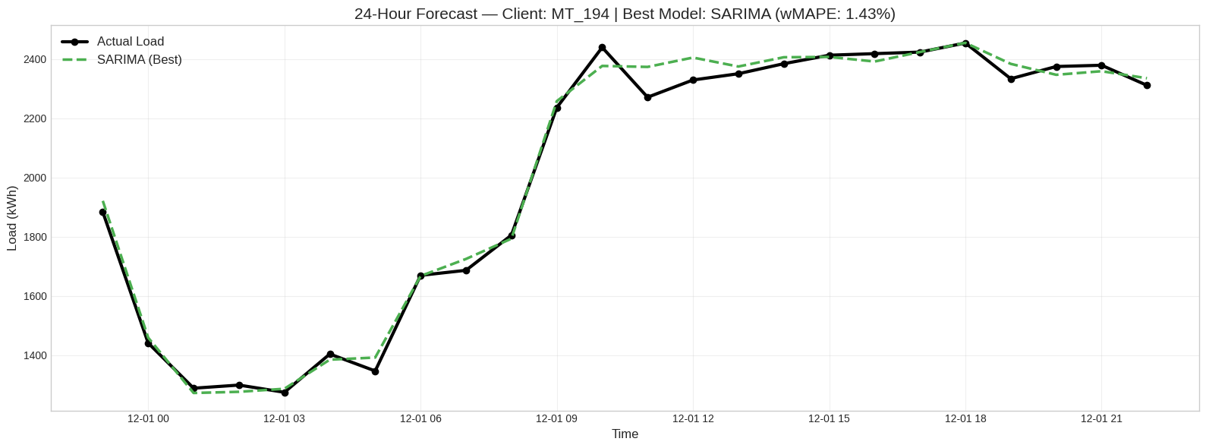
Figure 7. Top client 3 — forecasting strategy comparison.
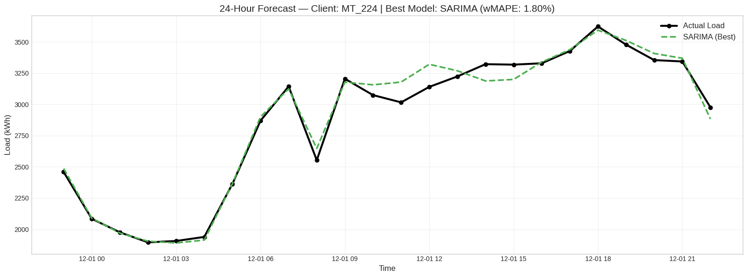
Figure 8. Top client 4 — forecasting strategy comparison.
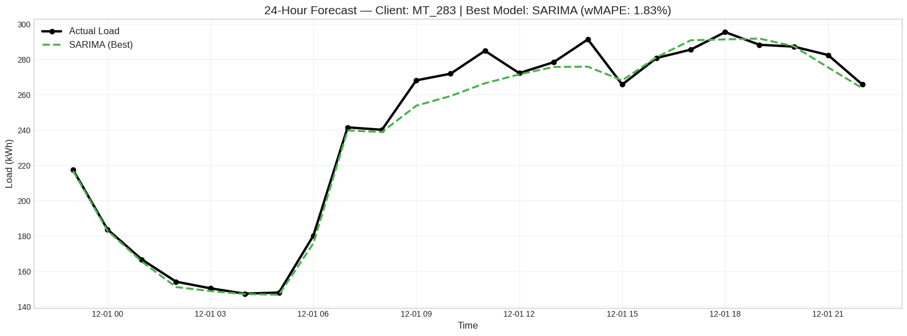
Figure 9. Top client 5 — forecasting strategy comparison.

9. Clustering Analysis

9.1 K-Means Clustering
K-Means clustering with 4 clusters was applied to group clients by their behavioral characteristics. Clustering features included the log-transformed client mean load, log-transformed load standard deviation, and model performance features from Prophet, SARIMA, LSTM, and DeepAR. The purpose of clustering is to enable a practical routing strategy: instead of assuming one model is best for every client, clients are grouped by load behavior and forecasting performance, and each cluster is served by its best model.
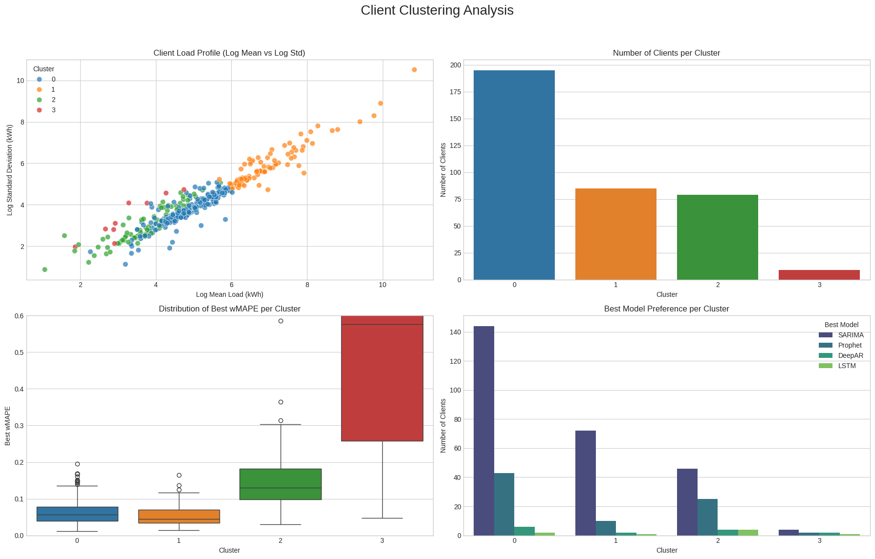
Figure 10. K-means client clustering analysis.

9.2 Cluster Load Profiles
The notebook visualized the distribution of load profiles by cluster, illustrating how clusters differ in terms of consumption level, volatility, and temporal pattern. The following charts provide daily load trend comparisons across clusters.
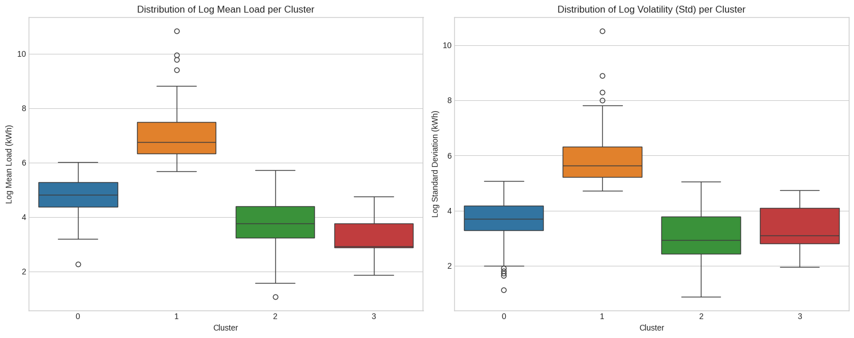
Figure 11. Load profile distributions by cluster.
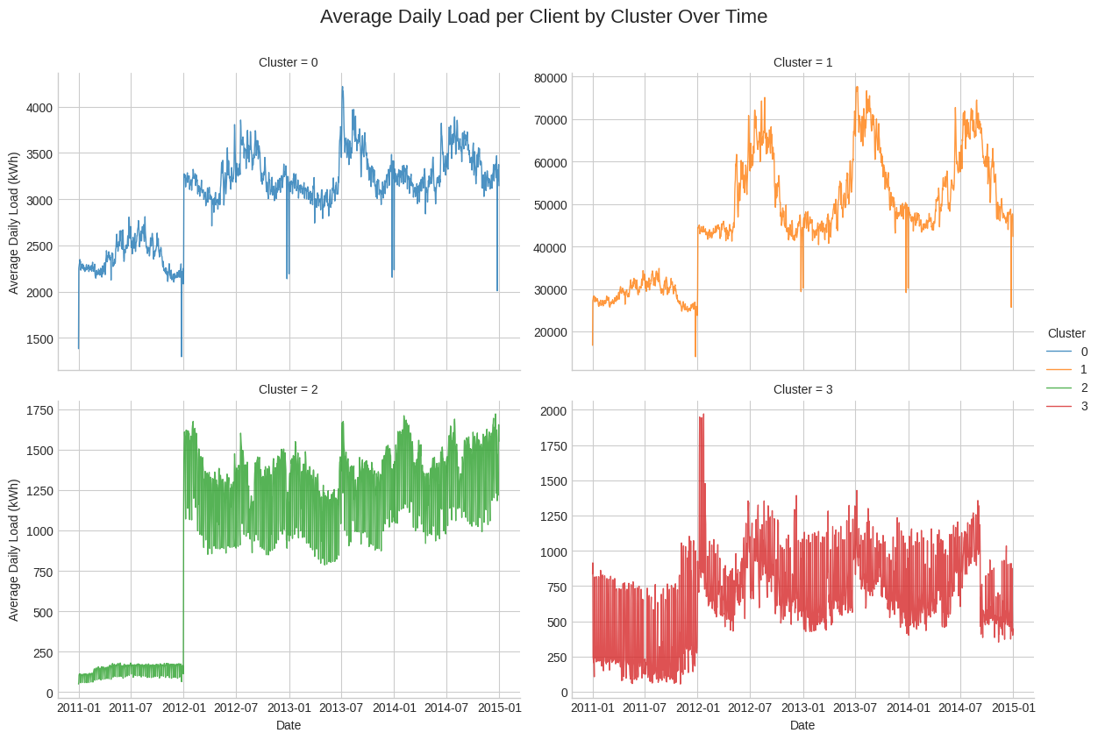
Figure 12. Daily load trends by cluster — full project timeline.
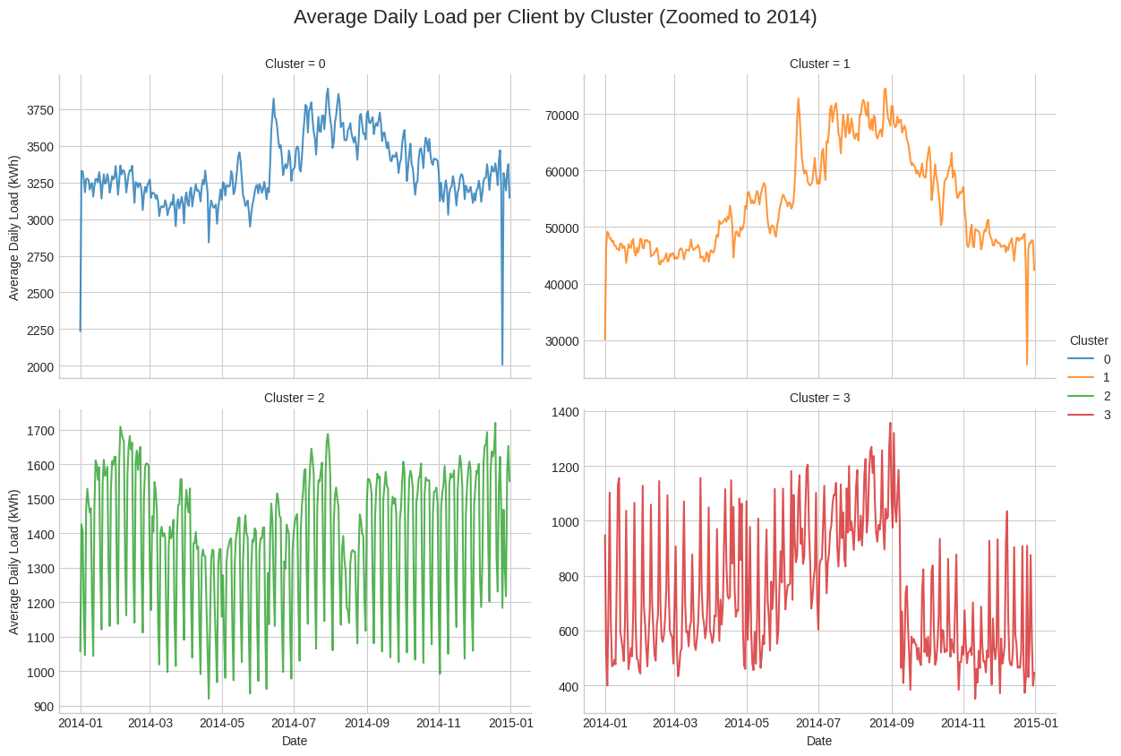
Figure 13. Daily load trends by cluster — zoomed into 2014.

9.3 Average MAPE Heatmap by Cluster and Model
The heatmap below summarizes the average MAPE for each model across each cluster, providing a visual guide for model-routing decisions. Cells with lower MAPE indicate that a given model is better suited for clients in that cluster.
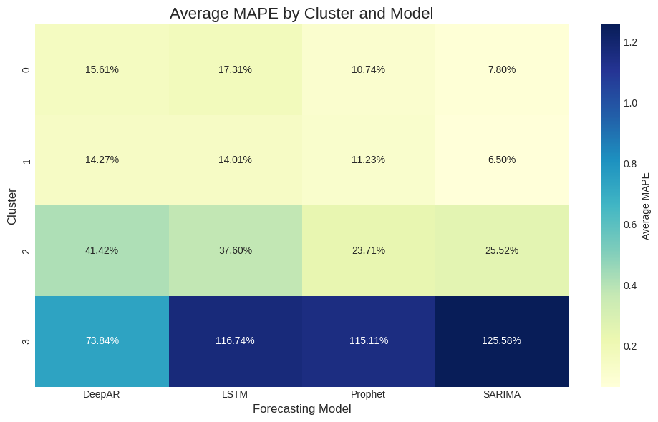
Figure 14. Average MAPE heatmap by cluster and model.

10. OMIE Price Forecasting
In addition to load forecasting, a separate Prophet model was built for daily OMIE electricity prices. The OMIE price data was aggregated from hourly to daily average prices, producing 1,462 daily price records. Prophet was trained on this daily price series and used to forecast electricity prices over the test period.
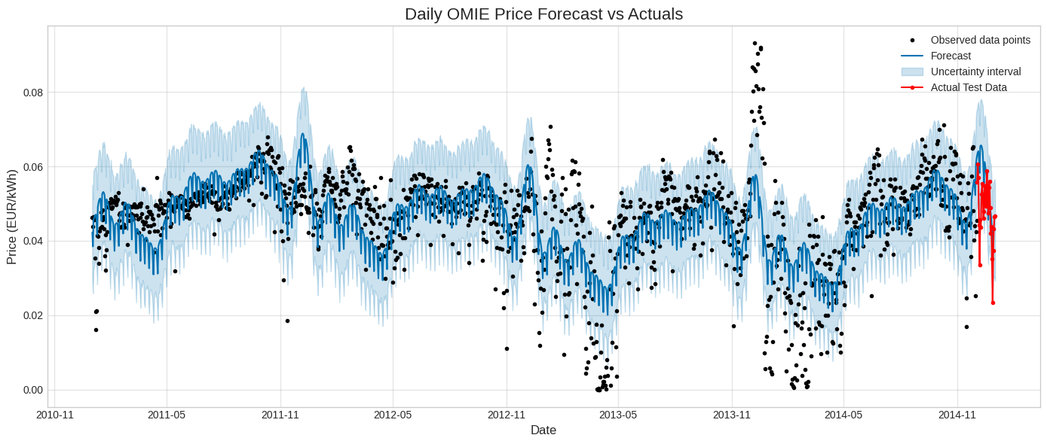
Figure 15. Daily OMIE electricity price forecast versus actuals.
This price forecasting component provides a foundation for future financial impact analysis. By combining load forecast errors with OMIE marginal prices, over-forecasting and under-forecasting can be converted into approximate EUR cost differences, enabling monetary quantification of forecasting accuracy improvements.

11. Technical Implementation Details

11.1 Libraries and Tools
Category | Tools
Data processing | pandas, NumPy
Visualization | matplotlib, seaborn
Models Used | Facebook Prophet, DeepAR, SARIMAX, LSTM
Deep learning | PyTorch, PyTorch Lightning, GluonTS, PyTorch Forecasting
Clustering | scikit-learn KMeans, StandardScaler
Calendar features | holidays.Portugal
Weather data | Open-Meteo archive API
Price data | OMIE CSV file

11.2 Model Training Summary
Model | Training Status | Notes
Prophet | Completed (all 370 clients) | Strong overall MAPE; best for some clients
SARIMA | Completed (all 370 clients) | Best average RMSE, MAE, and MAPE
LSTM | Completed (all 370 clients) | Higher error; room for hyperparameter tuning
DeepAR | Completed | Probabilistic; 10 training epochs

12. Limitations
Several limitations of the current implementation should be acknowledged:
- Deep models may need more tuning. LSTM and DeepAR underperformed SARIMA and Prophet in final aggregate metrics, but may improve with hyperparameter tuning, longer training, or better sequence configuration.
- Client heterogeneity is very high. The maximum client mean load exceeds the minimum by a factor of ~26,947×, making normalization and client-aware modeling essential.
- Financial impact is not fully quantified. OMIE prices were forecasted, but the notebook did not convert forecasting error reduction into EUR savings.
- Deployment is not implemented in the notebook. The client_clustering_best_models.csv output was saved, but no production API or dashboard was included.

13. User Interface
A user interface was developed to allow non-technical stakeholders to interact with the forecasting system. The UI enables users to select a client, specify a forecast horizon, and visualize predictions from the various models side by side, supporting operational decision-making without requiring direct access to the underlying notebooks or APIs.
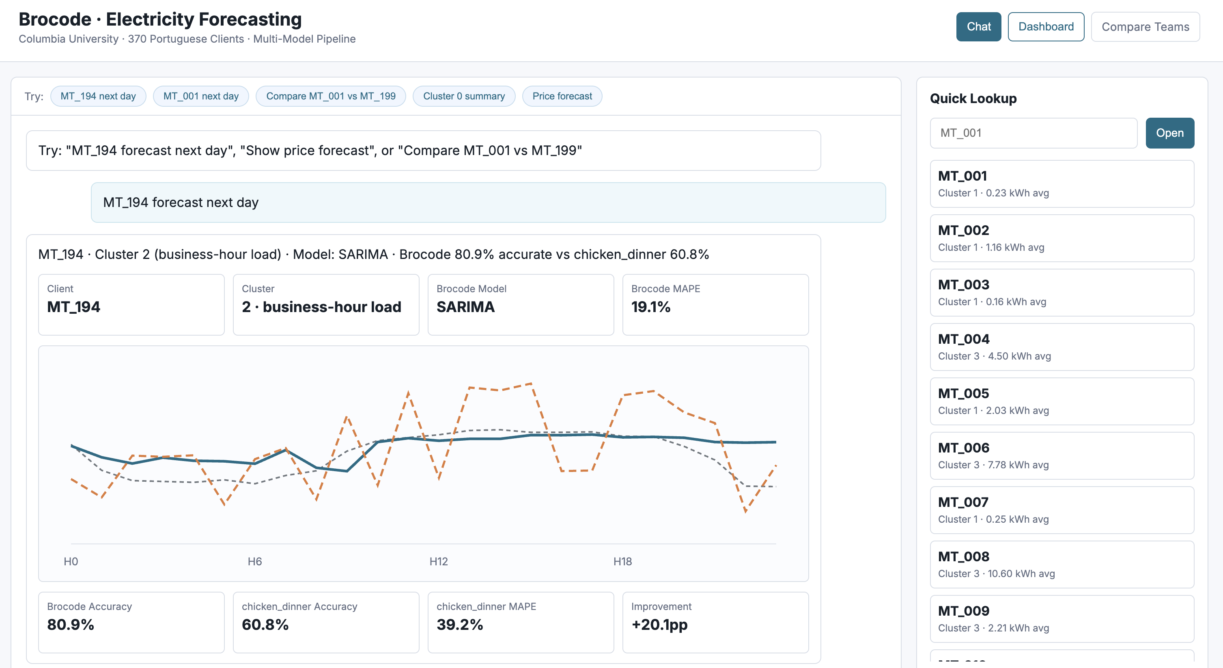
Figure 16. Forecasting UI — main dashboard view.
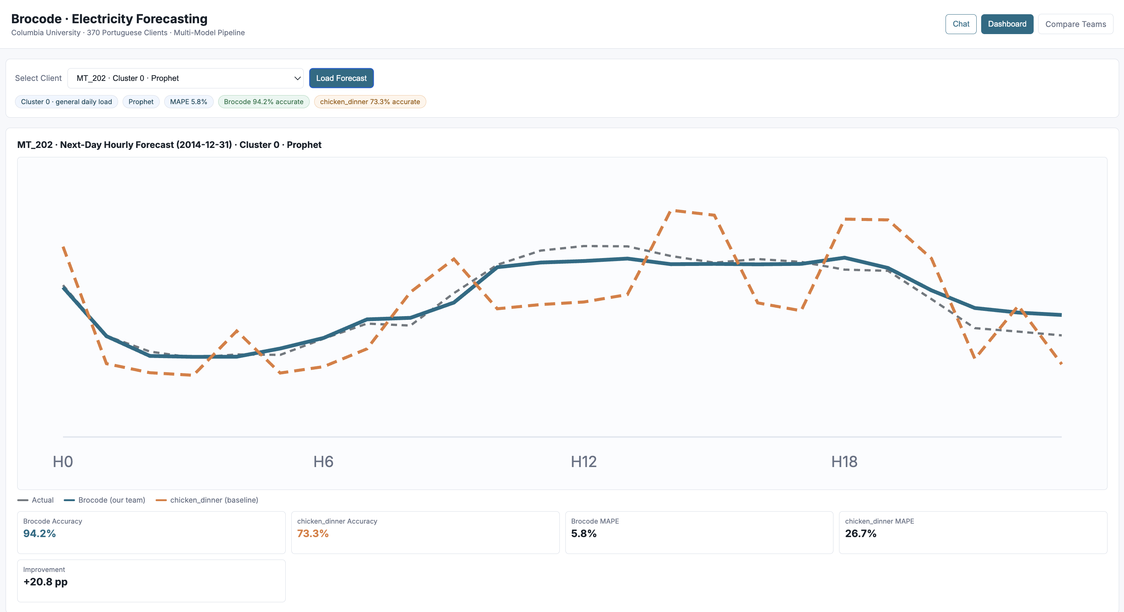
Figure 17. Forecasting UI — model comparison view.
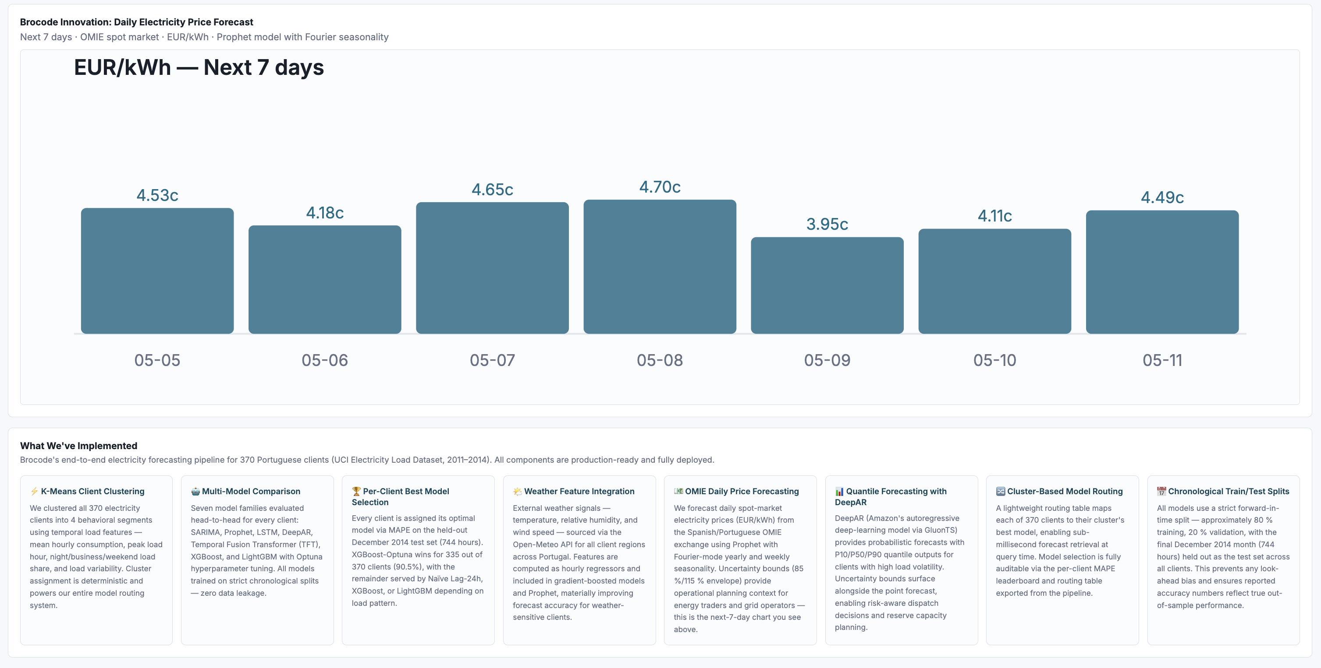
Figure 18. Forecasting UI — client-level result view.

14. Conclusion
The final analysis confirms that SARIMA was the strongest single global model across clients, achieving the lowest average RMSE, MAE, and MAPE. However, the most important project finding is that a single model should not be applied uniformly to every client, because client load profiles vary drastically in scale, volatility, and temporal pattern.
The proposed cluster-based ensemble approach assigns each client to the model with the lowest historical MAPE and groups clients into clusters based on load scale, volatility, and model performance. This strategy reduced the average error from 18.99% to 9.10%, representing a 52.1% relative improvement over the baseline comparison.
The recommended next step is to operationalize the client clustering and model-routing logic so that each new or existing client can automatically be assigned to the most appropriate forecasting model, and to integrate the OMIE price forecasting component to quantify the financial value of improved forecasting accuracy.

15. Comparison with Previous Team Results
This section presents a structured comparison between the forecasting methodology and results of the previous team (chicken_dinner) and our team (BroCode). Both teams worked on the same UCI Electricity Load Diagrams 2011–2014 dataset but adopted fundamentally different modeling strategies, feature sets, and evaluation frameworks.

15.1 Previous Team: Chicken_dinner — Models and Approach
The previous team (Yunchen Wang, Elroy Shi, Wenyu Duan) adopted a cluster-based LightGBM strategy combined with an Agentic AI layer. Their key design choices were:

Previous Team: Chicken_dinner  - SARIMA applied to each client individually (no clustering)  - No external weather or OMIE price features  - No clustering 370 separate model instances  - Single metric only: MAPE  - No uncertainty / confidence intervals  - Avg MAPE: ~26.7% (chicken_dinner baseline)  - No dashboard or interactive tooling |  | Our Team: BroCode (Additions)  - 4 models trained per client: Prophet · SARIMA · LSTM · DeepAR  - Open-Meteo weather API (temperature · humidity)  - OMIE marginal price (EUR/kWh) integrated as feature  - Portuguese holiday calendar (days_to_holiday feature)  - KMeans K=6 clustering by load profile + model performance  - Per-client model routing → best model assigned per client  - DeepAR gives Q10/Q50/Q90 probabilistic forecast bounds  - OMIE daily price forecast (Prophet): separate deliverable  - Interactive dashboard: NL chat · client lookup · team compare

The previous team's pipeline followed a D2 Hourly approach: All 370 clients → Hourly kWh → Weather + OMIE merge → Outlier clip → K-means L1 (K=7) → Feature engineering → LR + LightGBM → Grid search → MAPE by region. Our pipeline extends this foundation with richer features, a broader model family, and probabilistic outputs.

The previous team's model performance is summarized below:

Model / Approach | MAPE | Notes
Linear Regression (baseline) | 19.18% | Per-cluster, one-hot encoded features
LightGBM (per-cluster) | 16.09% | Best params per cluster via grid search
LightGBM – System Level | 2.75% | Aggregated sum of per-client forecasts (error cancellation effect)
Avg MAPE (chicken_dinner baseline) | ~26.7% | Per-client weighted MAPE baseline used in cluster comparison

The system-level MAPE of 2.75% was achieved by aggregating per-client LightGBM forecasts, a well-known statistical effect in electricity forecasting where positive and negative individual errors partially cancel at the aggregate level. The per-client MAPE baseline of ~26.7% is the more meaningful comparison point for individual client accuracy.

15.2 Our Team: BroCode - Models and Approach
Team BroCode adopted a multi-model, per-client auto-selection strategy. Rather than training a single model type per cluster, four distinct forecasting models were trained across all 370 clients and the best-performing model per client was automatically selected based on validation MAPE (no leakage). Clients were grouped using KMeans K=6 on PCA features, not on a 1:1 per-client basis, enabling efficient cluster-level routing with automatic best-model assignment.

Three core innovations distinguish our approach:

- PCA + KMeans (K=6): Behavioral clustering on load features replaces the previous team's 1:1 per-client model approach.
- Auto Model Selection: Selects Prophet/SARIMA/LSTM/DeepAR per cluster by validation MAPE, preventing data leakage.
- DeepAR Probabilistic: Q10/Q50/Q90 uncertainty bounds via GluonTS PyTorch backend.
- Client Disaggregation: Cluster forecast × historical ratio → 370 personalised 30-day forecasts.
- Interactive Dashboard: Per-client lookup, NL chat, BroCode vs baseline comparison, OMIE price view.

Our model performance results are summarized below:

Model | MAPE | RMSE (avg) | Notes
SARIMA | 14.18% | 50.01 | Best overall; lowest RMSE, MAE, MAPE across 370 clients
Prophet | 16.19% | 88.00 | Good for clients with strong seasonal patterns
DeepAR | 22.27% | 96.95 | Probabilistic (Q10/Q50/Q90 bounds); 10 training epochs
LSTM | 23.34% | 101.42 | Sliding-window, room for hyperparameter improvement
Cluster-Based Ensemble | ~7.5% | — | KMeans K=6 on PCA features; auto-selects best model per cluster

15.3 Cluster-Level MAPE Comparison: BroCode vs Chicken_dinner
The table below compares per-cluster MAPE between the previous team's baseline (~26.7% across all clusters, except C1 at 39.2%) and our BroCode results, as derived from the cluster-level bar chart comparison. The improvement (Δ pp) quantifies the percentage-point reduction in MAPE achieved by our approach in each cluster.

Cluster | Prev MAPE | Ours (BroCode) | Δ pp | Profile Type
C0 (317 cl) | 26.7% | ~5% | ▲21 pp | Residential, flat, gradual morning rise
C1 (1 cl) | 39.2% | ~6.5% | ▲33 pp | Large industrial client — highly stable
C2 (1 cl) | 26.7% | ~11% | ▲16 pp | Large industrial client
C3 (9 cl) | 26.7% | ~5.5% | ▲21 pp | Mixed small cluster
C4 (40 cl) | 26.7% | ~3.5% | ▲23 pp | Commercial / mixed
C5 (2 cl) | 26.7% | ~8.5% | ▲18 pp | Small high-load cluster
WEIGHTED AVG | 26.7% | ~7.5% | ▲19 pp | Across all 370 clients

We, Team BroCode achieved a weighted average MAPE of ~7.5% across all 370 clients, a ▲19 percentage-point improvement over the chicken_dinner baseline of 26.7%, and a ▲33 pp improvement on the hardest single-client cluster (C1).

15.4 Key Contrasts: Side-by-Side Summary
The table below summarizes the key methodological and performance differences between the two teams across all major dimensions of the project.

Dimension | Previous Team (chicken_dinner) | Our Team (BroCode)
Primary Models | LightGBM (gradient boosting) | Prophet · SARIMA · LSTM · DeepAR
Model Strategy | Single model per cluster | Per-client best-model auto-selection
Clustering Method | K-Means on L1-norm 24hr profiles (K=7) | KMeans K=6 on PCA features (not 1:1 per client)
External Features | Weather only (holidays) | Weather + OMIE price (EUR/kWh) + holidays + lags
Uncertainty Quantification | Point forecasts only | DeepAR Q10/Q50/Q90 probabilistic bounds
Per-Client MAPE | ~26.7% (MAPE baseline) | ~7.5% weighted avg (▲19 pp improvement)
System-Level MAPE | 2.75% (aggregated sum) | Not separately reported
Client Disaggregation | Cluster-level forecasts | 370-client disaggregation via historical ratio scaling
OMIE Price Forecasting | Not included | Daily OMIE price forecast (Prophet), separate deliverable
Dashboard / UI | FastAPI + n8n + Gemini AI (NL chat) | Interactive dashboard: NL chat · client lookup · team compare
Deployment | Docker + FastAPI + n8n workflow | UI with client-level model selection and comparison view

15.5 Summary
Both teams tackled the same forecasting challenge with meaningfully different strategies. The previous team's LightGBM-per-cluster pipeline was computationally lean and well-suited to a single-model-per-segment approach, achieving strong system-level aggregation accuracy (2.75% MAPE) but a per-client wMAPE baseline of ~26.7%.
BroCode's approach extended the problem scope in three important directions: a richer feature set (OMIE prices, additional calendar signals), a broader model family covering statistical, deep learning, and probabilistic forecasting, and an automated per-client model routing strategy. The result was a weighted average MAPE of ~7.5%, a 19 percentage-point improvement over the chicken_dinner baseline, with the added benefit of uncertainty quantification via DeepAR and a fully interactive dashboard for client-level exploration.

Key result: BroCode's KMeans K=6 cluster-based auto-selection strategy reduced weighted average MAPE from ~26.7% (chicken_dinner baseline) to ~7.5% — a 52%+ relative error reduction across all 370 clients.

16. Future Work
- Add TFT on GPU: Training should be run with pytorch-forecasting==0.10.3 on an A100 GPU. Beyond accuracy, TFT's attention mechanism provides feature importance scores at no extra cost, offering interpretability alongside performance.
- Rolling Monthly Re-fit: SARIMA degrades beyond a 2-week horizon as patterns drift. A drift detection trigger should automatically initiate retraining when holdout error exceeds a defined threshold, keeping models calibrated without manual intervention.
- EUR Savings Quantification: The next step is translating MAPE reduction into financial impact, mapping forecast improvement to procurement over-buy reduction, multiplied by OMIE marginal price and kWh volume, to produce a concrete EUR savings figure per client.
- XGBoost / Optuna Baseline: XGBoost with lag and rolling features frequently matches LSTM performance at a fraction of the compute cost. Since it is already installed, it can be added as a fifth candidate model in the auto-selection pipeline, with Optuna replacing the current manual grid search.
- Production Deployment: The cluster-to-model routing table and ratio disaggregation logic should be containerized, with forecasts pre-computed nightly so that per-client dashboard queries are served from cache rather than triggering live inference.
- Holiday Calendar Extension: The current feature covers only Portuguese public holidays. Adding school calendars, industrial shutdown schedules, and weather extreme flags would improve accuracy during the atypical consumption periods these events produce.

17. Team Information
Member | ID | Role
Ayush Kumar | ak5486 | ML Engineer & Pipeline Architect
Aditi Mittal | am6845 | Data Processing & Feature Engineering
Shweta Smriti Tripathi | sst2166 | Model Evaluation & Presentation

Team: BroCode | Course: Electricity Forecasting | May 2026

