- \\
- Instal NodeJS
https://nodejs.org/en/download
or
- sudo apt install npm

# Download and install nvm:
curl -o- https://raw.githubusercontent.com/nvm-sh/nvm/v0.40.2/install.sh | bash

# in lieu of restarting the shell
\. "$HOME/.nvm/nvm.sh"

# Download and install Node.js:
nvm install 22

# Verify the Node.js version:
node -v # Should print "v23.11.0".
nvm current # Should print "v23.11.0".

# Verify npm version:
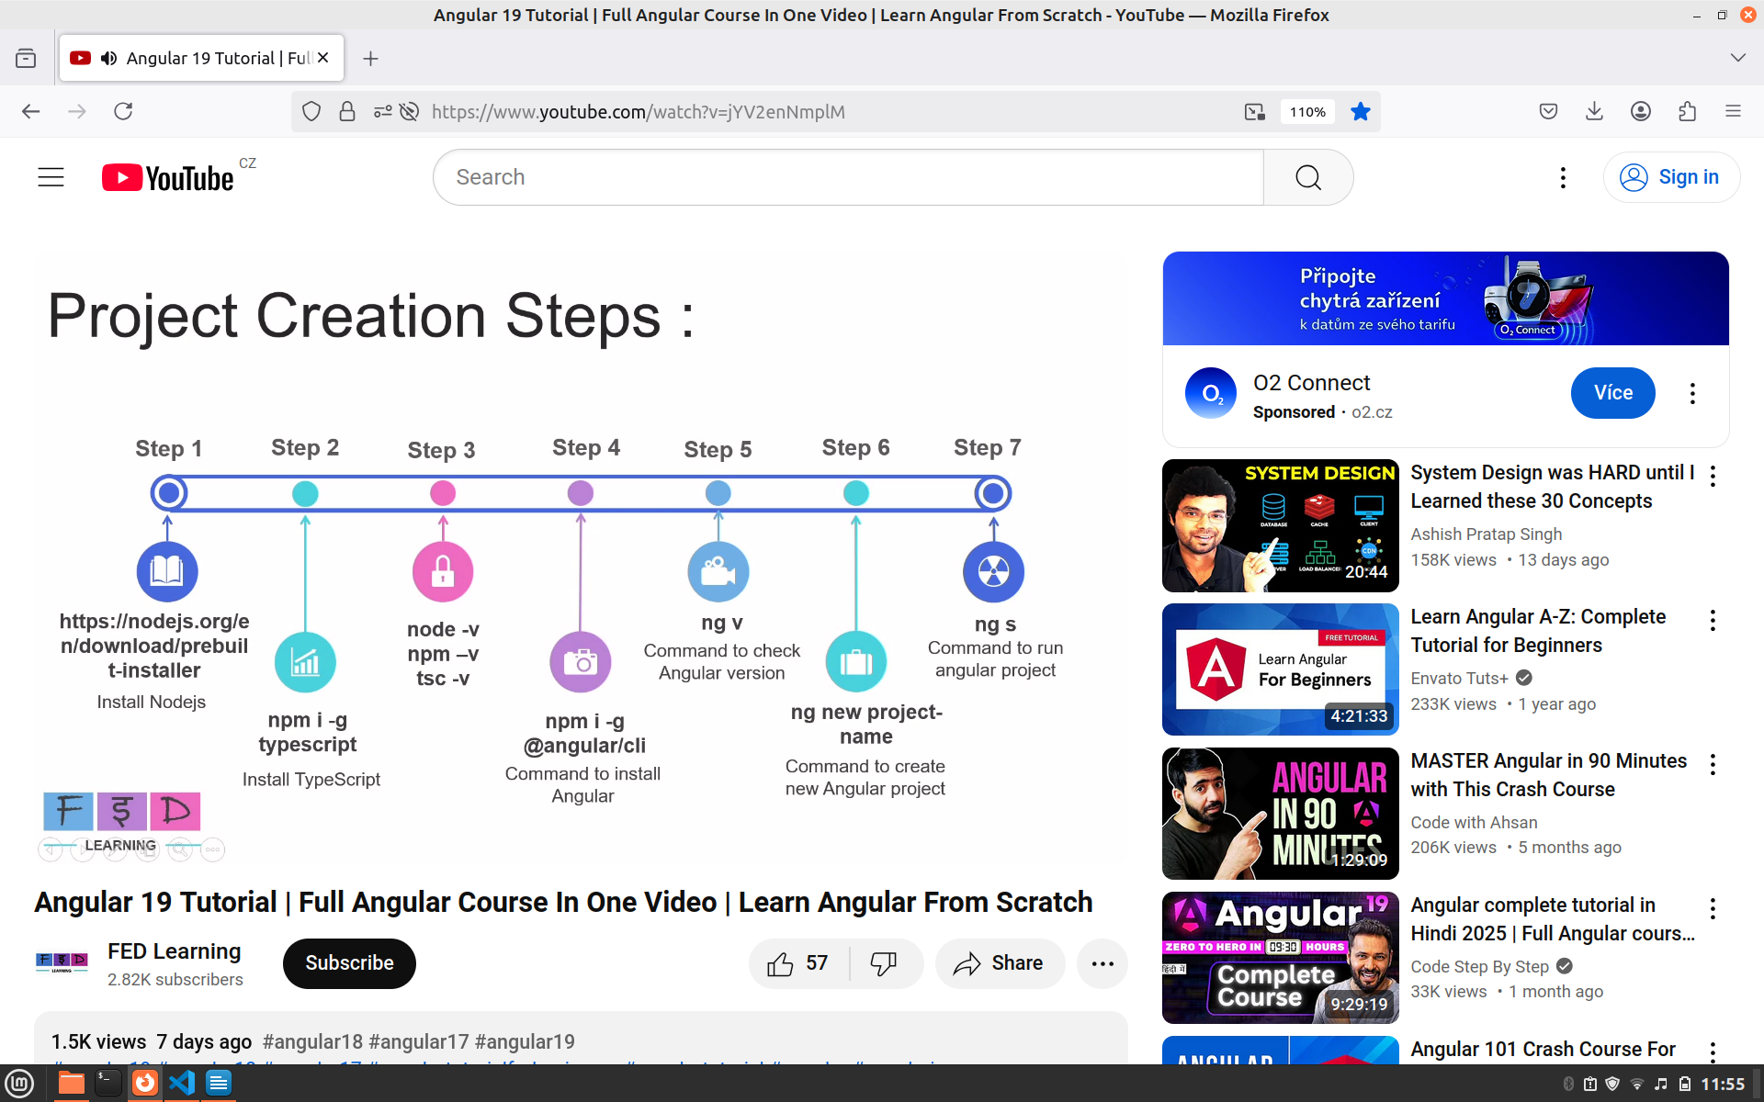
npm -v # Should print "10.9.2".

npm I -g typescript

- install typescript extension to visual studio code

- ng new Angular_19_tutorial

5 ng s
starts application

################## RUN ##########################
npm i uuid

npm i jquery --save
npm i datatables.net --save
npm i datatables.net-dt --save
npm i angular-datatables --save
npm i @types/jquery --save-dev

npm i bootstrap5

ng add @ng-bootstrap/ng-bootstrap

npm list -g
/home/vj/.nvm/versions/node/v23.11.0/lib
├── @angular/cli@19.2.6
├── corepack@0.32.0
├── npm@10.9.2
├── typescript@5.8.3
└── uuid@11.1.0

Feedback
People also se

Manual for integrating datatables into Angular project
https://nipuanandawansha.medium.com/angular-datatables-with-angular-19-4ee54d989639

npm install json-server

npm i @types/datatables.net --save-dev

npm i json-server

Angular_19/src/REST-endpoints$
json-server -w users-data.json

angular-datatables-master

https://github.com/l-lin/angular-datatables/tree/master

npm start

this starts development server
localhost:4200

npm i –save @types/jquery

ng add @angular/material

PROJECT EXPORT
git archive --format=zip --output zipfile.zip development

json-server -w employee-data.json

json-server -p 4000 -w users-data.json

http://localhost:4000/users

server
java -agentlib:jdwp=transport=dt_socket,server=y,suspend=y,address=8000 -jar target/backend-0.0.1-SNAPSHOT.jar

DOCKER
MONGODB
docker pull mongo
docker run -d --name my-mongodb -p
27017:27017 mongo

docker exec -it my-mongodb mongosh

/home/vj/Desktop/Angular/myapp-backed/backend
run without docker
mvn clean install
java -jar target/backend-0.0.1-SNAPSHOT.jar

run with docker
docker build -t myapp-backend:1.0.0 .
docker run -p 9090:9090 myapp-backend:1.0.0
docker container stop myapp-backend:1.0.0

run without docker
~/Desktop/Angular/myapp$
ng build
ng s or npm start
run with docker
docker build -t myapp-web:1.0.0 .
docker run -p 80:80 myapp-web:1.0.0
docker container stop myapp-web:1.0.0

MUSIC
docker build -t music:1.0.0 .
docker run -p 8080:8080 music:1.0.0
docker container stop music:1.0.0

LIST OF Images and Containers
docker images
docker container ps

removes all stopped contianers
docker container prune

remove all stopped containers
docker container prune

Show containers
docker container ps -a

docker run -p 9090:9090 myapp-backend
docker run -p 80:80 myapp-web

use mydb
db.createCollection("users")
db.users.insertOne({name: "John Doe", email: "john@example.com"})

TEST USE OF PERSISTENCE
docker stop my-mongodb
docker rm my-mongodb

TEST DB FIND
docker exec -it my-mongodb mongo
use mydb
db.users.find()

Where is the Docker volume?
/var/lib/docker/volume
Volumes are also stored as part of the host file system, which is managed by Docker. On Linux, volumes are stored in “/var/lib/docker/volume”.

https://shamsfiroz.medium.com/running-mongodb-in-docker-a-practical-guide-2b4cf39d5d60

https://www.baeldung.com/ops/docker-mounting-multiple-volumes

https://www.mongodb.com/resources/products/compatibilities/spring-boot

https://www.baeldung.com/spring-data-
mongodb-tutorial

RUN PGADMIN
https://www.pgadmin.org/docs/pgadmin4/latest/container_deployment.html

docker pull dpage/pgadmin4

docker run -p 180:180 \ -e 'PGADMIN_DEFAULT_EMAIL=user@domain.com' \
-e 'PGADMIN_DEFAULT_PASSWORD=SuperSecret' \
-e 'PGADMIN_CONFIG_ENHANCED_COOKIE_PROTECTION=True' \
-e 'PGADMIN_CONFIG_LOGIN_BANNER="Authorised users only!"' \
-e 'PGADMIN_CONFIG_CONSOLE_LOG_LEVEL=10' \
-d dpage/pgadmin4

2025-05-27 21:22:40.942 | Error: Database is uninitialized and superuser password is not specified.
2025-05-27 21:22:40.942 | You must specify POSTGRES_PASSWORD to a non-empty value for the
2025-05-27 21:22:40.942 | superuser. For example, "-e POSTGRES_PASSWORD=password" on "docker run".
2025-05-27 21:22:40.942 |
2025-05-27 21:22:40.942 | You may also use "POSTGRES_HOST_AUTH_METHOD=trust" to allow all
2025-05-27 21:22:40.942 | connections without a password. This is *not* recommended.
2025-05-27 21:22:40.942 |
2025-05-27 21:22:40.942 | See PostgreSQL documentation about "trust":
2025-05-27 21:22:40.942 | https://www.postgresql.org/docs/current/auth-trust.html

How to integrate backend with frontend (myapp, myapp-backed);
1. ng build for myapp (web)

2 Copy myapp/dist/myapp/browser content into myapp-backedsrc/main/resources/static

3. mvn clean install in project myapp-backend

4. java -jar target/backend-0.0.1-SNAPSHOT.jard a docker image

Angular material
ng add @angular/material

