Instalace a spusteni

Prerekvizity
Instalace Docker Desktop, Java 25 sdk, nodejs 26, pgAdmin 4 nejnovejsi

Moje klice
keys
0 | "f539e9247651ceaab8b3e7a993d4da7b746d50ce76734b0a02e044b9c953e495"
keys_base64
0 | "9TnpJHZRzqq4s+epk9Tae3RtUM52c0sKAuBEuclT5JU="
root_token | "hvs.dr0GtFA0lKKZrFvdywOW2wdj"

Instalace a spusteni HashiCorp Vault
Nejdriv vytvorim docker sit projects-network
docker network create projects-network
Ověření:
docker network ls | grep projects-network

1. Instalace HashiCorp Vault docker image a spusteni docker containeru
cd vault-docker-compose
docker compose up

2. Pri prvnim spusteni se podivejte do konzole vault image a zkopirujte si hesla pro unseal vaultu a root token pro prihlasovani do vaultu. Taky se da vault inicializovat na http://localhost:8200

2A. korenovem adresari spuste
nejdriv vault odemkneme unseal klici staci 1 kdyz je treashhold 1 nastavuje se pri prvnim spusteni webove aplikaci na localhost:

pro unseal vaultu pouzijte nasledujici prikaz:
docker exec -it vault vault operator unseal
2B. konfigurace Vaultu
vytvor key-value engine secrets. V nem
secrets datatables a listek
Spust demo projekty
Po prve spust HashiCorp Vault.
cd vault-docker-compose
./docker compose up
http://localhost:8200
tam nastav pocet klicu a limit pro odemknuti trezoru na 1
vygenerovane klice si stahni budes je potrebovat k dalsi praci, pristup k heslum pro aplikace.

Po druhe a dal spust vault nasledujicim prIkazem, pokud nebezi!
./run_vault.sh
Dole je uvedeno jak nastaveni provest

Parametry k nastaveni datatables aplikace
DATATABLES_DB_NAME: datatables
DATATABLES_DB_PASSWORD: password
DATATABLES_DB_USERNAME: postgres
DATATABLES_KEYCLOAK_ADMIN_PASSWORD: demo123
DATATABLES_KEYCLOAK_ADMIN_USERNAME: demo
DATATABLES_RABBITMQ_PASSWORD: mypassword
DATATABLES_RABBITMQ_USERNAME: myuser

Parametry k nastaveni listek aplikace
DB_NAME: listek
DB_PASSWORD: password
DB_URL: jdbc:postgresql://postgres:5432/listek
DB_USERNAME: postgres

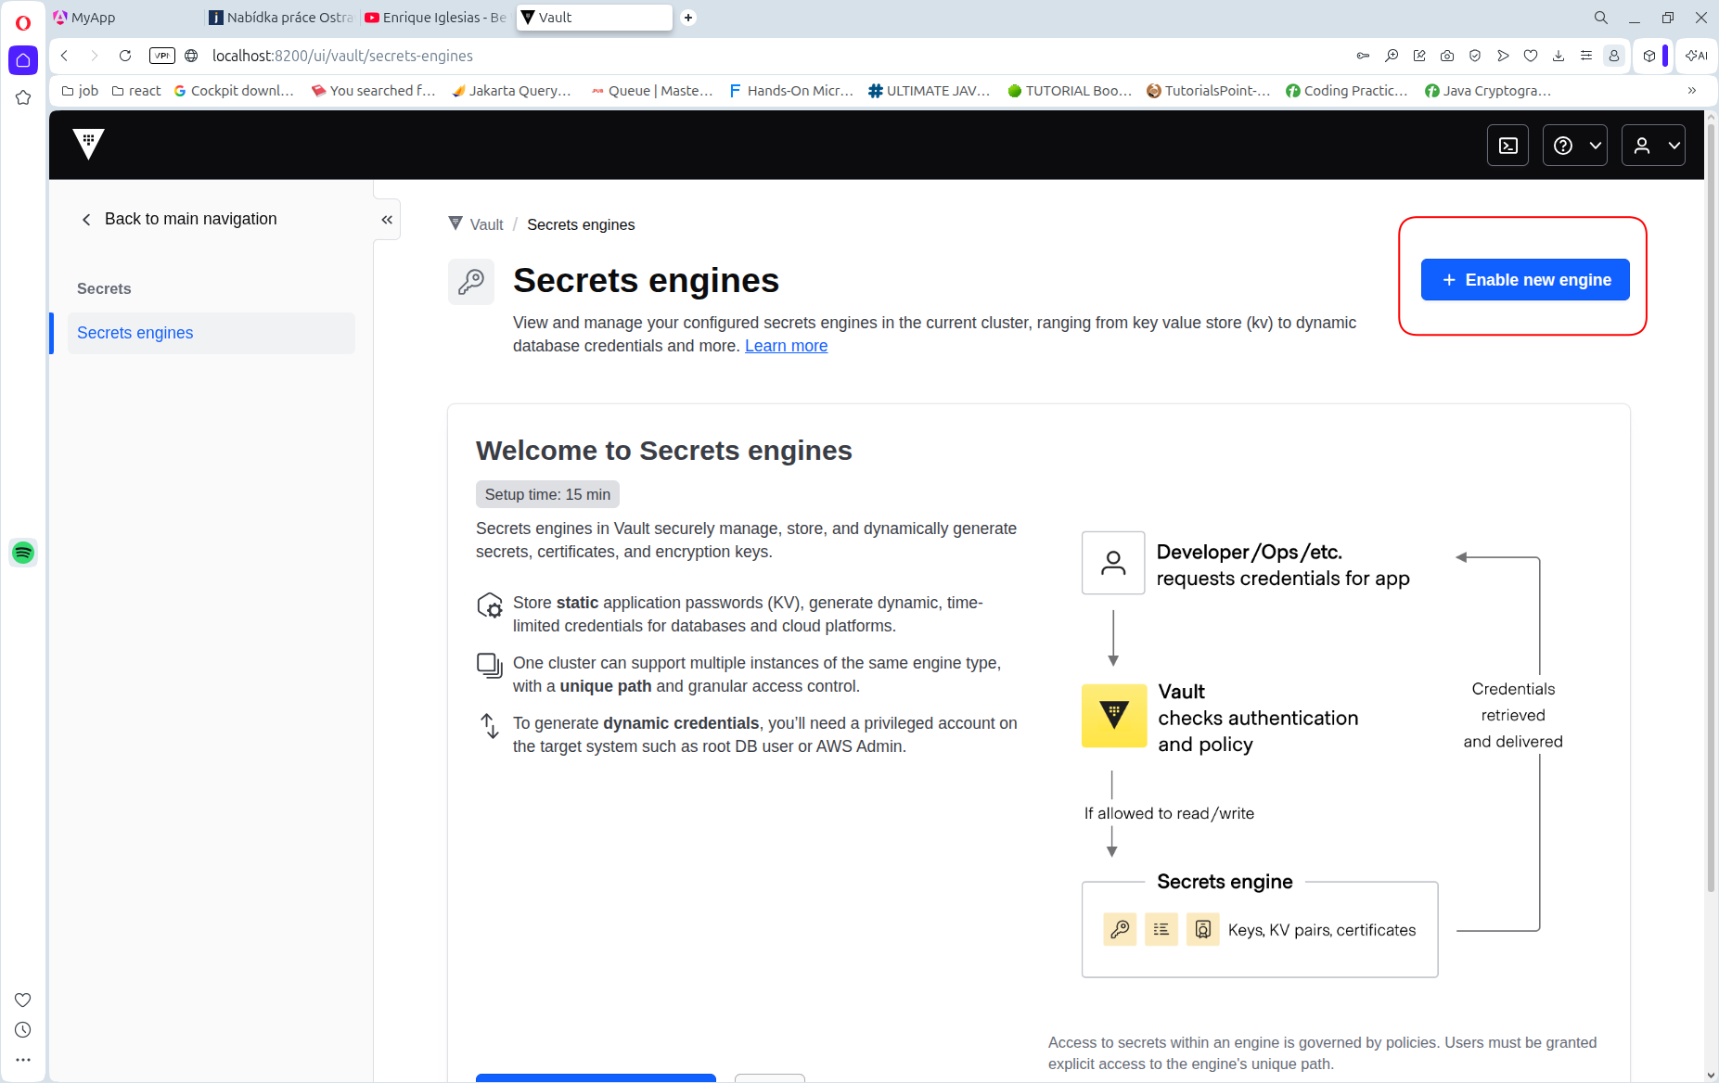
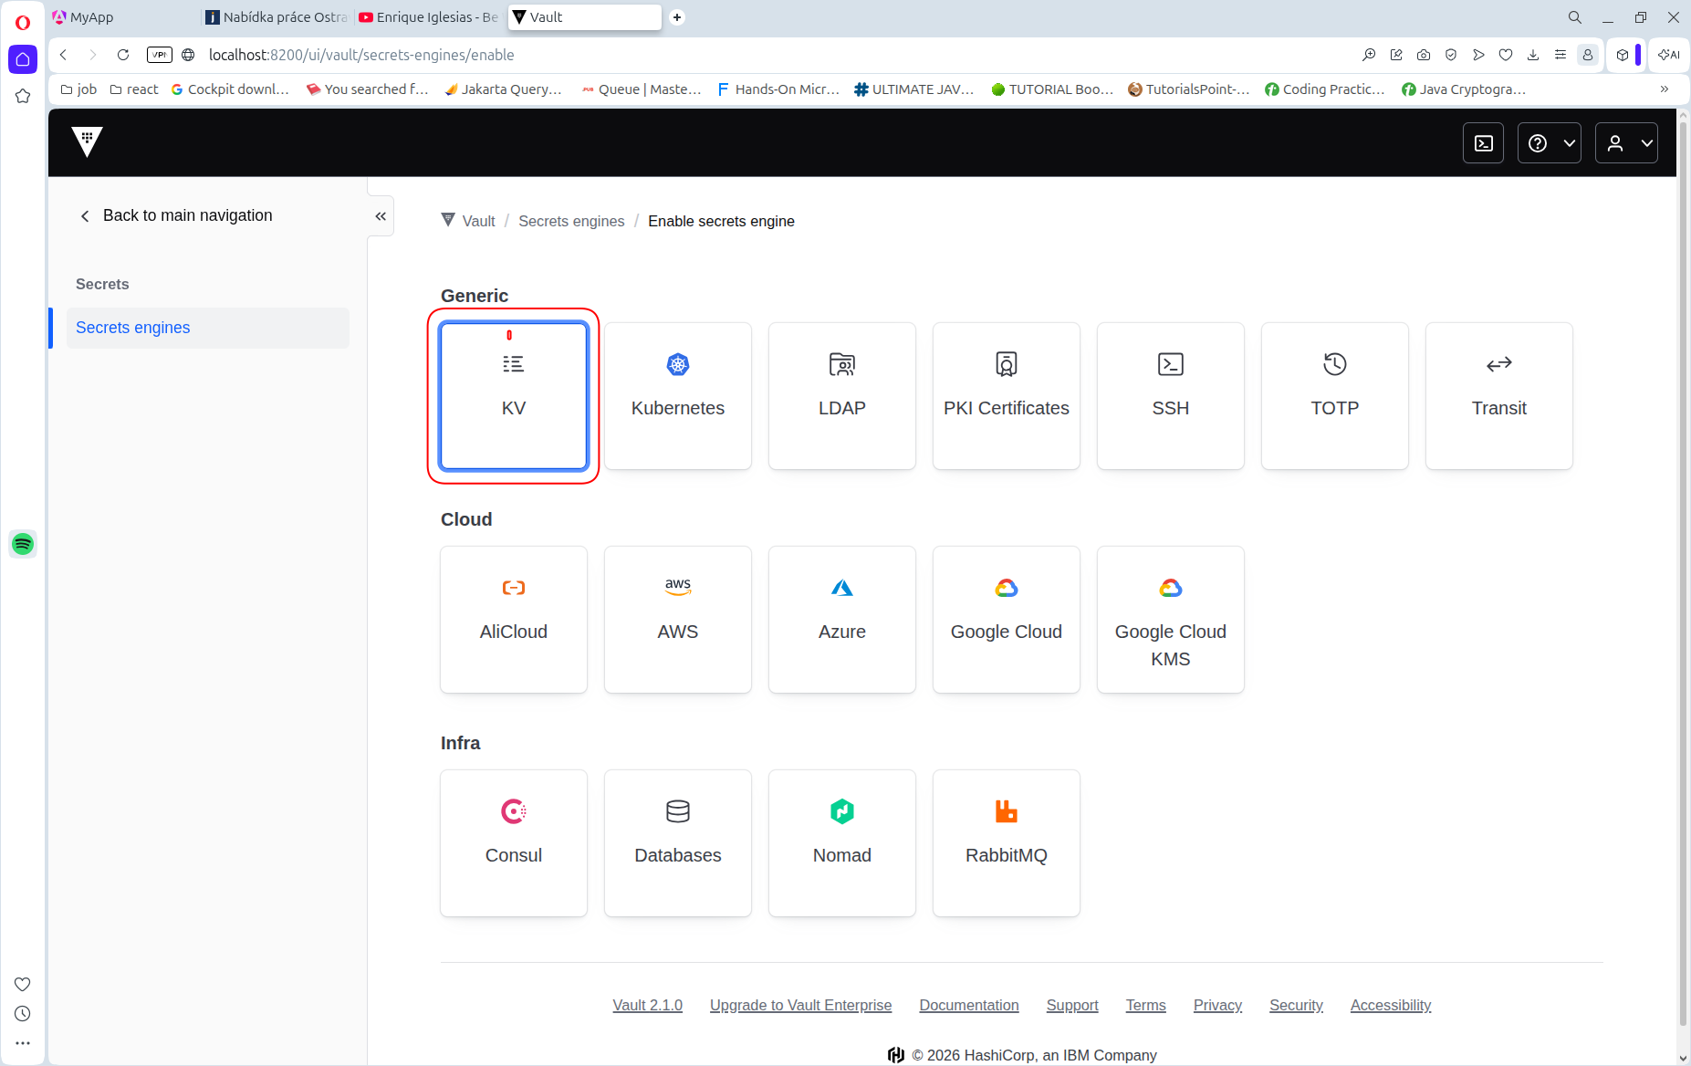

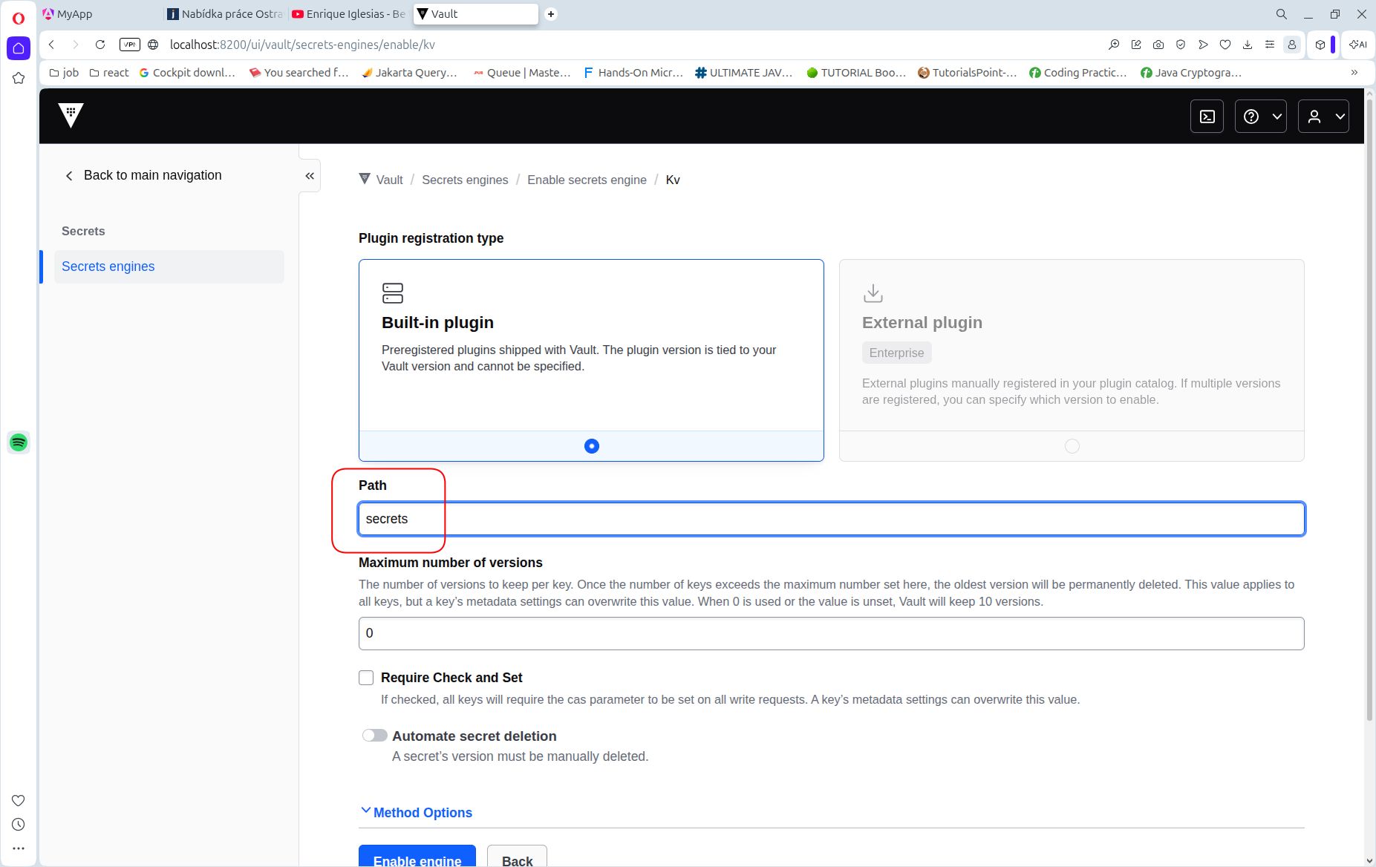
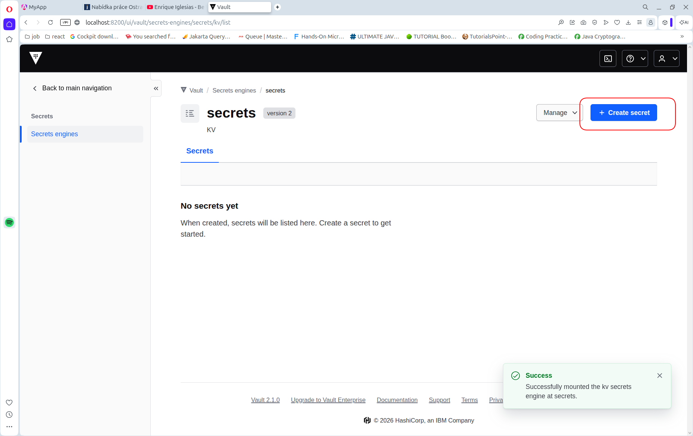
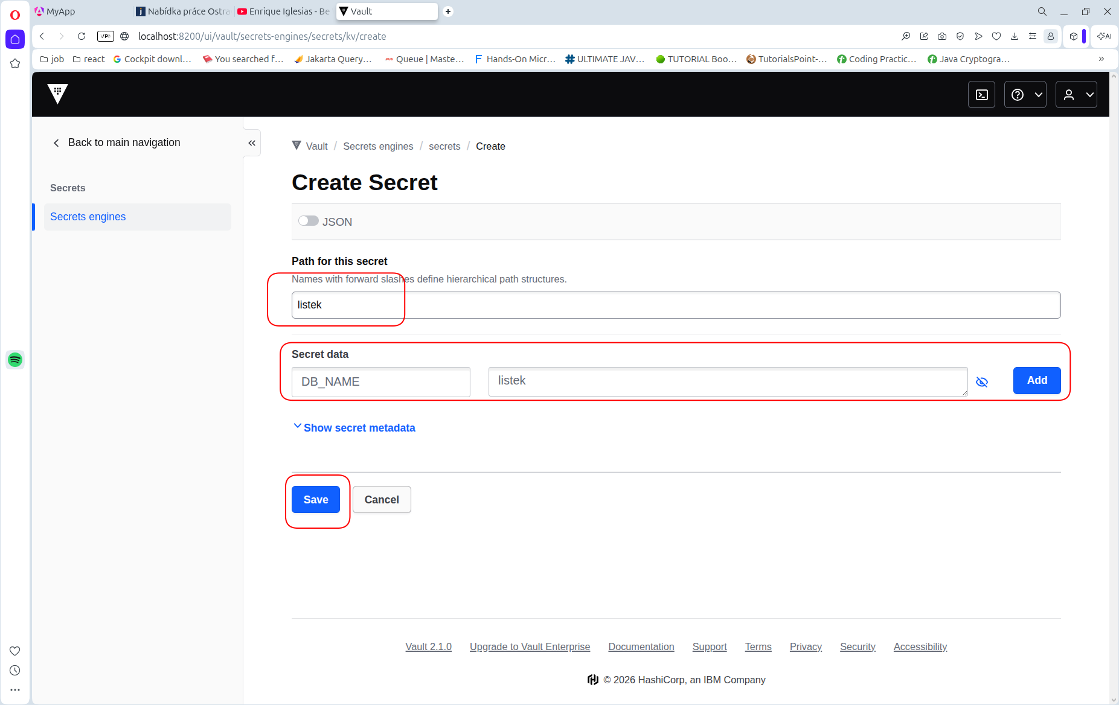

Spusteni zbytku infrastruktury
1. Spust zbytek infrastruktury
v korenovaem adresari spustte:
./rest_of_infrastructure.sh

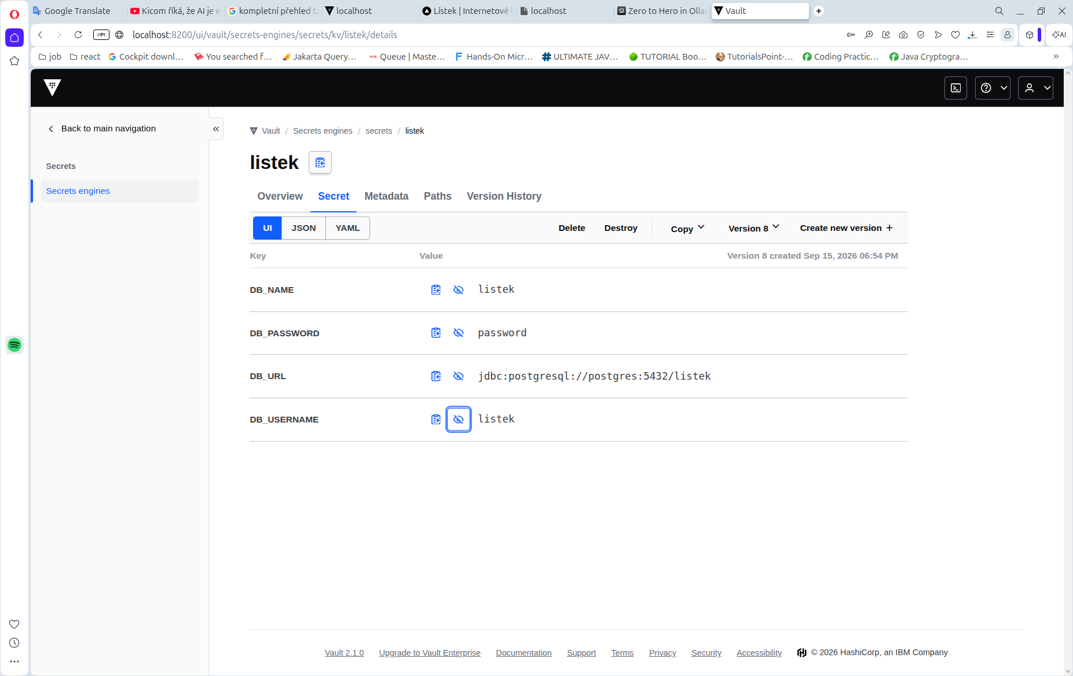

Dale spust nasledujici skripty
./run_rest_of_infrastructure.sh
./run_demo_projects.sh

./listek-backend/build.sh
./listek-backend/docker-compose-vault.sh

4. configuruj Posgresql databaze
v pgAdminu vytvor server s connection parametry

Pro aplikaci Listek:
DB_NAME: listek
DB_USERNAME: postgres
DB_PASSWORD: password

Pro aplikaci datatables:
DATATABLES_DB_NAME: datatables
DATATABLES_DB_USERNAME: postgres
DATATABLES_DB_PASSWORD: password

