MongoDBConnection.java

import com.mongodb.client.MongoClient;
import com.mongodb.client.MongoClients;
import com.mongodb.client.MongoDatabase;
import com.mongodb.client.MongoCollection;
import org.bson.Document;
public class MongoDBConnection {
public static void main(String[] args) {
String connectionString = "mongodb://localhost:27017";
try (MongoClient mongoClient = MongoClients.create(connectionString)) {
MongoDatabase database = mongoClient.getDatabase("testdb");
MongoCollection<Document> collection = database.getCollection("user");
collection.deleteMany(new Document());
Document userDoc = new Document();
userDoc.append("sl_no", "201");
userDoc.append("name", "Arun");
userDoc.append("email", "arun@gmail.com");
userDoc.append("address", "Bihar");
collection.insertOne(userDoc);
System.out.println("=========================================");
System.out.println("Connected successfully to MongoDB via IntelliJ!");
System.out.println("Database 'testdb' & Collection 'user' Created!");
System.out.println("Data Inserted: Arun (Bihar) successfully!");
System.out.println("=========================================");
} catch (Exception e) {
System.out.println("MongoDB Connection Failed! " + e);
}
}
}

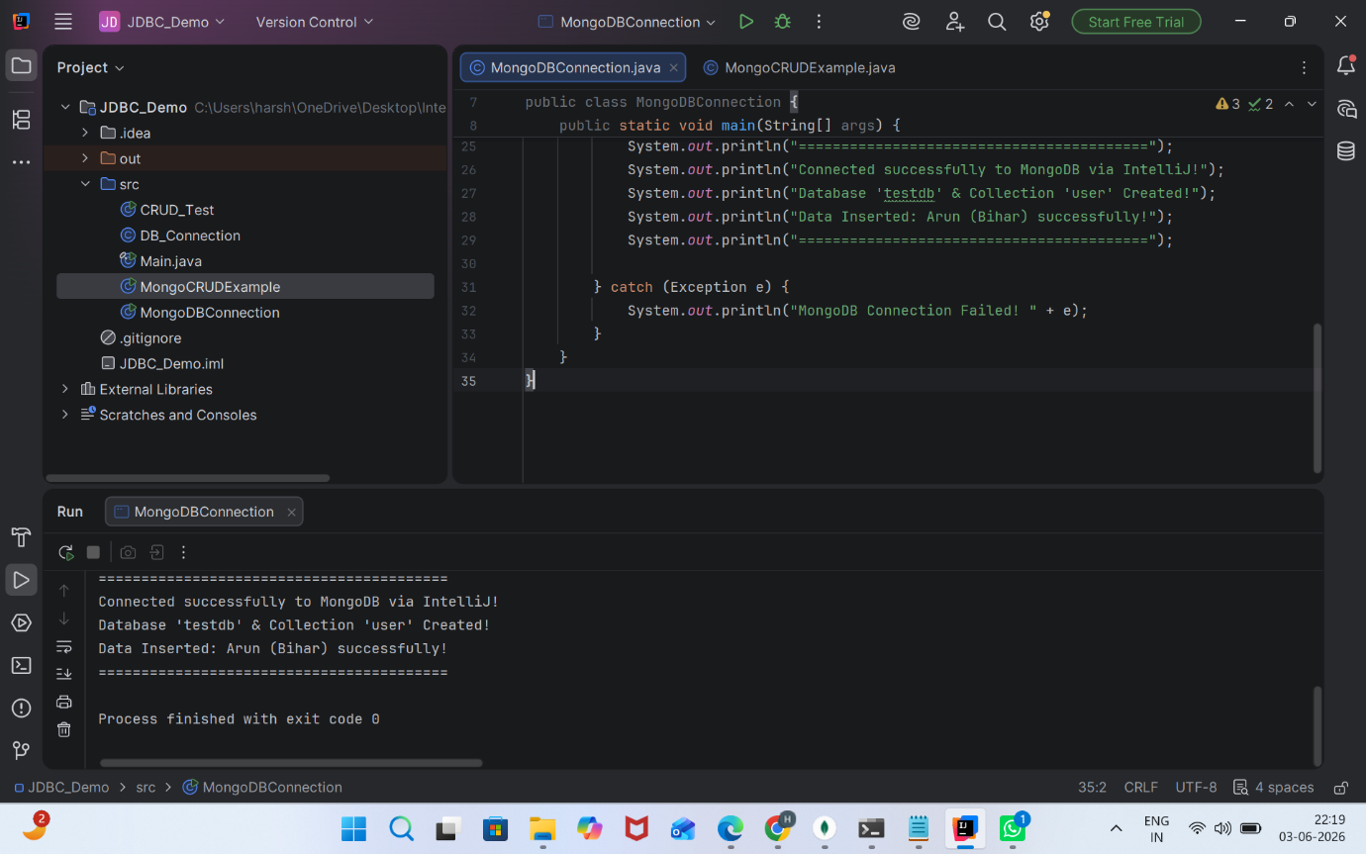

MongoCRUDExample.java

import com.mongodb.client.*;
import com.mongodb.client.model.Filters;
import com.mongodb.client.model.Updates;
import org.bson.Document;
import java.util.Arrays;
public class MongoCRUDExample {
public static void main(String[] args) {
MongoClient mongoClient = MongoClients.create("mongodb://localhost:27017");
MongoDatabase database = mongoClient.getDatabase("CollegeDB");
MongoCollection<Document> collection = database.getCollection("Students");
collection.deleteMany(new Document());
Document student = new Document("id", 101)
.append("name", "John")
.append("department", "CSE")
.append("cgpa", 8.7);
collection.insertOne(student);
System.out.println("Document Inserted Successfully");
collection.insertMany(Arrays.asList(
new Document("id", 1).append("name", "Alice").append("department", "CSE").append("cgpa", 9.0),
new Document("id", 2).append("name", "Bob").append("department", "ECE").append("cgpa", 7.8),
new Document("id", 3).append("name", "Charlie").append("department", "CSE").append("cgpa", 8.5)
));
System.out.println("Multiple Documents Inserted Successfully");
System.out.println("\nStudent Records:");
FindIterable<Document> students = collection.find();
for (Document doc : students) {
System.out.println(doc.toJson());
}
collection.updateOne(
Filters.eq("id", 101),
Updates.set("cgpa", 9.2)
);
System.out.println("\nDocument Updated Successfully");
Document updatedStudent = collection.find(Filters.eq("id", 101)).first();
System.out.println("Updated Record:");
if (updatedStudent != null) {
System.out.println(updatedStudent.toJson());
}
Document doc = collection.find(Filters.eq("id", 2)).first();
System.out.println("\nFind Specific Document (id 2):");
if (doc != null) {
System.out.println(doc.toJson());
}
collection.updateOne(
Filters.eq("id", 2),
Updates.set("name", "Bobby")
);
System.out.println("Specific Document Updated Successfully (Bob to Bobby)");
collection.updateMany(
Filters.eq("department", "CSE"),
Updates.set("department", "Computer Science")
);
System.out.println("All CSE Departments Updated to Computer Science");
System.out.println("\nStudent Records After updateMany:");
FindIterable<Document> updatedList = collection.find();
for (Document d : updatedList) {
System.out.println(d.toJson());
}
collection.deleteOne(Filters.eq("id", 101));
System.out.println("\nDocument with ID 101 Deleted Successfully");
collection.deleteOne(Filters.eq("id", 2));
System.out.println("Specific Document with ID 2 (Bobby) Deleted Successfully");
System.out.println("\nFinal Student Records Remaining:");
FindIterable<Document> finalStudents = collection.find();
for (Document d : finalStudents) {
System.out.println(d.toJson());
}
mongoClient.close();
}
}

