

.top-line { position: relative; }

.top-line:after { content: ""; position: absolute; top: 0; left: 0; right: 0; height: 1px; background: #fff; opacity: 0; -moz-transform: translateY(-10px); -ms-transform: translateY(-10px); -webkit-transform: translateY(-10px); transform: translateY(-10px); -moz-transition: -moz-transform 300ms, opacity 300ms; -o-transition: -o-transform 300ms, opacity 300ms; -webkit-transition: -webkit-transform 300ms, opacity 300ms; transition: transform 300ms, opacity 300ms; }

.top-line:hover:after { opacity: 1; -moz-transform: translateY(0); -ms-transform: translateY(0); -webkit-transform: translateY(0); transform: translateY(0); }

.top-line.is-active:after { display: none; }

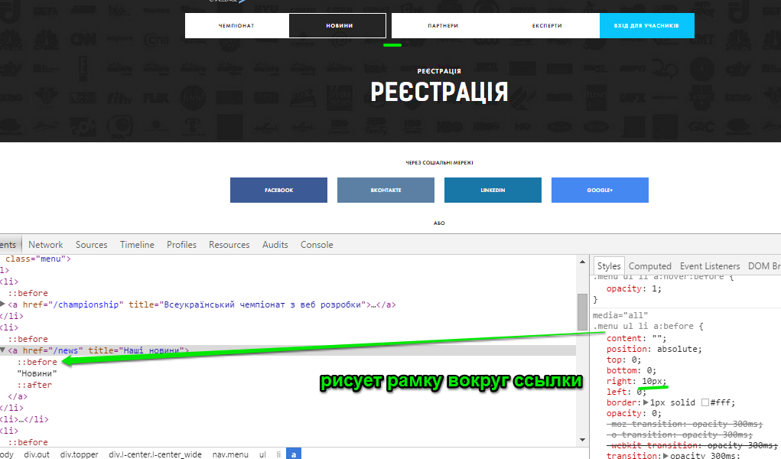

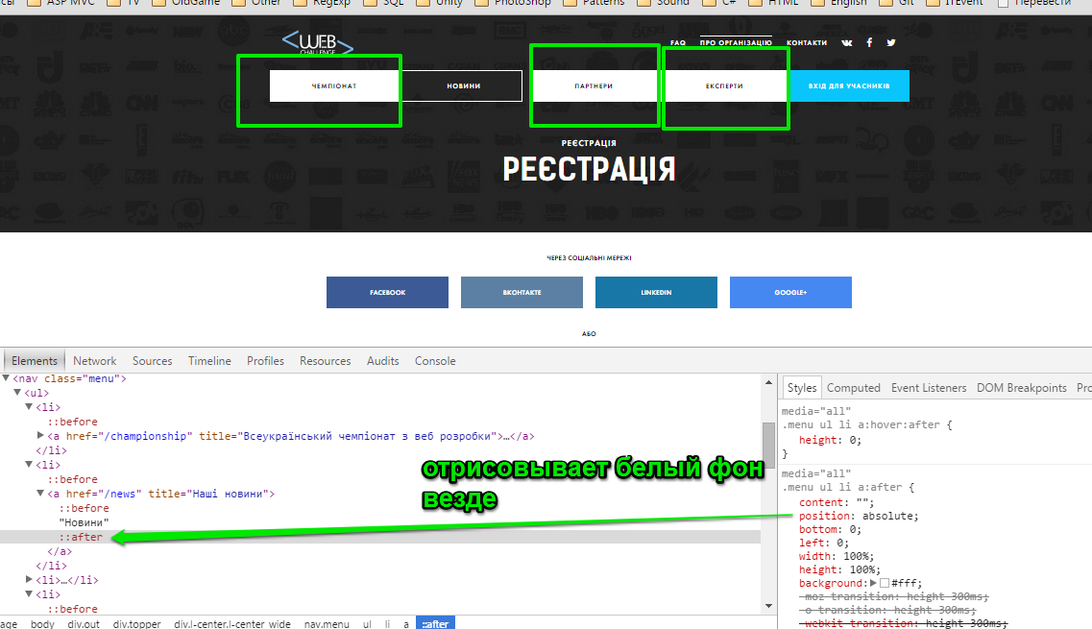

Еще добавлена (не видно на снимке)

1. transition: height 300ms;
2. z-index: -1;

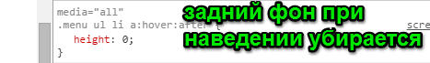

Раздвижение по сторонам

