

using System;

using System.Collections.Generic;

using System.IO;

using System.Linq;

using System.Text;

using System.Threading;

using System.Threading.Tasks;

namespace DelArrayFromClass

{

class Program

{

class Test:IDisposable

{

private MemoryStream mem;

private bool disposed;

private Object[] o = new Object[1000000];

public Test()

{

for (int i = 0; i < 1000000; i++)

{

o[i] = new Object();

}

mem=new MemoryStream();

StreamWriter sw = new StreamWriter(mem);

sw.WriteLine("Hello world");

sw.WriteLine("Hello Vitek");

sw.Flush();

}

public void Dispose()

{

Clean();

GC.SuppressFinalize(this);

}

public override string ToString()

{

mem.Position = 0;

return new StreamReader(mem).ReadToEnd();

}

void Clean()

{

if (!disposed)

{

mem.Close();

mem = null;

disposed = true;

}

}

~Test()

{

Clean();

Console.WriteLine("finalize");

}

}

static void Main(string[] args)

{

Test t=new Test();

Console.WriteLine(t);

Console.WriteLine(t);

Console.WriteLine(GC.GetTotalMemory(false) / 1024);

t.Dispose();

GC.Collect();

Console.WriteLine(GC.GetTotalMemory(false)/1024);

Console.ReadKey();

}

}

}

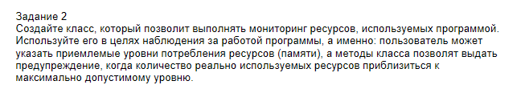

#define v2

using System;

using System.Threading;

namespace Task_1

{

class MonitorMemory

{

readonly int memoryLimit;

public MonitorMemory(int memoryLimit)

{

this.memoryLimit = memoryLimit;

}

bool IsMemoryLimitExceeded()

{

return this.memoryLimit < GC.GetTotalMemory(false);

}

public void WarnIfMemoryLimitExceeded(object errorMessage)

{

if (IsMemoryLimitExceeded())

{

Console.WriteLine("{0}", errorMessage);

}

}

}

class LargeObject

{

int[] array = new int[100000000]; // 100 000 000 Б * 4 = 400 000 000 Б = 390 625 КБ = 381 МБ

public void Method(int i)

{

Console.WriteLine(i);

}

}

class Program

{

static void Main()

{

Timer timer = new Timer(new MonitorMemory(100000000).WarnIfMemoryLimitExceeded,

"Warning memory out", 0, 200);

LargeObject[] array = new LargeObject[1000];

for (int i = 0; i < array.Length; i++)

{

new LargeObject().Method(i);

}

Console.ReadKey();

}

}

}