Install-Package Microsoft.AspNet.Identity.Owin -Version 2.1.0

Install-Package Microsoft.AspNet.Identity.EntityFramework -Version 2.1.0

Install-Package Microsoft.Owin.Host.SystemWeb -Version 3.0.0

Install-Package Microsoft.AspNet.WebApi.Owin -Version 5.2.2

Install-Package Microsoft.Owin.Security.OAuth -Version 3.0.0

Install-Package Microsoft.Owin.Cors -Version 3.0.0

install-package Sendgrid

// Use NuGet to install SendGrid (Basic C# client lib)

private async Task configSendGridasync(IdentityMessage message)

{

var myMessage = new SendGridMessage();

кому

myMessage.AddTo(message.Destination);

myMessage.From = new System.Net.Mail.MailAddress("taiseer@bitoftech.net", "Taiseer Joudeh");

зголовок

myMessage.Subject = message.Subject;

тело

myMessage.Text = message.Body;

myMessage.Html = message.Body;

var credentials = new NetworkCredential(ConfigurationManager.AppSettings["emailService:Account"],

ConfigurationManager.AppSettings["emailService:Password"]);

// Create a Web transport for sending email.

var transportWeb = new Web(credentials);

// Send the email.

if (transportWeb != null)

{

await transportWeb.DeliverAsync(myMessage);

}

else

{

//Trace.TraceError("Failed to create Web transport.");

await Task.FromResult(0);

}

}

Добавьте поддержку OAuth предъявителя маркеры поколения

http://bitoftech.net/2014/06/01/token-based-authentication-asp-net-web-api-2-owin-asp-net-identity/

Install-Package Microsoft.Owin.Security.OAuth -Version 2.1.0

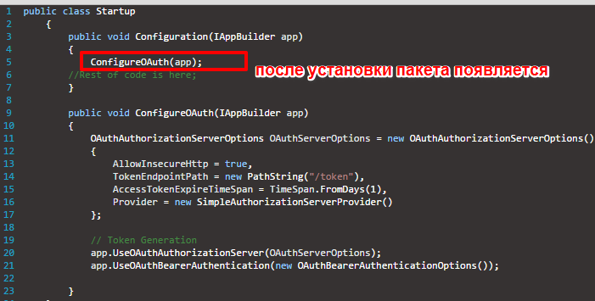

Install-Package Microsoft.Owin.Cors -Version 2.1.0